hello.cpp

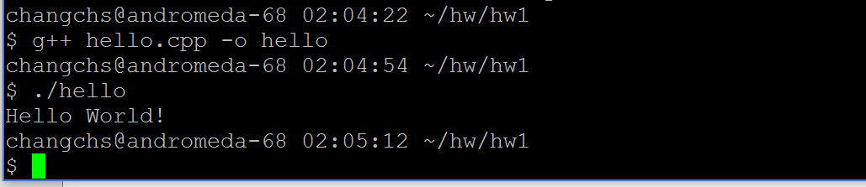

convert.cpp

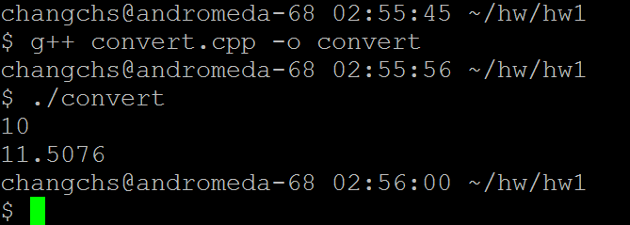

Stack.h & test_stack.cpp

