Problem 1 Coins.h

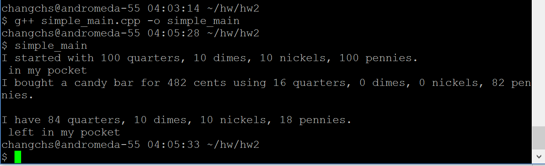

Problem 2 coins_main.cpp

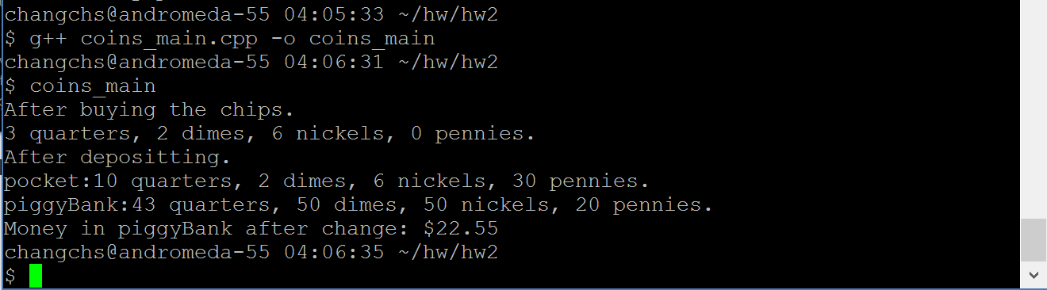

Problem 3 coins_menu.cpp

