November 10, 2016

To Whom It May Concern:

I am withdrawing from the October 26th 2016 class at Codeup. Withdrawal date was effective on November 4th, 2016.

Reason for withdrawal was additional courses needed to be completed as a foundation to successfully complete the Codeup course.

Immediate re-enrollment for Codeup course will be February 6th, 2017.

I intend to transfer all tuition and credit to the February 6th, 2017 course.

Thank you,

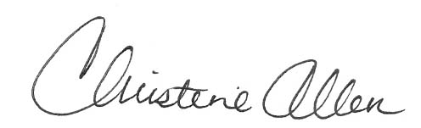

Christy Allen