Mobile based telehealth tools versus traditional in-person (standard of care) visit effects on quality of life outcomes for hypertensive geriatrics

Christine Ly

Stony Brook University

Professor Hants Williams

HHA 506

August 12, 2020

**Introduction**

As the Baby Boomer population ages, the number of geriatrics across the United States is also increasing rapidly. By 2025, the number of geriatrics who are 65 years old or older around the world will reach 761 million which is more than twofold of the amount from 1990.1 Within the geriatric population, hypertension is a major public health problem and telehealth provides a solution to allow these individuals to continue living a healthy lifestyle in their homes.1,2 Hypertension is a health condition where individuals have a systolic blood pressure (SBP) equal to or above 140 mm of Hg or a diastolic blood pressure (DBP) equal to or above 90 mm of Hg.1 Without having a normal blood pressure, the function of vital organs such as the heart, kidneys, and brain could be compromised.1 Geriatrics suffer from health issues related to aging, but hypertension remains a prevalent health condition among the population that should be managed well daily.

Telehealth utilization is beneficial for geriatrics by improving their control of blood pressure and their self-management ability for hypertension.2 Telehealth refers to the remote communication of health information and delivery of medical care, preventive care, or public health interventions.3 Ben-Pazi et al. also discussed that telehealth usage has decreased the amount of travel costs and time paid by patients compared to in-person visits.4 Telehealth tackles all three dimensions of the Triple Aim through improving patient experience, costs for health care, and population health for geriatrics. Telehealth tools such as mobile applications provide remote monitoring (RM) of patients beyond the traditional clinical setting like from a patient’s home.5 The mobile application has a teleconsultation feature with videoconferencing and when paired with a wearable tracking device to collect a patient’s clinical data, such as blood pressure, temperature, and heart rate, physicians can view the collected data to provide healthcare services remotely.5,6 An additional feature is a virtual social support group for hypertensive individuals and a list of tips for better self-management. This feature is beneficial since patients can converse with others diagnosed with hypertension leading to better self-management outcomes.7

Based on previous research, the impact of mobile based telehealth tools usage on quality of life outcomes is a relatively gray area. Currently, there is no concrete evidence that there is a clear correlation between daily mobile based telehealth tool use and quality of life outcomes for the hypertensive geriatric population.8 Previous research also focused on the economic benefits of telehealth, but few have gathered a large enough sample that will accurately represent a specific population.2 There is also very limited knowledge on this topic during the COVID-19 pandemic as more geriatrics are quarantined at home to follow lockdown protocols. While the combination of wearable tracking devices and mobile applications have been utilized before, this was not within the New York City (NYC) area and did not target a specific age group.

To fill in these gaps within the literature, the research question for the study is in the NYC hypertensive geriatric population aged 65 and older, how does the daily utilization of mobile based telehealth tools to continuously monitor symptoms compared to traditional in-person (standard of care) visits affect quality of life outcomes within 30 days of downloading the mobile application? The research hypothesis is that quality of life outcomes are improved in hypertensive geriatric patients who utilize mobile based telehealth tools daily to continuously monitor their symptoms compared to geriatric patients who utilize traditional in-person visits. The sample is not too small or large and is limited to only geriatric patients who reside within NYC. This makes the population more focused and directs the recruitment of participants for the sample to be more representative of geriatrics within that area. The exclusion criteria encompasses individuals who are under 65 years old, from other areas outside NYC, not diagnosed with hypertension, and other healthcare tools besides mobile based telehealth tools. Technical expertise of mobile based telehealth tools is necessary to educate users how to properly utilize videoconferencing, mobile applications, and self-monitoring features to gain healthcare services from home. The 30 day timeframe is tangible since Srinivas et al. mentioned that 30 days of continuous use of the mobile application is sufficient enough to increase patient engagement to integrate self-care behaviors in their daily life.9 The answer to this research question would be relatively useful since the COVID-19 pandemic has pushed for the wider adoption of telehealth technology to provide healthcare services to patients. This information may assist policymakers and healthcare professionals to push for the expanded use of home mobile based telehealth tools if there are positive results. The ability to limit the amount of in-person visits is essential in flattening the curve and especially important to prevent at risk older adults from being exposed to COVID-19.10 It should also be noted that participation in this study is completely voluntary and should not delay any medical treatment the patient were to receive initially as well as allow the patient to leave the study without any consequences.

Previous research has shown that home telehealth tools can provide geriatric patients with the ability to video call their healthcare providers and find virtual social groups to join to decrease loneliness which improves their health as well.6,7 According to Banbaury et al., social groups are beneficial through providing patients with the opportunity to converse with others diagnosed with similar health conditions and share their emotions about faced challenges, leading to more success with self-management.6 In general, telemedicine usage has showed positive benefits for geriatric patients through reducing the travel risks and readmission rates after their hospital visit.10,11 This question can address future research by providing limitations and potential suggestions on how to gather more information on the topic. Attention can be brought to what went wrong in this study and can be adjusted for another study by possibly selecting a different population or measuring quality of life outcomes with another method.

**Methods**

*Trial design*

A parallel/stepped-wedge approach will be implemented for this study as this is a common approach to evaluate health services.12 A parallel stepped-wedge approach is most suitable to address the question since a single intervention will be exposed to each cluster after starting off with the control condition.12 A cluster is a subgroup of individuals, such as a village, that will be recruited for the study to observe results that are representative of a larger population.13 For this study, a cluster includes all the hypertensive geriatrics aged 65 years old or older living within a specific zip code within New York City (NYC). There will be five zip code areas selected, each from a different borough. Clusters will be randomized to a sequence which indicates the time periods an entire cluster will spend with the control condition and the intervention treatment.13 The independent variable is the type of care the patient will receive which can be either the traditional in-person (standard of care) visit or the mobile based telehealth tool. The dependent variable is the quality of life outcome the geriatric patients experience as a result of the intervention treatment with the mobile based telehealth tool. In this case each cluster will initially start with the control condition which includes in-person visits and will ultimately receive the intervention which is telehealth through the daily use of a mobile application to assist in the monitoring of their blood pressure. There will be six time periods or sequences where each zip code will sequentially receive the intervention within one week intervals. At each period, there will be the same participants within the cluster assessed which is done in the form of a Cambridge Pulmonary Hypertension Outcome Review (CAMPHOR) questionnaire.

Figure 1. Parallel stepped wedge schematic. Each cell represents a point of data collection. The time duration for each step, T1 to T5, will be 30 days. The red shaded cells indicate the preliminary time period when each cluster will receive a baseline survey to complete. Blue shaded cells represent when each cluster is undergoing the intervention treatment based on their assigned sequence. Unshaded cells indicate the clusters undergoing the control condition. The T1-T6 surveys will be distributed to each participant via mobile application in the cluster after 30 days of undergoing the intervention treatment according to their assigned sequence. This schematic was based on the presented by Hemming et al.13

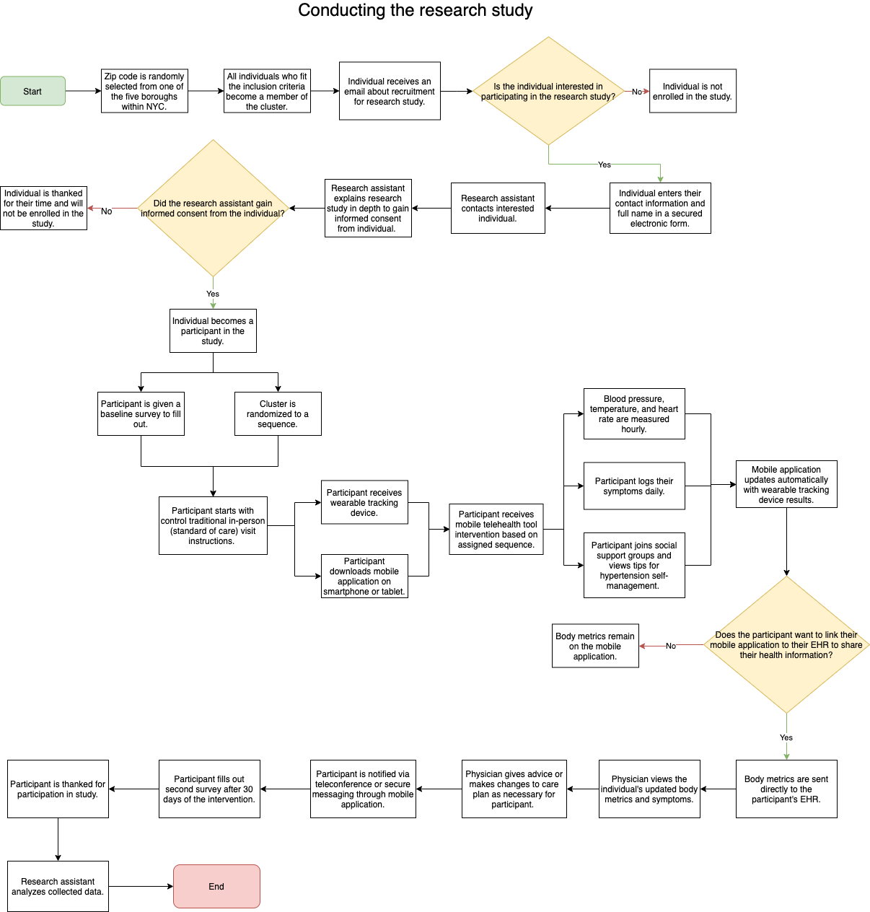

Figure 2. Visio of how the research study will be conducted. This is a visual representation of the steps a participant will undergo throughout the research study.

*Survey tool*

CAMPHOR was developed to specifically target hypertensive patients to gain patient reported outcome measures (PROMs) that included quality of life measures and actual patient values.14 According to previous studies, patients reported that CAMPHOR was a valid, internally consistent and reliable questionnaire that was easy to use and asked questions that covered all the essential aspects of the disease.15 It was the only disease-specific instrument available that evaluated quality of life outcomes which can be used as a tool to assist physicians in making more effective evidence-based decisions.15 These questionnaires will be distributed to participants on the mobile application to fill out before they are randomized to the intervention and after the 30 day mark after utilizing the intervention. CAMPHOR contained three sections where the first one focused on overall symptoms, asking users to answer yes or no to 25 questions depending on if they have experienced the symptom.14,15 The second section focused on the ability to function and carry out their activities of daily living (ADLs); users were asked 15 questions with three response options which included, “able to do on own without difficulty,” “able to do on own with difficulty,” and “unable to do on own.”14,15 The third section focused on quality of life outcomes which included the patient’s ability to satisfy their needs in life; there are dichotomous response options such as true or false.14,15 The first and third section will be rated on a scale from 0-25, while the second section will be rated on a scale from 0-30.14,15 Higher scores on all of these scales indicated more intense exacerbations of symptoms, worse functioning, and poorer quality of life.14

Table 3. Example CAMPHOR items and Croatian translation. These are items that were asked in each respective section of the questionnaire with a Croatian translation.5

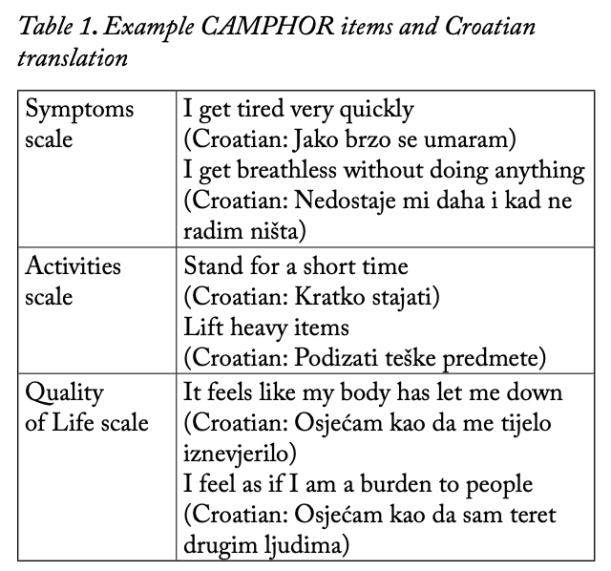

CAMPHOR was implemented in various countries such as, but not limited to Portugal and Croatia, indicating the ability to reach a wider pool of participants since the questionnaire can be translated.15,16 Any changes such as a delay between progressing to the next step for a certain cluster will alter the results and affect some observations. Thus, if it becomes an issue when transitioning a cluster from the control treatment to the intervention, the 30 day implementation will be pushed to a later date for that particular cluster.

*Participants*

Participants include any geriatrics aged 65 or older who are also diagnosed with hypertension and living within the selected zip code area in NYC. There should be a minimum of 850 participants recruited in total and informed consent must be gained from the selected participants. Participants who are not diagnosed with hypertension, are not 65 years old or older, live outside the selected zip code area, or decline to participate in this study will be excluded. All participants with a neurological disorder or the inability to provide informed consent will also be excluded to avoid ethical complications with this study. A cluster includes these eligible participants living in the selected zip code within one of the five boroughs. The data will be collected from questionnaire via Research Electronic Data Capture (REDCap) to allow for less technical members of the research team to access and view the data as well.17 All data will be collected from NYC and be shared digitally as well as securely to maintain HIPAA compliance. Only authorized personnel of the research team will have access to the database and patient data for the purpose of this study.

*Intervention*

The intervention is a mobile application hypertensive geriatric patients need to download onto their mobile device or tablet. The questionnaires will also be on the mobile application and the data will be collected via REDCap. Each geriatric patient will also receive a wearable tracking device that they will be required to wear continuously for the next 30 days. This device will measure the geriatric patient’s blood pressure, heart rate, and temperature which will automatically send this data to the mobile application. These metrics will be collected hourly to allow for physicians to view trends when the data points are aggregated together and visually showcased in the form of a graph. The geriatric patient is also required to log their symptoms and general activity information every day on this mobile application. The mobile application will also provide the participant with the ability to schedule a videocall with their physician, access their electronic health record (EHR), provide tips, access to support groups online, and encourage goal setting. Additionally, the information will be securely shared with their assigned physician and updated on their EHR if allowed by the patient. All participants will start the study with the control treatment which is the in-person standard of care visit. Participants will receive the intervention depending on which time period they are randomly assigned based on their cluster.

*Control*

The control condition involves instructions given to the participants from the traditional in-person (standard of care) visit. Participants will schedule an appointment with their physician for an in-person visit they would usually attend. Their physician will monitor their symptoms in person and create a care plan based on what they observed when their patient is physically at the clinic. Participants will return home and follow the advice their physician has provided for their treatment plan. This is comparable to the intervention group since the participants will be receiving treatment plans for their hypertension management from physicians in two different forms. The control is in-person while the intervention is virtual and remotely provided. The mobile based telehealth intervention contains the ability to provide real-time updates communicated remotely from physicians to participants. However, the control condition provides the physician the ability to conduct a full physical examination that the intervention lacks, leading to some missed details.

*Outcomes*

The primary outcome measure will be the quality of life outcomes for the hypertensive geriatric patients. Quality of life outcomes will be measured based on the responses given by the participants on the CAMPHOR questionnaire. The secondary outcome measure would be self-management behaviors and the effects on other comorbidities patients may have in addition to their hypertension such as diabetes management. Questionnaires will be given to participants in the beginning of the study when they are undergoing the control treatment and at the end of the study after the participants received the intervention for 30 days.

Any changes to these outcomes that occur during the trial may include internet connection issues in which the data will need to be manually inputted into the mobile application. There may also be an issue in which the data will not be transferred directly to the EHR because of the loss of internet connection. However, all data will be stored directly onto the mobile device, indicating that if there were to be a loss of internet connection, it will automatically update once internet connection is regained. Potential secondary outcomes include the effect of the collected metrics such as blood pressure, heart rate, and temperature on the patient’s comorbidities. These metrics collected can assist physicians in understanding the daily lifestyle of the patient and recommend behavioral changes to self-manage their comorbidities such as diabetes.

*Sample size*

The sample size of a minimum of 850 participants was selected based on a similar study conducted by Millán‐Calenti et al. who recruited 850 participants for their cross-sectional study.2 Based on previous literature, the sample size appeared to be too small so for this study, there should be a large, diverse sample recruited to better represent the geriatric population in NYC. Each cluster should have at least 170 participants to ensure the minimum of 850 total participants is met. An interim analysis will be conducted as the study progresses to show any cases that the intervention does not show beneficial results and shows significantly negative outcomes compared to the control treatment. If this is the case, stopping guidelines will be in effect and the study will end in the chance to save resources and stop exposing the intervention to the participants.

*Sequence generation*

Each cluster will be randomly assigned a computer-generated number that will correspond with one of the 6 sequences. This sequence indicates the time for the crossover of where all participants in the cluster will switch from the control treatment to the intervention. Unrestricted randomization will be utilized where each cluster contains random participants as they are hypertensive geriatrics aged 65 years old or older living within that particular zip code area. Each cluster will be randomly assigned a computer-generated number that will indicate the sequence number the cluster follows. Randomization will occur in the beginning of the study before any cluster is undergoing the control treatment, and the sequence the cluster is assigned to will be permanent.

*Allocation concealment mechanism*

When informed consent is gained from all participants in all five clusters, each cluster will be randomized to a sequence number. The allocation sequence will only be known by the study investigators and will not be told to the participants. Participants will be blinded and will not know when their cluster will receive the intervention until the day of crossover. Participants in other clusters that did not receive the intervention at the time will be unaware of when other clusters received the intervention for their allocated sequence as well.

*Implementation*

Recruitment of study participants will be conducted with cluster sampling in which clusters are formed based on zip codes within NYC. There will be one cluster of hypertensive geriatrics aged 65 years old or older selected from each borough, resulting in five clusters. Eligible participants include geriatric patients aged 65 years old or older who have been diagnosed with hypertension and live within NYC. Eligible participants will be emailed or mailed a physical letter describing the voluntary research study and provide all necessary information to gain informed consent from the person. Participants who are unable to give informed consent or have a neurological disorder that will hinder the patient from understanding the entirety of the research study will be excluded for ethical concerns. Once informed consent is gained, participants will be enrolled into the study and a research assistant will reach out to the participant to provide any additional information. Participants will be assigned to the intervention based on the allocated sequence number assigned to the specific cluster the participant is in.

Participants will be sent the documentation providing details regarding the purpose of the study, procedures, risks, benefits, payment, confidentiality of their information, costs to them, alternatives, rights as a research subject, and a method to contact the research team in regards to any additional questions they may have. Informed consent will be gained through the selected participant signing their full name and writing down the date of when consent was gained on a document stating that they fully understand every aspect of the study.

*Blinding*

Participants will be blinded from knowing the exact time they will receive the intervention. Since the intervention is utilizing a mobile based telehealth tool, it will be difficult to blind the participants as they will have to download the mobile application and use it every day. The study investigators will be aware of the allocation sequence numbers assigned to each cluster, and will know when the crossover will occur for each cluster. Physicians who regularly see the participants for in-person visits will be blinded since they will be unaware of when the participant will switch over to telehealth utilization until the crossover has already occurred.

*Written data section/plan*

The purpose of this dataset was to provide data related to hypertensive patients and other cardiovascular diseases such as heart disease and strokes. The features included ID number, age, marriage status, smoking status, BMI, average glucose level, residence area, work type, and whether the individual had suffered from a stroke, hypertension, or heart disease. This data could be used to explore whether there is a correlation between the mentioned social determinants of health and the likelihood for individuals to suffer from hypertension, heart disease, and/or stroke. For example, the correlation between gender and BMI is observed in terms of whether these factors influence the likelihood for them to suffer from hypertension, heart disease, and/or stroke. The dataset also divides individuals based on where they reside or by their smoking status to view if there was a strong or weak association between these categorical values with the continuous values.

A problem with this dataset is that it needed to be cleaned up slightly in terms of changing the values for hypertension, heart_disease, and stroke from “0” and “1” into “no” or “yes.” However, there was a data dictionary provided with the original dataset file to clarify the meanings. The other problem with this dataset was the formatting for the id, hypertension, heart_disease, and stroke features were int64 or float64 data types when they should be object data types. There were also four outliers from the BMI values and five outliers from the average glucose level values. The four outlier values were 58.0, 61.2, 61.6, and 67.0 for BMI and the five outliers for average glucose levels were 123.35, 126.01, 160.0, 190.39, 205.97. The dataset had 14,328 observations that were missing values, but this is a relatively small amount compared to the total number of observations for the overall data set which was 43,400 observations. A limitation of the data was the inability to view the types of symptoms each individual experienced with their cardiovascular condition.

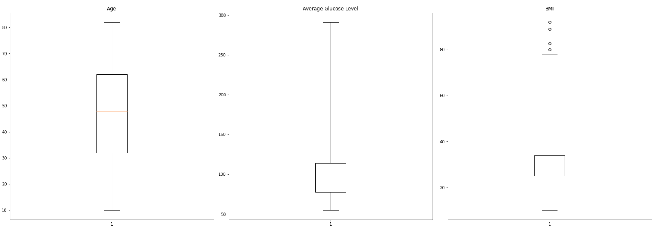

Figure 3. Boxplots of continuous variables.

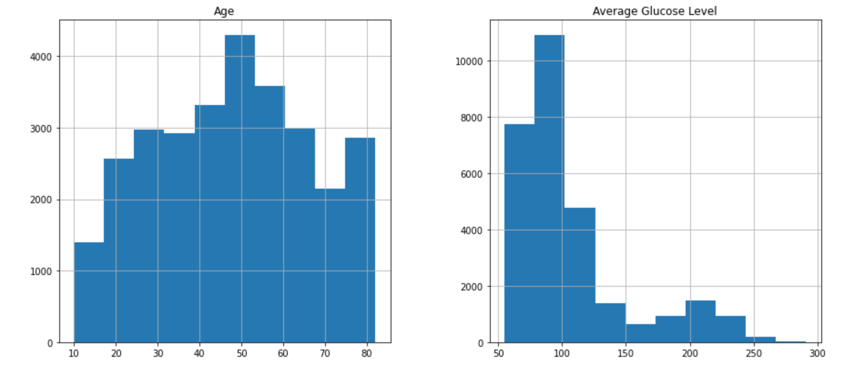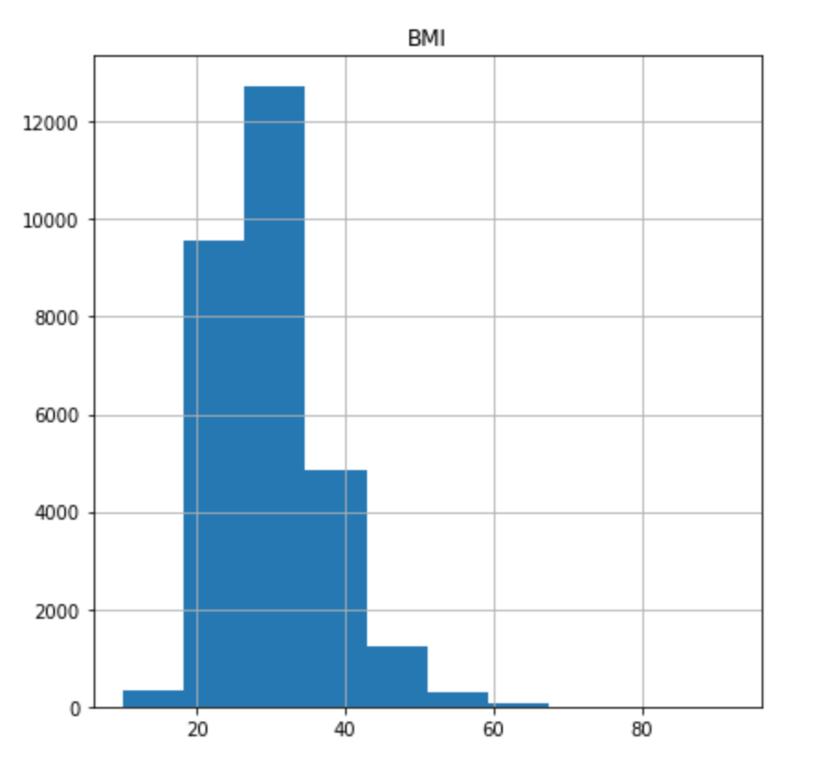

Figure 4. Histograms of continuous variables.

The distribution for age appears to be normally distributed while the distributions for average glucose level and BMI are skewed to the right according to the histograms. The box plots also show the same results where BMI had four outliers as well. There are many values found on the lower end of the x-axis for BMI and average glucose level, indicating that the distribution is skewed to the right. A majority of the values for age are located in the middle like a bell shaped curve.

Table 5. Descriptive statistics of continuous variables.

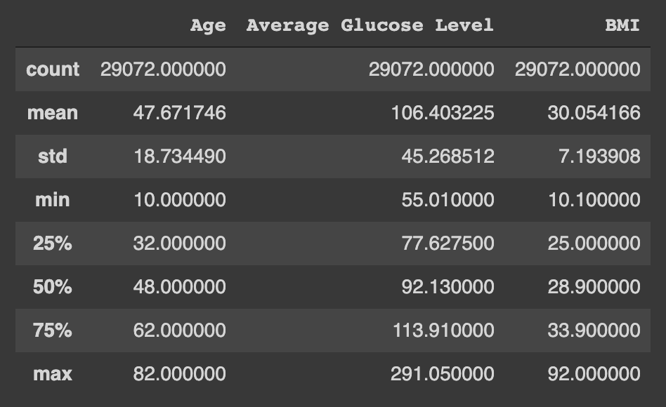

This table showcases the descriptive statistics for the continuous features from the data set. In this case, the continuous features are age, average glucose level, and BMI. The table was created after the missing values within the dataset were deleted since the count was lowered to 29,072 instead of 43,400. The dataset collected data from a wide range of individuals from children aged 10 years old to individuals aged 82 years old. The quartile values for the continuous variables was also shown at 25%, 50%, and 75%. For age, the mean was 47.671746, standard deviation was 18.734490, minimum value was 10, 25% quartile value was 32, 50% was 48, 75% was 62, and the maximum value was 82. For average glucose level, the mean was 106.403225, standard deviation was 45.268512, minimum value was 55.01, 25% quartile value was 77.6275, 50% was 92.13, 75% was 113.91, and the maximum value was 291.05. For BMI, the mean was 30.544166, standard deviation was 7.193908, minimum value was 10.1, 25% quartile value was 25, 50% was 28.9, 75% was 33.9, and the maximum value was 92.

**Results**

The dataset selected for the data analysis portion does not answer the research question specially since it was difficult to find datasets with values pertaining to telehealth usage with hypertension. However, this dataset contains data regarding social determinants of health, demographic information, health measurements, hypertension status, heart disease status, and stroke status which was posted on Kaggle.com. The descriptive statistics from this dataset describe the count, mean, standard deviation, minimum, quartile, and maximum values of the continuous variables. In this case, the continuous features are age, average glucose level, and BMI when the dataset was cleaned up. The distribution of values for age is relatively normally distributed while for average glucose level and BMI levels, the distribution is skewed to the right. There are more values towards the lower quantities for average glucose level and BMI indicating that high values are rare among the sample.

The dataset was formatted well, making the data cleaning process more focused on displaying the values in a more coherent manner so any individual can understand it on first glance. For example, there were “0” and “1” used in place for “No” and “Yes” for the hypertension, heart disease, and stroke statuses. Based on the provided data dictionary for the dataset, 0 indicated the individual has not suffered from hypertension, heart disease, and/or stroke while 1 indicated that they have. The feature names also included underscores and were not capitalized, so that had to be changed as well for stylistic reasons. There were 14,328 missing values for BMI and smoking status which were dropped since this quantity was low in comparison to the total 43,400 observations. The values for work type were replaced to include the full names of government job, never worked, and children to make the dataset easier to comprehend. The data types for the id, hypertension, heart_disease, and stroke features were int64 or float64, but were changed into object data types instead since these are categorical variables.

After the dataset was cleaned and missing values were dropped, the descriptive statistics table, histograms, and box plots were created to view the central tendency and quartile values. When the data was grouped by hypertension, it was noted that the mean age was higher for those who suffered from hypertension at 61.294045 compared to 45.962564. Similar results appeared for average glucose level and BMI where both means were higher for those who suffered from hypertension at 126.091993 mmol/L and 32.679944 compared to 103.932887 mmol/L and 29.724711. Thus, those who suffered from hypertension were older, had a higher average glucose level, and higher BMI level. This lead to the creation of visualizations to display the correlations between multiple variables at once.

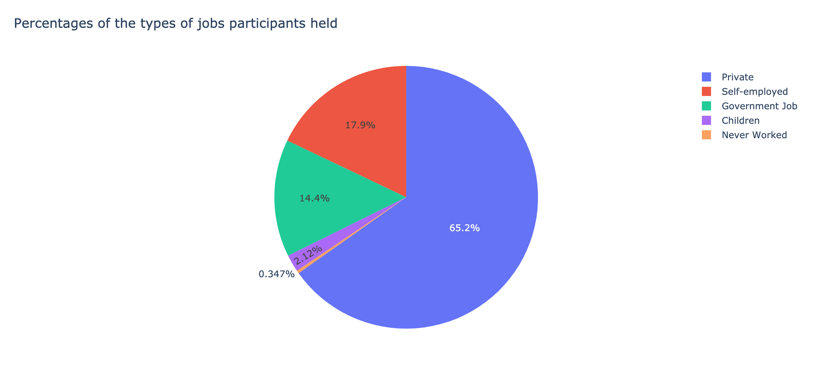

Figure 6. Pie chart of work types. This pie chart displays the different types of occupations the individuals held with percentages.

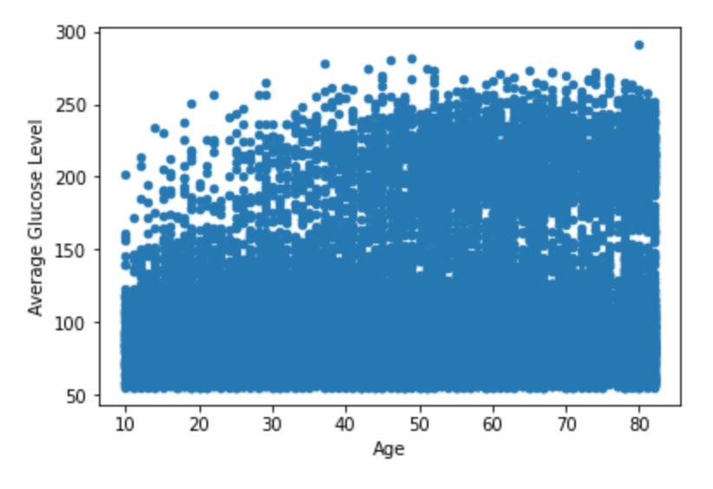

Figure 7. Scatterplot of age versus average glucose level. There is no correlation between age and average glucose level because the data is randomly dispersed and does not follow a specific trend line.

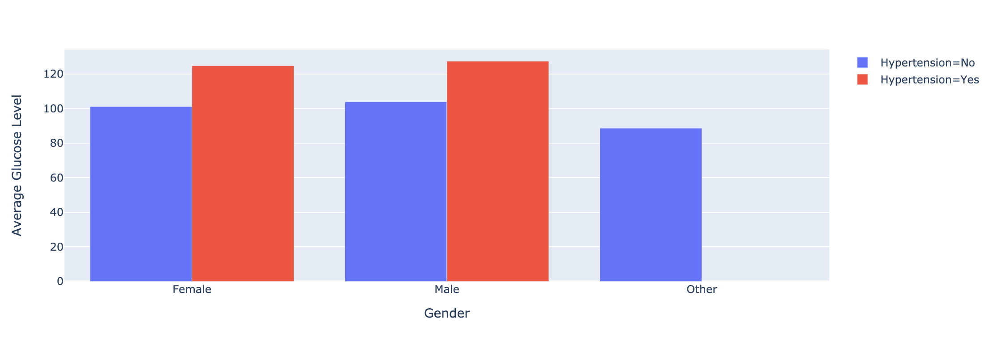

Figure 8. Bar graph of average glucose levels based on gender and hypertension status. The average glucose levels are higher in individuals who have suffered from hypertension and for males in general.

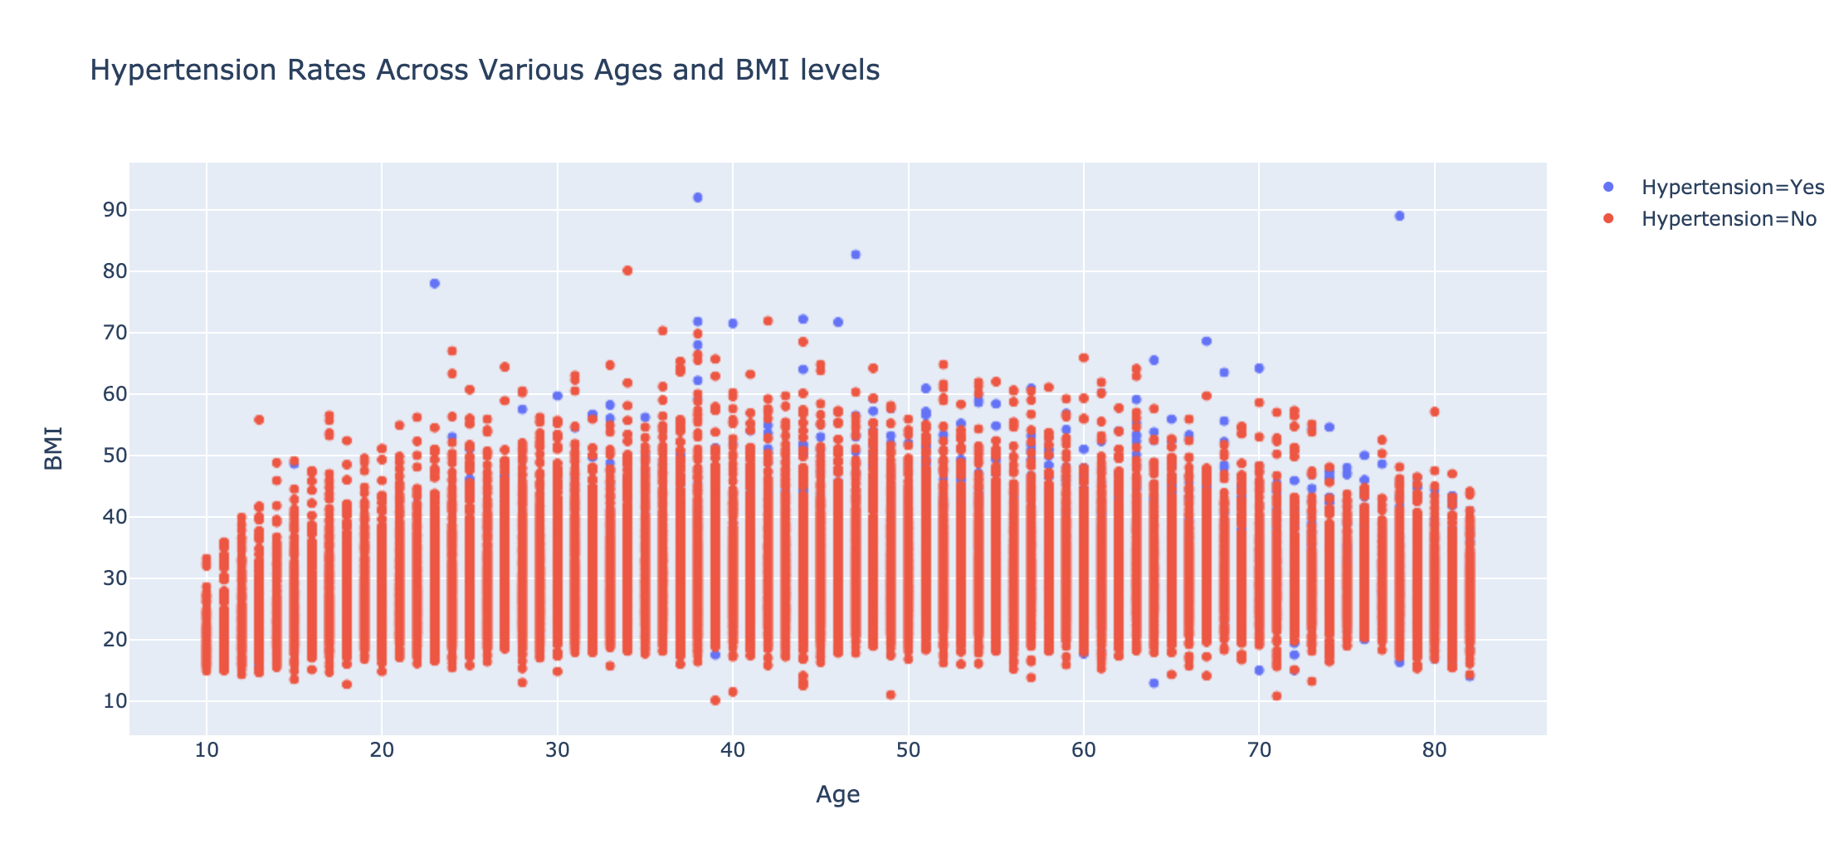

Figure 9. Scatterplot of hypertension rates across various ages and BMI levels. This Plotly scatterplot has more layers to it and when you hover over points, the parameters are displayed. The red dots indicate individuals that did not suffer from hypertension and the blue dots indicate that they have suffered from hypertension. While the dots overlap, there appears to be more individuals who have not suffered from hypertension across all ages and BMI levels.

Unresolved issues for the dataset included the lack of sophisticated visualization to display the data. This was especially the case for comparisons among the categorical variables since most of the figures compared the continuous variables with each other or only one categorical variables. There could be more visualizations with more layers to emphasize trends among the data that can not be seen on the surface level of viewing the spreadsheet of data. A potential problem involves the unanswered research question with this dataset since the dataset does not have the specific data necessary. The dataset has general healthcare data and does not contain symptoms, quality of life measures or data related to mobile based telehealth tool usage.

**Conclusion**

The research process is an arduous process since each part of the process requires a high level of attention to detail and time. While picking a topic of interest was not difficult, forming the research question required identifying a gap in the literature from published research. Gathering a sufficient amount of peer-reviewed articles from scholarly journals required multiple websites and the usage of filters to find relevant information for the literature review. The methods section can be taken in many different directions in terms of design and a thorough explanation of every component was needed to ensure any person could comprehend all parts of the research study. Utilizing a Jupyter notebook to analyze the dataset also proved to be a challenge as syntax errors and showcasing the data in an understandable manner was difficult. Overall from the dataset, it is noted that hypertensive individuals are older and have higher average glucose levels and BMI levels. This adds to the reasoning behind the research question to provide mobile based telehealth tools to geriatrics to monitor their systems continuously in hopes to improve their quality of life outcomes.

Without the lack of time and expertise with Python, the data can be analyzed in a more in depth manner. Categorical data can be compared with other categorical data with counts to see if there is a correlation between the two variables. For example, the data for the hypertension, heart disease, and stroke features can be compared with each other to see which gender and age group had a higher risk for these health conditions. This would require a higher level of knowledge and time for the data visualization portion to produce graphs with more layers. The graphs created in the data analysis portion are rather general, but with Plotly there are more sophisticated figures that can showcase the data in a more dynamic way. With additional time, this would also allow for proper implementation of the research study to address the research question.

For the next steps, this research study can be conducted if there are enough resources in terms of time, money, and people. With five clusters, the timeframe for executing the study is approximately 60 days to complete. This proposed research protocol also needs to be approved by an institutional review board (IRB) before the study can be conducted. Individuals for the research team should be identified and be trained to properly carry out their assigned tasks. Once the necessary resources and approval are gained, data is collected from the NYC geriatrics aged 65 years old or older. The data will focus on the quality of life outcome measures from the CAMPHOR survey tool. Meta-analysis is used for the data analysis portion to compare the heterogeneity between every cluster to see the effects of mobile based telehealth tools across the various clusters.12 The dataset gained from this study should collect more data on symptoms and quality of life measures as the previous dataset did not provide enough information to answer the research question. Since the wearable tracking device and mobile applications will be free of charge, a relatively high budget is needed to account for these costs. Some concerns include providing these telehealth tools to all 850 participants at once and securely storing their health information within the mobile application. However, if all the proper precautions are prepared for in advance, the research study can be carried out and produce results to bridge the gap within the literature.

References

1. Panicker N.V., Kumar A.S. Tablet PC Enabled Body Sensor System for Rural Telehealth Applications. *International journal of telemedicine and applications*. 2016;2016:1-9. doi:10.1155/2016/5747961
2. Millán‐Calenti J.C., Martínez‐Isasi S., Lorenzo‐López L., Maseda A. Morbidity and medication consumption among users of home telecare services*. Health & Social Care in the Community*. 2017;25(3):888-900. doi:10.1111/hsc.12377
3. Heckemann B., Wolf A., Ali L., Sonntag S.M., Ekman I. Discovering untapped relationship potential with patients in telehealth: a qualitative interview study. *BMJ Open*. 2016;6(3):e009750-. doi:10.1136/bmjopen-2015-009750
4. Ben-Pazi H., Browne P., Chan P., et al. The Promise of Telemedicine for Movement Disorders: an Interdisciplinary Approach. *Current Neurology and Neuroscience Reports*. 2018;18(5):1-10. doi:10.1007/s11910-018-0834-6
5. Rojahn K., Laplante S., Sloand J., et al. Remote Monitoring of Chronic Diseases: A Landscape Assessment of Policies in Four European Countries. *PloS one*. 2016;11(5):e0155738-. doi:10.1371/journal.pone.0155738
6. Banbury A., Nancarrow S., Dart J., Gray L., Parkinson L. Telehealth Interventions Delivering Home-based Support Group Videoconferencing: Systematic Review. *Journal of medical Internet research*. 2018;20(2):e25-. doi:10.2196/jmir.8090
7. Banskota S., Healy M., Goldberg E.M. 15 Smartphone Apps for Older Adults to Use While in Isolation During the COVID-19 Pandemic. *The western journal of emergency medicine*. 2020;21(3):514-525. doi:10.5811/westjem.2020.4.47372
8. Middlemass J.B., Vos J., Siriwardena A.N. Perceptions on use of home telemonitoring in patients with long term conditions - concordance with the Health Information Technology Acceptance Model: a qualitative collective case study. *BMC medical informatics and decision making*. 2017;17(1):89-13. doi:10.1186/s12911-017-0486-5
9. Srinivas P., Cornet V., Holden R. Human Factors Analysis, Design, and Evaluation of Engage, a Consumer Health IT Application for Geriatric Heart Failure Self-Care. *International Journal of Human-Computer Interaction: Human Factors of Health Information Technology*. 2017;33(4):298-312. doi:10.1080/10447318.2016.1265784
10. Nguyen N.P., Vinh-Hung V, Baumert B, et al. Older Cancer Patients during the COVID-19 Epidemic: Practice Proposal of the International Geriatric Radiotherapy Group. *Cancers*. 2020;12(5):1287-. doi:10.3390/cancers12051287
11. Lopez-Villegas A., Catalan-Matamoros D., Robles-Musso E., Peiro S. Effectiveness of pacemaker tele-monitoring on quality of life, functional capacity, event detection and workload: The PONIENTE trial. *Geriatrics & gerontology international*. 2016;16(11):1188-1195. doi:10.1111/ggi.12612
12. Hemming K., Taljaard M., Forbes A. Modeling clustering and treatment effect heterogeneity in parallel and stepped-wedge cluster randomized trials. *Statistics in medicine*. 2018;37(6):883-898. doi:10.1002/sim.7553
13. Hemming K., Taljaard M., McKenzie J.E. et al. Reporting of stepped wedge cluster randomised trials: extension of the CONSORT 2010 statement with explanation and elaboration. *British Medical Journal*. 2018;363:k1614-. doi:10.1136/bmj.k1614
14. Reis A., Santos M., Vicente M. et al. Health-Related Quality of Life in Pulmonary Hypertension and Its Clinical Correlates: A Cross-Sectional Study. *BioMed research international*. 2018;2018:1-10. doi:10.1155/2018/3924517
15. Reis A, Twiss J, Vicente M, et al. Portuguese validation of the Cambridge pulmonary hypertension outcome review (CAMPHOR) questionnaire. *Health and quality of life outcomes*. 2016;14(1):110-. doi:10.1186/s12955-016-0513-8
16. Hećimović A., Heaney A., McKenna S.P. et al. Adaptation and validation of the cambridge pulmonary hypertension outcome review (camphor) for Croatia. *Acta clinica Croatia (Tisak)*. 2019;58(1):3-12. doi:10.20471/acc.2019.58.01.01
17. Dunn W.D., Cobb J., Levey A.I., Gutman D.A. REDLetr: Workflow and tools to support the migration of legacy clinical data capture systems to REDCap. *International Journal of Medical Informatics*. 2016;93:103-110. doi:10.1016/j.ijmedinf.2016.06.015