**USER-MANUAL**

A. HOW TO INSTALL MOODLE

[***1-System requirements***](https://docs.moodle.org/34/en/Complete_install_packages_for_Windows#System_requirements)

- 256 MB RAM (minimum), 1GB RAM (recommended)

- 500 MB free Fixed Disk (more space will be needed depending on user uploads)

For old versions of Moodle:

-Windows 98/ME (minimum)

-Windows NT/2000/XP/2003 (recommended)

For Moodle 3.1 and later versions:

-Windows Vista/7/8/10/2008/2012

-Microsoft Visual C++ 2015 Redistributable package is required for PHP ([download link)](https://www.microsoft.com/en-us/download/details.aspx?id=48145). This must be the **vc_redist.x86.exe** download as the PHP build is 32-bit.

**2**-**Install complete package process**

The complete install package is a zip file that contains a webserver called [Apache](https://docs.moodle.org/34/en/Apache), plus Moodle and Moodle's required [MySQL](https://docs.moodle.org/34/en/MySQL) database and [PHP](https://docs.moodle.org/34/en/PHP) program.

There are three basic parts to the this install process.

Download and unpack the complete install package.

Start the webserver.

Install Moodle using a web browser

**First create file structure**

Download the package ([Download Windows](http://download.moodle.org/windows) )

**Second - start the webserver**

These programs control both Apache and MySQL programs that operate the webserver. Some sites will individually start and stop Apache and MySQL with the Xampp bat files found in the "server" subfolder.

**Third - start Moodle installation**

Start your web browser and type localhost, or http://127.0.0.1 or http://localhost in the address bar. You will either start your first time Moodle installation or if it is already installed you will enter the Moodle site's [Front Page](https://docs.moodle.org/34/en/Front_Page) or Login screen.

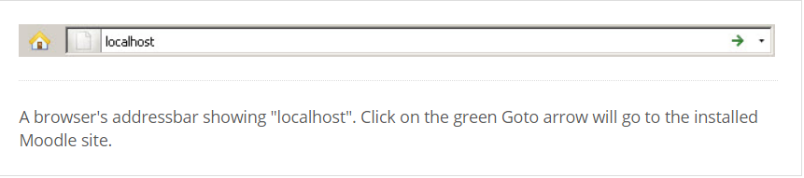

Set language

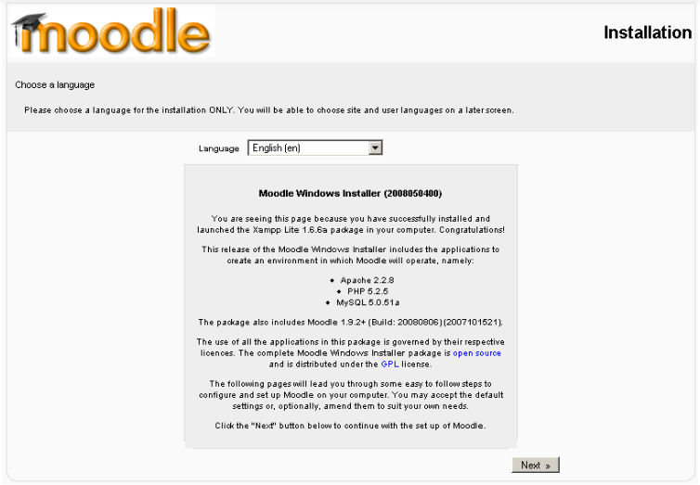

**Diagnostic results**

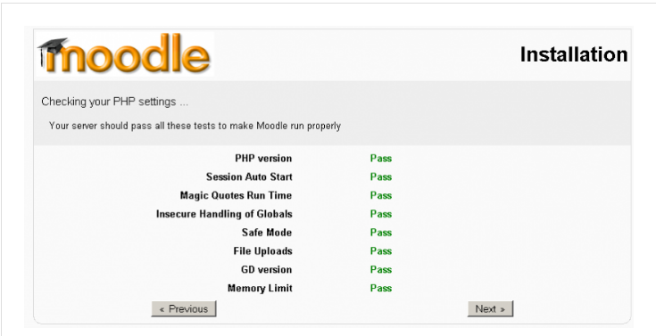

Click next

**Moodle paths**

The paths for your Moodle installation are shown – if you are only using this as a local testing server, accept the ones that are shown on your screen.

**Database configuration**

In the next fields, we enter the database settings. The fields are populated with some suggested values.

We strongly recommend you place a user name and password in this screen. (Don't forget them).

DO NOT USE THE “ROOT” USER WITHOUT A PASSWORD FOR PRODUCTION INSTALLATIONS AS THIS CREATES A SECURITY VULNERABILITY

**Check server**

The install process checks the server it installed.

**Confirm initial language pack**

Moodle will now check to see if the language pack is available for the language you selected at the first step. If it is not, Moodle will continue with the install in English.

**Confirm config.php**

Provided the Moodle folder is writable, a message confirming the configuration has been completed will be displayed.

**Moodle copyright & agreement**

The Moodle copyright / license notices are displayed.

**Current release and unattended option**

The current release information is shown. Check off the unattended operations box. This will automatically advance through many screens. If you would like to watch the install screen by screen, do not check this box and be prepared to press the "continute button" many times.

Click the "Continue" button and wait.

**Installation modules and blocks screens**

In most cases this will be followed by a series of screens that have a continue button on the bottom. This process stops with Admin user profile settings which needs to be filled out.

**Administrator user profile**

Front page settings

The next screen is the Front Page settings page. There are two parts to it. The first part will ask for your Full site name and a short name for the navigation bar. There is also a place for a description. You can change these later.

**Congratulations - Moodle has been installed**

This finishes the installation of a complete package. Type http://localhost (or whatever you set for web address earlier in the setup!) in your browser and Moodle will open.

Your next task will be to configure Moodle to meet your needs. Don't worry; it is easy to change any of the settings now that Moodle is up and running.

Check *Settings > Site administration* for further links.

**B. HOW TO ADD USER**

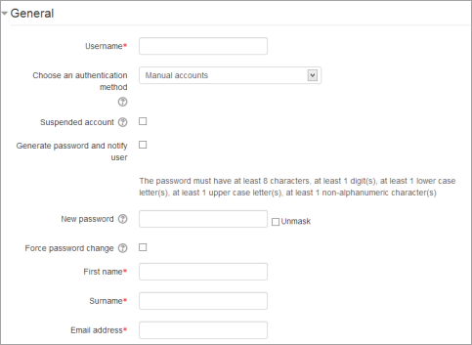

An administrator or manager (or any other user with the capability [moodle/user:create](https://docs.moodle.org/34/en/Capabilities/moodle/user:create)) can create new user accounts in Site administration > Users > Accounts > Add a new user.

**General**

**Username**

The user will use this username to log in to the Moodle instance. It needs to be unique. This may be changed. A user's name can only contain alphabetical letters in lowercase, numbers, hyphen '-', underscore '_', period '.', or an at character '@' - unless you enable 'Allow extended characters in usernames' ( *Site Administration > Security > Site Policies*)

**Authentication method**

The setting specifies how Moodle will check whether the user's specified password is correct.

Accounts created by an administrator use the **Manual Accounts** method, and accounts created by the user themselves using the email sign-up method use the E-mail based self-registration method.

**Suspended account**

Suspended user accounts cannot log in or use web services, and any outgoing messages are discarded.

**Generate password and notify user**

Moodle will generate a temporary password and email the user with instructions on how to log in and change it. The email message (as in the screenshot below) may be changed in *Site administration > Language > Language customization*. Select 'moodle.php' and the string identifier *new user new password text*

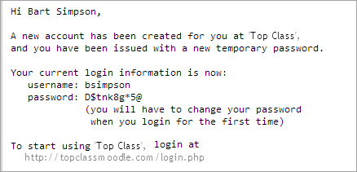

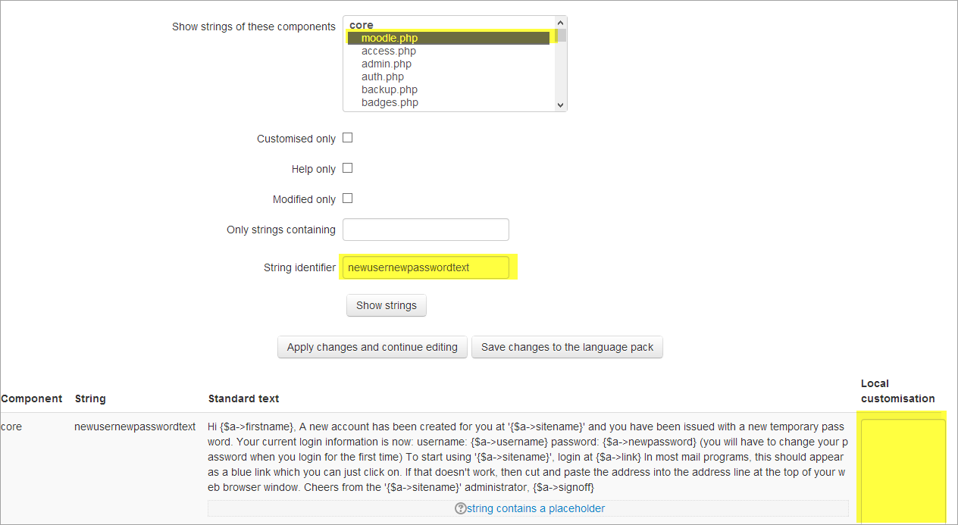  
Password

This is the user's password. It is subject to the password policy in [Site policies](https://docs.moodle.org/34/en/Site_policies). A user can change their password via *User menu > Preferences*.

First Name

The user's first name. It is displayed along with the last name in messages, forum posts, participants list, reports and anywhere where something about the user is shows on the page.

Surname

The user's surname. It is displayed along with the first name in messages, forum posts, participants list, reports and anywhere where something about the user is shows on the page.

Email address

Password reset notices, forum digests and other messages are sent to this email address from the Moodle site.

**New in 3.0:** Duplicate email addresses may be allowed if the setting 'Allow accounts with the same email' is enabled in *Site administration > Plugins >Authentication >Manage authentication.*

__________________________________________________________________________

**C . How to Assign Role To any user :**

**\*** Administration > Site Administration > Users > Permissions > Assign system roles

* Appear list of users Chose any and Assign Roles ( Manager – Staff – Student …)   
3- Click Add

**D. HOW TO CREATE NEW COURSE**

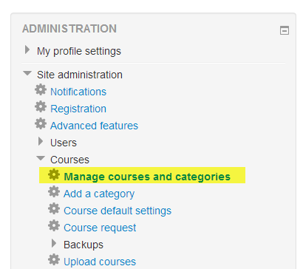

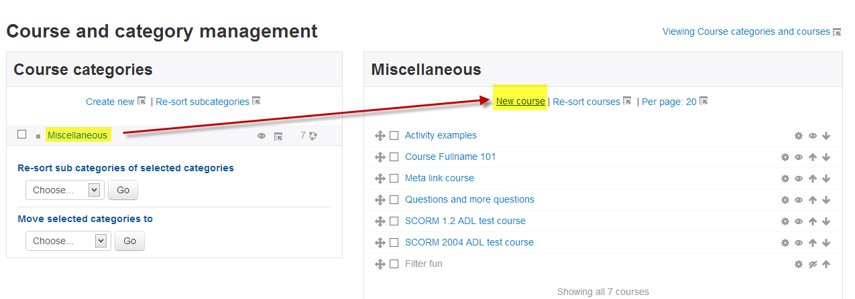

Go to *Administration>Site Administration>Courses>Manage courses and categories*

Click on the category where you want your course to be. For more information see [Course categories](https://docs.moodle.org/28/en/Course_categories)

Click the "New course" link

Enter the [course settings](https://docs.moodle.org/28/en/Course_settings), then click the "Save changes" button.

On the next screen, choose your students/teachers to assign to the course.

**E.How To add Teacher and Student To any Course**

*Enrolling Teacher and student*

**1**-Go to Administration > Course administration > Users > Enrolled users

**2**-Click the ‘users' button at the top right or bottom left of the page

**3**- Click on Enrollment Methods

**4**-Select enrolment options as appropriate (Manual Enrollemnt)

5-**5**-Browse or search for the user. (Note that when searching for users, exact matches are listed first.)

**6**-Click the Enroll button opposite the user. The user will indent in the list and the enroll button will disappear, indicating that the user is enrolled.

**7**-When you have finished, click the 'Finish enrolling users' button (or simply close the enroll users box) ( )

**\*\*Can Assign Roles (Managers – Staff – Student ……)**

__________________________________________________________________________

**F. HOW TO INSTALLING PLUGINS**

To install a plugin, its source code must be put (deployed) into the appropriate location inside the Moodle installation directory and the main administration page *Administration > Site administration > Notifications* must be visited. There are three ways how the plugin code can be deployed into Moodle.

Plugin code may be deployed from within Moodle, either directly from the Moodle plugins directory or by uploading a ZIP file. The web server process has to have write access to the plugin type folder where the new plugin is to be installed in order to use either of these methods.

Alternatively, a plugin may be deployed manually at the server.

Installing directly from the Moodle plugins directory

Login as an admin and go to *Site administration > Plugins > Install plugins*. (If you can't find this location, then plugin installation is prevented on your site.)

Click the button 'Install plugins from Moodle plugins directory'.

Search for a plugin with an Install button, click the Install button then click Continue.

Confirm the installation request

Check the plugin validation report

Installing via uploaded ZIP file

Go to the [Moodle plugins directory](https://moodle.org/plugins), select your current Moodle version, then choose a plugin with a Download button and download the ZIP file.

Login to your Moodle site as an admin and go to *Administration > Site administration > Plugins > Install plugins*.

Upload the ZIP file. You should only be prompted to add extra details (in the Show more section) if your plugin is not automatically detected.

If your target directory is not writeable, you will see a warning message.

Check the plugin validation report

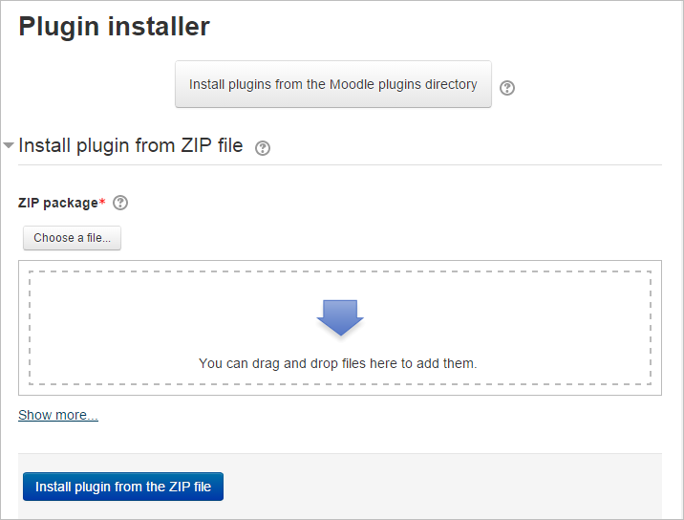

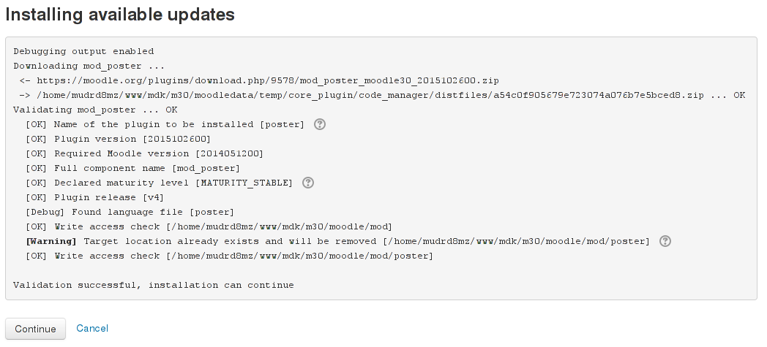

**G. How To use this plugin**

1) As a teacher, on your course, turn editing on

2) Add an activity or resource

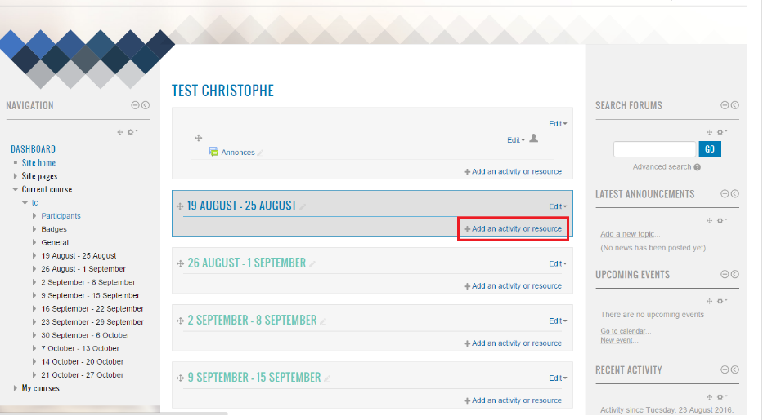

3) Select E-Voting

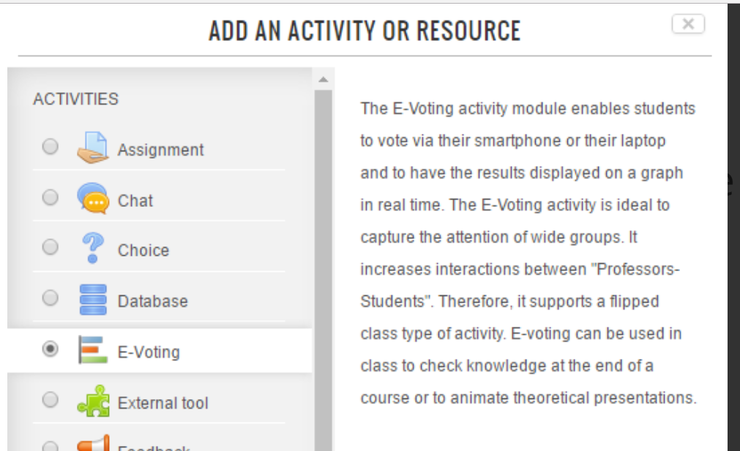

4) Fill the form to create a new E-Voting poll

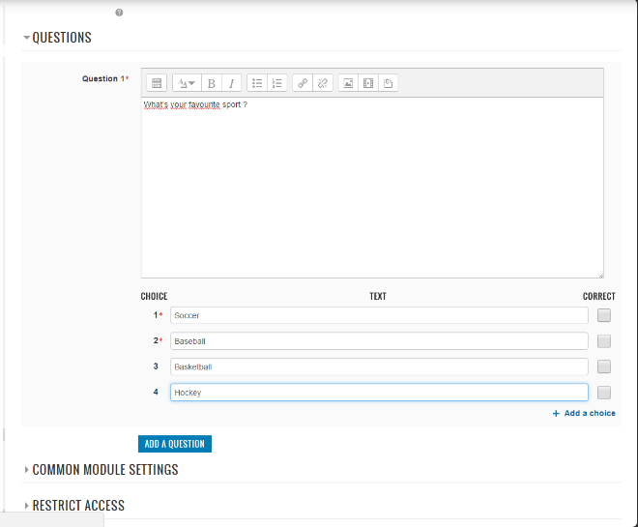

5) On the E-Voting page, Click on the QR Code to show it bigger

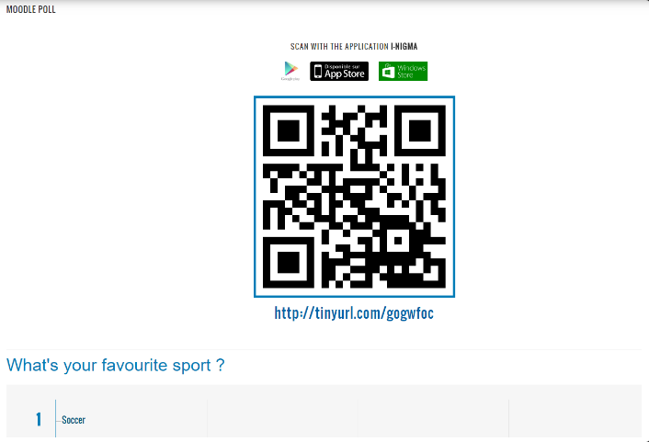

6) Your students in class shall have the option for seeing the vote panel to

7) Click "Start button" to start the e-voting poll (you can select if you want time for voting or not)

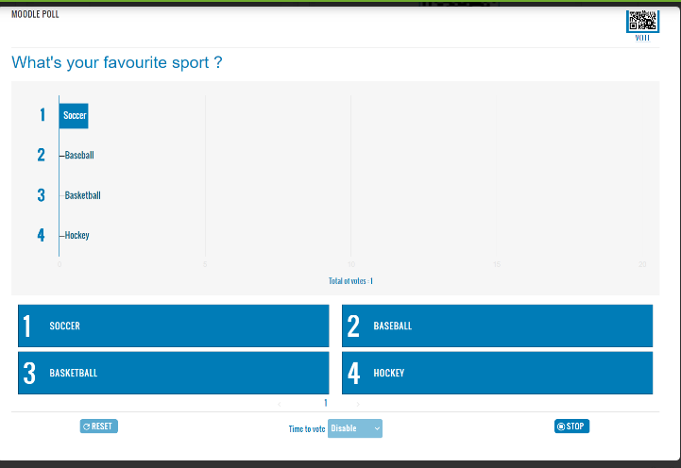

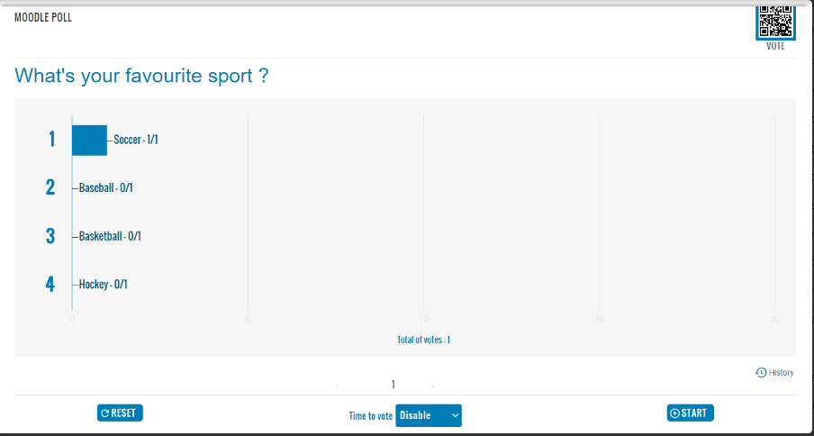

**8)** Only at this moment, your student can vote with Smartphone, laptop,

**9)** When you want to stop the poll, click the "Stop button"

**10**) You Can Reset Your Option

___________________________________________________________________________

**H. HOW TO REMOVE MOODLE**

to remove Moodle ,we need to delete its code directory, data directory and database.

In the config.php we will find variable $CFG->dbtype that says what database engine is used with that installation and variable $CFG->dbname will tell we which database you should remove.

In the same config.php we will also find where data is configured and where is the code path set - variables to check are: $CFG->dataroot and $CFG->dirroot. If we have absolutely no idea where to look for moodle installation, we have to check it in your apache/nginx (or other http server) configuration.

**E-voting(Steps In Moodle )**

ADD QUESTIONS

_________________

To do that you need to:-

Login as a teacher

Add E-voting activity

Add multi choices to your questions

**Hint:-**

- Student needs to click on the QR Code to be able answer the question

Student needs Click "Start button" to start the e-voting poll -

- Only at this moment, your student can vote with Smartphone, laptop, ...

When you want to stop the poll, click the "Stop button"-

- - student should answer at once he click on "Start button" because there is specific time.