Balance table:

|  | **Control** | **Treatment** | **Difference** |  |
| --- | --- | --- | --- | --- |
| Academic Quality | 0.515 | 0.466 | 0.049 |  |
| Athletic Quality | 0.424 | 0.551 | -0.127 | * |
| Near Big Market | 0.36 | 0.7 | -0.34 | *** |

Treatment and control are not similar. The athletic quality is significantly higher in the treatment group. Colleges in the treatment group are also significantly more likely to be located near a large metropolitan area.

The committee selecting treatment assignment (which programs get ranked) may be considering variables other than those available to us. If this is the case, and if those variables are nonrandom and correlated not only with treatment but also with alumni donations, then our propensity score would not capture an important source of variation and would likely produce biased results.

Overlap:

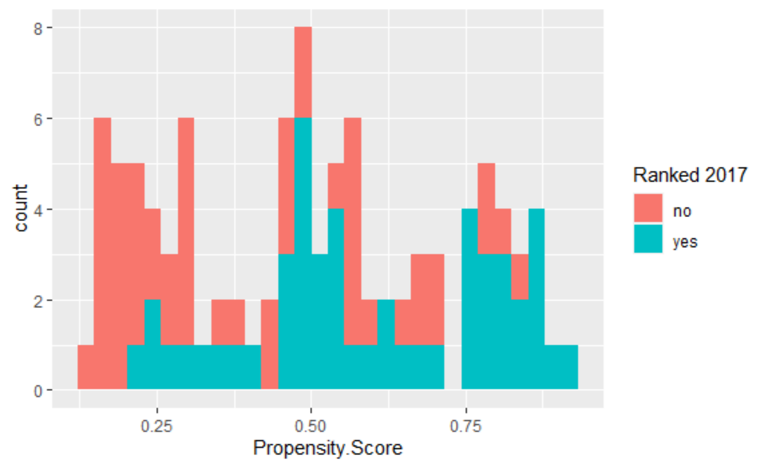

Regression:

|  |  |
| --- | --- |
|  | |
|  | Alumni Donations in 2018 |
|  | |
| Constant | .12 |
|  | (.40) |
| Ranked in 2017 | 500.47*** |
|  | (.23) |
| College ID | -.002 |
|  | (.01) |
| Academic Quality | 100.20*** |
|  | (.46) |
| Athletic Quality | 49.68*** |
|  | (.74) |
| Near Big Market | 999.42*** |
|  | (.62) |
|  | |
| Blocked propensity score fixed effects | Yes |
|  | |
| Observations | 100 |
| R2 | 1.00 |
| Adjusted R2 | 1.00 |
|  | |
| *Note:* | * p<0.1, ** p<0.05, *** p<0.01 |
|  | Standard errors in parentheses. |

**Notes**: This table contains regressions predicting the effect of being ranked on alumni donations to a college the following year. The model blocks on propensity score (which predicts which colleges were ranked) and includes block fixed effects. The model also controls for college, the academic quality of the college, the quality of the program's historical athletic programs, and whether the college is located near a large metropolitan area. Standard OLS standard errors are reported.

On average, being ranked appears to result in a $500,000 increase in total alumni donations to the college the following year, even when controls and fixed effects are included.