INFO 6150 final project journal

Week 10, Nov 6
The final project of INFO 6150 is coming! I’m so excited about it. Luckily, I will work with my three brilliant classmates, Danni Chen, Bingcheng Hu, Zexu Jin, as a team towards it.
After a very short discussion, we decide to develop a recipe website. For more ideas, we visit several fantastic recipe websites and settle down our structure according to the project requirement. There would be homepage, category page, dish detail page, about us page, subscribe page and a 404 page. The smooth progress goes on really great and fast.
When discuss about how the pages looks like on different breakpoints, I help to come up ideas and describe the page structure when my teammates referring to existing websites and drawing our pages. We already have a clear view of our website in half an hour. What’s more, I come up the main categories we are going to include. Finally, we divide the works of this week and I’m going to take charge of the sitemap and user flows.
I’m so glad that we have plenty of discussions therefore I can start my work directly. Firstly, I started to draw the sitemap. It’s really a fun to draw boxes and lines and apply a color theme to it using PowerPoint. The color theme of our website is also discussed in our conversation which should be warm and attractive. So, I think it is a better way to show it directly when draw the sitemap in a visual way. I also differentiate the pages to make them distinguishable for reader to know what template they are assigned to.
After finishing the structure, I come to an idea that, to make our future work easier, why not include links to the dishes of the website we are referring to. We no longer need to search for sources times and times again. Then I just take 24 links from https://www.foodnetwork.com and add to the boxes within sitemap.
When comes to the user flow, actually I am kind of forgetting what it is since the class has been week ago. So, I just pattern the writing given in the project requirements which comes out to be three lines. This is going to be considered so wrong days later.

Week 11, Nov 13
I was feeling so bad when I received the reminder from our teacher yesterday says that the user flows should not be just lines but a diagram too! I started to look through the lecture before and search for some examples. I have to say it is a huge mistake and fortunately I still have time to fix it. Then I draw more boxes and lines to indicates the user flows I wrote, which makes the whole structure of our site clearer.
Now we have sitemap and user flows from me, look and feel, wireframes, which are really specific and clear, from my teammates. It a great time to go further! I feel very proud of our team that we are the only group show up in the classroom and have a meaningful conversation to discuss our works and reach a fabulous outcome.
Here is the Google doc link we work on during the discussion:
https://docs.google.com/document/d/12_Yjgo2BCMiQJMTiC8PaRergIJep5xMwbWVrghQZZng/edit
We decide to use JSON for the source content and come up the key/value pairs it’s going to include referring to the recipe website and based on some of my suggestions. There would be dish id, name, category, summary, picture, level, cooking time, yield, ingredients and directions within a dish’s recipe.
Also, we decide the form should include first name, last name, email address, birthday, sex, preferred flavor and the frequency the user would like to receive our recommendation email after subscription. Me and my team together come up the way of how would all of them meet the requirement.
Then we design the about us page and make it show the introduction of all the four of us, It’s really fun!
At the end of discussion, we clarify the work we should finish by next week. There should be basic HTML and effective links of every page. We divided the tasks and I take the dish detail page development part.
Sometimes it is a little bit hard to demonstrate my individually contribution to the discussion. Because all the team members are thinking and speaking, with valuable ideas coming out all the time. The conclusion is always contributed equally by four of us, which makes me feel so proud and cherish everyone’s work in this team.
We start with filling the JSON file. Each of us goes through a category and paste down the content of six recipes into dishes.json and merge together. All the components files are created so we can do our own part.
My job is to develop the dish recipe detail page. Within the component DishDetail, props is used to get the specific dish id from outside and find and show the right content from JSON. I create four main sections, which are dish image, dish brief (including summary, total time and yield), ingredients and directions. According to the frameworks, elements should be shown differently to response to breakpoints in a grouped way which is gathered by these sections.
Writing the component with HTML and CSS is never a difficult task. However, I spend a night figuring out how to manipulate with props to get the right content and half a day figuring out how to use the props extracted from URL into the component.
I look into former assignments and search for React JS tutorials. Maybe it is because of our JSON file is not in a perfect structure currently, I finally come up an idea that is to have a hash map, storing dish id as the key and the dish element in JSON array as the value.
In the home page code, which is written by Bingcheng, an id is extracted from URL and pass to my component. I actually know nothing about React, router, switch, match, params, etc. And I Google for it. There is a link in which the content helps me a lot:
https://tylermcginnis.com/react-router-url-parameters/
Then I think it should work! However, there are errors show up. I set up many console.log() to find out why this happen but all I get is saying hashmap.get(props.id) is undefined when I can see my hash map is in a great structure filled with key and value pairs. I search for this error and ironically there are a lot of people make the same mistake and post it on stackoverflow for the answer. The props.id comes in is a string while the key in my hash map is integer. Problem solved! It is definitely a silly bug but I’m still satisfied by fix it.
Now my dish detail page is working perfectly and it is responsive and adaptive with breakpoints.

Week 12, Nov 20
In class, we test usability helped by other groups. This test really helps us figure out what problem we have. I set up the three tasks for our website. The first one is looking into one Thanksgiving recipe through the homepage. Ideally user is expected to click on the specific category in homepage while they actually click into the category page from navigation bar. It is fair enough. The second is looking into Christmas category from a recipe detail page. Two of my testers are doing great job, clicking the navigation bar to find it. But my last tester runs into a stuck. He doesn’t know where he is, the category page or the category dishes page. This situation reminds us to put a Breadcrumbs on every page since our pages containing card components are pretty similar to each other. The third task is submitting a subscription of our website, which is done very well.
At the same time, we are testing other groups’ websites as well. There are lots of shining points we can learn. Some websites support searching function. Some websites have really good style, including color, font, page framework. And we are reminded that we missed the copyright in footer.
Till now, our website is 90% completed according to the final project requirements. All links are working, all images are attaching and all pages with contents are presented as we planed the first week. We are proud of the rising steep slope line of our commitment activities on GitHub with over 100 commits pushed by all of us evenly.
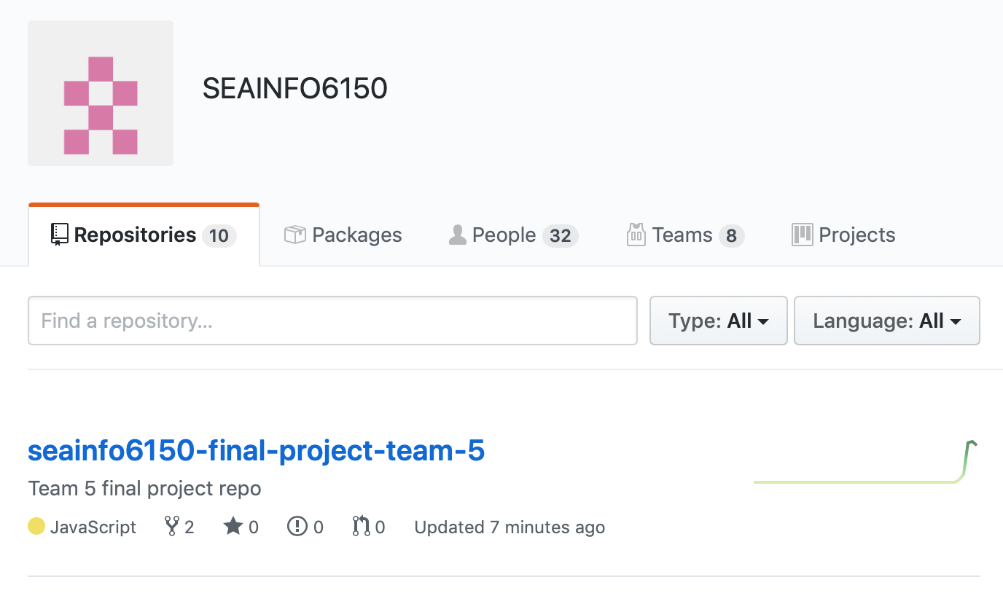
I am the kind of loving-checking-everything person so my role after finishing my part is to check details of our website and see whether it matches the requirements. So, I look into every page at every checkpoint and content. There is a wrong spelling and dislocation of an image on category page. The form is not absolutely meeting the requirements where two set of radio should be changed into dropdown. Also, I add missing background image for categories.
One more requirement is not implemented yet, which is the HTML based responsive image. I volunteer to do this in my dish detail page. Actually, it takes a few hours to figure it out because we are using React, in which the srcSet of img doesn’t support props list unless I write a complex component to realize it myself. I refer to this link and decide to do the art direction switching using <Picture>:
https://developer.mozilla.org/en-US/docs/Learn/HTML/Multimedia_and_embedding/Responsive_images
Images we are sourcing are now local with two different resolutions, which is switched when it reached 500px.
And some extra work is done. When I try to put the dish title upon the image, I find that it’s hard recognized. Because images have different colors and makes it never satisfying using any font color. I come up an idea to use glowing text and here is what I find most useful:
https://freefrontend.com/css-glow-text-effects/
Also, I find that when the page is widened over 1000px, the space between image and summary section is not good looking. So, I make it limited in 1000px and stay in the center if the window is keeping enlarged.

Week 13, Dec 4
Today is our final presentation! We finished all work yesterday. I write down a list of what we are going to present. I will show our general design first, with our website topic, page templates and color theme, content source, etc. Then we are going to present our personal works separately.

