Build and push Docker custom image

$docker build -t nginx .

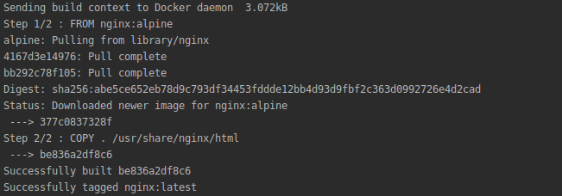
$docker images
$ docker run -d --name latestnginx -p 8081:80 nginx:latest
$docker images
$docker ps

$docker tag be836a2df8c6 christinsujith/latestnginx
$docker images
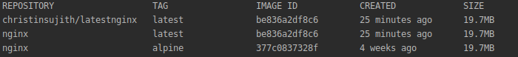
$docker login –username=christinsujith
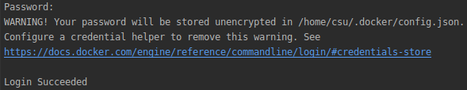
$docker push christinsujith/latestnginx

