Run Custom Image on Local Kubernetes
Execute Custom Image on MiniKube Local Machine

1. Start Minikube
minikube start
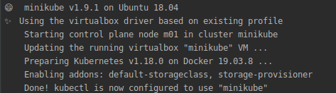

2. Verify Minikube is running
kubectl get node

3. Start the Deployment on Kubernetes Cluster.
kubectl create deployment latestnginx --image=christinsujith/latestnginx
4. Get Information of Running Deployments
kubectl get deployments
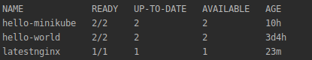

5. Describe the Running Deployment
kubectl describe deployment latestnginx
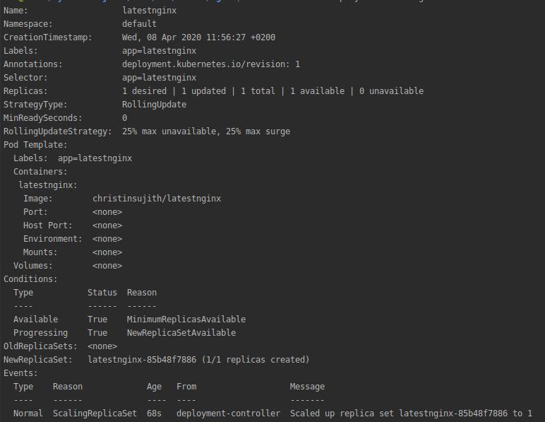

6. Make the NGINX container accessible via the internet:
kubectl create service nodeport latestnginx --tcp=80:80
7. Get Running Services
kubectl get svc
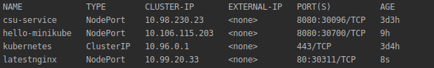
8. Get Service access point
minikube service latestnginx --url

9. Remove Services
kubectl delete services latestnginx

10. Remove Deployment
kubectl delete deployment latestnginx

