**INDIVIDUAL PROJECT PROPOSAL**

**Name: Christ John Ortega**

**Year and Section: 3 F2**

**Selected Content Management System: PrestaShop**

1. **Brief Description of the Organization**

Juan Café, located in Oriental Mindoro, has become a popular destination for those seeking a relaxing and stylish spot to enjoy quality beverages. Since its establishment, the café has captured the hearts of the local community with its Instagram-worthy ambiance and a carefully curated menu that offers a wide selection of milk teas, fruit teas, frappes, and coffee.

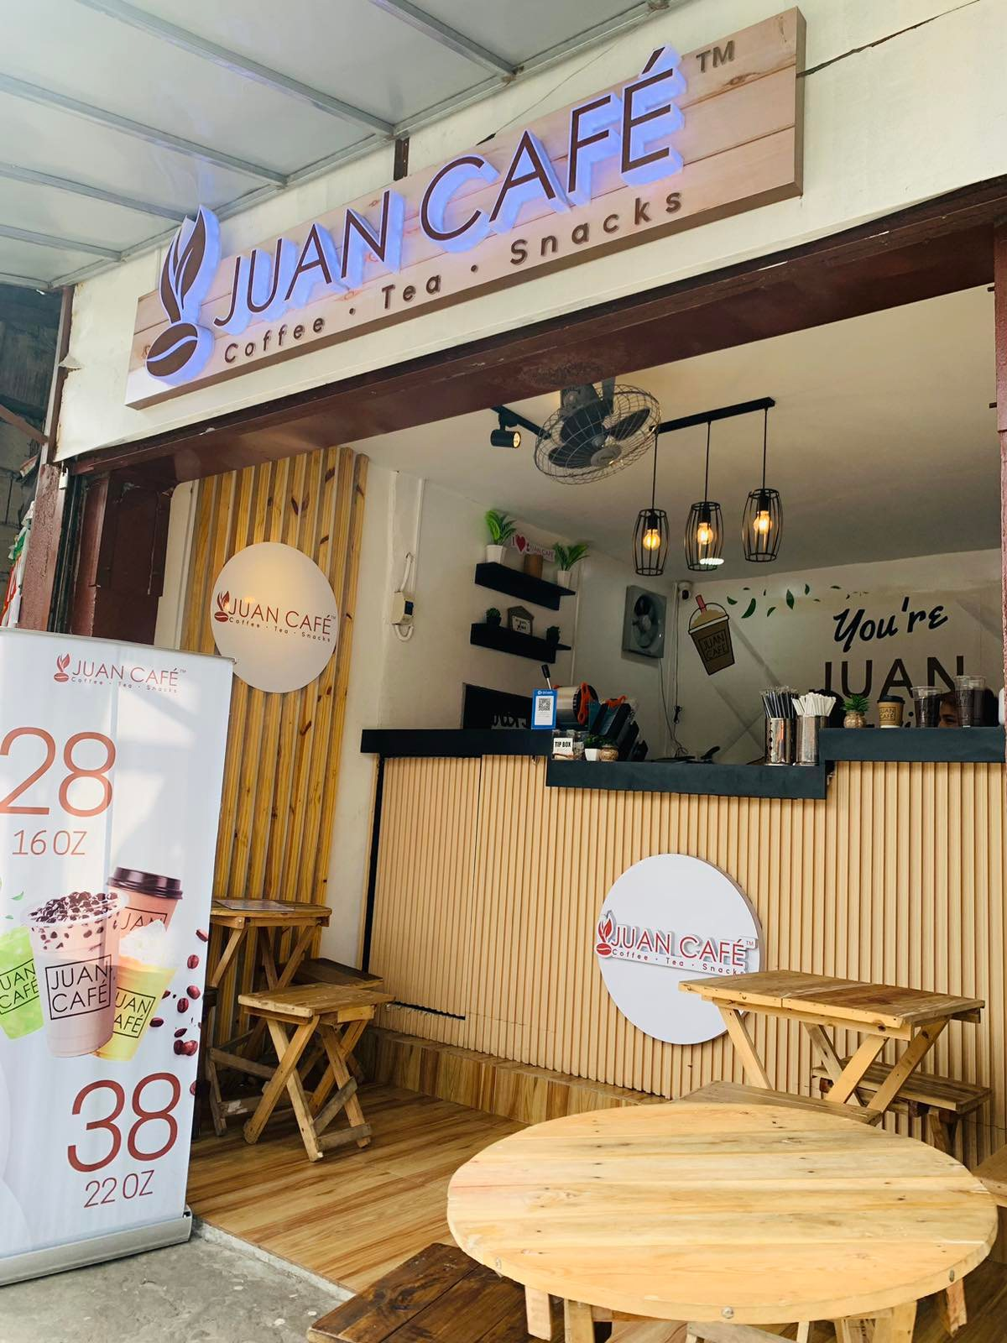

**Figure 1:** Juan Café Store

With a modern vibe that brings a touch of urban café culture to the province, Juan Café is the go-to place for milk tea enthusiasts, coffee lovers, and anyone looking for a cozy space to unwind. The café's menu boasts a variety of crowd-favorites, including refreshing fruit teas, indulgent frappes, and premium coffee options. Whether you're craving a creamy milk tea, a flavorful frappe, or a classic coffee, Juan Café offers a delightful beverage experience that keeps patrons coming back for more.

1. **Current Business Processes**

At **Juan Café**, daily operations are designed to offer a smooth and enjoyable beverage experience to customers. Below are the primary business processes and the steps involved in completing transactions:

#### **1. Dine-In Process**

Customers can visit Juan Café for a relaxed in-house experience. The typical dine-in transaction follow there steps:

* **Step 1: Guest Arrival:** Upon arrival, gests are warmly welcomed by the staff and invited to choose their table
* **Step 2: Order Placement:** Guests browse the menu, which features a wide variety of milk teas, fruit teas, frappes, and coffee options. They place their order at the counter, where the cashier inputs the order into the café POS system.
* **Step 3: Order Preparation:** The café’s skilled baristas prepare the beverages, ensuring quality and accuracy, while any requested add-ons like whipped cream or espresso shots are included.
* **Step 4: Serving:** Once the drinks are ready, they are served to the customers at their table, or guest may opt to pick up their drinks at the counter.
* **Step 5: Billing:** After receiving their drinks, customers proceed with payment at the counter. Payment options include cash, and digital methos like Gcash.
* 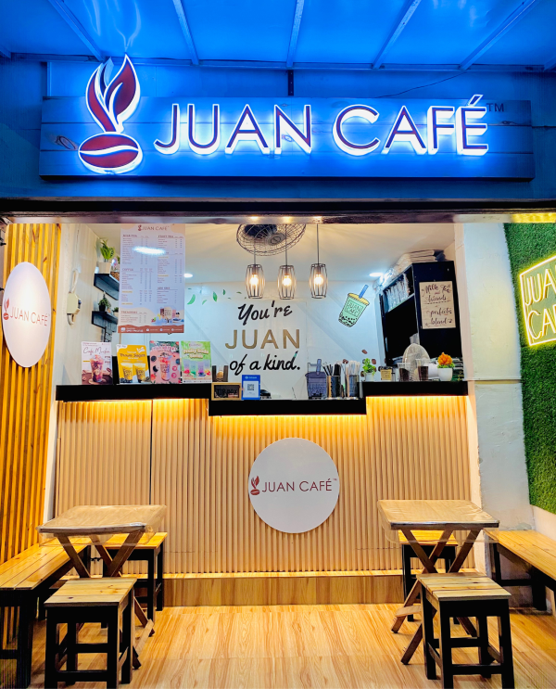**Step 6: Feedback:** Customers are encouraged to share their thoughts and experiences via social media or in-store feedback forms to help improve the café’s service

**Figure 2:** Menu Spotlight and Aesthetics

#### 

1. **Content Management System**

For managing the digital presence and operations of Juan Café, PrestaShop will be utilized as the core platform. PrestaShop is selected for its powerful e-commerce functionalities and flexibility, ensuring both efficient business operations and a seamless online customer experience.

1. PrestaShop

PrestaShop is a leading e-commerce platform that will be used to manage key aspects of Juan Café's digital operations, including online orders, inventory, and customer management. Here's why PrestaShop is the perfect fit for Juan Café:

#### E-Commerce Focus: PrestaShop is specifically designed for online selling, making it ideal for managing online orders, allowing Juan Café to offer delivery or pick-up options for their drinks and beverages.

#### Customizability: With PrestaShop's open-source nature, Juan Café can customize the platform to match its branding and specific business needs, ensuring a personalized and user-friendly online experience.

#### Order and Payment Management: PrestaShop supports multiple payment gateways (such as credit cards and GCash), making it easy for customers to place orders online and choose from various payment methods.

#### Inventory Management: PrestaShop offers robust tools for tracking stock levels, managing ingredients, and ensuring that popular drinks and add-ons are always available. It helps streamline the ordering process and avoids out-of-stock issues.

#### Scalability: As Juan Café grows, PrestaShop’s flexibility allows for easy expansion, from adding new products to integrating advanced features, without disrupting current operations.

#### PrestaShop is the ideal choice for Juan Café, providing a powerful and customizable solution for managing online sales, customer relationships, and inventory, ensuring that both online and in-store operations run smoothly.

#### **Conclusion**

By leveraging the e-commerce capabilities of PrestaShop, Juan Café can ensure efficient management of its digital operations while delivering a seamless and engaging online experience for customers. This approach allows the café to streamline back-end processes like inventory and order management, while also providing a flexible, user-friendly platform for customers to browse, order, and pay online. With PrestaShop, Juan Café is well-equipped to optimize its business operations and continue growing its presence both in-store and online.

1. **Expected Output**

The integration of PrestaShop will result in a streamlined, efficient system that enhances both internal operations and customer engagement for Juan Café. Below is the target output, along with the functionalities that PrestaShop will provide:

1. PrestaShop: E-commerce and Digital Operations Management

PrestaShop will serve as the primary platform for managing Juan Café’s online transactions and digital presence. The expected outputs from implementing PrestaShop are:

* **Automated Inventory Management:** PrestaShop will track stock levels of ingredients and supplies, issue alerts for restocking popular items like milk teas, coffee, and add-ons, and help prevent shortages.
* **Online Sales and Payment Integration:** The system will manage online orders, allowing customers to browse the menu, place orders for delivery or pickup, and pay using various methods such as credit card and GCash. PrestaShop will also track sales and generate detailed reports for all online transactions.
* **Customer Relationship Management (CRM):** Through its CRM functionalities, PrestaShop will help Juan Café manage customer feedback, track repeat customers, and implement promotions, loyalty programs, or discounts for regular patrons.
* **Order and Delivery Management**: PrestaShop will automate the order process, allowing Juan Café to manage delivery orders efficiently, assign delivery personnel, and track the status of each order, ensuring timely and accurate service.
* **User-Friendly Customer Experience:** PrestaShop’s customizable interface will ensure a smooth, user-friendly experience for customers, making it easy to navigate the menu, place orders, and interact with Juan Café online.

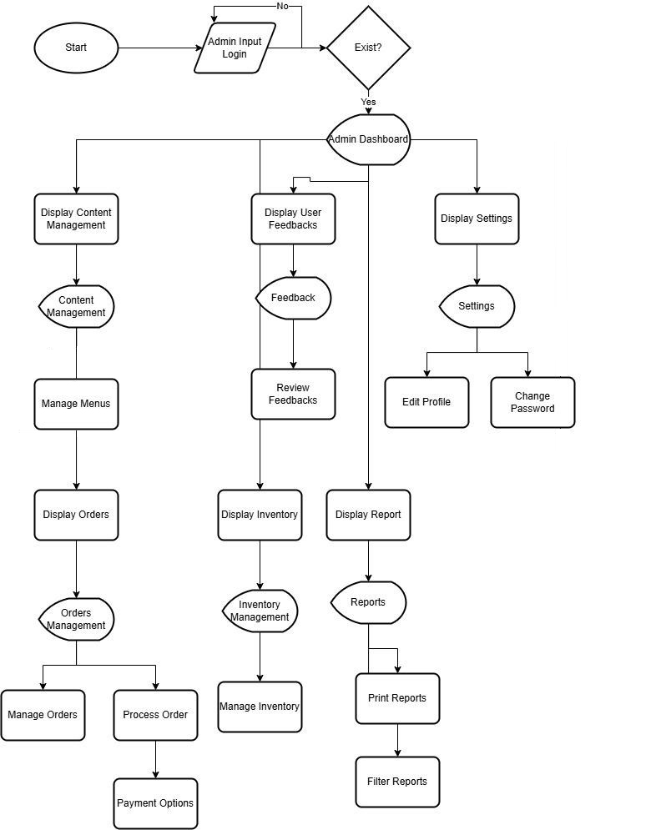 **Figure 5:** Admin Side System Flow

The PrestaShop admin system for Juan Café starts with login and leads to an Admin Dashboard. From there, the admin can manage orders, process payments, and track inventory levels with automated reordering. Customer feedback, promotions, and loyalty programs are handled in the Customer Management section. The system also generates sales reports and provides profile and settings management, ensuring full control over digital operations and customer engagement. This setup allows for efficient and streamlined e-commerce management.

**NAME: Christ John Ortega**

**YEAR AND SECTION: 3F2**

**EVALUATION CRITERIA**

|  |  |  |  |  |  |
| --- | --- | --- | --- | --- | --- |
| **CRITERIA** | **EXCELLENT (4)** | **GOOD (3)** | **SATISFACTORY (2)** | **NEEDS IMPROVEMENT (1)** | **SCORE** |
| 1. Brief Description of the Organization | Thoroughly describes all important details: Business Owner, Address, Year Established, Services/Products, with pictures. | Describes most of the important details but lacks minor information or has less visual representation. | Provides some details but lacks important information and minimal visual representation. | Incomplete or missing information, lacks clear and concise details. |  |
| 1. Current Business Processes | Clearly outlines different transactions with detailed steps, well-organized descriptions, and multiple relevant pictures. | Outlines different transactions with steps but lacks some detail or organization. Includes some pictures. | Describes transactions in a basic manner with few steps and minimal pictures. | Lacks clarity in the description of business processes, missing steps, and pictures. |  |
| 1. Content Management System (CMS) | Provides a comprehensive discussion on the selected CMS with a strong justification for its choice, including relevant visuals. | Discusses the selected CMS with a reasonable justification but lacks depth or detailed visuals. | Provides a basic discussion of the CMS with a weak justification and minimal visual content. | Inadequate discussion of the CMS or unjustified choice; missing visuals. |  |
| 1. Expected Output | Clearly discusses the target output, including detailed descriptions of CMS functionality, well-crafted illustrations, flowcharts, and system architecture. | Discusses the target output with clear descriptions of CMS functionality but lacks some detail in visuals. | Provides a basic discussion of the target output, with minimal details on CMS functionality and limited visual aids. | Lacks clear discussion of the expected output, CMS functionality, and is missing key visual elements. |  |
| 1. Visual Quality | Uses high-quality, relevant images, illustrations, and diagrams that enhance understanding and presentation. | Uses relevant visuals that aid in understanding but lacks in quality or diversity. | Uses some visuals but they are of low quality or do not fully aid understanding. | Rarely uses visuals or uses visuals that are irrelevant or unclear. |  |
| 1. Clarity and Organization | Information is well-organized, logically structured, and clearly presented for all sections. | Information is mostly organized and clearly presented with minor lapses in logical flow. | Information is somewhat organized, but sections are confusing or poorly structured. | Information is disorganized, confusing, and lacks logical structure. |  |
| 1. Depth of Analysis | Demonstrates a deep understanding and thorough analysis of each section, with critical thinking and insightful observations. | Demonstrates a good understanding and analysis of each section but lacks depth or insight in some areas. | Demonstrates a basic understanding of each section with limited analysis or critical thinking. | Lacks understanding and analysis, with superficial or missing observations. |  |

Scoring Guide:

* Excellent (4): Outstanding level of understanding, depth, and clarity with high-quality visuals.
* Good (3): Above average understanding, good organization, and clarity with sufficient visuals.
* Satisfactory (2): Average understanding, acceptable organization, and clarity with minimal visuals.
* Needs Improvement (1): Below average understanding, poor organization, and clarity with little to no visuals.