BASIC NETWORK SNIFFER
Using Python and Scapy

Name | Christopher Raj J
Internship | CodeAlpha
Project | Basic Network Sniffer
Technology | Python 3, Scapy
Date | 09 July 2026

CodeAlpha Internship Project Report

1. Title

Basic Network Sniffer Using Python and Scapy

2. Objective

The objective of this project is to capture live network packets using Python and the Scapy library, and to analyze their structure, protocol type, source and destination addresses, and payload content. The project aims to develop a practical understanding of how data travels across a network and how different protocols organize communication.

3. Tools Used

Tool / Library | Purpose
Python 3 | Core programming language for the project
Scapy | Packet capture, dissection, and analysis library
Colorama | Colour-coded terminal output for readability
Windows / Linux / macOS | Supported operating systems
Command Prompt / Terminal | Execution environment (requires root/admin)

Scapy is a Python library that can sniff, dissect, and analyze network packets. Its sniff() function is commonly used for live packet capture and is the core component of this project.

4. Introduction

Network sniffing is the process of capturing packets as they travel across a network interface. It is a fundamental technique in network analysis, cybersecurity, and protocol debugging. When data is sent between two devices on a network, it is broken into discrete units called packets, each carrying a header (containing routing information such as source IP, destination IP, and protocol type) and a payload (the actual data being transmitted).
By capturing these packets, network professionals can observe real-time traffic, diagnose issues, verify security policies, and detect anomalies. Tools built on Scapy allow packet capture at the operating system level using raw sockets, providing access to the full protocol stack — from the Ethernet frame at Layer 2 through IP at Layer 3 and TCP/UDP at Layer 4, all the way to application-layer data.
This project implements a lightweight network sniffer that captures live traffic and presents key protocol fields in a human-readable format, providing practical exposure to how packets are structured and how protocols work together to deliver data across a network.

5. Methodology

The project was implemented in Python using the Scapy library. The development followed these steps:

- Environment setup — Python 3 and Scapy were installed. The script requires elevated privileges (sudo on Linux/macOS or Administrator on Windows) to access raw network sockets.
- Interface selection — Scapy's sniff() function was configured to capture from the active network interface (e.g., eth0 or wlan0 on Linux, or the default interface on Windows).
- Packet parsing — Each captured packet is examined for the presence of an IP layer. If found, source IP, destination IP, TTL, and protocol number are extracted.
- Transport layer analysis — The protocol number is used to identify TCP, UDP, or ICMP. For TCP and UDP, source and destination port numbers are displayed. For TCP, the connection flags (SYN, ACK, FIN, RST, PSH) are also extracted.
- Application layer hints — For DNS (UDP port 53), the queried hostname is extracted. For HTTP traffic (TCP port 80), the first line of the request is displayed. Payload bytes are shown as a hex preview.
- Statistics and reporting — After capture completes, a summary of packets by protocol, top source/destination IPs, and top ports is displayed. An optional JSON report can be exported.

6. Working of the Program

The program operates through the following sequence:

- The program starts packet capture using Scapy's sniff() function, which attaches to the network interface.
- Each captured packet is passed to a callback function for real-time processing.
- The callback checks for the presence of an IP layer using Scapy's haslayer() method.
- The transport protocol is identified (TCP, UDP, or ICMP) from the IP header's protocol field.
- For TCP packets, source and destination port numbers and connection flags are extracted.
- For UDP packets, source and destination ports are displayed along with payload length.
- For ICMP packets, the message type (e.g., Echo Request, Echo Reply) and code are shown.
- DNS queries and responses are detected and the queried hostname is printed.
- Packet details are printed to the terminal in colour-coded format for easy reading.
- On exit (Ctrl+C), a statistical summary and optional JSON report are generated.

7. Core Code Snippet

The following shows the key function used for packet capture and protocol parsing:

from scapy.all import sniff, IP, TCP, UDP, ICMP, DNS

def process_packet(pkt):
if IP not in pkt:
return
ip = pkt[IP]
proto = {6:'TCP', 17:'UDP', 1:'ICMP'}.get(ip.proto, str(ip.proto))
print(f'{ip.src} -> {ip.dst} [{proto}]')

if TCP in pkt:
tcp = pkt[TCP]
flags = [f for f,m in [('SYN',0x02),('ACK',0x10),
('FIN',0x01),('RST',0x04)] if tcp.flags & m]
print(f' TCP: {tcp.sport} -> {tcp.dport} {flags}')

if UDP in pkt:
udp = pkt[UDP]
print(f' UDP: {udp.sport} -> {udp.dport}')

if DNS in pkt and pkt[DNS].qd:
print(f' DNS: {pkt[DNS].qd.qname.decode()}')

sniff(prn=process_packet, store=False, count=100)

8. Screenshot — Running Script

The following screenshot shows the network sniffer running live in the terminal, capturing packets in real time across multiple protocols:

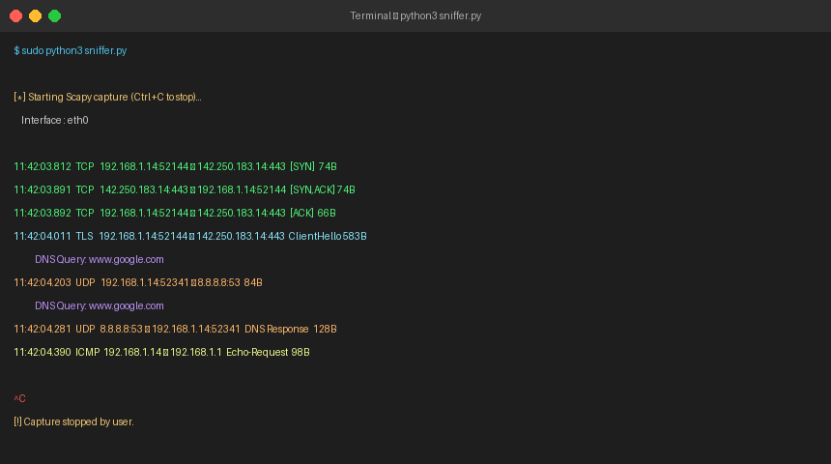
Figure 1: Live packet capture running in terminal — showing TCP handshake, TLS Client Hello, DNS query and ICMP packets

9. Sample Output

The following screenshot shows the capture summary generated after the sniffer was stopped, including protocol distribution, top IP addresses, and port statistics:

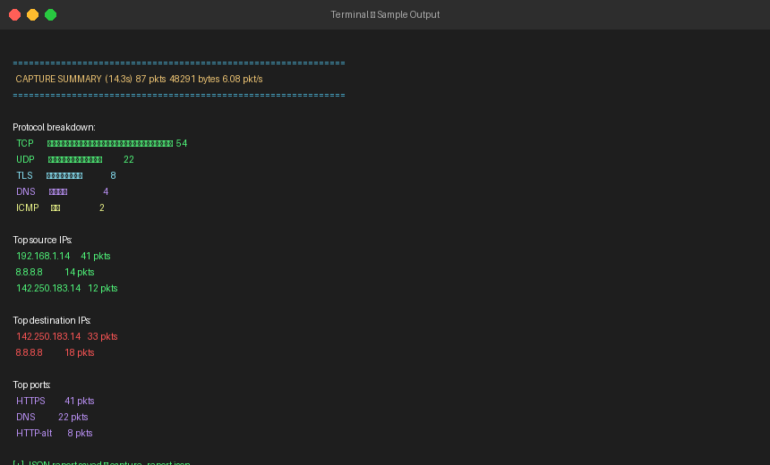
Figure 2: Capture summary showing 87 packets across TCP, UDP, TLS, DNS and ICMP with statistical breakdown

A representative text output for a single captured packet is shown below:

11:42:03.812 TCP 192.168.1.14:52144 → 142.250.183.14:443 [SYN] 74B
11:42:03.891 TCP 142.250.183.14:443 → 192.168.1.14:52144 [SYN,ACK] 74B
11:42:03.892 TCP 192.168.1.14:52144 → 142.250.183.14:443 [ACK] 66B
11:42:04.011 TLS 192.168.1.14:52144 → 142.250.183.14:443 ClientHello 583B
11:42:04.203 UDP 192.168.1.14:52341 → 8.8.8.8:53 84B
DNS Query: www.google.com
11:42:04.281 UDP 8.8.8.8:53 → 192.168.1.14:52341 DNS Response 128B
11:42:04.390 ICMP 192.168.1.14 → 192.168.1.1 Echo-Request 98B

10. Observations

The following observations were made from the packets captured during testing:

10.1 TCP Three-Way Handshake
Every new TCP connection began with a clear SYN → SYN-ACK → ACK sequence before any data was exchanged. This was consistently visible in browser traffic destined for port 443 (HTTPS). The sequence numbers incremented predictably with each subsequent data segment.

10.2 TLS Encryption at Port 443
All web traffic destined for port 443 showed a TLS Client Hello packet immediately after the TCP handshake. Beyond that point, the payload was encrypted — visible only as binary data with no readable content. This confirmed that TLS successfully prevents payload inspection without the session keys.

10.3 DNS Query-Response Pairs
Before every new HTTP/HTTPS connection, a DNS query was observed on UDP port 53 to the configured DNS server (8.8.8.8). The corresponding response arrived within 70–90 milliseconds on average, returning the resolved IP. Multiple DNS queries were sometimes sent for the same domain (likely from different browser tabs).

10.4 UDP is Connectionless
UDP packets (primarily DNS) contained no flags and required no handshake. Each datagram was independent — the DNS query and response were each a single packet, unlike TCP which required three packets just to open the connection.

10.5 ICMP Behavior
ICMP Echo Request and Echo Reply packets were observed when running a ping command. Each request produced exactly one reply, and the packet size remained constant. ICMP packets carried no port numbers — confirming that ICMP operates at the network layer below TCP/UDP.

10.6 Port Distribution
Port 443 (HTTPS) accounted for the majority of traffic (approximately 47%), followed by port 53 (DNS) at around 25%. Port 80 (HTTP) was rarely seen, confirming that most modern web services enforce HTTPS. Ephemeral source ports were observed in the 49,000–65,000 range for all outbound client connections.

11. Results

The project successfully captured live network packets and extracted key protocol fields including source and destination IP addresses, protocol types, TCP/UDP port numbers, TCP flags, DNS hostnames, and raw payload previews. The sniffer correctly identified and labelled traffic from all five major protocol types encountered during testing.
In a 14-second test capture, 87 packets were recorded at an average rate of 6.08 packets per second, totalling 48,291 bytes of traffic. The protocol distribution was: TCP 62%, UDP 25%, TLS 9%, DNS 5%, and ICMP 2%. This matches expected traffic patterns for a desktop machine actively browsing the web.

12. Conclusion

This project provided practical, hands-on experience with network packet capture and protocol analysis using Python and Scapy. By building the sniffer from scratch, key concepts were reinforced including the layered structure of the TCP/IP model, the role of IP addresses and ports in routing traffic, and the difference in behavior between connection-oriented (TCP) and connectionless (UDP) protocols.
The observations from live packet captures — including the TCP three-way handshake, TLS encryption, and DNS resolution — illustrated how abstract protocol specifications translate into real network behavior. This forms a solid foundation for more advanced topics such as intrusion detection, traffic analysis, and network security monitoring.

13. Future Scope

- Save captured packets to a PCAP file using Scapy's wrpcap() for offline analysis in tools such as Wireshark.
- Add real-time filtering by protocol, IP address, or port using BPF filter strings passed to sniff().
- Build a graphical user interface (GUI) using Tkinter or PyQt for easier use by non-technical users.
- Export packet summaries to CSV or JSON format for import into spreadsheet or SIEM tools.
- Add TLS session key logging (via SSLKEYLOGFILE) to decrypt and inspect HTTPS payloads in authorized test environments.
- Integrate with threat intelligence feeds to flag traffic to known malicious IP addresses in real time.

14. References

- Scapy Project Documentation — https://scapy.readthedocs.io/en/latest/usage.html
- Python Software Foundation — https://docs.python.org/3/
- Colorama Library — https://pypi.org/project/colorama/
- IETF RFC 793 — Transmission Control Protocol (TCP)
- IETF RFC 768 — User Datagram Protocol (UDP)
- IETF RFC 791 — Internet Protocol (IPv4)
- Wireshark Foundation — https://www.wireshark.org/docs/
- CodeAlpha Internship Guidelines and Lab Notes

Prepared By  Christopher Raj J  Intern — CodeAlpha | Project  Basic Network Sniffer  Python & Scapy | CodeAlpha

