Christopher Straub 17.12.2021

Léo Vigna

# Deep Learning Projects

# Project 1

The code is divided in two files. The first one “Project1.py” has the training loops for the different architectures. The second file “comparisonNets.py” contains the three architectures.

In order to launch the code you simple run the main script “Project1.py” and it outputs the result of the training and testing of the three architectures in the console.

The three architectures are composed as follow :

1. The input tensor is seen has a 2 channels image. There is a feature extraction with two convolutionals layers and then a fully connected head that predict if the first digit is lesser or equal to the second digit.
2. Each channel of the input tensor is processed by the same network (weight sharing) which try to identify the number with a softmax function with 10 output. Then a fully connected layer try to predict if the first digit is lesser or equal to the second digit.
3. Same as 2, but we use auxiliary loss to force the network to optimize the digit recognition part.

Before each training, we call a function “initParameter” that initialize the weights according to the following rule :

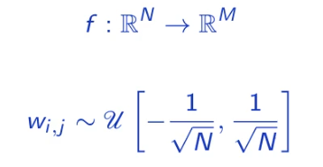

Figure 1: Xavier initialization method

Finally, we get those results :

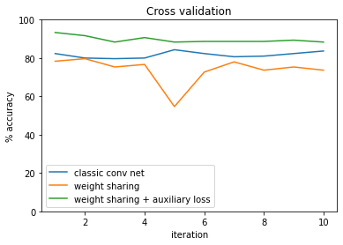

Figure 2: Results cross-validation

We see that the weight sharing and the auxiliary loss outperform the two other architectures. It might be because we ensure that the network learn to recognize a number and then compare the intermediate result to reach to a conclusion. In the two other cases we simply try to optimize a model in order to minimize the binary cross entropy loss of the final decision which seems to be capped around 80% with the given dataset.

|  |  |
| --- | --- |
| **Performance with test set** | **Accuracy %** |
| Classic conv net | **80.59** |
| Weight sharing | **74.59** |
| Weight sharing + auxiliary loss | **91.00** |

A future work could be to tune the loss in order to give a bigger importance to the recognition of the digit first and then optimize the loss of the final decision.

Project 2

There is two files test.py and NNmodule.py. The test.py file uses NNmodules.py to build a neural network, train and test it on a set of labeled points in a square of the plane.

Assuming that a neuron network always consists of compositions of functions, which successively associate each of the linear combinations of its inputs, the output of a continuous function (activation), NNmodules.py creates a neural network using the

Sequential module which takes Parameter modules (Linear) or Activation module (ReLU, Tanh) as argument (Figure 3).

During network initialization, Fields “sigma” and “sigma” are assigned in the activations module with the functions which represent the activation function and his derivative. Finally the class Net is created containing the layers of the network, as well as all the mechanics necessary for its training and its operation.

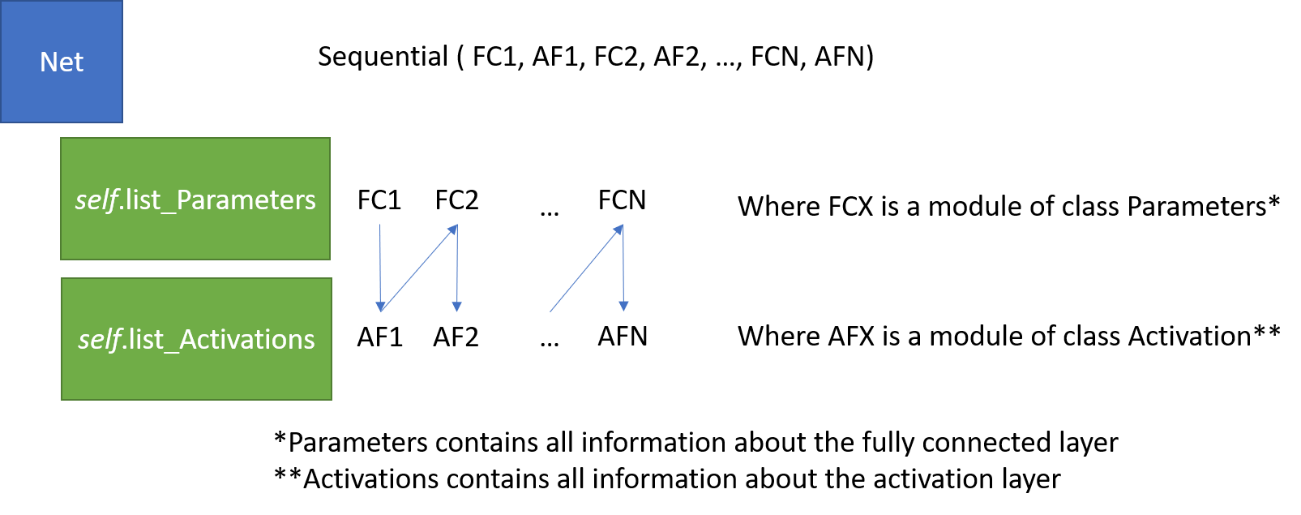

Figure 3: Structure overview

Each Parameter and Activation module stores in memory the data necessary for backpropagation during the forward. The only values ​​to remember are in the Activation class:

* ds_da: activation function’s derivative evaluated in s.
* da_dw: linear function’s derivative with respect of this weights (directly the input of the activation function: x (previous layer)).

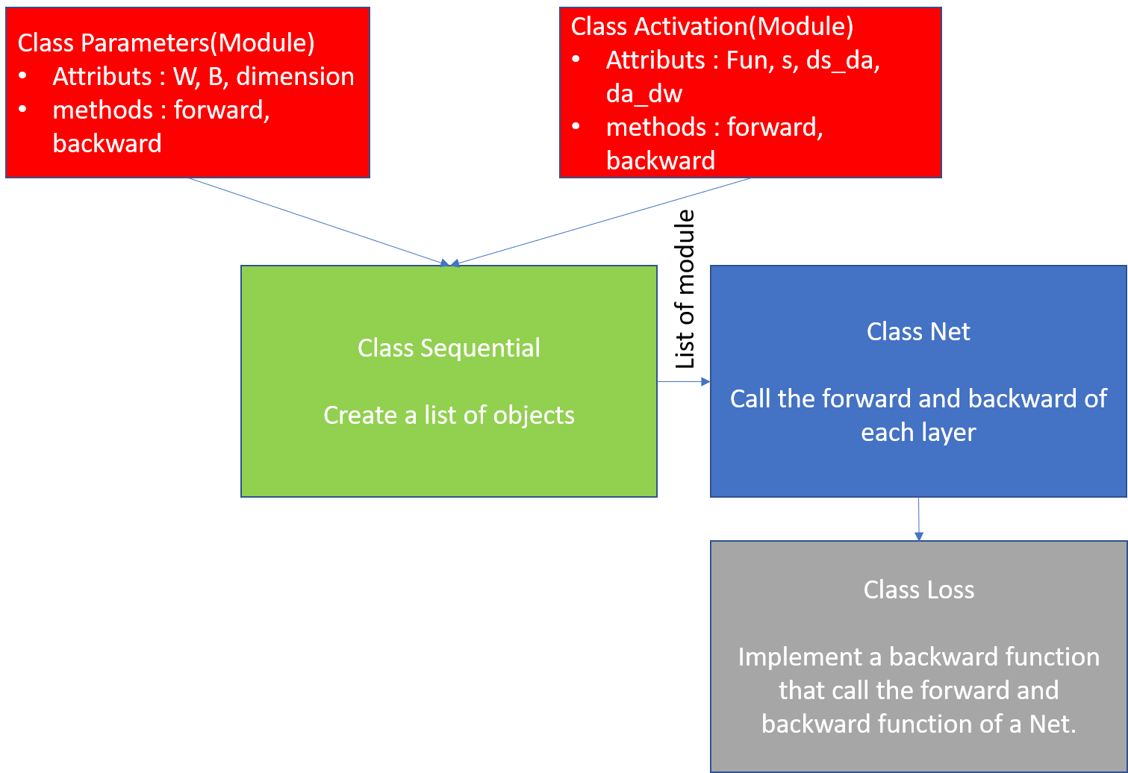

Figure 4: Global structure

The backward function from Net’s module takes as input the loss derivative evaluated at the output of his forward. Like the way forward is implemented, the backward functions of the elements in the Parameter and Activations fields are successively calls in reverse order (right to left).

Using the stored values ​​(in Activation), the loss gradients in respect of the linear combinations coefficients from the linear previous layer can be returned by the backward function of the elements of the Net Activation field.

That way the gradients in the Net class can be accumulated, to update the network’s weights (which are stored in each Parameter’s module ) for each new mini-batch with SGD module.

The last two figures represent the results after 767 epoch for 7 seconds training time.The errors are : 2% on the test set, 1.4% for the train, 1.9% for the validation. The stop criterion in this case was the gradient magnitude which value was 0.00092.

The stop criterion is useful when the initializations weights are poorly conditioned such that the gardien descent is stuck in a local minimum. In that case the stop criterion prevents the training to go throw all the 2000 epochs.

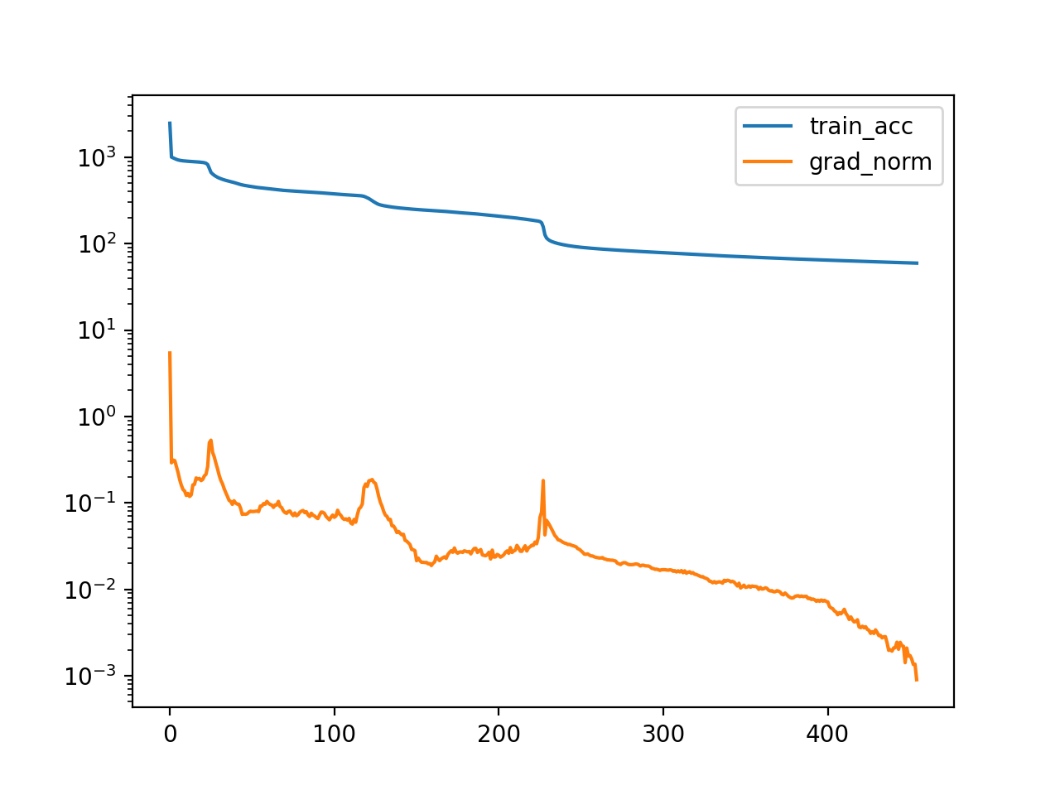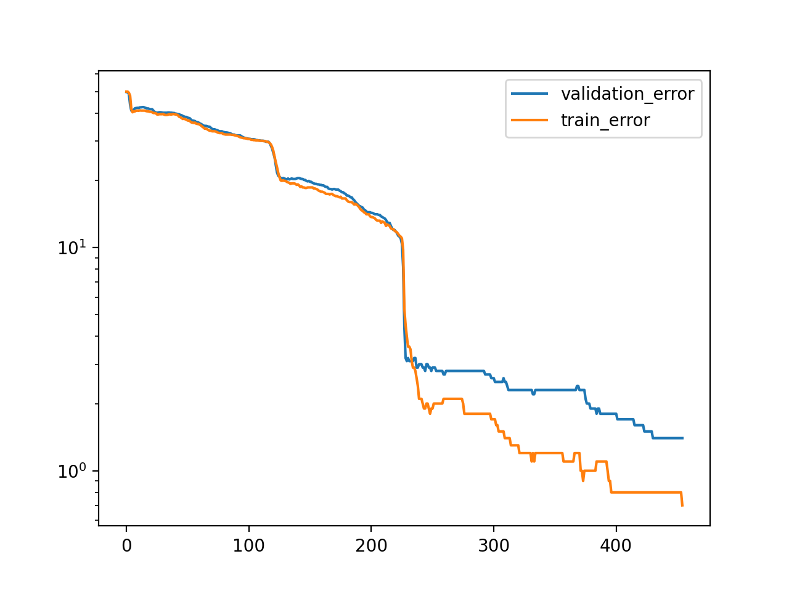

The last one represents the test point after classification with the first layer hyperplan for each linear combinaison.

