# Brainstorm

**TIP**

You can select a sticky note and hit the pencil [switch to sketch] icon to start drawing!

**TIP**

Participants can use their cursors to point at where sticky notes should go on the grid. The facilitator can confirm the spot by using the laser pointer holding the **H key** on the keyboard.

#### Before you collaborate

###### A little bit of preparation goes a long way with this session. Here’s what you need to do to get going.

**10 minutes**

**1**

#### Define your problem statement

**Outgoing Cabinet Minister to lose in the election**

**Anant Geete – Minister of Heavy Industries and Public Enterprises (Raigad) Shiv Sena[176]**

**Outgoing Ministers of State to lose in the election**

**Manoj Sinha - Minister of State for Communications (Independent charge) (Ghazipur) BJP**

**Alphons Kannanthanam - Minister of State for Electronics and IT and**

**2**

#### Brainstorm

###### Write down any ideas that come to mind that address your problem statement.

**10 minutes**

**3**

#### Group ideas

###### Take turns sharing your ideas while clustering similar or related notes as you go. Once all sticky notes have been grouped, give each cluster a sentence-like label. If a cluster is bigger than six sticky notes, try and see if you and break it up into smaller sub-groups.

**TIP**

Add customizable tags to sticky notes to make it easier to find, browse, organize, and categorize important ideas as themes within your mural.

**20 minutes**

1. The BJP's total vote share stood at 37.4 per cent, an increase of

**4**

#### Prioritize

###### Your team should all be on the same page about what's important moving forward. Place your ideas on this grid to determine which ideas are important and which are feasible.

**20 minutes**

#### After you collaborate

You can export the mural as an image or pdf to share with members of your company who might find it helpful.

**Quick add-ons**

# & idea prioritization

Use this template in your own brainstorming sessions so your team can unleash their imagination and start shaping concepts even if you're not sitting in the same room.

**A Team gathering**

Define who should participate in the session and send an invite. Share relevant information or pre-work ahead.

**B Set the goal**

Think about the problem you'll be focusing on solving in the brainstorming session.

**C Learn how to use the facilitation tools**

Use the Facilitation Superpowers to run a happy and

***Politicalparties***

More than 650 parties contested in these elections. Most of them were small with regional appeal. The main parties are the Bharatiya Janata Party (BJP) and the Indian National Congress (INC). This was the first time that BJP (437) contested more seats than Congress (421) in the Lok Sabha elections.

**Minister of State for Tourism (Independent charge) (Ernakulam) BJP Hardeep Singh Puri - Minister of State for Housing and Urban Poverty Alleviation (Amritsar) BJP**

**Hansraj Gangaram Ahir - Minister of State for Home Affairs (Chandrapur) Pon Radhakrishnan - Minister of State for Finance (Kanyakumari) BJP Former Prime Minister to lose in the election**

**H. D. Deve Gowda (JD-S)- Prime Minister of India from 1996–1997 lost from Tumkur of Karnataka[177]**

**Former Chief Ministers to lose in the election**

**H. D. Deve Gowda - Karnataka (Tumkur) JD(S) Sheila Dikshit - Delhi (North East Delhi) INC[178] Digvijaya Singh - Madhya Pradesh (Bhopal) INC**

**Sushil Kumar Shinde - Maharashtra (Solapur) INC[179]**

**Person 1**

Legislative assembly elections in the

states of Andhra Pradesh, Arunachal

Pradesh, Odisha and Sikkim were held simultaneously with the general election,[15][16] as well as by- elections of twenty-two seats of the Tamil Nadu Legislative Assembly

In addition, the BJP- led National Democratic Alliance (NDA) won 353 seats.[9] The BJP won 37.76%[10] of votes, while the NDA's combined vote

was 45% of the 603.7 million votes that were polled.

Around 912 million people were eligible to vote, and voter turnout was over 67 percent – the highest ever, as well as the highest ever participation by women voters

***2019IndianGeneralElection:***

**General elections** were held in India in seven phases from 11 April to 19

May 2019 to elect the members of the 17th Lok Sabha. Votes were counted and the result was declared on 23 May.[1][2][3][4] The election resulted in a landslide victory for the BJP which won 303 seats and formed the government.

**Person 2**

The Bharatiya Janata Party received 37.36% of the vote, the highest vote share by a political party since the 1989 general election, and won 303 seats, further increasing its substantial majority.[

**Person 3**

***Politicalparties***

More than 650 parties contested in these elections. Most of them were small with regional appeal.

The main parties are the Bharatiya Janata Party (BJP) and the Indian National Congress (INC). This was the first time that BJP (437) contested more seats than Congress (421) in the Lok Sabha elections.

**Person 4**

All 543 elected MPs are elected from single-member constituencies using first- past-the-post voting. The President of

India appoints an additional two members from

the Anglo-Indian community if he believes that community is under- represented.

Eligible voters must be Indian citizens, 18 or older than 18, an ordinary resident of the polling area of the constituency and registered to vote (name included in the electoral rolls), possess a valid voter identification card issued by the Election Commission of India or an equivalent.

Some people convicted of electoral or other offences are barred from voting. The elections are held on schedule and as per the Constitution of India that mandates parliamentary elections once every five years.

### over 6 percentage points from 31.34 per cent in 2014. The National Democratic Alliance secured a vote share of 45 per

cent, compared to 38 per cent in 2014. In contrast, the vote **+**

### share of Indian National Congress remained the same at 19.5 per cent.

***2019IndianGeneralElection: GeneralelectionswereheldinIndiainsevenphasesfrom11***

***Aprilto19May2019toelectthemembersofthe17thLok Sabha.Voteswerecountedandtheresultwasdeclaredon 23May.[1][2][3][4]Theelectionresultedinalandslidevictory fortheBJPwhichwon303seatsandformedthe government.***

**A Share the mural**

**Share a view link** to the mural with stakeholders to keep them in the loop about the outcomes of the session.

**B Export the mural**

Export a copy of the mural as a PNG or PDF to attach to emails, include in slides, or save in your drive.

**10 minutes** to prepare

**1 hour** to collaborate

**2-8 people** recommended

productive session.

[**Open article**](https://support.mural.co/en/articles/2113740-facilitation-superpowers)

**Ashok Chavan - Maharashtra (Nanded) INC[180]**

**Harish Rawat - Uttarakhand (Nainital–Udhamsingh Nagar) INC Bhupinder Singh Hooda - Haryana (Sonipat) INC Veerappa Moily - Karnataka (Chikkballapur) INC**

**Mukul Sangma - Meghalaya (Tura) INC**

**Nabam Tuki - Arunachal Pradesh (Arunachal West) INC Shibu Soren - Jharkhand (Dumka) JMM**

**Jitan Ram Manjhi - Bihar (Gaya) HAM Babu Lal Marandi - Jharkhand (Kodarma) JVM(P)**

**Mehbooba Mufti - Jammu and Kashmir (Anantnag) PDP**

Encourage wild ideas.

**Person 5**

## 

***ElectionSchedule;***

The election was scheduled to be held in seven phases. In Bihar, Uttar Pradesh and West Bengal, the election was held in all seven phases. The polling for the Anantnag constituency in the state of Jammu and Kashmir was held in three phases, due to violence in the region.

In January 2019, Bahujan Samaj Party and Samajwadi Party announced a grand alliance (Mahagathbandhan) to contest 76 out of the 80 seats in Uttar Pradesh leaving two seats, namely Amethi and Rae Bareli, for INC and another two for other political parties.[122]

Political parties

More than 650 parties contested in these elections. Most of them were small with regional appeal. The main parties are the Bharatiya Janata Party (BJP) and the Indian National Congress (INC). This was the first time that BJP (437) contested more seats than Congress (421) in the Lok Sabha elections.

1. The Lok Sabha comprises of a total of 545 seats. Out of these, elections will be conducted by the Election Commission to fill 543 seats. The remaining two seats are filled by nomination of representatives of the Anglo-Indian Community if the President feels that this community has not been represented adequately.

The Bharatiya Janata Party received 37.36% of the vote, the highest vote share by a political party since the 1989 general election, and won 303 seats, further increasing its substantial majority.[

**Keep moving forward**

**Strategy blueprint**

Define the components of a new idea or strategy.

[**Open the template**](https://app.mural.co/template/e95f612a-f72a-4772-bc48-545aaa04e0c9/984865a6-0a96-4472-a48d-47639307b3ca)

**Customer experience journey map**

Understand customer needs, motivations, and obstacles for an experience.

Defer judgment.

Listen to others.

1. The correct option is D House of the people. The Lok

[**Open the template**](https://app.mural.co/template/b7114010-3a67-4d63-a51d-6f2cedc9633f/c1b465ab-57af-4624-8faf-ebb312edc0eb)

Go for volume. If possible, be visual.

### Sabha, or House of the People, is the lower house of India's bicameral Parliament. Members of the Lok Sabha are elected by universal adult suffrage.

##### Importance

If each of these tasks could get done without any difficulty or cost, which would have the most positive impact?

**Strengths, weaknesses, opportunities & threats**

Identify strengths, weaknesses, opportunities, and threats (SWOT) to develop a plan.

Eligible voters must be Indian citizens, 18 or older than 18, an ordinary resident of the polling area of the constituency and registered to vote (name included in the electoral rolls), possess a valid voter identification card issued by the Election Commission of India or an equivalent.

Some people convicted of electoral or other offences are barred from voting. The elections are held on schedule and as per the Constitution of India that mandates parliamentary elections once every five years.

|  |  |
| --- | --- |
|  |  |
|  |  |

[**Open the template**](https://app.mural.co/template/6a062671-89ee-4b76-9409-2603d8b098be/ca270343-1d54-4952-9d8c-fbc303ffd0f2)

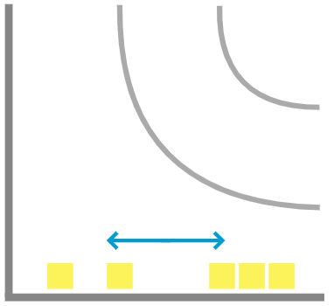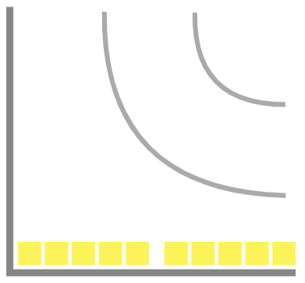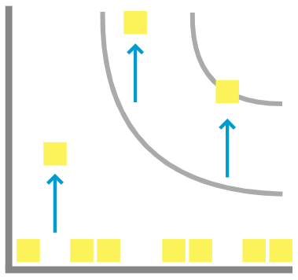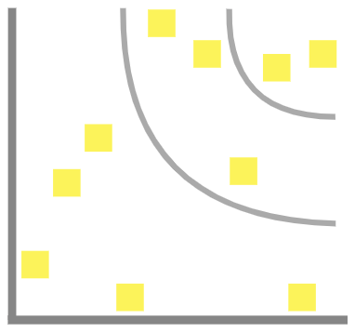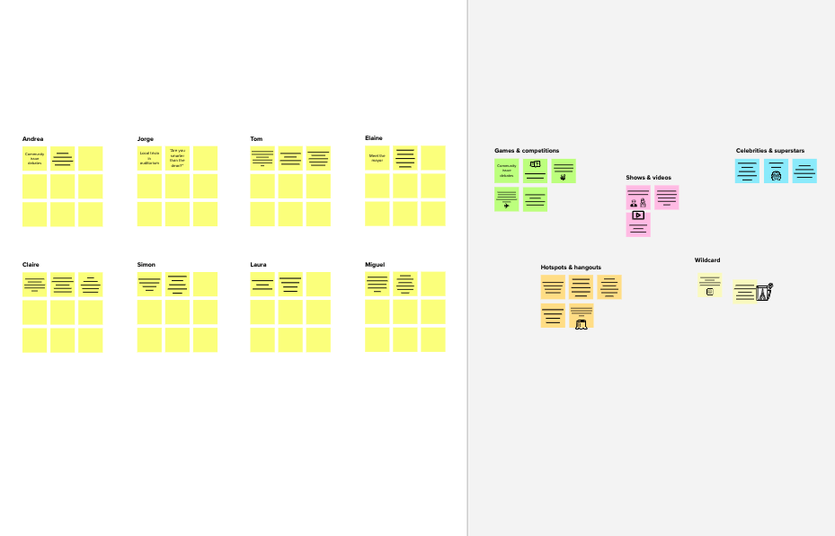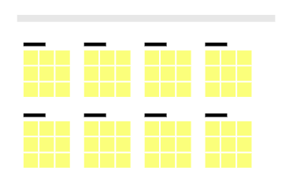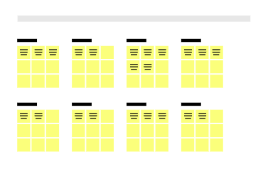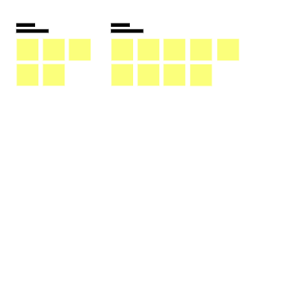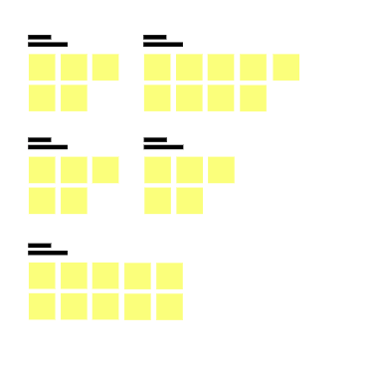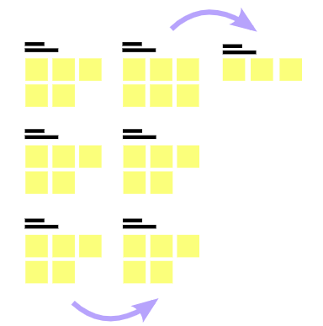

**Template**

[**Share template feedback**](https://muralco.typeform.com/to/CiqaHVat?typeform-source=app.mural.co)

**-**

##### - Feasibility

**+**

Regardless of their importance, which tasks are more feasible than others? (Cost, time, effort, complexity, etc.)

**Need some inspiration?**

See a finished version of this template to kickstart your work.

[**Open example**](https://app.mural.co/template/e5a93b7b-49f2-48c9-afd7-a635d860eba6/93f1b98d-b2d2-4695-8e85-7e9c0d2fd9b9)