[Christofer Paes](mailto:chr2139977@maricopa.edu)

Program #14

CSC 240AA

11/22/21

The story, game, and finite state machine I wanted to write was a story of The Little Red Riding Hood. Throughout the story you’re given three choices, which are the paths for the character to walk down or travel to. You can easily run in circles with this program, so if you're trying to get a complete run follow the edge map directions. The end state of the program is supposed to be the Little Red Riding Hood arriving at her grandmothers living room. The destinations are a state in the finite state machine, and picking up the key is another state, the states are as followed:

open_road.

forest,

the_bridge,

introduction_to_the_wolf,

second_attempt,

grandmother_house_no_key,

doormat,

grandmothers_house_key,

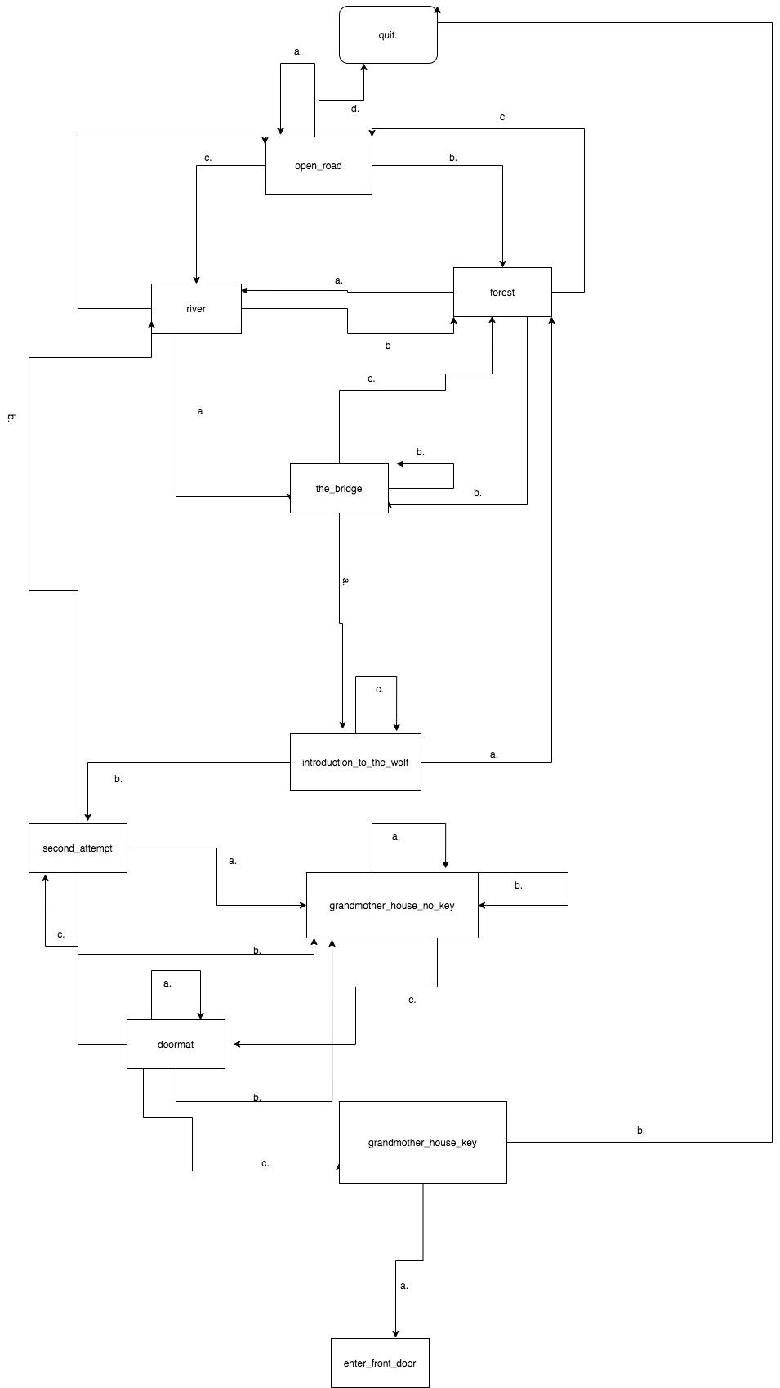

The program was written in prolog.