**\*\*\*\*This file is all about the project\*\*\*\***

**----Read all the information clearly----**

**\*\*Turning On local server and Creating Database\*\***

**Install the Xampp server v3.3.0,**

**First turn on the Xampp Server.**

* 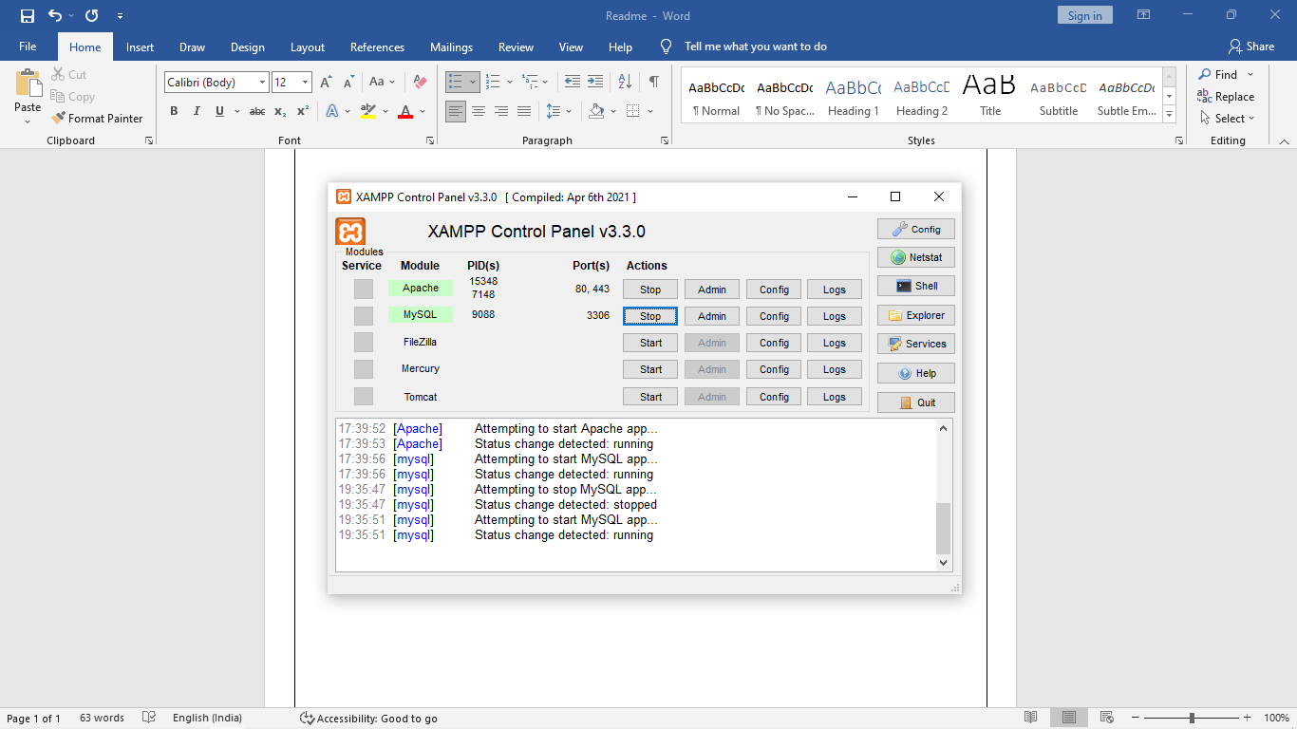In **Xampp Server**, Switch on the Apache server and SQL server



* Copy the files into Local Disk -> Xampp -> htdocs -> paste the QRSystem folder in the location.

# **LOCALHOST**

* Go to Chrome or any browser.
* Type localhost/ in the search bar.
* Click on phpMyAdmin.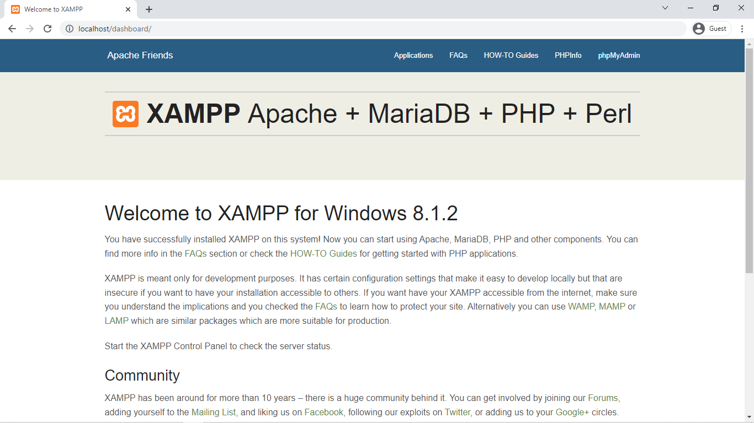



* Click on New.

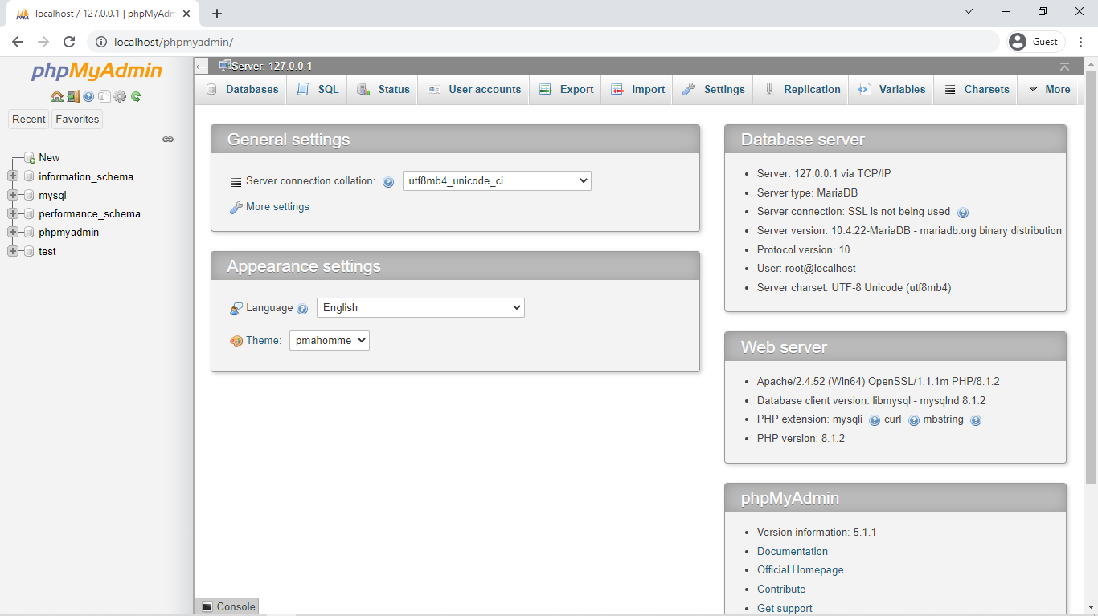



* Create Database with database name qrsystem
* 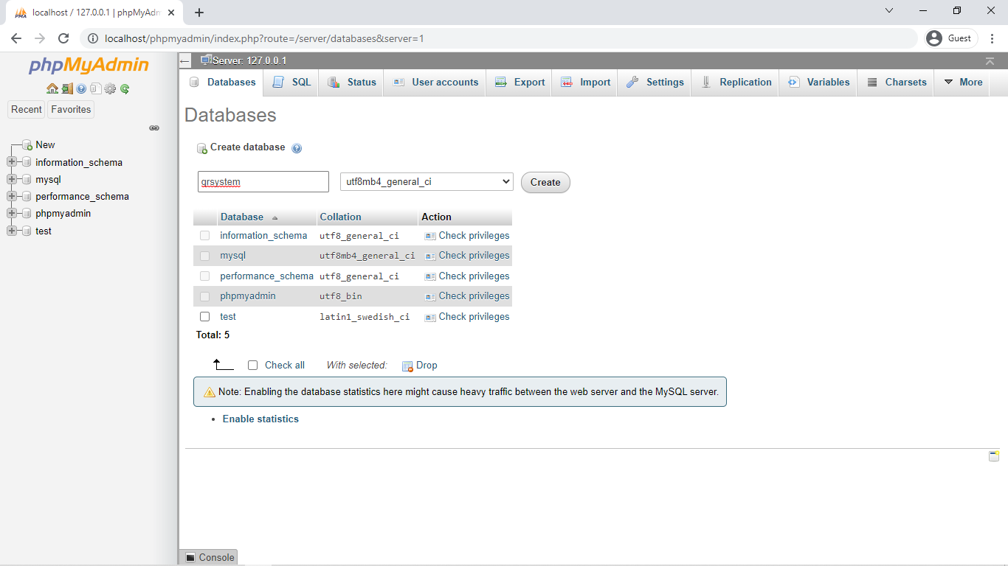Then Click on Create.



* Click on IMPORT button.

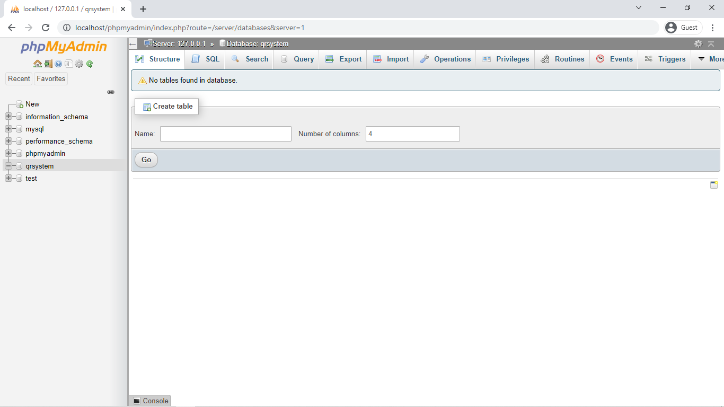



* Click On Choose file and select the file qrsystem.sql from the location htdocs 🡪 qrsystem 🡪 qrsystem.sql
* Then Press GO at the bottom right corner of the page.
* Open a new tab and type [**http://localhost/qrsystem/login.php**](http://localhost/qrsystem/login.php)

**The Database and the Tables of the database is created.**

**Importing Already existing data**

* **Select the database in localhost phpMyAdmin**
* **Click on import button from the menu bar.**
* **Select choose and go to c: 🡪 xampp 🡪 htdocs 🡪 qrsystem 🡪 backup and select the latest dated sql file and click go in right bottom corner of the import page**
* **The Data is imported to the database.**

**Opening the Webpage**

* **Go to any browser and type the url.**
* **localhost/qrsystem/index.php**
* **The login page will pop up.**
* **Enter the email and password.**

**[Note: Default username is** [**admin@gmail.com**](mailto:admin@gmail.com) **and password is 123. The password cant be changed as it is in encoded format but the username can be changed .]**

**Creating a device and Configuring the device in Enrolment Mode and Attendance Mode**

* **Select the device from the tab.**
* **Click create device button and give the name of the device name and device department.**

**[Note: Bootstrap is included so, check for data connectivity while creating the device and it may need only for the first time of configuration.]**

* **Select the enrolment button while the users are registering and switch to attendance mode while using it as the time keeper.**

# **Adding users**

* **Go to manage users.**
* **The card which has to be added must be selected,**
* **Enter the Name, Class number, (Degree, year and department all together)**

**[Note: The Degree means whether UG or PG. The last two digits of the year is used and the department. Eg: PG20electronics]**

* **Select the gender and click on add user..**
* **To update a card select the card and Change the required updates and click on update user.**
* **To remove an individual user select the card and click on remove user button.**

**Adding Users into the database in bulk**

* Create a Excel sheet with the format defined below

|  |  |  |  |  |  |  |  |  |  |  |
| --- | --- | --- | --- | --- | --- | --- | --- | --- | --- | --- |
| id | username | serialnumber | gender | email | card_uid | card_select | user_date | device_uid | device_dep | add_card |
| 2 | Toney Abraham | 1460 | Male | PG20Electronics | 10957 | 0 | ######## | 6c4ce926d5971fbd | Library | 1 |

* The id should be continuous and the last id can be found at the users section in webpge. Try to verify the id if not there could be error, so id should no be repeated, and should not be skipped.
* Second column is name and third column is Class Number.
* 4th is gender and in place of email , put the CourseName. Please follow ADDING USER for creating the proper CourseName.
* 5th column is Admission no.
* fill the remaining column as it is kept in the Example.
* Once the Excel is filled, save it as **Microsoft Excel Comma Separated Values File (.csv)**
* Now open the PHPAdmin panel. And click qrsystem database then click on users in database.
* Now in the menu bar on top click on import menu .
* Choose the csv file which has been created.
* Scroll down and change the format to csv in the format section.
* Then scroll down and click on import button.
* This will add all the new data into the database.

**Some important Things about the software head**

* **Their must be data connectivity while creating a device and changing the admin panel.**
* **Kindly connect to the internet and open all the menus.**
* **Always remember to switch between enrolment and attendance mode on requirement.**
* **The page for deleting the pass out students and download database is in admin menu.**
* **Kindly don’t mess with the database also don’t confuse as the degree, year and department are stored in the variable email in databases user table.**
* **While exporting the data from the users log page remember to select all the filtering options.**
* **Save the database after adding the users also check in backup folder if the database has been downloaded.**
* **After deleting the data of pass out students kindly verify it in the database.**

**Hardware**

* **Open the Arduino ide and select the board as node mcu and port.**
* **Compile and upload the file.**

**[Note: The device and database running localhost machine must be in same network. The ip address of the machine running localhost and the device token must be edited into the code. The ssid and password of the wifi network must be edited into the code.]**

* **The QR reader and the power supply should be dismantled while uploading the code.**