**PNAS**

**Title. Genetic, demographic and morphological heterogeneity promote division of labor in experimental social groups**

**Abstract.** Group composition can have profound effects on the behavior and function of social groups, but few social systems afford sufficient control over group composition to precisely quantify those effects. Here, we analyze the relationship between group composition and division of labor in a social insect with unique experimental amenability, the clonal raider ant. We use automated behavioral tracking to quantify division of labor in 120 experimental colonies with controlled variation in genetic, demographic, and morphological composition, three of the main factors affecting behavior in social insects. We find that heterogeneity in colony composition generates patterns of behavioral organization that cannot be inferred from the behavior of homogeneous colonies or from the intuitive predictions of a commonly used model for division of labor. However, these patterns can be explained by considering factors that are empirically documented but theoretically rarely considered, such as variation in task efficiency or interactions between task demand from the brood and task performance by workers. With these biologically realistic sources of variation, theory can capture the full spectrum of behavioral organization observed across experimental colonies containing different types and amounts of heterogeneity.

**Main text.** Many of the collective behaviors displayed by animal groups (e.g., flocks of birds, traffic jams) can be explained by self-organization principles governed by simple individual-level behavioral rules. These principles often rely on the amplification of underlying fluctuations, or heterogeneity between group members [(1)](https://paperpile.com/c/L0XgXK/s0bK). Experimental tests of the influence of group heterogeneity on collective behavior are needed, but complicated by the limited availability of systems allowing to precisely manipulate group composition and by the technical challenges associated with measuring individual behavior in groups [(2)](https://paperpile.com/c/L0XgXK/OLnE).

Social insect colonies are striking examples of highly integrated, complex social systems that are able to self-regulate without centralized control. Social insects are also experimentally amenable, and have emerged as powerful systems to study collective behavior and social dynamics. Colonies of social  insects typically contain a large and heterogeneous workforce composed of individuals that differ in age, genotype, and/or morphology. These individual traits have repeatedly been reported to correlate with individual task performance [(3, 4)](https://paperpile.com/c/L0XgXK/sYaV+YRsS). For example, older workers typically engage in extranidal tasks like foraging, while younger workers disproportionately engage in intranidal tasks like nursing [(5–8)](https://paperpile.com/c/L0XgXK/zYpk+UXib+K8AN+RPe0). Similarly, workers from different patrilines [(9, 10)](https://paperpile.com/c/L0XgXK/QEPM+wXjw) or matrilines [(11)](https://paperpile.com/c/L0XgXK/69kK) can vary in behavioral propensities.  Finally, worker morphology (e.g., size) correlates with task performance, both in species with and without discrete morphological castes [(9, 12)](https://paperpile.com/c/L0XgXK/22Q6+QEPM). A key colony trait, division of labor, has long been thought to depend on colony composition, and specifically, to rely on workforce heterogeneity. However, the inherent complexity of social insect colonies often makes their composition intractable. As a result, few experimental studies have comprehensively measured the influence of group composition on division of labor [(13)](https://paperpile.com/c/L0XgXK/ObrW), limiting our understanding of how the properties of individual group members affect group-level behavior, and conversely, how colony composition affects individual behavior. Finally, the results of empirical studies on inter-individual behavioral variation have so far overwhelmingly been discussed in the context of variation in individual response thresholds, while the significance of other parameters of individual behavior, such as task performance efficiency or duration, has been largely overlooked, despite empirical evidence for inter-individual variation in these traits (efficiency [(14–16)](https://paperpile.com/c/L0XgXK/Kk4m+thMZ+NYwR), duration [(17)](https://paperpile.com/c/L0XgXK/WKvf)).

To overcome the practical challenges associated with studying complex social systems, we capitalize on the advantages of the clonal raider ant (*Ooceraea biroi*), a novel experimental system whose unique biology affords precise control over the main aspects of colony composition that are thought to affect individual- and group-level behavior in social insects. Colonies of clonal raider ants are queenless and exclusively composed of workers that reproduce clonally and synchronously, meaning all adults within a colony are genetically nearly identical and emerge in discrete age cohorts. This affords maximum experimental control over the genotype and age of individuals. Here we work with two commonly used genotypes, A and B (REFS). Synchronous reproduction drives a behavioral cycle, whereby colonies switch between reproductive phases, in which all workers stay in the nest and lay eggs, and brood care phases, in which workers nurse the larvae at the nest but also leave the nest to forage, explore, or dispose of waste.  Furthermore, colonies contain two morphological subcastes: low-reproductive individuals (LRIs) that have 2-3 ovarioles and no visible eyes, and high-reproductive individuals (HRIs) that are larger, have 4-6 ovarioles, visible vestigial eyes, and reduced foraging activity [(19)](https://paperpile.com/c/L0XgXK/0dL5).  We used this unique biology to create replicate experimental colonies that were either homogeneous or heterogeneous with respect to genetic, demographic and morphological composition, manipulating each factor independently from the others (see Methods, Table S1). For example, demographically homogeneous colonies contained either only young workers (1 month-old) or only old workers (3 month-old), and heterogeneous colonies contained a 1:1 ratio of young and old workers, while genotype and morphology was kept constant both within and between colonies. Each colony consisted of 8 or 16 workers—a fully functional group size in the clonal raider ant [(20)](https://paperpile.com/c/L0XgXK/WTWr)—and the same number of age-matched larvae hosted in a Petri dish with a plaster floor. We used a high-throughput automated behavioral tracking setup and custom software [(20)](https://paperpile.com/c/L0XgXK/WTWr) to record and analyze the behavior of all individual ants in 120 experimental colonies over a brood care phase. The propensity of each ant to perform extranidal tasks (e.g., foraging, waste disposal) as opposed to intranidal tasks (e.g., nursing) was computed as the two-dimensional root-mean-square deviation (r.m.s.d.) of its spatialcoordinates [(20)](https://paperpile.com/c/L0XgXK/WTWr) (see Methods). This yielded behavioral profiles for all individuals in colonies of precisely controlled composition, providing the opportunity to quantify: 1) the effect of individual attributes on behavior, 2) the effect of group heterogeneity on DOL, and 3) the effects of colony composition on individual behavior, as well as the direction and magnitude of these effects. Finally, we combine this experimental approach with mathematical modelling to explore what minimal mechanisms could theoretically explain the observed behavioral patterns.

**Results:**

**Effects of individual attributes on behavior.** Our experiments reveal robust differences in behavior (r.m.s.d.) across ant genotypes, age cohorts, and morphological subcastes (Fig.1). In two separate experiments, B workers spent more time away from the nest than A workers,  both across homogeneous colonies (GLMM post hoc Tukey tests; Bhom vs. Ahom: z=7.75, p= 3.64*10-14 in colonies with A brood; Bhom vs. Ahom: z=7.45, p=2.80*10-13 in colonies with B brood) and within heterogeneous colonies (Bhet vs. Ahet: z=4.61, p=8.06*10-06 in colonies with A brood; Bhet vs. Ahet: z=7.68, p= 6.57*10-14 in colonies with B brood). Old workers spent more time away from the nest than young workers irrespective of colony demographic composition (Younghom vs. Oldhom: z=-6.05, p=4.39*10-09, Younghet vs. Oldhet: z=-13.31, p< 2*10-16). Finally, LRIs spent less time at the nest than HRIs in heterogeneous colonies (LRIhet vs. HRIhet: z=8.95, p<2*10-16), but not across homogeneous colonies (LRIhom vs. HRIhom: z=2.14, p= 0.10). Thus, differences in individual age and genotype can drive variation in mean behavior between homogeneous colonies composed of a single age cohort or genotype. This does not fit the simplest, intuitive predictions of the FTM, where colonies, irrespective of their composition, track the colony’s needs by flexibly allocating workers to different tasks, resulting in constant mean behavior across colonies of different compositions. Because the individual behavioral tendencies observed in homogeneous colonies persisted in heterogeneous colonies, we asked whether heterogeneous colonies had higher DOL than homogeneous colonies.

**Effects of colony heterogeneity on DOL.** DOL describes the non-random variation in task performance among members of a social group [(21)](https://paperpile.com/c/L0XgXK/b0pT) and is characterized by between-individual behavioral variation and within-individual behavioral consistency, or specialization.To quantify DOL, we computed behavioral variation as the standard deviation across r.m.s.d. values of all ants from the same colony, and behavioral consistency as the r.m.s.d. rank correlation between consecutive days, averaged over the brood care phase. We find that heterogeneous colonies indeed have higher values of behavioral consistency (Fig. 2; GLM post hoc Tukey tests; Bhom vs. mixed: z=-2.78, p= 0.02; Ahom vs. mixed: z=1.25, p= 0.26 in colonies with A brood; Bhom vs. mixed: z=-2.41, p=0.047 ; Ahom vs. mixed: z=0.88, p= 0.38 in colonies with B brood;  LRIhom vs. mixed: z=-4.35, p= 4.05*10-05, HRIhom vs. mixed: z=2.73, p=0.01; Younghom vs. mixed: z=3.01, p= 0.01; Oldhom vs. mixed: z=5.01, p=1.63*10-06)  and behavioral variability (Fig. S1) than homogeneous colonies. Thus, each of three common forms of workforce heterogeneity promote colony-wide DOL, in line with the intuitive predictions of the FTM. However, because colony-level increases in DOL could in principle arise via multiple individual processes, we further investigated the type-specific behavior in homogeneous vs. heterogeneous colonies.

**Effects of colony composition on individual behavior.** Mixing individuals with different behavioral tendencies could in principle have three outcomes: 1) individual behavior is unaffected by colony composition, meaning the difference between types across homogeneous colonies is similar to the difference between the same types within heterogeneous colonies: |Ahom-Bhom| = |Ahet-Bhet|, 2) behavioral ‘contagion’: individuals become behaviorally more similar to each other when mixed, so that |Ahom-Bhom| > |Ahet-Bhet|, and 3) behavioral ‘amplification’: individuals become behaviorally more different from each other when mixed, so that |Ahom-Bhom| < |Ahet-Bhet|. This last outcome is the intuitive prediction of the threshold model, assuming that individuals vary only in threshold. Surprisingly, we find that the direction and magnitude of change in individual behavior between homogeneous and heterogeneous colonies depends on the type of workforce heterogeneity that we manipulated, so that all three outcomes occurred across our experiments. In two separate experiments, genetic heterogeneity resulted in behavioral contagion (Fig. 1a-b; Student’s t-test: t=-3.86, p=0.002 in colonies with A brood, t=-2.62, p= 0.02 in colonies with B brood). In contrast, age-specific behavior was unaffected by demographic heterogeneity (Fig. 1c; t=1.50, p=0.16). Finally, morphological heterogeneity resulted in behavioral amplification (Fig. 1d; t=2.44, p=0.02). In cases where type-specific behavior was affected by colony composition (i.e. for genetic and morphological heterogeneity), we further tested whether the amplitude of the effect differed across types, in which case we expected the behavior of heterogeneous colonies to differ from the mean behavior of both homogeneous colonies (mixed ≠ mean (Ahom, Bhom)). We find clear evidence for asymmetric behavioral contagion in genetically heterogeneous colonies with A brood (Fig. 1a), where extranidal activity of A workers was greatly increased by the presence of B workers (mixed vs. mean (Ahom, Bhom): t=9.18, p=3.76*10-05), while in the other cases the effects of colony composition on type-specific behavior did not differ across types (Fig. 1b: mixed vs. mean (Ahom, Bhom) in colonies with B brood: t=-1.31, p=0.23, Fig. 1d: mixed vs. mean (HRIhom, LRIhom): t=-0.03, p=0.97).

**Theoretical analysis.** We then used mathematical modelling to explore what minimal mechanisms can explain the observed patterns. We began by investigating whether fixed response thresholds [(22)](https://paperpile.com/c/L0XgXK/WUvk), the best theoretically established mechanism for DOL, could recapitulate the empirical results. The FTM was a natural starting point for our analysis because of its simplicity and past success in capturing the emergence of DOL based on variation in individual response threshold [(20)](https://paperpile.com/c/L0XgXK/WTWr). Each task is assumed to have an associated stimulus that signals the colony demand for that task. Individuals respond to these stimuli based on fixed internal thresholds that govern their likelihood for performing a task given its stimulus level; the higher the stimulus for a task relative to an individual’s threshold, the more likely it is to begin the task. The task-specific thresholds are drawn from a normal distribution for each task, and there are no task-switching costs. The stimuli increase at constant rates; when a task is performed, however, its stimulus level decreases (see Methods; analytical calculations in SI Appendix).

First, we asked whether our empirical results could be recapitulated by considering two types of ants that differed only in mean response threshold, the most commonly considered source of heterogeneity in models of DOL. This simplistic assumption failed to capture key features of our results (Fig. S2), particularly differences in mean behavior across pure colonies (Fig. 1a-d) and behavioral contagion (Fig. 1a-b). Thus, variation in mean threshold alone was insufficient to explain the observed data. This suggested the need to consider other biologically realistic sources of heterogeneity in the FTM. Ants of different age, genotype, or morphology can vary in the efficiency with which they performed the tasks, the within-type variation in response threshold, and the average duration during which they perform a given task, in addition to the mean threshold. Although these variations have been documented in the empirical literature [(14–17, 23)](https://paperpile.com/c/L0XgXK/Kk4m+thMZ+NYwR+WKvf+ykBb), they have been largely ignored in the theoretical modelling of DOL. We also considered genetically determined variation in task demand emanating from the larvae; larvae have a major influence on worker behavior in *O. biroi* [(24)](https://paperpile.com/c/L0XgXK/pfny) and the interaction between brood and worker genotypes is known to affect colony-level phenotypes [(18)](https://paperpile.com/c/L0XgXK/5tuQ). Motivated by these empirical insights, we systematically investigated which heterogeneity or combination of heterogeneities could capture the empirical observations. Introducing between-type variation in task demand emanating from the brood and task performance efficiency of workers resulted in predictions that qualitatively matched the behaviors observed in colonies with genetic mixing, including the asymmetry in behavioral contagion (Fig. 3a-b). Similarly, introducing between-type variation in both task performance efficiency and mean threshold captured the behavioral patterns observed in morphological and demographic mixing (Fig. 3c-d). Thus, fixed thresholds, despite their simplicity, demonstrated strong explanatory power for the observed behaviors of homogeneous and heterogeneous colonies. Given this, we used the FTM to further explore expected patterns of task allocation in colonies with more complex compositions. Both simulations (Fig. S3) and analytical calculations (SI Appendix) predicted that the colony-level mean task performance changes nonlinearly as the ratio of genotypes was varied, providing testable quantitative predictions for future empirical work.

**Discussion**

Our quantitative analysis of the effects of colony genetic, demographic and morphological composition on collective behavior provides a comprehensive overview of the factors modulating division of labor in a social insect. We find robust effects of individual traits on behavior that are consistent with observations made in other systems: despite its unusual social organization, *O. biroi* displays the “classic” form of  age polyethism found in other social insects [(5–8, 25)](https://paperpile.com/c/L0XgXK/zYpk+UXib+K8AN+RPe0+vhaU), with older individuals allocating more time to extranidal tasks, while younger individuals spend more time at the nest taking care of the brood. Individuals from two clonal genotypes also consistently differed in their propensity to perform extranidal tasks. Finally, reproductive physiology influenced behavior, with HRIs spending more time at the nest than LRIs. Because the larger body size and higher reproductive potential of HRIs correspond to a more queen-like phenotype, these behavioral differences mirror empirical data from other systems—including other queenless [(26)](https://paperpile.com/c/L0XgXK/4JCe) and clonal [(27)](https://paperpile.com/c/L0XgXK/T3pD) ant species—, where reproductive potential often negatively correlates with foraging activity.

In most experiments, the effects of individual attributes on behavior were present in both homogeneous and heterogeneous colonies. This caused variation in group-level behavior across colonies with different compositions, in contrast with the most intuitive predictions of the FTM. Because work demand was kept constant across all colonies within each experiment, this indicates that the flexibility with which workers can be allocated to different tasks is constrained by individual traits.  However, individuals also displayed significant behavioral plasticity in response to colony genetic and morphological composition. Surprisingly, plasticity varied both in magnitude and in direction depending on the source of workforce heterogeneity. Genetically heterogeneous colonies showed unexpected patterns of behavioral contagion between genotypes. Behavioral contagion is well-documented across social taxa [(28, 29)](https://paperpile.com/c/L0XgXK/x0sH+U1JV), including social insects: recruitment to food sources [(30)](https://paperpile.com/c/L0XgXK/crqz) or new nest sites [(31)](https://paperpile.com/c/L0XgXK/B1E6), for example, rely on the contagion of behavioral states among colony members, and asymmetric behavioral contagion between genotypes has been reported in at least one other social insect [(32)](https://paperpile.com/c/L0XgXK/6v4q). Ants of different ages showed robust differences in behavior, demonstrating age polyethism, but did not change behavior in response to variation in colony demographic composition, suggesting limited age-related behavioral flexibility in the clonal raider ant. This contrasts with results from honeybees [(13)](https://paperpile.com/c/L0XgXK/ObrW), but mirrors results from other ants [(33)](https://paperpile.com/c/L0XgXK/tUWg), supporting the view that considerable variation in age-related behavioral flexibility exists across systems [(34)](https://paperpile.com/c/L0XgXK/ThhV). Finally, morphological heterogeneity resulted in behavioral amplification. Of all empirical observations, only the latter matched the predictions from the simplest scenario under the FTM, which assumes variation in threshold alone. In all other cases, however, the FTM could qualitatively recapitulate the observed behavioral patterns by incorporating additional sources of biologically realistic inter-individual variation in behavior [(14–18, 23)](https://paperpile.com/c/L0XgXK/Kk4m+thMZ+NYwR+WKvf+ykBb+5tuQ), highlighting the importance of considering not only the amount, but also the type of heterogeneities that may exist in social groups. Additionally, our theoretical analysis makes several testable predictions regarding division of labor in colonies with more complex composition (e.g. different ratios of ant types) than the ones used in this study.

Finally, we found that workforce heterogeneity promotes division of labor, irrespective of the source of heterogeneity and despite the existence of forces that counteract this effect (e.g., behavioral contagion). Division of labor, the hallmark of social life, is widely thought to underlie the ecological success of ants and other highly social species, and our findings thus highlight the central role that heterogeneity plays in the function and performance of social systems.

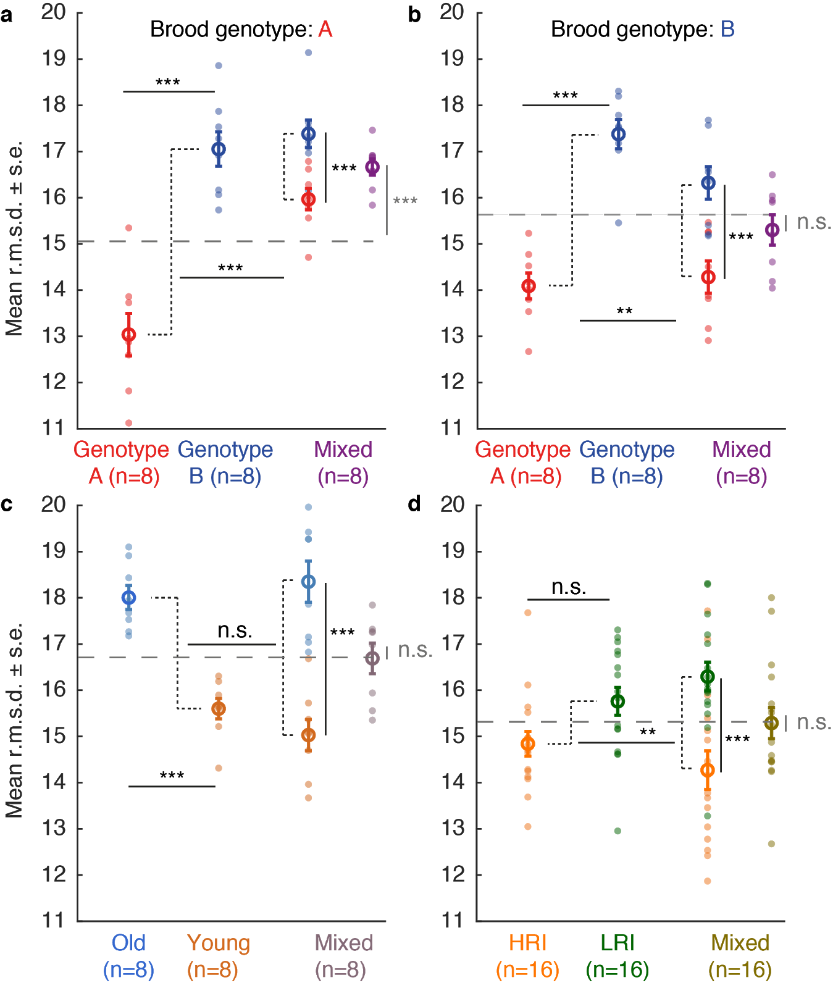

**Figure 1. Mean RMSD (a proxy for extranidal activity) as a function of colony composition.** Small full circles represent colonies. Large open circles represent average values across replicate colonies. For mixed colonies, data are shown both as type-specific mean behavior and colony-level mean behavior (in ‘combined’ color). **a-b,** behavior as a function of colony genetic composition. Colony size 16. **c,** behavior as a function of colony demographic composition. Adult and brood genotype: B. Colony size 16 **d**, behavior as a function of colony morphological composition. Adult and brood genotype: B. Colony size 8. Horizontal grey dashed lines represent the average value of the homogeneous colonies (first two columns) in their respective panels. n.s.: non-significant, **: p < 0.01, ***: p < 0.001.

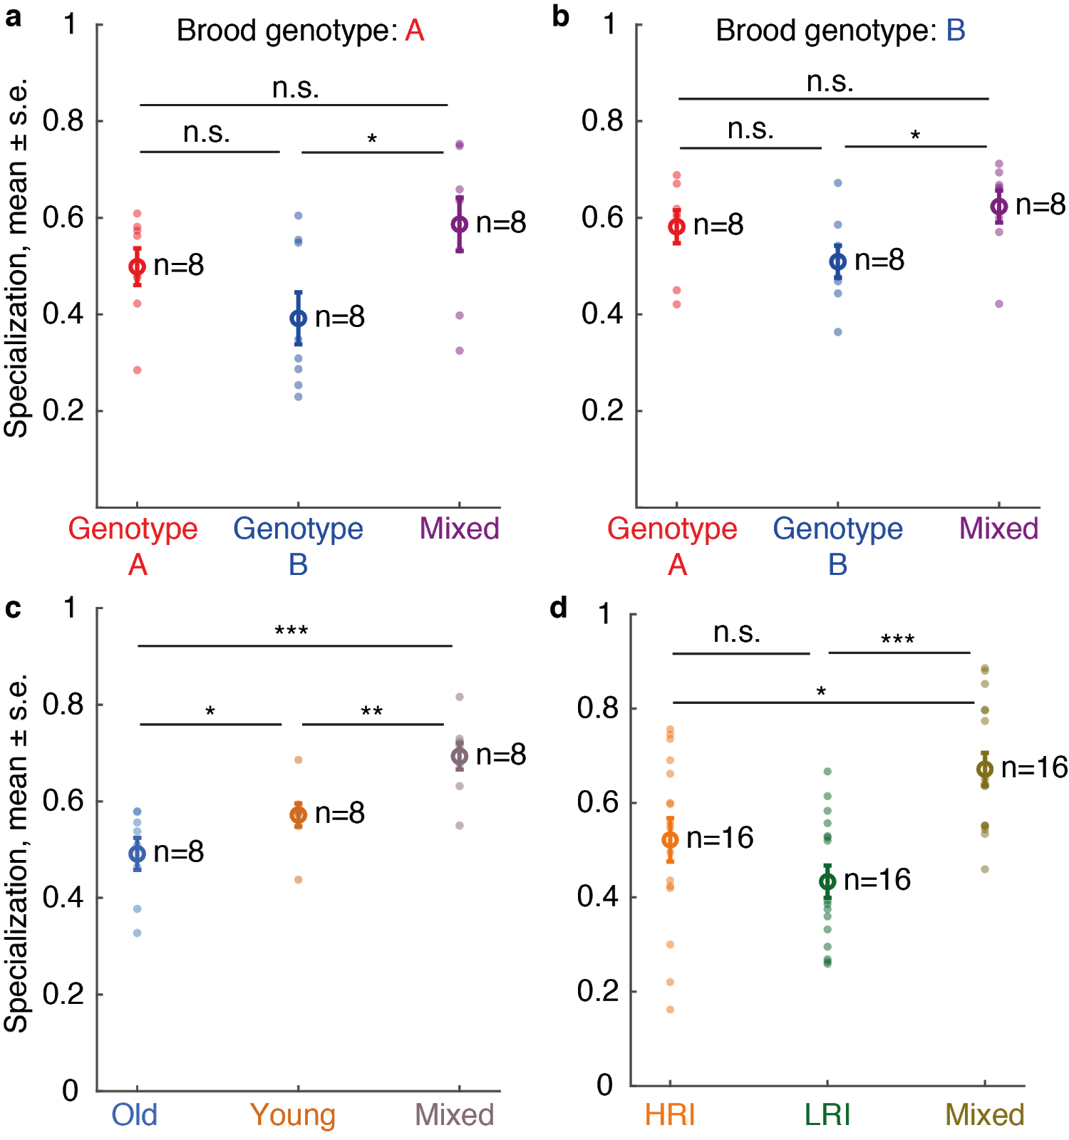

**Figure 2. Specialization (day-to-day rank correlation in r.m.s.d.) as a function of colony composition.** Small full circles represent colonies. Large open circles represent average values across replicate colonies. For mixed colonies, data are shown as the colony-level specialization. **a-b,** specialization as a function of colony genetic composition. Colony size 16. **c,** specialization as a function of colony demographic composition. Adult and brood genotype: B. Colony size 16. **d**, specialization as a function of colony morphological composition. Adult and brood genotype: B. Colony size 8. n.s.: non-significant, *: p < 0.05, **: p < 0.01, ***: p < 0.001.

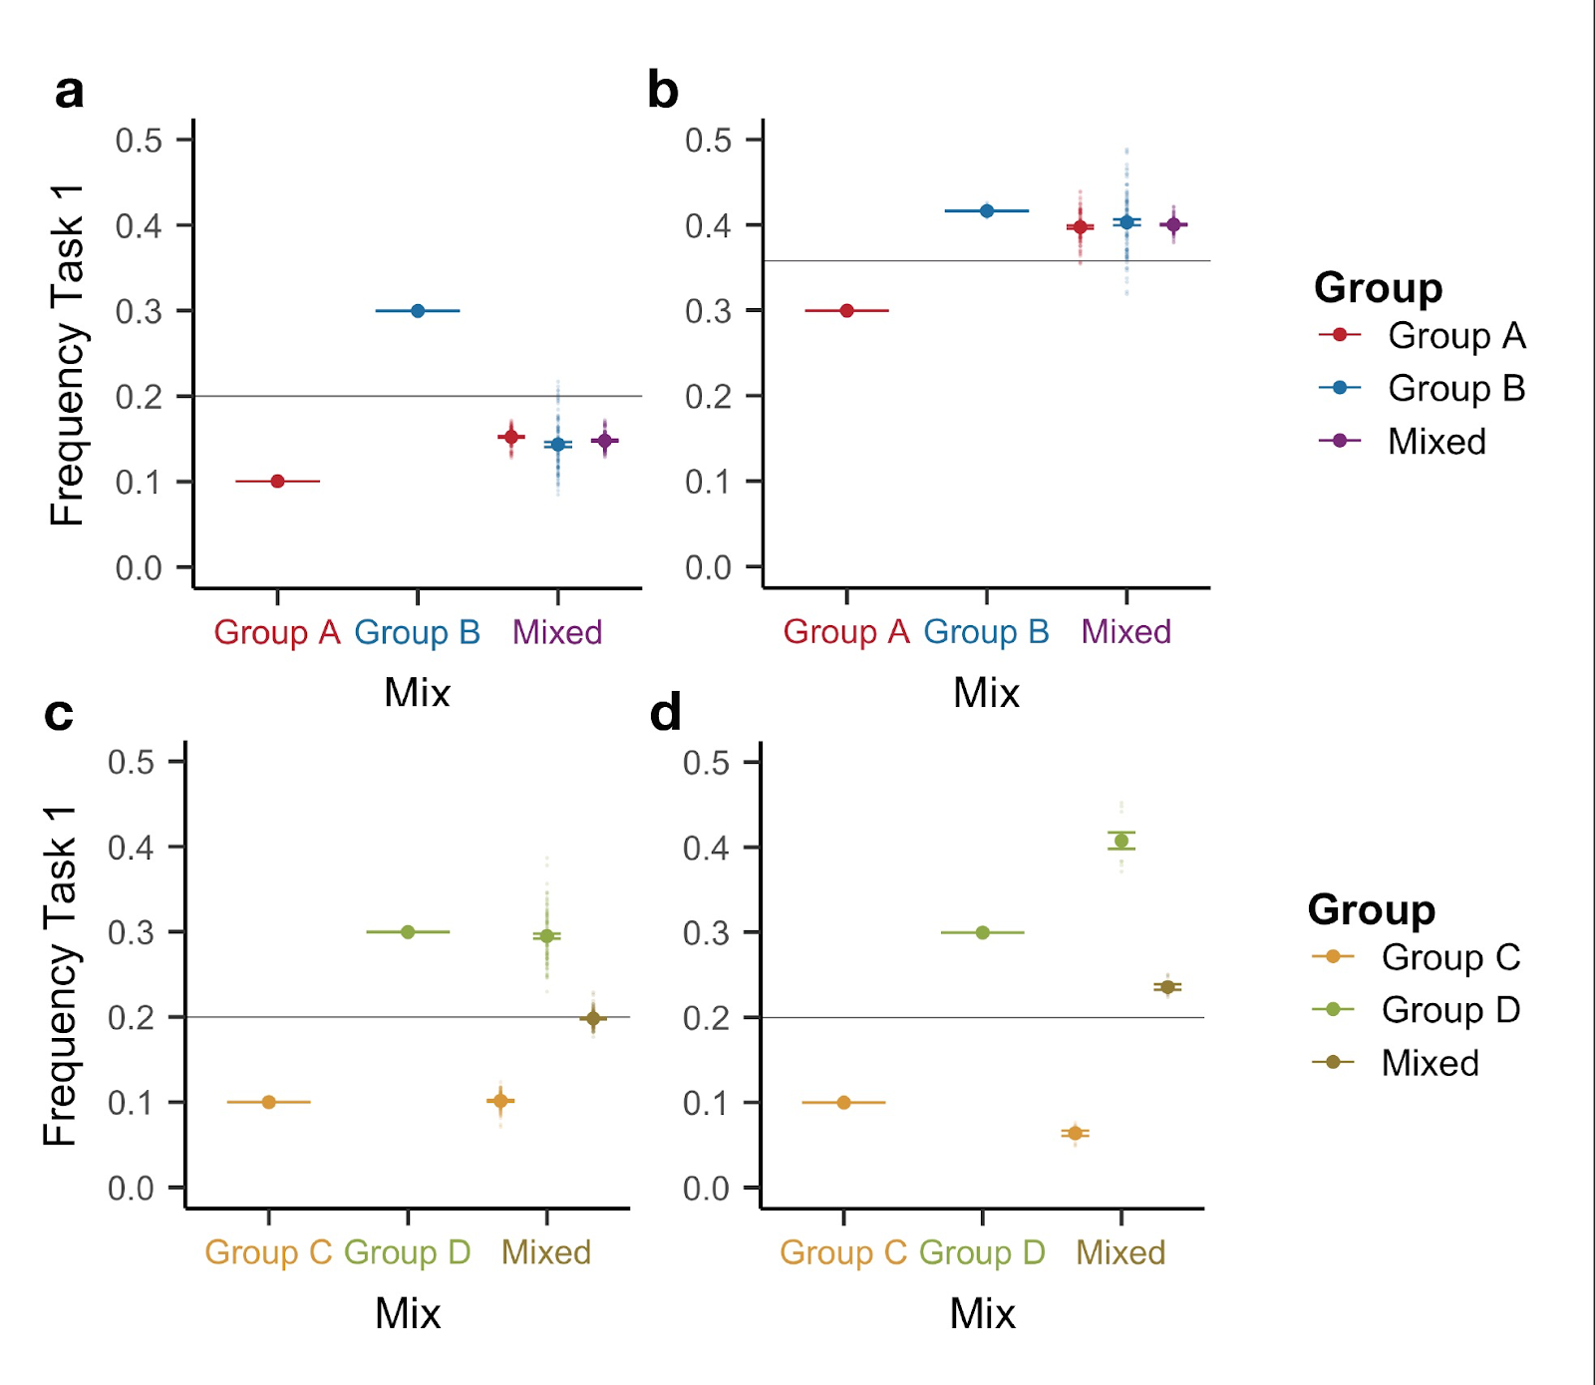

**Figure 3. Theoretical predictions of the FTM.** Task performance frequency as a function of colony composition. One hundred replicates were simulated for each colony composition and for each parameter combination. Each opaque circle represents an individual replicate colony; each solid circle represents average value (mean ± s.e.) across all replicates for its corresponding colony (or sub-colony) composition. Horizontal gray lines represent the average value of the homogeneous colonies (first two columns) in their respective panels. **a, b**: Varying the task efficiency (α) and the demand rate (𝛿) captures *asymmetric behavioral contagion,* downward(**a**) and upward (**b**). Groups A and B represent genotypic classes. Larvae are less demanding in **a** (𝛿 = 0.4) than in **b** (𝛿 = 0.6). For a given 𝛿, Group A is more efficient than Group B (*αA*= 2, *αB*= 1). Group B is efficient when the larvae are less demanding (**a**) but inefficient when more demanding (**b**); Group A is efficient in both cases. Parameters: 𝜎 = 0.1, *μ* = 10, *η* = 7, *τ* = 0.2. **c, d**: Varying the task efficiency (α) and the mean threshold (*μ*) captures both a *lack of behavioral contagion* (**c**) and *behavioral amplification* (**d**). Groups C and D represent demographic or morphological classes. Compared to Group D, Group C is more efficient (*αC*= 6, *αD*= 2) and has a higher threshold for both tasks (*μC*= 14 in (**c**) and *μC*= 20 in (**d**); *μD*= 10). Parameters: 𝜎 = 0.1, *η* = 7, 𝛿 = 0.6, *τ* = 0.2.

**Table S1. List of experimental treatments**. Text in bold denotes the variable of interest for each experiment. All mixed colonies contained 50:50 or each ant type.

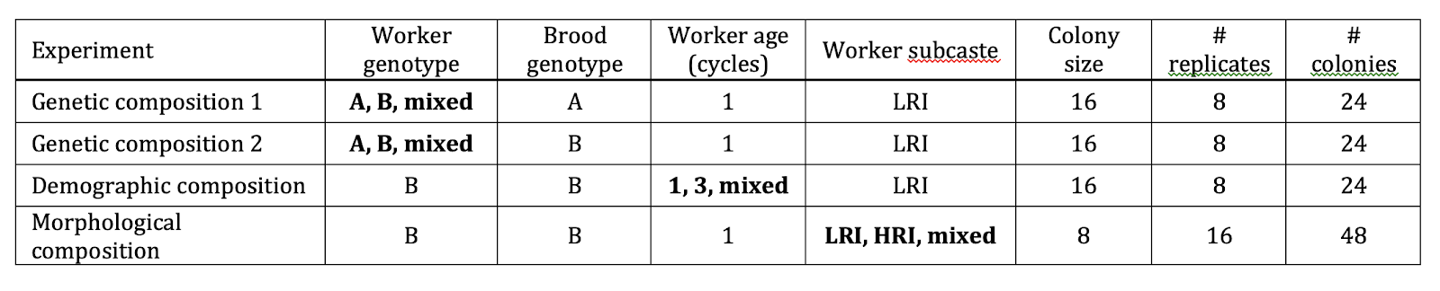

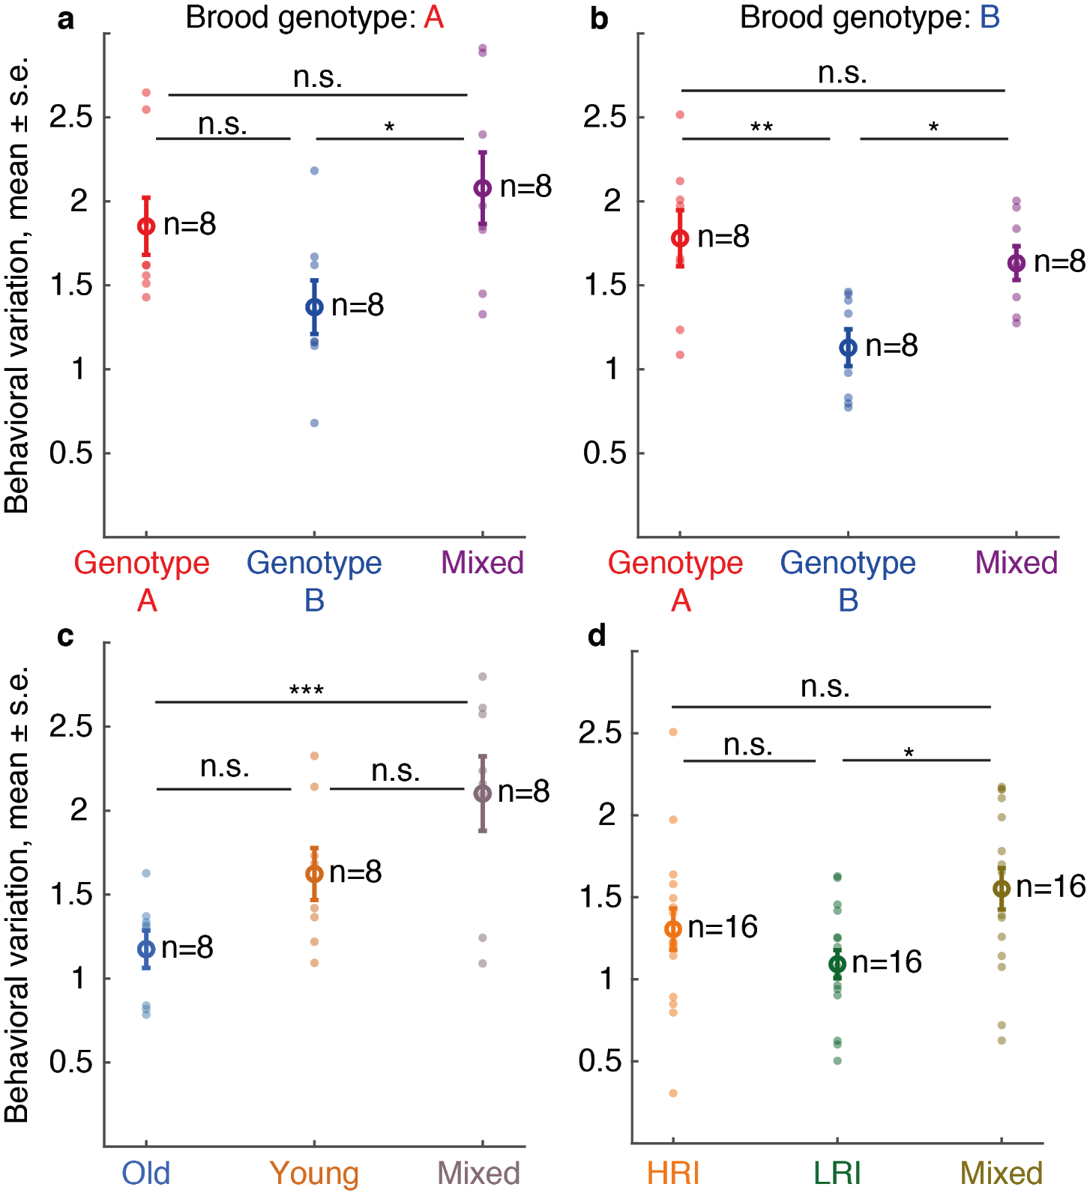

**Figure S1. Behavioral variation (stdev in r.m.s.d. across colony members) as a function of colony composition.** Small full circles represent individual colonies. Large open circles represent average values across replicate colonies. For mixed colonies, data are shown as the colony-level behavioral variation. **a-b,** behavioral variation as a function of colony genetic composition. Colony size 16. **c,** behavioral variation as a function of colony demographic composition. Adult and brood genotype: B. Colony size 16. **d**, behavioral variation as a function of colony morphological composition. Adult and brood genotype: B. Colony size 8. n.s.: non-significant, *: p < 0.05, **: p < 0.01, ***: p < 0.001.

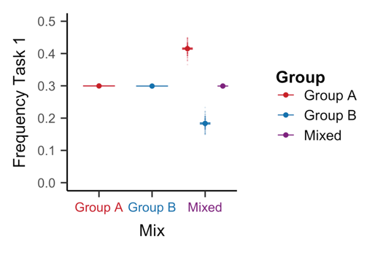

**Figure S2. Theoretical predictions of the FTM with variation in threshold alone.** One hundred replicates were simulated for each colony composition. Each opaque circle represents an individual replicate colony; each solid circle represents average value (mean ± s.e.m.) across all replicates for its corresponding colony (or sub-colony) composition. Group A ants have lower thresholds for both tasks than Group B ants (𝜇A = 10, 𝜇B = 20). All other parameters are identical for both genotypes: *δ* = 0.6, *α* = 2, *σ* = 0.1, *η* = 7, and *τ* = 0.2.

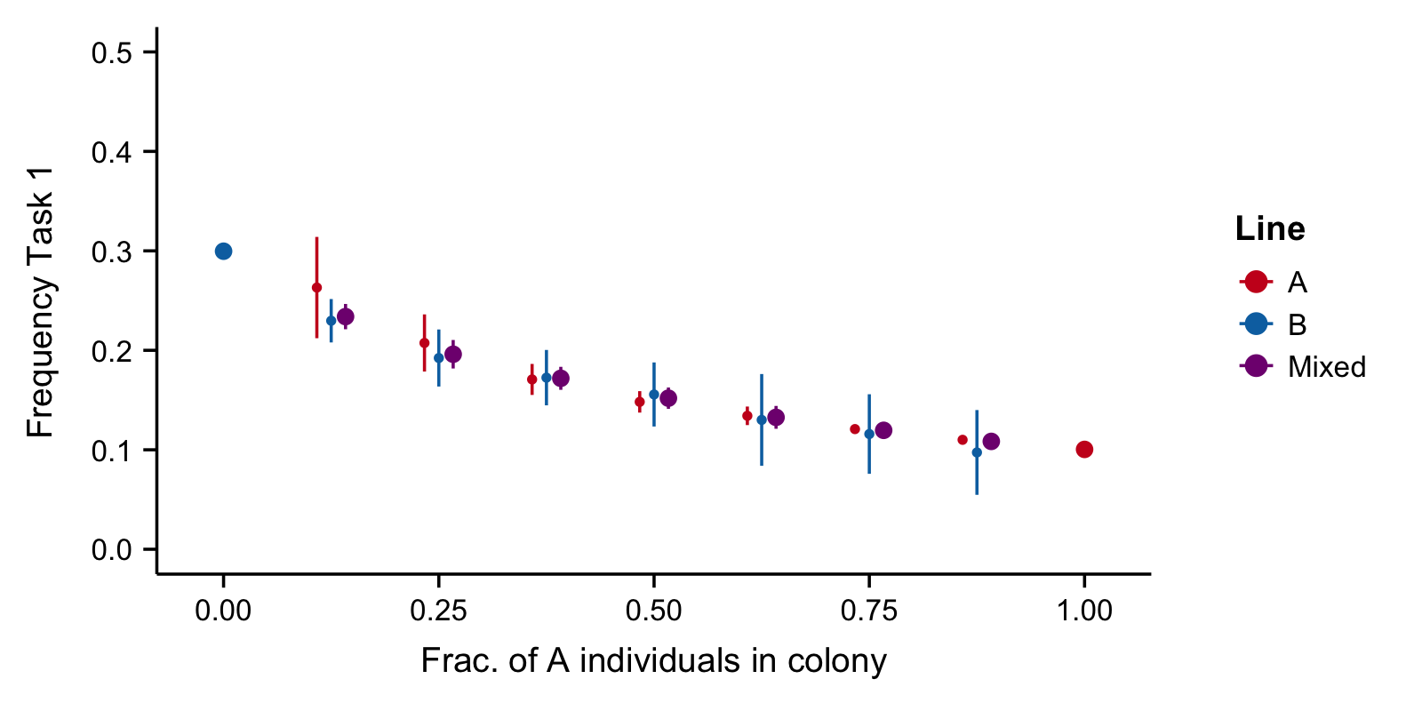

**Figure S3. Additional predictions of the FTM model**. Simulation results with varying ratios of genotype A and B ants. Genotype A ants are more efficient than genotype B ants at both tasks (αAj = 6; αBj = 2). Both simulations and analytical calculations (somewhere in SI) predict a nonlinear relationship between colony-level mean task performance and the mix ratio. Parameters: μ = 10, δ = 0.6.

**References**

1. [Bonabeau E, Theraulaz G, Deneubourg JL, Aron S, Camazine S (1997) Self-organization in social insects. *Trends Ecol Evol* 12(5):188–193.](http://paperpile.com/b/L0XgXK/s0bK)

2. [Sumpter DJT (2006) The principles of collective animal behaviour. *Philosophical Transactions of the Royal Society B: Biological Sciences* 361(1465):5–22.](http://paperpile.com/b/L0XgXK/OLnE)

3. [Duarte A, Weissing FJ, Pen I, Keller L (2011) An Evolutionary Perspective on Self-Organized Division of Labor in Social Insects. *Annual Review of Ecology, Evolution, and Systematics* 42(1):91–110.](http://paperpile.com/b/L0XgXK/sYaV)

4. [Jeanson R, Weidenmüller A (2014) Interindividual variability in social insects - proximate causes and ultimate consequences. *Biol Rev Camb Philos Soc* 89(3):671–687.](http://paperpile.com/b/L0XgXK/YRsS)

5. [Naug D, Gadagkar R (1998) The role of age in temporal polyethism in a primitively eusocial wasp. *Behavioral Ecology and Sociobiology* 42(1):37–47.](http://paperpile.com/b/L0XgXK/zYpk)

6. [Seeley TD (1982) Adaptive significance of the age polyethism schedule in honeybee colonies. *Behavioral Ecology and Sociobiology* 11(4):287–293.](http://paperpile.com/b/L0XgXK/UXib)

7. [Tripet F, Nonacs P (2004) Foraging for Work and Age-Based Polyethism: The Roles of Age and Previous Experience on Task Choice in Ants. *Ethology* 110(11):863–877.](http://paperpile.com/b/L0XgXK/K8AN)

8. [Hinze B, Leuthold RH (1999) Age related polyethism and activity rhythms in the nest of the termite Macrotermes bellicosus (Isoptera, Termitidae). *Insectes Sociaux* 46(4):392–397.](http://paperpile.com/b/L0XgXK/RPe0)

9. [Eyer P-A, Freyer J, Aron S (2013) Genetic polyethism in the polyandrous desert ant Cataglyphis cursor. *Behavioral Ecology* 24(1):144–151.](http://paperpile.com/b/L0XgXK/QEPM)

10. [Oldroyd BP, Thompson GJ (2006) Behavioural Genetics of the Honey Bee Apis mellifera. *Advances in Insect Physiology*:1–49.](http://paperpile.com/b/L0XgXK/wXjw)

11. [Blatrix R, Durand J-L, Jaisson P (2000) Task Allocation Depends on Matriline in the Ponerine Ant Gnamptogenys striatula Mayr. *Journal of Insect Behavior* 13(4):553–562.](http://paperpile.com/b/L0XgXK/69kK)

12. [Wetterer JK (1999) The ecology and evolution of worker size-distribution in leaf-cutting ants (Hymenoptera : Formicidae). *Sociobiology* 34(1):119–144.](http://paperpile.com/b/L0XgXK/22Q6)

13. [Huang ZY, Robinson GE (1996) Regulation of honey bee division of labor by colony age demography. *Behav Ecol Sociobiol* 39(3):147–158.](http://paperpile.com/b/L0XgXK/ObrW)

14. [Wilson EO (1980) Caste and Division of Labor in Leaf-Cutter Ants (Hymenoptera, Formicidae, Atta) .2. The Ergonomic Optimization of Leaf Cutting. *Behav Ecol Sociobiol* 7(2):157–165.](http://paperpile.com/b/L0XgXK/Kk4m)

15. [Kay A, Rissing SW (2005) Division of foraging labor in ants can mediate demands for food and safety. *Behav Ecol Sociobiol* 58(2):165–174.](http://paperpile.com/b/L0XgXK/thMZ)

16. [Mertl AL, Traniello JFA (2009) Behavioral evolution in the major worker subcaste of twig-nesting Pheidole (Hymenoptera: Formicidae): does morphological specialization influence task plasticity? *Behav Ecol Sociobiol* 63(10):1411–1426.](http://paperpile.com/b/L0XgXK/NYwR)

17. [Weidenmuller A (2004) The control of nest climate in bumblebee (Bombus terrestris) colonies: interindividual variability and self reinforcement in fanning response. *Behav Ecol* 15(1):120–128.](http://paperpile.com/b/L0XgXK/WKvf)

18. [Teseo S, Chaline N, Jaisson P, Kronauer DJC (2014) Epistasis between adults and larvae underlies caste fate and fitness in a clonal ant. *Nat Commun* 5. Available at:](http://paperpile.com/b/L0XgXK/5tuQ) <https://www.ncbi.nlm.nih.gov/pmc/articles/3363>[.](http://paperpile.com/b/L0XgXK/5tuQ)

19. [Ravary F, Jaisson P (2004) Absence of individual sterility in thelytokous colonies of the ant Cerapachys biroi Forel (Formicidae, Cerapachyinae). *Insectes Soc* 51(1):67–73.](http://paperpile.com/b/L0XgXK/0dL5)

20. [Ulrich Y, Saragosti J, Tokita CK, Tarnita CE, Kronauer DJC (2018) Fitness benefits and emergent division of labour at the onset of group living. *Nature* 560(7720):635–638.](http://paperpile.com/b/L0XgXK/WTWr)

21. [Jeanne RL (2016) Division of labor is not a process or a misleading concept. *Behav Ecol Sociobiol* 70(7):1109–1112.](http://paperpile.com/b/L0XgXK/b0pT)

22. [Bonabeau E, Theraulaz G, Deneubourg J-L (1996) Quantitative study of the fixed threshold model for the regulation of division of labour in insect societies. *Proceedings of the Royal Society of London Series B: Biological Sciences* 263(1376):1565–1569.](http://paperpile.com/b/L0XgXK/WUvk)

23. [Wright CM, Holbrook CT, Pruitt JN (2014) Animal personality aligns task specialization and task proficiency in a spider society. *Proc Natl Acad Sci U S A* 111(26):9533–9537.](http://paperpile.com/b/L0XgXK/ykBb)

24. [Ulrich Y, Burns D, Libbrecht R, Kronauer DJC (2016) Ant larvae regulate worker foraging behavior and ovarian activity in a dose-dependent manner. *Behav Ecol Sociobiol* 70(7):1011–1018.](http://paperpile.com/b/L0XgXK/pfny)

25. [Biedermann PHW, Taborsky M (2011) Larval helpers and age polyethism in ambrosia beetles. *Proc Natl Acad Sci U S A*. doi:](http://paperpile.com/b/L0XgXK/vhaU)[papers2://publication/doi/10.1073/pnas.1107758108](http://dx.doi.org/papers2://publication/doi/10.1073/pnas.1107758108)[.](http://paperpile.com/b/L0XgXK/vhaU)

26. [Ito F, Higashi S (1991) A Linear Dominance Hierarchy Regulating Reproduction and Polyethism of the Queenless Ant Pachycondyla-Sublaevis. *Naturwissenschaften* 78(2):80–82.](http://paperpile.com/b/L0XgXK/4JCe)

27. [Bernadou A, et al. (2018) Stress and early experience underlie dominance status and division of labour in a clonal insect. *Proc Biol Sci* 285(1885). doi:](http://paperpile.com/b/L0XgXK/T3pD)[10.1098/rspb.2018.1468](http://dx.doi.org/10.1098/rspb.2018.1468)[.](http://paperpile.com/b/L0XgXK/T3pD)

28. [van de Waal E, Borgeaud C, Whiten A (2013) Potent social learning and conformity shape a wild primate’s foraging decisions. *Science* 340(6131):483–485.](http://paperpile.com/b/L0XgXK/x0sH)

29. [Berdahl A, Torney CJ, Ioannou CC, Faria JJ, Couzin ID (2013) Emergent sensing of complex environments by mobile animal groups. *Science* 339(6119):574–576.](http://paperpile.com/b/L0XgXK/U1JV)

30. [Razin N, Eckmann JP, Feinerman O (2013) Desert ants achieve reliable recruitment across noisy interactions. *J R Soc Interface* 10(82). doi:](http://paperpile.com/b/L0XgXK/crqz)[ARTN 20130079](http://dx.doi.org/ARTN%2020130079)[.](http://paperpile.com/b/L0XgXK/crqz)

31. [Seeley TD, Buhrman SC (1999) Group decision making in swarms of honey bees. *Behavioral Ecology and Sociobiology* 45(1):19–31.](http://paperpile.com/b/L0XgXK/B1E6)

32. [Calderone NW, Page RE (1992) Effects of interactions among genotypically diverse nestmates on task specialization by foraging honey bees (Apis mellifera). *Behav Ecol Sociobiol* 30(3):219–226.](http://paperpile.com/b/L0XgXK/6v4q)

33. [Kwapich CL, Tschinkel WR (2016) Limited flexibility and unusual longevity shape forager allocation in the Florida harvester ant (Pogonomyrmex badius). *Behav Ecol Sociobiol* 70(7):1045–1045.](http://paperpile.com/b/L0XgXK/tUWg)

34. [Traniello JFA, Rosengaus RB (1997) Ecology, evolution and division of labour in social insects. *Anim Behav* 53(1):209–213.](http://paperpile.com/b/L0XgXK/ThhV)