Sorting

# Types:

1. Bubble Sort
2. Selection Sort
3. Insertion Sort
4. Shell Sort
5. Merge Sort
6. Quick Sort

Visualizing Sorting algos:

<https://www.toptal.com/developers/sorting-algorithms>

<https://visualgo.net/en>

# Bubble Sort

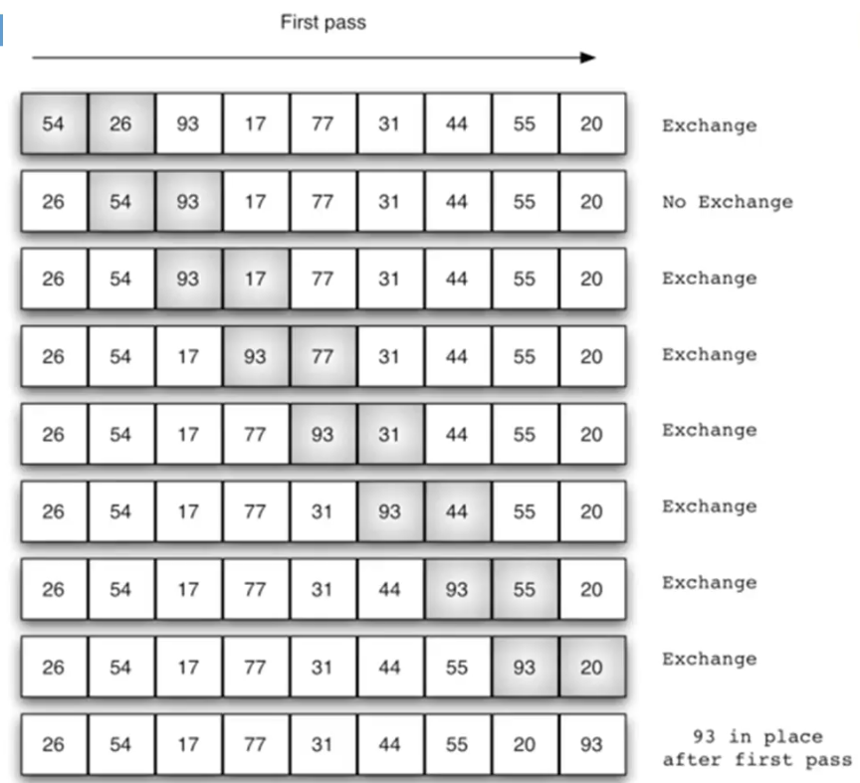

* Each element is compared with its neighbor
* Swap is performed if the neighbor to the right is smaller
* This will continue until the element reaches a spot which is lesser than its right-hand side neighbor
* Hence the name **Bubble Sort since the element Bubbles up its place**

[7,10,2,5,11]

This is n 4

Index check for k 0

Index check for k 1

Index check for k 2

Index check for k 3

This is n 3

Index check for k 0

Index check for k 1

Index check for k 2

This is n 2

Index check for k 0

Index check for k 1

This is n 1

Index check for k 0

[2, 5, 7, 10, 11]

K is where the bubbling is occurring.

The bubbling keeps reducing as we move through n.

# Selection Sort:

* Improves on Bubble sort by making only one exchange for every pass through the list
* A Selection Sort looks for the largest value as it makes a pass and after completing the pass, places it in the proper location.
* After the first pass, the largest item is in its correct place.
* After the second pass, the next largest is in place.
* The process continues and requires n-1 passes to sort n items (since the final item must be in place after n-1 st pass)

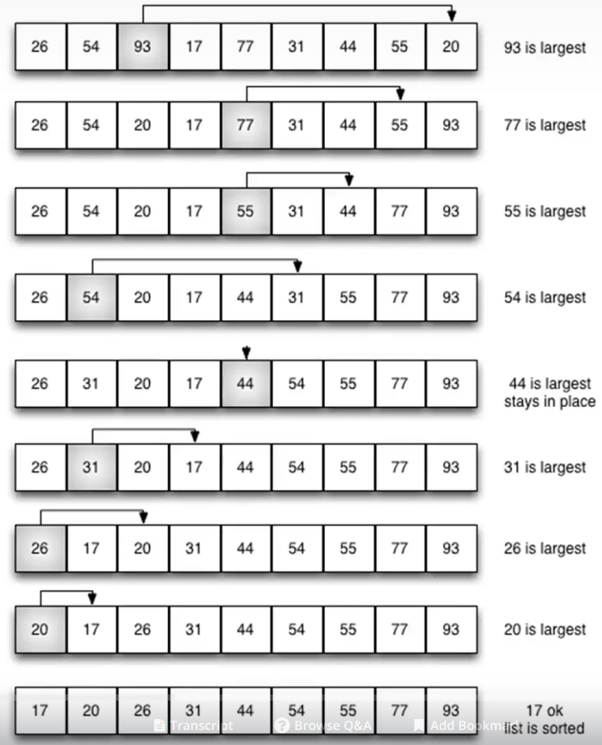

* 1st pass: 93 is largest and moved to the end of the list
* 2nd pass: 77 is largest and moved to second last place.

[7, 10, 2, 5, 11]

[2, 10, 7, 5, 11]

[2, 5, 7, 10, 11]

[2, 5, 7, 10, 11]

[2, 5, 7, 10, 11]