

<!--header-->

<!--we will not put a container div on the header section as we want it to expand all throughout the browser size.-->

<header id="myheader">

<!--Bootstrap Jumbotron (formerly hero unit) is a large banner like section with large text, light gray background wrap with box that has a border radius in it.-->

<!--jumbotron-fluid class to make it fluidly responsive.-->

<div class="jumbotron jumbotron-fluid" id="banner">

<div class="parallax text-center" style="background-image: url(img/cover.jpg);">

<div class="parallax-pattern-overlay">

<div class="container text-center" id="size-banner">

<h2 class="display-2">Hello! I am Chris</h2>

<h3 class="learn">Wanna know how to use it?</h3>

<a href="#" ><img class="learn" id="site-title" src="" alt="Read More"/></a>

</div>

<div id="down-arrow-div" class="learn">

<a id="scroll-arrow" href="#aboutus">

<img class="learn" id="down-arrow" src="img/downarrow.png" alt="Read More"/>

</a>

</div>

</div>

</div>

</div>

</header>

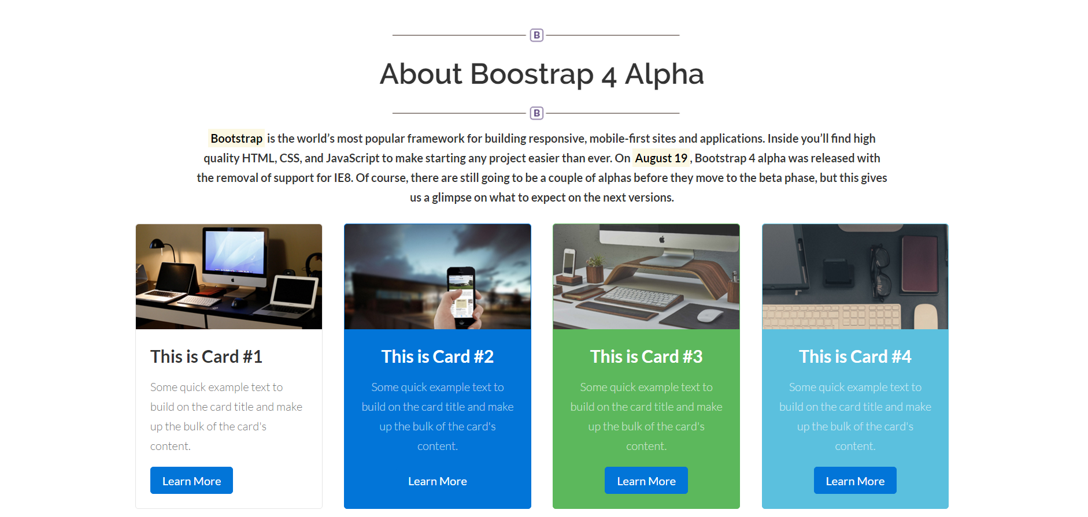

<!--about us-->

<section class="aboutus" id="aboutus">

<!-- bootstrap’s container class to wrap elements and contain its grid system. We will be using a fixed container. This means that as the viewport changes, its width remains intact, until it meets a certain breakpoints.-->

<div class="container">

<!--rows and columns inside container divs. The basic purpose of rows is to wrap up column while column contains the content.-->

<div class="row">

<div class="col-lg-12">

<div class="heading text-center">

<img class="dividerline" src="img/sep.png" alt="">

<h2>About Boostrap 4 Alpha</h2>

<img class="dividerline" src="img/sep.png" alt="">

<h3><mark>Bootstrap</mark> is the world’s most popular framework for building responsive, mobile-first sites and applications. Inside you’ll find high quality HTML, CSS, and JavaScript to make starting any project easier than ever. On <mark>August 19</mark>, Bootstrap 4 alpha was released with the removal of support for IE8. Of course, there are still going to be a couple of alphas before they move to the beta phase, but this gives us a glimpse on what to expect on the next versions.</h3>

</div>

</div>

</div>

<div class="row">

<div class="col-md-3">

<div class="card">

<img class="card-img-top" src="img/card1.jpg" alt="Card image cap">

<div class="card-block">

<h4 class="card-title">This is Card #1</h4>

<p class="card-text">Some quick example text to build on the card title and make up the bulk of the card's content.</p>

<a href="http://v4-alpha.getbootstrap.com/components/card/" class="btn btn-primary">Learn More</a>

</div>

</div>

</div>

<div class="col-md-3">

<div class="card card-inverse card-primary text-center">

<img class="card-img-top" src="img/card2.jpg" alt="Card image cap">

<div class="card-block">

<h4 class="card-title">This is Card #2</h4>

<p class="card-text">Some quick example text to build on the card title and make up the bulk of the card's content.</p>

<a href="http://v4-alpha.getbootstrap.com/components/card/" class="btn btn-primary">Learn More</a>

</div>

</div>

</div>

<div class="col-md-3">

<div class="card card-inverse card-success text-center">

<img class="card-img-top" src="img/card3.jpg" alt="Card image cap">

<div class="card-block">

<h4 class="card-title">This is Card #3</h4>

<p class="card-text">Some quick example text to build on the card title and make up the bulk of the card's content.</p>

<a href="http://v4-alpha.getbootstrap.com/components/card/" class="btn btn-primary">Learn More</a>

</div>

</div>

</div>

<div class="col-md-3">

<div class="card card-inverse card-info text-center">

<img class="card-img-top" src="img/card4.jpg" alt="Card image cap">

<div class="card-block">

<h4 class="card-title">This is Card #4</h4>

<p class="card-text">Some quick example text to build on the card title and make up the bulk of the card's content.</p>

<a href="http://v4-alpha.getbootstrap.com/components/card/" class="btn btn-primary">Learn More</a>

</div>

</div>

</div>

</div>

</div>

</section>

<div class="col-md-3">

<div class="card card-inverse card-primary text-center">

<img class="card-img-top" src="img/card2.jpg" alt="Card image cap">

<div class="card-block">

<h4 class="card-title">This is Card #2</h4>

<p class="card-text">Some quick example text to build on the card title and make up the bulk of the card's content.</p>

<a href="http://v4-alpha.getbootstrap.com/components/card/" class="btn btn-primary">Learn More</a>

</div>

</div>

</div>

<div class="col-md-3">

<div class="card card-inverse card-success text-center">

<img class="card-img-top" src="img/card3.jpg" alt="Card image cap">

<div class="card-block">

<h4 class="card-title">This is Card #3</h4>

<p class="card-text">Some quick example text to build on the card title and make up the bulk of the card's content.</p>

<a href="http://v4-alpha.getbootstrap.com/components/card/" class="btn btn-primary">Learn More</a>

</div>

</div>

</div>

<div class="col-md-3">

<div class="card card-inverse card-info text-center">

<img class="card-img-top" src="img/card4.jpg" alt="Card image cap">

<div class="card-block">

<h4 class="card-title">This is Card #4</h4>

<p class="card-text">Some quick example text to build on the card title and make up the bulk of the card's content.</p>

<a href="http://v4-alpha.getbootstrap.com/components/card/" class="btn btn-primary">Learn More</a>

</div>

</div>

</div>

</div>

</div>

</section>

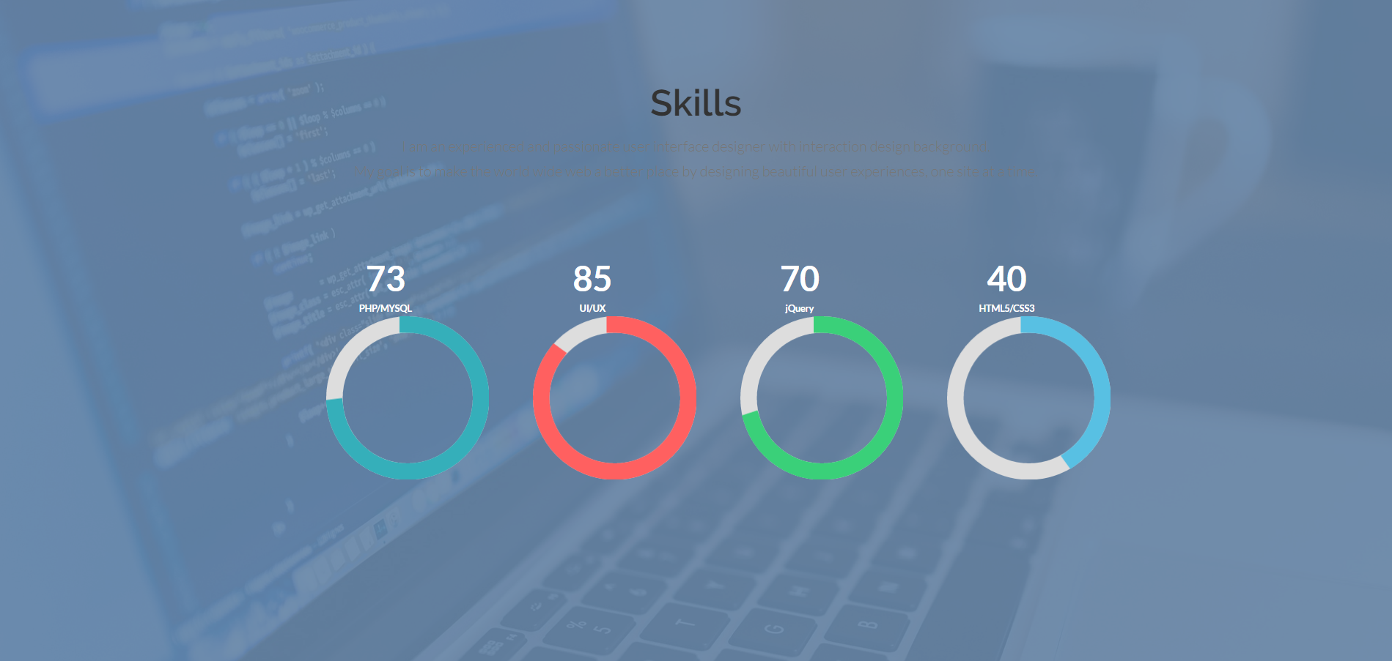

<div class="skills" id="skills">

<section class="container">

<div class="wrap">

<div class="row-content1">

<div class="heading text-center">

<!--<img class="dividerline" src="img/sep.png">-->

<h2>Skills</h2>

<!--<img class="dividerline" src="img/sep.png">-->

<p class="para wow fadeInUp" data-wow-duration="1200ms" data-wow-delay="300ms">I am an experienced and passionate user interface designer with interaction design background.<br>My goal is to make the world wide web a better place by designing beautiful user experiences, one site at a time.</p>

</div>

<div class="col-md-12 text-center">

<div class="chart" data-percent="73" data-bar-color="#35AFBA" data-animate="4000">

<div class="chart-content">

<div class="percent"></div>

<div class="chart-title">PHP/MYSQL</div>

</div><!-- chart-content -->

</div><!-- chart -->

<div class="chart" data-percent="85" data-bar-color="#FF6060" data-animate="2500">

<div class="chart-content">

<div class="percent"></div>

<div class="chart-title">UI/UX</div>

</div><!-- chart-content -->

</div><!-- chart -->

<div class="chart" data-percent="70" data-bar-color="#3AD079" data-animate="3000">

<div class="chart-content">

<div class="percent"></div>

<div class="chart-title">jQuery</div>

</div><!-- chart-content -->

</div><!-- chart -->

<div class="chart" data-percent="40" data-bar-color="#58C0E3" data-animate="3500">

<div class="chart-content">

<div class="percent"></div>

<div class="chart-title">HTML5/CSS3</div>

</div><!-- chart-content -->

</div><!-- chart -->

</div><!-- col-md-12 -->

<div class="clearfix"></div>

</div>

</div>

</section><!--text-light-->

</div><!-- skills-->

<div class="col-md-3">

<div class="card card-inverse card-primary text-center">

<img class="card-img-top" src="img/card2.jpg" alt="Card image cap">

<div class="card-block">

<h4 class="card-title">This is Card #2</h4>

<p class="card-text">Some quick example text to build on the card title and make up the bulk of the card's content.</p>

<a href="http://v4-alpha.getbootstrap.com/components/card/" class="btn btn-primary">Learn More</a>

</div>

</div>

</div>

<div class="col-md-3">

<div class="card card-inverse card-success text-center">

<img class="card-img-top" src="img/card3.jpg" alt="Card image cap">

<div class="card-block">

<h4 class="card-title">This is Card #3</h4>

<p class="card-text">Some quick example text to build on the card title and make up the bulk of the card's content.</p>

<a href="http://v4-alpha.getbootstrap.com/components/card/" class="btn btn-primary">Learn More</a>

</div>

</div>

</div>

<div class="col-md-3">

<div class="card card-inverse card-info text-center">

<img class="card-img-top" src="img/card4.jpg" alt="Card image cap">

<div class="card-block">

<h4 class="card-title">This is Card #4</h4>

<p class="card-text">Some quick example text to build on the card title and make up the bulk of the card's content.</p>

<a href="http://v4-alpha.getbootstrap.com/components/card/" class="btn btn-primary">Learn More</a>

</div>

</div>

</div>

</div>

</div>

</section>

<div class="chart" data-percent="40" data-bar-color="#58C0E3" data-animate="3500">

<div class="chart-content">

<div class="percent"></div>

<div class="chart-title">HTML5/CSS3</div>

</div><!-- chart-content -->

</div><!-- chart -->

</div><!-- col-md-12 -->

<div class="clearfix"></div>

</div>

</div>

</section><!--text-light-->

</div><!-- skills-->

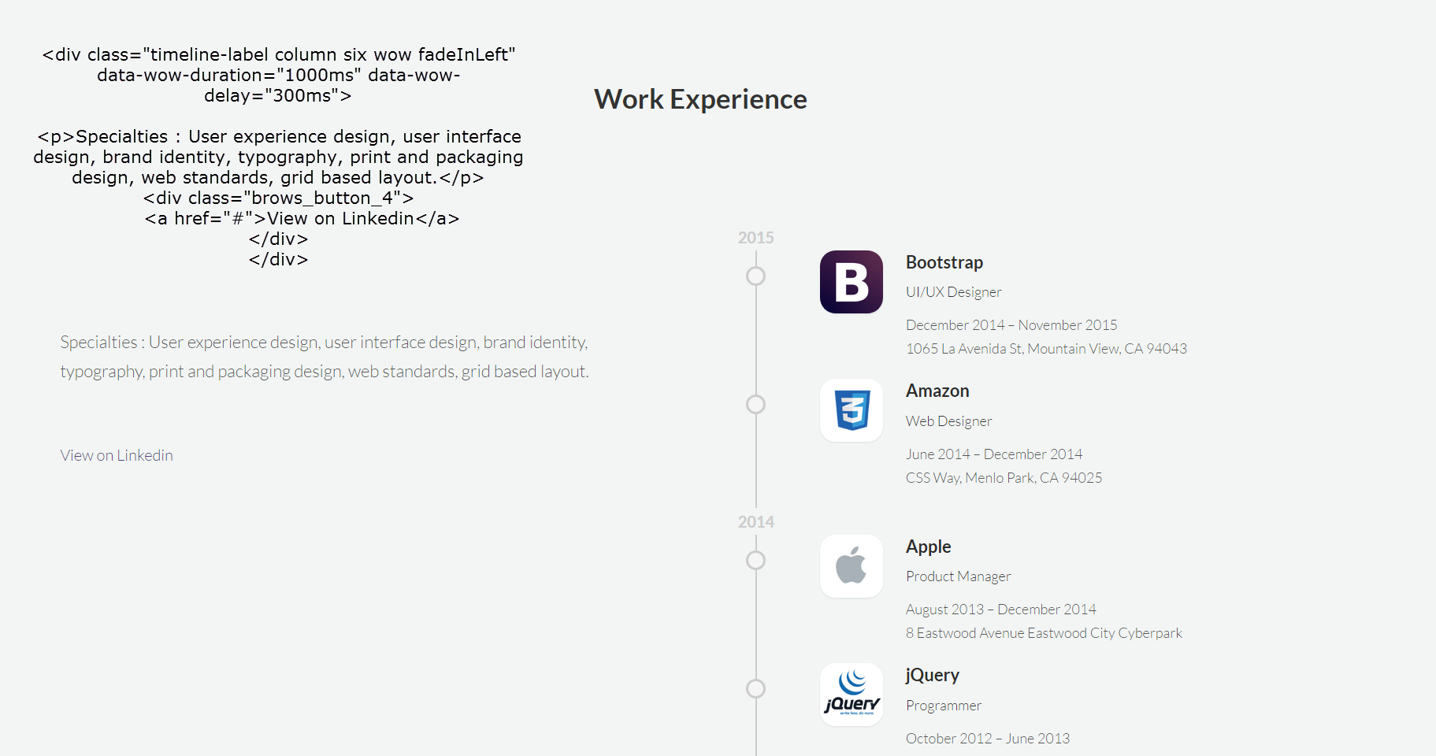

<div class="experience">

<span class="circle"></span>

<div class=" wow fadeInRight" data-wow-duration="1000ms" data-wow-delay="300ms">

<div class="experience-img"><img src="img/asset01.jpg" alt=""></div>

<div class="experience-info clear-after">

<h5>Bootstrap</h5>

<div class="role">UI/UX Designer</div>

<p>December 2014 – November 2015<br />1065 La Avenida St, Mountain View, CA 94043</p>

</div><!-- experience-info -->

</div><!--wow -->

</div><!-- experience -->