The Decision

Table of Contents
1 Introduction 2
2 A Vision of SrrTrains 3
3 What Has Happened Until Now (Steps 0001 to 0032, 0033.01 to 0033.10) 5
4 Planning of Release "Fiat A" 6
4.1 Introduction 6
4.2 Some History for Completeness 7
4.3 Prophecy (i.e. Planning): 7
5 The Envisioned OMs for SrrTrains v0.01 8
5.1 Single User VR OM – VR with Classical X3D Player 8
5.2 Single User Desktop OM – Desktop VR with Classical X3D Player 8
5.3 Single User Desktop NG OM – WebGL Based X3D Player 8
5.4 Single User VR NG OM – VR with WebGL Based X3D Player 9
5.5 Multiuser Desktop+VR OM with any X3D Player 9
5.6 Mixed Reality OM 10
6 Sub-Projects for the Fiat A Release 11
6.1 SMUOS Project (Home Page To be Defined) 11
6.2 SIMULRR Project ( http://simulrr.sourceforge.net ) 12
6.3 SrrTrains v0.01 ( https://lc-soc-lc.at/host ) 12
7 Relation to the "Template" Projects 12

Introduction
Release "Fiat A" could become the first professional release of SrrTrains, still based on SrrTrains v0.01 (not yet based on SrrTrains 1.0).
Figure 1: Vision of S&P-ARK, SrrTrains 1.0 and Fiat A
Release Fiat A could enhance the usability of SrrTrains v0.01 and of SMUOS, by supporting professional GUIs / VR UIs and by support of WebGL Based X3D.
A necessary pre-condition for the achievement of release Fiat A is the fact that the SMUOS A Framework, which the SrrTrains v0.01 project is based on currently, should be replaced, or even better should be amended by the SMUOS B Framework.

A Vision of SrrTrains
Some of my readers might already know the history of the SrrTrains project, therefore I am focussing on the most important buzz words that have to be known, if you like to understand SrrTrains:
- Some "inspiration" was happening during the years 1993 – 2001 and hence
- I came to the conclusion that 3D graphics would become an important topic at the telecom industry (my employer), so I phrased the idea DIGITS in year 2002
- Nothing happened
- In year 2007 I started to gain know how about 3D graphics, this was the time, when I invented the SIMUL-RR project, which should combine a multi player virtual railroad with a real life model railroad (or even with real railways)
- In 2009 I decided to use the X3D standard with it's NSN and I renamed the project from SIMUL-RR to SrrTrains v0.01
The Mixed Reality Session should consist of
- Virtual Players, using some VR equipment or at least flat 3D displays with mouse input
- Real Players, using classic control equipment to control the model railroad
- an MR enhanced model railroad (sensors!, actors!, IoT!)
- an Interface To Reality, which would connect the VR multiuser session with the model railroad
- Some Connectivity Platform to connect the scene instances and the ITR within the Multiuser Session
All this is depicted in Figure 2:

Figure 2: Virtual Players (VP), Real Players (RP) and an Interface to Reality (ITR) are connected via a Connectivity Platform (CP)

What Has Happened Until Now (Steps 0001 to 0032, 0033.01 to 0033.10)

Figure 3: How to get from instable software "Demo 2012" to "Stable Release 0033"

Planning of Release "Fiat A"

Introduction
This hobby report describes the topics that will be introduced with release "Fiat A" of the SrrTrains v0.01 project.
Release "Fiat A" will not implement any functional improvements that are related to the 3D Scene. That means: no (new) locomotives, no new tracks and turnouts, no new MIDAS Objects, and so on.
The only changes will be architectural changes, which can be summarized as follows:
The SMUOS Framework will do a metamorphosis from SMUOS A to SMUOS B, considering following topics in particular
- WebGL based X3D
- VR/AR/MR (e.g. WebXR)
Note: Some experimental Scene Wrapper GUI was already available with the former "official pre-alpha releases", based on the BS Contact Com plugin and on Visual Basic. Please refer to https://www.mediafire.com/folder/edhwj4cacq0m5/SrrTrains-v0.01 to download the software).
Since then, the SrrTrains v0.01 project has existed in hibernation mode and had only "inofficial releases" without Scene Wrapper GUI (0033.09bf4, 0033.10bf3 and 0033.10.5).
These architectural changes will be kind of orthogonal to the other functional improvements that are envisioned for the releases "step 0033.11" and "step 0033.12".
Some still missing functionality – and some missing optional architectural features – will be added in parallel or afterwards (anyway beyond 2035).
The Train Manager Extension will then be finished by the last release of the 0033 series.
This will then finally lead to the "Stable Release 0033", which will become the "Alpha Release of SrrTrains v0.01".

Some History for Completeness
- The "1st Hibernation Phase of SrrTrains" was entered some time after the last official release of ArrT (in the year 2014) and it lasted until Friday, December 15th, 2017, when I decided to continue the project.
- Then the project was briefly ACTIVE until Friday, March 16th, 2018.
- Then the project was CLOSED.
- Since 2020-01-01 the project has been HIBERNATING again – making slow progress every now and then – until the start of the S&P-ARK project caused me to put the SrrTrains project ON HOLD, finally.
- On Saturday, 2025-06-14, I decided to START THE PROJECT AGAIN, as a beacon project.

Prophecy (i.e. Planning):
- Release Fiat A 0033.10.99 release date depends
- Release Arimathea 0033.11 release "not before 2035", if at all
- Release Sabbath 0033.12 release "even later", if at all

The next figure shows, what happens, after we have started the release "Fiat A" (0033.10.99):

Figure 4: Details of Release "Fiat A" – SMUOS B will be started / Wrapper GUI available
That means, "Fiat A" will be the "sixth official pre-alpha":
- Scene Wrappers/GUIs will be implemented (VR / AR / MR, e.g. WebXR)
- WebGL Based X3D will be supported
- the work on SMUOS B will be started

The Envisioned OMs for SrrTrains v0.01
The first step of the "Fiat A" project will be to define a Testing Scene (working title "VR/AR Commando Room"), where all features of the SMUOS Framework can be tested within all of the following Operational Modes (OMs):

Single User VR OM – VR with Classical X3D Player
A classical X3D Player (e.g. BS Contact) will be used with an INTERNAL GUI to play in SINGLE USER VR MODE:
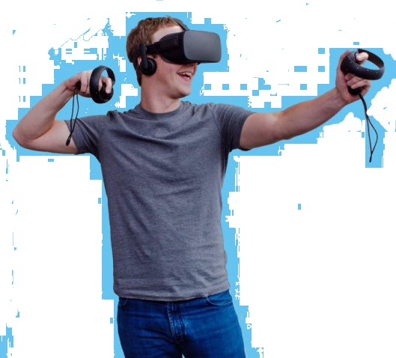Figure 5: OM Single User VR

Single User Desktop OM – Desktop VR with Classical X3D Player
An EXTERNAL GUI application will be written to play in SINGLE USER DESKTOP MODE:
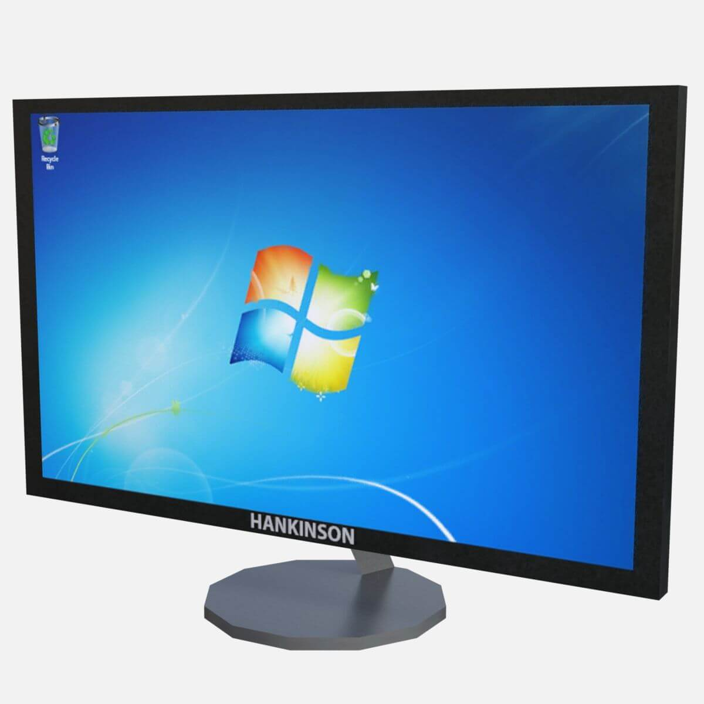Figure 6: OM
Single User Desktop

Single User Desktop NG OM – WebGL Based X3D Player
Experience with WebGL will be gained and a Browser application will be written to play in SINGLE USER DESKTOP MODE:
Figure 7: OM
Single User Desktop NG

Single User VR NG OM – VR with WebGL Based X3D Player
A WebGL based X3D Player will be used to play in SINGLE USER VR MODE:
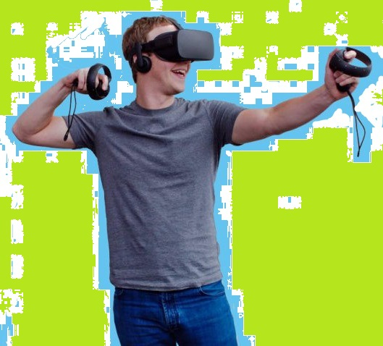Figure 8: OM
Single User VR NG

Multiuser Desktop+VR OM with any X3D Player
Classical X3D Players, WebGL Based X3D Players and a Connectivity Platform will be used for Multiuser Desktop + VR Mode.
Figure 9: OM Multiuser Desktop + VR

Mixed Reality OM
Classical X3D Players, WebGL Based X3D Players, an ITR and a Connectivity Platform will be used for Mixed Reality Mode.
Figure 10: OM for Mixed Reality

Sub-Projects for the Fiat A Release

SMUOS Project (Home Page To be Defined)
The SMUOS Project will provide all essential software that will be necessary to create – experimental – X3D based Simple Multiuser Scenes (SMS).

SMUOS will specify all external interfaces, so following parts can be replaced by your own software: Scene Interface, GUI Switcher, Internal GUI, External GUI, 2D Scene Wrapper.
Only the SMUOS Framework itself will be essential to create SMS.

SIMULRR Project ( http://simulrr.sourceforge.net )
The SIMULRR project will be an example of a project that uses the SMUOS project.
The SIMULRR project:
- will provide extension MIDAS Objects for Railway Simulations (SRR Objects)
- will provide a new SMUOS Extension – the Train Manager Extension (TME)
- and the according internal and external GUI extensions

SrrTrains v0.01 ( https://lc-soc-lc.at/host )
The SrrTrains v0.01 project will be a wrapper project that just uses simulrr and smuos and adds some documentation.

Relation to the "Template" Projects
The project SrrTrains is related to three other projects of the projects that I am currently handling:
Project | Home Page | Status (2025-06-18)
SrrTrains | SrrTrains v0.01  SrrTrains 1.0 (tbd.) | Active  Not Started
N.I.L. / DIGITS | GitHub Repo | Phase 0
S&P-ARK | GitHub Repo | Phase 1
P&S-ARK | GitHub Repo | Doesn't matter

SrrTrains and DIGITS were inspired by some "initial inspiration" (before 2007, as I wrote).
Then the SRR Framework was inspired by the SrrTrains project: we outsourced the SRR Framework to an own sourceforge project in 2009.
Then the SMUOS Framework was inspired by the SRR Framework: we outsourced the "base module" of the SRR Framework (i.e the SMUOS Framework) to an own sourceforge project in 2013.
The projects S&P-ARK and P&S-ARK are "template" projects. That means, they are not "real" projects but I use them to publish my opinion about projects that SHOULD be started, imho.
S&P-ARK should elaborate the "community requirements" for the Network Sensor Node (NSN) and then – after its implementation – use it.
P&S-ARK should elaborate the "celestial requirements" for the Network Sensor Node (NSN) and then – after its implementation – use it.
Also S&P-ARK and P&S-ARK could use SMUOS, optionally.

SMUOS B is a working title for some metamorphosis of the SMUOS Framework, which should be based on the standardized NSN, or even on the mature NSN. An interworking with DIS might be considered, too.
SrrTrains = Simulated Railroad Trains
Please refer to https://letztersein.com/2017/05/28/brief-an-meine-tochter-2017-05-25/ (German language)
DIGITS = Distributed Internet Geographic Information Transmission Service
NSN = Network Sensor Node
Please refer to https://lc-soc-lc.at/host for details.

