Scene Wrappers and GUIs

Table of Contents
1 Planning of Release "Fiat A" 1
2 The Envisioned OMs for SrrTrains v0.01 3
2.1 Single User VR OM – VR with Classical X3D Player 3
2.2 Single User Desktop OM – Desktop VR with Classical X3D Player 4
2.3 Single User Desktop NG OM – WebGL Based X3D Player 4
2.4 Single User VR NG OM – VR with WebGL Based X3D Player 4
2.5 Multiuser Desktop+VR OM with any X3D Player 5
2.6 Mixed Reality OM 5
3 Sub-Projects for the Fiat A Release 6
3.1 SMUOS Project ( http://smuos.sourceforge.net ) 6
3.2 SIMULRR Project ( http://simulrr.sourceforge.net ) 7
3.3 SrrTrains v0.01 ( http://members.chello.at/christoph.valentin ) 7
3.4 SP-ARK / SMUOS B 7

Planning of Release "Fiat A"
This hobby report describes some topics that could(!) be introduced with release "Fiat A" (0033.10.5) of the SrrTrains v0.01 project, by <yyyy-mm-dd>, eventually:
- Scene Wrappers
- GUIs
Some experimental Scene Wrapper GUI was already available with the former "official pre-alpha releases", e.g. with the "Fifth official pre-alpha release 0033.09bf2" by 2014-06-18 ( please refer to https://www.mediafire.com/folder/edhwj4cacq0m5/SrrTrains-v0.01 to download the software).
Since then, the SrrTrains v0.01 project has existed in hibernation mode and had only "inofficial releases" without Scene Wrapper GUI (0033.09bf4 and 0033.10bf3).
Now, when we could(!) be going to start the project again, then we should(!) want to have a next release – the release "Fiat A" –, which could(!) have all necessary parts including a Scene Wrapper GUI.
Some still missing functionality – and some missing architectural features – could(!) be added on top by the following release, i.e. by the "Arimathea" release 0033.11 (beyond 2020).
Prophecy (i.e. Planning):
- Release Fiat A "not before 2020", if at all
- Release Arimathea "beyond 2020", if at all
Well, the next figure shows all that has already happened and the vision of a "stable release 0033":

Figure 1: How to get from instable software "Demo 2012" to "Stable Release 0033"
The next figure shows what could(!) happen in detail, if we started the release "Fiat A" (0033.10.5)

Figure 2: Details of Release "Fiat A"
That means:
- Scene Wrappers/GUIs could(!) be implemented (it could be the "sixth official pre-alpha")
- the work on SMUOS B could(!) be started (SMUOS B is the same like SMUOS A, but based on WebGL)

The Envisioned OMs for SrrTrains v0.01
The first step of the "Fiat A" project will be to define a Testing Scene, where all features of the SMUOS Framework can be tested within all of the following Operational Modes (OMs):

Single User VR OM – VR with Classical X3D Player
A classical X3D Player (e.g. BS Contact) will be used with an INTERNAL GUI to play in SINGLE USER VR MODE:
Figure 3: OM Single User VR

Single User Desktop OM – Desktop VR with Classical X3D Player
An EXTERNAL GUI application will be written to play in SINGLE USER DESKTOP MODE:
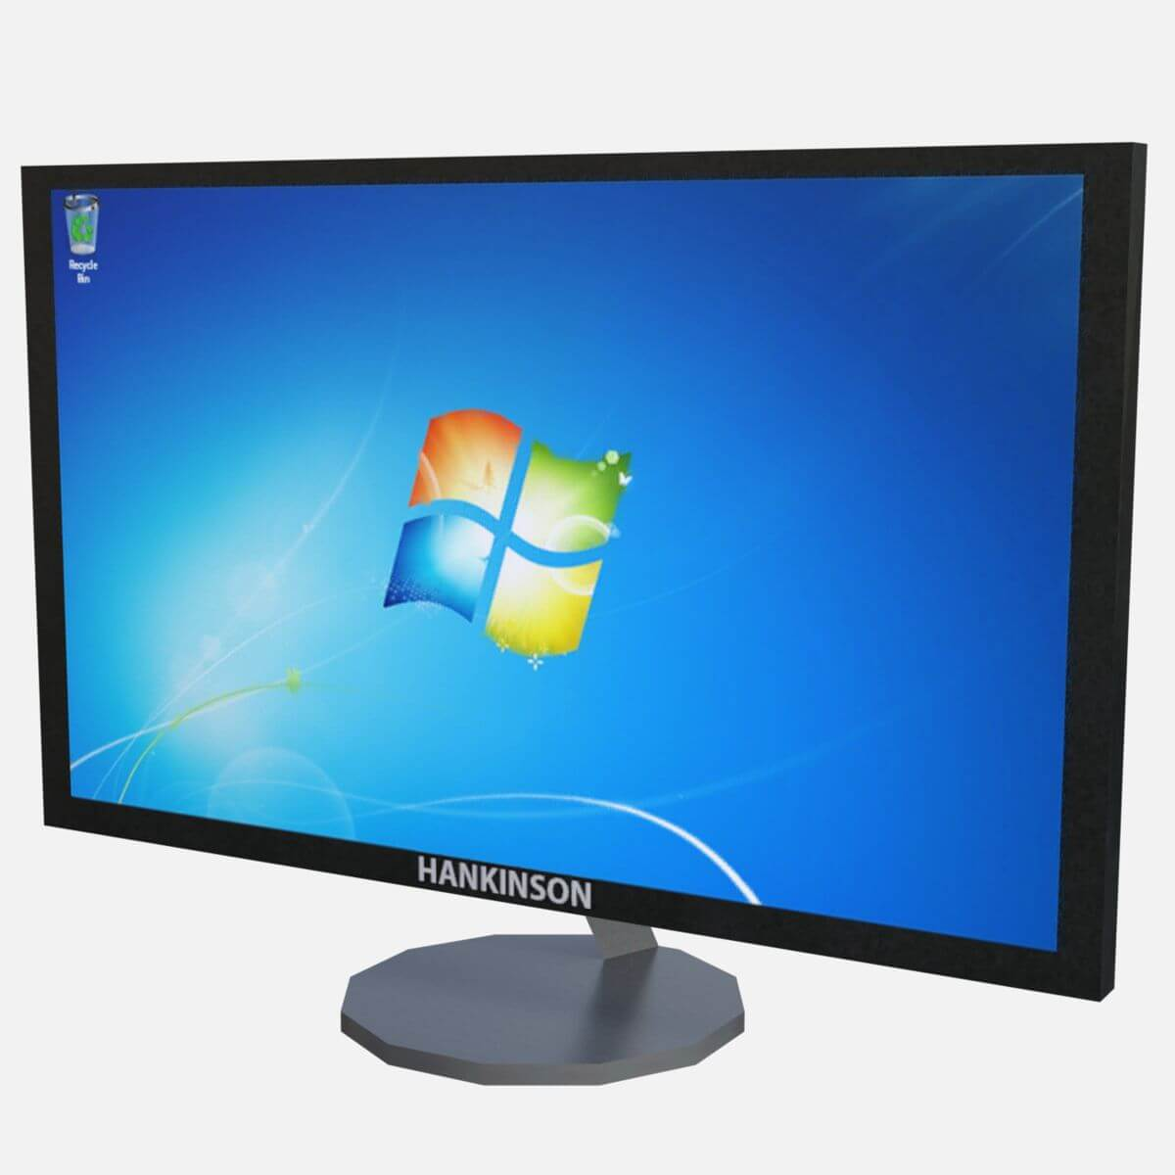Figure 4: OM
Single User Desktop

Single User Desktop NG OM – WebGL Based X3D Player
Experience with WebGL will be gained and a Browser application will be written to play in SINGLE USER DESKTOP MODE:
Figure 5: OM
Single User Desktop NG

Single User VR NG OM – VR with WebGL Based X3D Player
A WebGL based X3D Player will be used to play in SINGLE USER VR MODE:
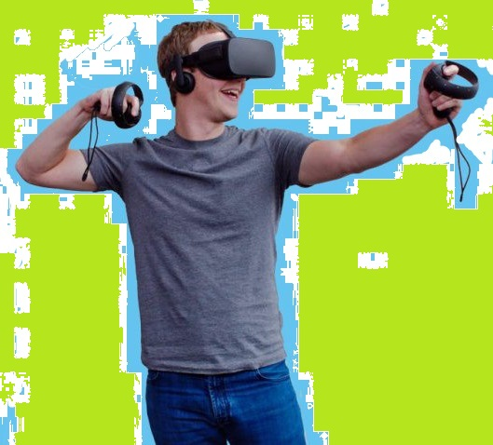Figure 6: OM
Single User VR NG

Multiuser Desktop+VR OM with any X3D Player
Classical X3D Players, WebGL Based X3D Players and a Collaboration Server will be used for Multiuser Desktop + VR Mode.
Figure 7: OM Multiuser Desktop + VR

Mixed Reality OM
Classical X3D Players, WebGL Based X3D Players, an ITR and a Collaboration Server will be used for Mixed Reality Mode.
Figure 8: OM for Mixed Reality

Sub-Projects for the Fiat A Release

SMUOS Project ( http://smuos.sourceforge.net )
The SMUOS Project could(!) provide all essential software that will be necessary to create – experimental – X3D based Simple Multiuser Scenes (SMS).

SMUOS could(!) specify all external interfaces, so following parts can be replaced by your own software: Scene Interface, GUI Switcher, Internal GUI, External GUI, 2D Scene Wrapper.
Only the SMUOS Framework itself will be essential to create SMS.

SIMULRR Project ( http://simulrr.sourceforge.net )
The SIMULRR project could(!) be an example of a project that uses the SMUOS project.
The SIMULRR project:
- could(!) provide extension MIDAS Objects for Railway Simulations (SRR Objects)
- could(!) provide a new SMUOS Extension – the Train Manager Extension (TME)
- and the according internal and external GUI extensions

SrrTrains v0.01 ( http://members.chello.at/christoph.valentin )
The SrrTrains v0.01 project could(!) be a wrapper project that just uses simulrr and smuos and adds some documentation.

SP-ARK / SMUOS B
Tbd.

