**Bur Oak Phenology Observations in North Ex Farm Oak Orchard**

At the Bur Oak orchard, observations were recorded by the same personnel walking through every day during Spring, Summer and Fall. A scale of 0-10 was used to describe the different phenology stages.

**Spring Phenology**: During Spring, the developmental stage of the terminal buds of each tree was scored on a scale from 0 to 2 (Figure 1).

0 = Dormant Bud

1 = Bud Flush

2 = Leaf Emergence

**Leaf Emergence**

**Bud Flush**

**Dormant Bud**

Figure 1: Spring Phenology Stages

**Early Summer Phenology:** Within a few weeks of leaf emergence we began scoring the developmental stages of the male and female flowers on a scale of 3 to 5 (Figure 2).

Note: Female flowers emerge during mid/end development of the male flowers.

3 = Male flowers beginning to emerge

4 = Male flowers fully emerged and starting to die off

5 = Female flowers beginning to emerge mid summer

**Female flower emerges**

**Male flower fully emerged**

**Male flower emerges**

Figure 2: Early Summer Phenology Stages

**Late Summer / Early Fall Phenology:** Shortly after the female flowers emerge, they are pollinated by the pollen and start forming the beginning stage of acorn development. These stages are scored from 6 to 8 (Figure 3)

6 = Flower ends and acorn starts to form

7 = Acorn formed near the end of August

8 = Acorn fully developed near the end of September

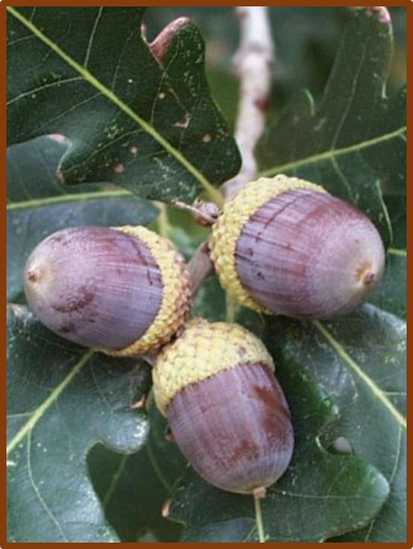

**Acorn fully developed**

**Acorn formed**

**Acorn forming**

Figure 3: Late Summer / Early Fall Phenology Stages

**Fall Phenology:** Leaf senescence dates in fall begin in late September and finish around early November. 50% leaf drop and 100% leaf drop were recorded. These stages were scored from 9 – 10 (figure 4).

9 = 50% of the leaves on the tree have turned yellow

10 = 100% leaf drop

**50% leaf senescence**

**100% leaf drop**

Figure 4: Fall leaf senescence changes