CVIX Clean Installation

August 12, 2013

Updated August 2013

Revision History

|  |  |  |  |
| --- | --- | --- | --- |
| **Date** | **Revision** | **Description** | **Author** |
| 8/12/2013 | 1.0 | Initial Version | Julian Werfel |
|  |  |  |  |
|  |  |  |  |
|  |  |  |  |
|  |  |  |  |
|  |  |  |  |
|  |  |  |  |
|  |  |  |  |
|  |  |  |  |
|  |  |  |  |

**Table of Contents**

1 Purpose 4

2 Acronyms and Definitions 4

3 Overview 4

4 Prerequisites 4

5 CVIX Installation 4

6 Post Install Steps 7

6.1 Enable Remote Desktop 7

6.2 Modify Firewall 8

6.2.1 Enable Ping 8

6.2.2 Allow VIX Connections 8

6.2.3 Allow Connections from Station 200 for Realm Authentication 8

6.3 Modify Hosts File 8

# Purpose

The purpose of this document is to describe how to configure a CVIX from scratch. This document assumes the base Windows Server installation has been completed and all necessary updates have been applied. It is assumed the user is doing this installation physically at the server due to Remote Desktop not being enabled by default.

# Acronyms and Definitions

|  |  |
| --- | --- |
| BHIE | Bidirectional Health Information Exchange |
| CVIX | Centralized VistA Imaging Exchange Service |
| DoD | Department of Defense |
| HAIMS | Health Artifact and Image Management Solution |
| LBS | Laurel Bridge |
| NCAT | Neurocognitive Assessment Tool |
| PSN | Product Serial Number |
| VIX | VistA Imaging Exchange |
| XCA | Cross Community Access |

# Overview

The CVIX is a cluster of servers load balanced to provide access to VA and DoD data to users. Each node contains a full CVIX software installation and must be configured identically to the other nodes in the cluster to work properly.

# Prerequisites

The following items are necessary for the CVIX installation. Many of these items can be found on \\vhacvixclu1a.r04.med.va.gov\g$\CVIX Install (for the Philadelphia CVIX) or \\VHACRBCLUCVIX1.DVA.VA.GOV\I$\CVIX Install (for the CRCC COOP CVIX)

1. The latest CVIX installation.
2. A copy of the latest vhasites.xml file for the site service (copying from an existing CVIX node guarantees the latest version will be used). Place this file in the C:\Site Service directory on the node you are installing (create the directory if needed).
3. The Laurel Bridge Product Serial Number for the CVIX node you are installing.
4. The Federation certificate for the CVIX node you are installing.

# CVIX Installation

The installation process should be done as a user with admin rights. The steps below assume a clean installation. Upgrades to a server node can follow the same process however many of the steps do not need to be repeated. For additional information about the CVIX installation see the MAG*3.0*104 CVIX documentation.

1. Double click on the CVIX MSI installation to install the CVIX installer. At this time the latest version of this installation is MAG3_0P138T17_CVIX_Setup.msi
2. Click next through the installation dialogs taking all defaults to install the CVIX Installation.
3. Click the Close button when the installation is complete.
4. From the Start menu select All Programs 🡪 VistA Imaging Programs 🡪CVIX Service Installation Wizard.

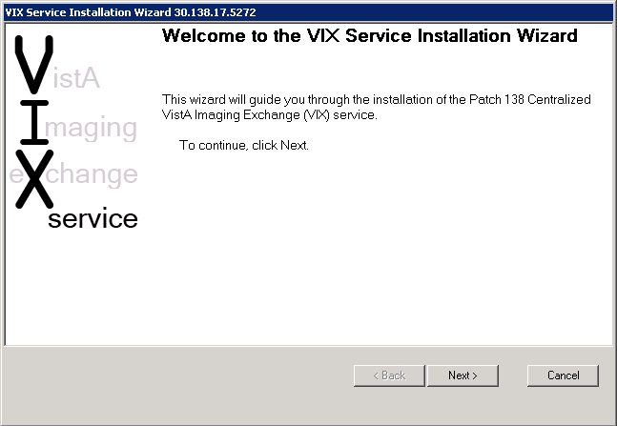

1. Press the Next button to start the installation process.
2. Press the Select button to select the vhasites.xml file to use (in the c:\Site Service directory). Press the Lookup Server Address button and verify the information is correct. Then press the Next button

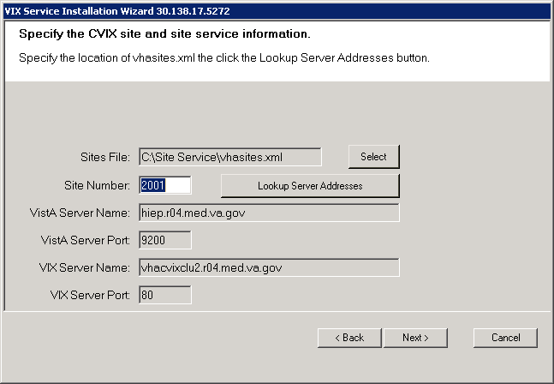

1. Install each prerequisite for the CVIX installation by pressing the Install button next to each component.

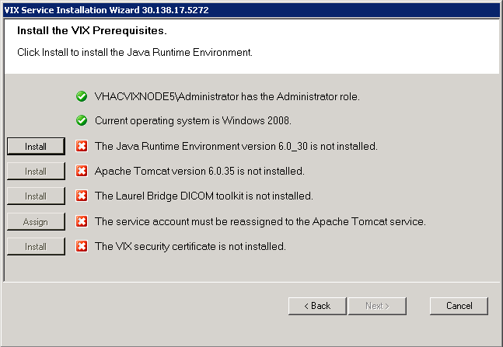

1. The Laurel Bridge DICOM toolkit will require the Product Serial Number. Enter **Philadelphia Sungard, PA** for the site (for the Philadelphia CVIX) and **Martinsburg, WV (CRRC)** for the CRCC COOP CVIX, **1** for the Number of CPUs and enter your contact information. Then press the Activate button. When successful click the Exit with Success button.

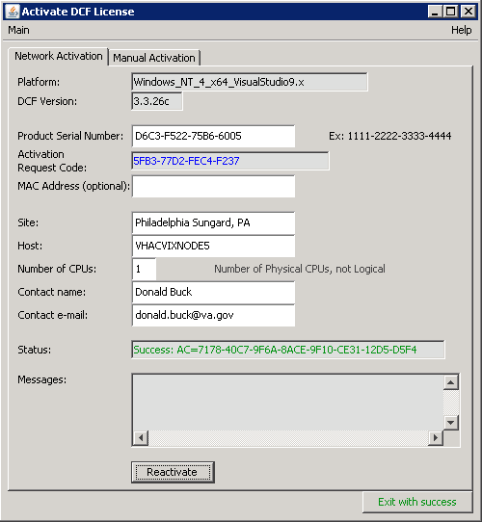

1. For the VIX certificate use the CVIX Federation certificate provided.
2. When all prerequisites are completed, press the Next button.
3. Press the create buttons to create the VixConfig and VixCache directories, then press Next
4. On the BHIE configuration tab, enter the username and password for BHIE and set the protocol to xcas
5. On the HAIMS configuration tab leave the username and password fields blank and set the protocol to xcas
6. On the NCAT Configuration tab leave the username and password fields blank
7. On the Station 200 Configuration, enter the username BHIE uses to query the CVIX
8. Set the XCA Connector Port to 443 (default) and the HTTP Connector Port to 80 (default).
9. Press the Select button to select the XCA keystore and truststore zip files. Select vhacvixclu2.r04.med.va.gov.zip which contains this certificate information (be sure you are using the current version –they expire yearly).
10. If needed, press the Install button to install the Visual Studio 2008 VC++ runtime.
11. Press the Validate button and then the Next button to continue.
12. Press the Install button to install the CVIX.
13. When complete, the CVIX should be installed. Press the Finish button to close the CVIX installation wizard.

# Post Install Steps

After the CVIX installation has been completed the server must be configured properly for the CVIX to work. The following steps only need to be done once for server node.

## Enable Remote Desktop

By default Remote Desktop in Windows Server 2008 R2 only allows one connection at a time. Modify this to allow multiple remote connections

1. Start 🡪Administrative Tools 🡪Remote Desktop Services 🡪Remote Desktop Session Host Configuration
2. Double click on *Restrict each user to a single session*
3. Uncheck *Restrict each user to a single session*

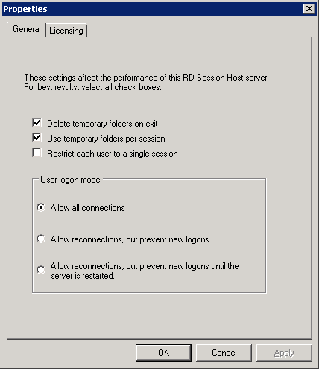

1. Click OK

## Modify Firewall

Run the following commands from a command line on the CVIX server to modify the firewall (as an administrator).

### Enable Ping

C:\>netsh advfirewall firewall set rule name="File and Printer Sharing (Echo Request - ICMPv4-In)" profile=domain,private new enable=yes

### Allow VIX Connections

C:\>netsh advfirewall firewall add rule name="VIX" dir=in enable=yes profile=any localport=80,443,8443 protocol=tcp interfacetype=any action=allow

### Allow Connections from Station 200 for Realm Authentication

C:\>netsh advfirewall firewall add rule name="Old Style RPC Broker to Station 200" dir=in enable=yes profile=any protocol=any interfacetype=any remoteip=10.186.200.0/24 action=allow

### Allow Connections from COOP Station 200 for Realm Authentication

C:\>netsh advfirewall firewall add rule name="Old Style RPC Broker to COOP Station 200 HIEC01" dir=in enable=yes profile=any protocol=any interfacetype=any remoteip=10.222.158.3 action=allow

C:\>netsh advfirewall firewall add rule name="Old Style RPC Broker to COOP Station 200 HIEC02" dir=in enable=yes profile=any protocol=any interfacetype=any remoteip=10.222.158.4 action=allow

C:\>netsh advfirewall firewall add rule name="Old Style RPC Broker to COOP Station 200 HIEC03" dir=in enable=yes profile=any protocol=any interfacetype=any remoteip=10.222.158.5 action=allow

C:\>netsh advfirewall firewall add rule name="Old Style RPC Broker to COOP Station 200 HIEC" dir=in enable=yes profile=any protocol=any interfacetype=any remoteip=10.222.158.6 action=allow

## Modify Hosts File

HAIMS requires the request to the server be made with the name of the server. Because of the configuration of the network the hostname of the HAIMS system does not resolve in the VA so a hosts entry must be made to allow the name resolution to work properly.

1. Open notepad as an administrator and open C:\Windows\System32\drivers\etc\hosts
2. Add the following entry to the file:

146.73.8.26 haims-wny.med.osd.mil

# Production HAIMS will eventually use this address:

# 146.73.8.163 central.haims.mhsi.mil

# Future HAIMS COOP system

# 146.73.8.162 central.haims.mhsi.mil

1. Save the file and close notepad