VIX/CVIX Statistics

August 13, 2013

Updated August 2013

Revision History

|  |  |  |  |
| --- | --- | --- | --- |
| **Date** | **Revision** | **Description** | **Author** |
| 8/13/2013 | 1.0 | Initial Version | Julian Werfel |
|  |  |  |  |
|  |  |  |  |
|  |  |  |  |
|  |  |  |  |
|  |  |  |  |
|  |  |  |  |
|  |  |  |  |
|  |  |  |  |
|  |  |  |  |

**Table of Contents**

1 Purpose 4

2 Acronyms and Definitions 4

3 Overview 4

4 VA/DoD Sharing Statistics 4

4.1 Configuration 4

4.2 Generating VA/DoD Sharing Statistics 4

5 Image Sharing Detail Reports 5

5.1 Configuration 6

5.2 Analysis Phase 6

5.3 Downloading Analysis 7

5.4 Report Phase 8

5.4.1 Averages Report 8

5.4.2 Cached Report 8

5.4.3 CVIX Report 9

5.4.4 Grouped Nodes and Edges 9

5.4.5 Site Communication Report 9

5.4.6 Site Growth Report 9

# Purpose

The purpose of this document is to describe how statistics for the VIX and CVIX usage are generated.

# Acronyms and Definitions

|  |  |
| --- | --- |
| AWIV | Advanced Web Image Viewer |
| CSV | Comma Separated Values |
| CVIX | Centralized VistA Imaging Exchange Service |
| DoD | Department of Defense |
| TSV | Tabbed Separated Values |
| VIX | VistA Imaging Exchange |

# Overview

Every request made to the VIX and CVIX is logged as a transaction. For each request, multiple transactions may be generated that track the request and result. On average, 1.5 million transactions are generated every day by all the VIX and CVIX servers. Each night, the CVIX failover clusters (both Philadelphia and CRCC COOP) download the transaction logs from each VIX and keep a copy of those logs. The collection of these logs occurs automatically each night. The CVIX servers attempt to download the logs from two days ago (to avoid any time zone issues) and it will attempt to download any logs that previously could not be downloaded due to network issues.

The statistics generated are based on those transaction logs and described in this document.

# VA/DoD Sharing Statistics

Each month the DoD requests an update to the number of images that have been shared between the VA and the DoD. The Transaction Log Statistics utility has been created to generate those statistics. This utility can generate many types of statistics. For the purpose of this document only the statistics generated for DoD sharing are described.

The default configuration of the Transaction Log Statistics utility will generate the output to the web server which can be viewed at: <http://vhacvixclu1a.r04.med.va.gov/stats/Year_2012.xml> (for 2012 stats) and [http://vhacvixclu1a.r04.med.va.gov/stats/Year_2013.xml](http://vhacvixclu1a.r04.med.va.gov/stats/Year_2013.xml%20) (for 2013 stats).

## Configuration

The Transaction Log Statistics utility must know where the transaction logs are and where to generate the output to. This configuration information is shown at the top of the utility and can be modified and then saved in the utility. The default configuration set on the server should not need to be changed

## Generating VA/DoD Sharing Statistics

1. Login to vhacvixclu1a.r04.med.va.gov using Remote Desktop as an administrator
2. From the Start menu select All Programs 🡪 VistA Imaging Programs 🡪 Transaction Log Statistics

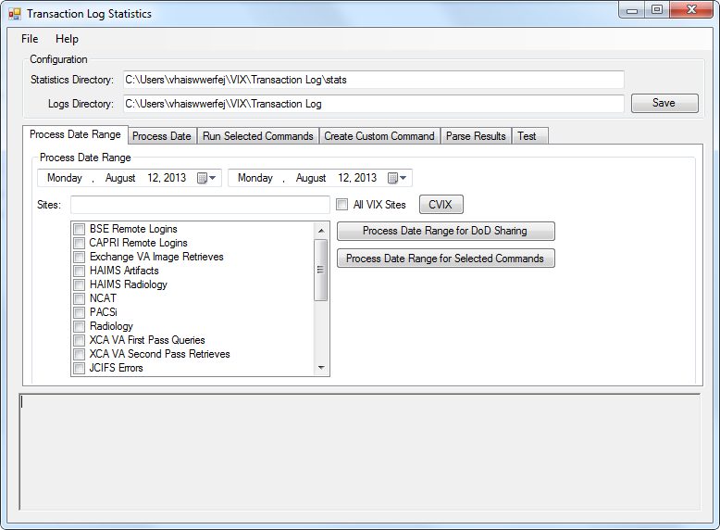

1. On the **Process Date Range** tab, set the date range to process. The start date should be the day after the last date processed. The end date should be the latest date of collected logs (usually 2 days before the current date).
2. Press the **CVIX** button to set the sites to the CVIX nodes.
3. Press **Process Date Range for DoD Sharing** button. The utility will read the transaction logs and update the reports. A dialog will appear when the generation is complete. The URLs shown above can be used to display the stats. Only stats in the selected date range will be updated.

# Image Sharing Detail Reports

The image sharing detail reports are several reports that show how image sharing is being used. These reports are generated in two phases, an analysis phase run on the CVIX failover cluster near the transaction logs and a report phase that uses the analysis information. The Daily Transaction Log Analyzer utility is used to generate the analysis and reports.

## Configuration

The Daily Transaction Log Analyzer needs to know where to find the transaction logs and where to generate reports. This is handled on the Settings tab and can be changed from that tab.

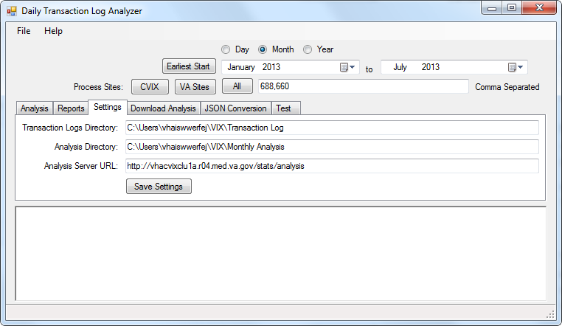

The Transaction Logs Directory field should point to the directory where the transaction logs have been downloaded to (in TSV format).

The Analysis Directory is the directory where the Analysis is generated and where the reports are generated to (in the Rollup directory within the Analysis directory).

The Analysis Server URL is the URL where the utility can download the analysis reports (for the workstation generating the reports).

## Analysis Phase

The analysis phase reads each transaction and generates an XML file that contains relevant counts for the reports. Because each transaction entry must be read the analysis phase must be run on the same server as the transaction logs. The logs can be copied to a workstation or the analysis can be run on the CVIX failover cluster (recommended).

The analysis should be run each month to cover the previous month data. It should be run after the 4th day of the month to ensure the logs from the previous month have been collected.

In January, a yearly analysis can be run on the previous year’s information (it simply sums the information from each month into a yearly report. The yearly report should be run after the December monthly report.

The following are the steps required to generate the monthly analysis:

1. Login to vhacvixclu1a.r04.med.va.gov using Remote Desktop as an administrator
2. From the Start menu select All Programs 🡪 VistA Imaging Programs 🡪Daily Transaction Log Analyzer
3. For monthly analysis the month option is already selected, for a year analysis change to the year option
4. Set the date range (for monthly analysis this will usually be the previous month).
5. Press the All button to select all VA sites including the CVIX server nodes

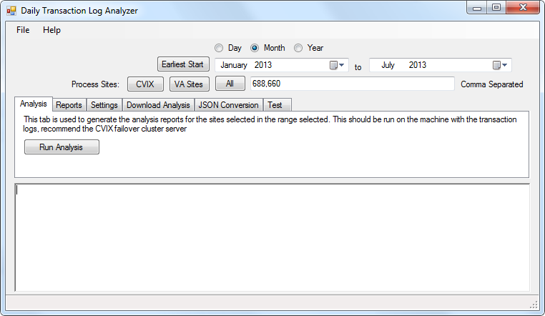

1. From the Analysis tab, press the Run Analysis button.
2. The status will be shown at the bottom of the screen

## Downloading Analysis

If the analysis is generated on a different workstation than the report will be generated on, it must be copied to the report workstation. An easy way to do this is to have the analysis information generated to a web server (as it is configured on the CVIX currently) and then download all of the files. This can be accomplished by the Daily Transaction Log Analyzer by using the Download Analysis tab. Set the proper date range and sites and then press the Download Analysis button. It will overwrite any existing copy of the analysis reports without prompting.

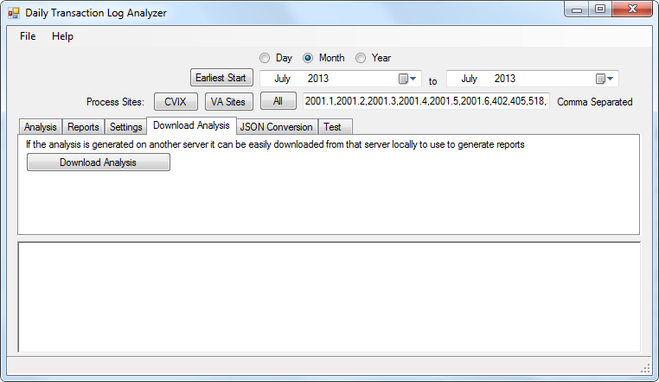

## Report Phase

Once the analysis has been generated reports can be created that use the analysis information. The reports are generated using Microsoft Excel and Microsoft PowerPoint so they must be run on a workstation that has Microsoft Office installed (2010 or higher). For this reason these reports cannot be generated on the CVIX cluster servers.

The reports can be generated for any date range (that the report supports) and for any sites. In general, all sites should be used for a full report (except the CVIX report which should only be the CVIX nodes).

To generate a report, select the date type and date range. Then select the sites to include. On the Reports tab, select the report to generate and press Generate Report. Output from the report will be displayed at the bottom of the screen.

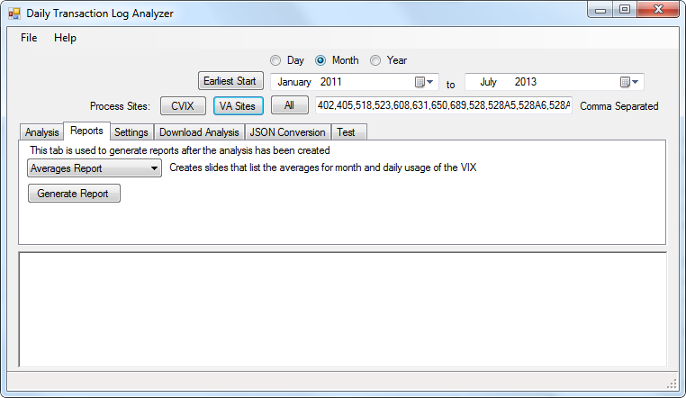

### Averages Report

This report generates averages for all of the data included in the report. This report should be generated using VA sites (without the CVIX) and for the full date range.

When the analysis information is updated (each month), this report should be regenerated in full. This report only supports generation by month.

### Cached Report

This report generates information based on how affective the cache is for the Clinical Display application. This report should be generated using VA sites (without the CVIX) and for the full date range.

When the analysis information is updated (each month), this report should be regenerated in full. This report only supports generation by month.

### CVIX Report

This report generates information based on the usage of the CVIX including traffic to and from the DoD and the usage of the AWIV. This report should be generated using the CVIX nodes and for the full date range.

When the analysis information is updated (each month), this report should be regenerated in full. This report only supports generation by month.

### Grouped Nodes and Edges

This report is used to create two CSV files. One that contains the sites and their GPS locations and one that contains the number of connections (representing how much data moved between the sites). This report can be used to generate graphs and maps of the information. This report should be generated using VA sites (without the CVIX) and for a specific date range.

This report supports monthly and yearly reports. It does not need to be updated after an analysis unless the analysis information it used has changed.

### Site Communication Report

This report shows what sites communicate with what other sites. Each site shows what sites it communicates with the most and moves the most data between. This report should be generated using VA sites (without the CVIX) for a specific date range.

This report supports monthly and yearly reports. It does not need to be updated after an analysis unless the analysis information it used has changed.

### Site Growth Report

This report shows the VIX usage over time. This report should be generated using VA sites (without the CVIX) and for the full date range.

When the analysis information is updated (each month), this report should be regenerated in full. This report only supports generation by month.