VIX Health Monitor User Guide

June 28, 2013

Updated July 2013

Revision History

|  |  |  |  |
| --- | --- | --- | --- |
| **Date** | **Revision** | **Description** | **Author** |
| 6/28/2013 | 1.0 | Initial Version | Julian Werfel |
| 7/23/2013 | 1.1 | Updated for version 2.0.0.22 | Julian Werfel |
|  |  |  |  |
|  |  |  |  |
|  |  |  |  |
|  |  |  |  |
|  |  |  |  |
|  |  |  |  |
|  |  |  |  |
|  |  |  |  |

**Table of Contents**

1 Purpose 5

2 Acronyms and Definitions 5

3 Overview 5

4 Current Version 5

5 What’s New 5

6 General Usage 5

6.1 Loading Health Information 5

7 Site Details Tab 6

7.1 Sites List 6

7.2 VIX Data Tab 8

7.2.1 VIX Cache 8

7.2.2 VIX Transaction Logs 8

7.2.3 VIX Java Logs 9

7.2.4 Site Service 9

7.2.5 Realm Configuration 9

7.2.6 Container Thread Details 9

7.2.7 System Information 10

7.2.8 Request Counts 10

7.2.9 Thread Durations 11

7.2.10 Request Processors 11

7.2.11 Release of Information (ROI) Statistics 12

7.2.12 View Transaction 12

7.3 Raw Data Tab 12

7.4 Monitored Errors Tab 13

7.5 Monitored Properties 14

8 Quick View Tab 14

8.1 Test Details Counts 15

8.2 Failed VIX Sites 15

8.3 CVIX Sites 16

8.4 Statistics 17

9 Sites List Tab 18

10 Watched Sites Tab 18

11 Test Sites Tab 18

12 Monitored Properties Tab 19

13 Long Running Threads Tab 19

14 Monitored Properties 19

15 Active Threads 20

16 Thread Stack Traces 20

17 Memory Information 21

18 Logged Test Results 21

19 VIX Administrators 22

20 Checksums 22

21 Settings 23

21.1 General Settings 23

21.2 Health Load Options Settings 23

21.3 Monitored Properties Settings 24

21.4 Test Sites Settings 25

# Purpose

The purpose of this document is to describe the functionality provided by the VIX Health Monitor.

# Acronyms and Definitions

|  |  |
| --- | --- |
| CVIX | Centralized VistA Imaging Exchange Service |
| VIX | VistA Imaging Exchange |

# Overview

The VIX Health Monitor is a utility that monitors the status of the VIX and CVIX servers. The monitor displays current information from VIX and CVIX servers and analyzes the information to alert the user of problems with a server

# Current Version

This document is based on version **2.0.0.22** of the VIX Health Monitor which can be downloaded from <http://vhacvixclu1a.r04.med.va.gov:8080/wiki/Wiki.jsp?page=VIXHealthMonitor>

# What’s New

This section describes what is new in the most recent version of the VIX Health Monitor.

|  |  |
| --- | --- |
| **New Feature** | **Feature Description Section** |
| Checksums | See Checksums |
| Site Service data source version | See Site Service |
| Test Sites | See Test Sites Tab |

# General Usage

The VIX Health is intended to be used by support personnel so they can monitor the VIX and CVIX services to ensure they are functioning properly. This VIX Health Monitor is not intended to be used by site support.

When the VIX Health Monitor loads it will automatically load the list of VIX and CVIX servers from the site service. This may take a few seconds to load. Once loaded the list of all VIX and CVIX servers will be displayed. If for some reason the application cannot communicate with the site service an error will be displayed at the bottom of the application. The user can manually reload the site service information by clicking on the *Reload VIX Site List* button.

## Loading Health Information

Health information from a server can be loaded in two ways. It can be manually loaded by double clicking on a site or health information can be loaded periodically by the Health Monitor. Loading information about a single site is done synchronously and the user must wait for the information to load. Loading all site information is done asynchronously and when a site is loaded it can be viewed immediately.

Pressing the *Test All Sites* button at the bottom will load information for all sites asynchronously. Pressing the *Start Interval Test* button at the bottom will load information for all sites asynchronously and refresh the data automatically based on the refresh time in the settings. While the interval test is running the status at the bottom right will say *Running* and the *Start Interval Test* button will change to say *Stop Interval Test*.



# Site Details Tab

The Site Details tab shows the list of all VIX and CVIX servers and details about each individual site.

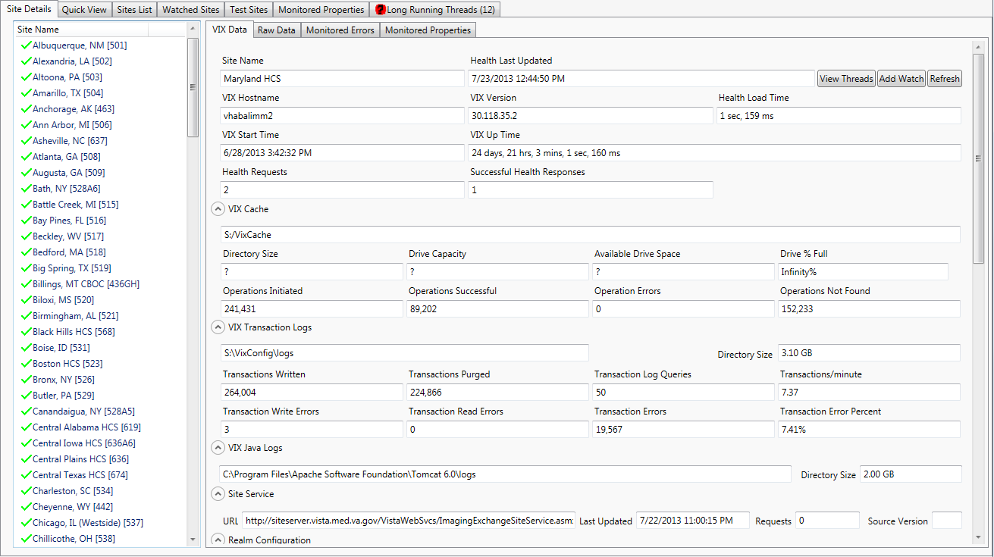

## Sites List

The list shows all sites that have a VIX and the CVIX servers. The icon next to the site indicates the status of the health of the VIX/CVIX. Right clicking on the site provides a list of options for viewing information

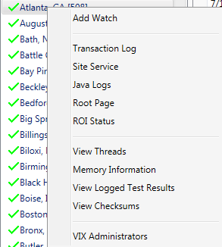

|  |  |
| --- | --- |
| Add Watch | Add the selected site to the list of watched sites. See Watched Sites Tab |
| Transaction Log | Open a web browser to the transaction log for the selected site |
| Site Service | Open a web browser to the site service page for the selected site |
| Java Logs | Opens a web browser to the Java logs page for the selected site |
| Root Page | Opens a web browser to the root page of the selected site. If the selected VIX/CVIX has at least Patch 119 installed then the page will display the current version of the VIX/CVIX. If the VIX is a version prior to Patch 119 then the Tomcat status page will be displayed. |
| ROI Status | Opens a web browser page to the ROI status page of the selected site. This option requires the site have at least a Patch 130 VIX installed. If a 130 VIX is not installed, an error will be displayed at the bottom of the Health Monitor. This is not available for CVIX servers. |
| View Threads | View the list of active threads on the VIX/CVIX. See Active Threads |
| Memory Information | View current memory information for the VIX/CVIX. See Memory Information |
| View Logged Test Results | View Logged Test Results. See Logged Test Results |
| View Checksums | View checksums from the site. See Checksums |
| VIX Administrators | View VIX Administrators for the site. See VIX Administrators |

## VIX Data Tab

The VIX Data tab shows the greatest detail about a site but only one site at a time.

|  |  |
| --- | --- |
| **Field** | **Description** |
| Site Name | The name of the site |
| Health Last Updated | The time when the health displayed was last updated |
| View Threads | View all active threads on the VIX/CVIX. See Active Threads |
| Add Watch | Add this site to the watch list. See Watched Sites Tab |
| Refresh | Refresh the health information for this VIX/CVIX |
| VIX Hostname | The network hostname of the VIX/CVIX |
| VIX Version | The installed version of the VIX/CVIX |
| Health Load Time | The amount of time it took to load the health information from the VIX/CVIX |
| VIX Start Time | The time when the VIX/CVIX last started |
| VIX Up Time | The amount of time the VIX/CVIX has been running |
| Health Requests | Number of times the health information has been requested from this site since the Health Monitor started |
| Successful Health Requests | Number of successful requests for health information since the Health Monitor started |

### VIX Cache

The VIX Cache section describes information about the status of the cache on the VIX/CVIX.

**Note**: for performance reasons, some information from the VIX Cache is not loaded typically because it took too long for the VIX to calculate. For those fields you may see a “*?”* for the value indicating that value is missing

|  |  |
| --- | --- |
| **Field** | **Description** |
|  | VIX Cache directory |
| Directory Size | The size of the VIX/CVIX cache directory |
| Drive Capacity | The capacity of the drive the VIX/CVIX cache exists on |
| Available Drive Space | The amount of space available on the drive the VIX cache is on |
| Drive % Full | The percent of the cache drive that is full |
| Operations Initiated | The number of cache operations initiated by the VIX/CVIX |
| Operations Successful | The number of cache operations completed without an error |
| Operation Errors | The number of cache operations completed with an error |
| Operation Not Found | The number of cache operations where the requested information was not found in the cache |

### VIX Transaction Logs

The VIX Transaction Logs section describes information about the transactions that are written to the log on the VIX/CVIX.

|  |  |
| --- | --- |
| **Field** | **Description** |
|  | The directory where the VIX/CVIX transaction logs are stored |
| Directory Size | The size of the directory where the transaction logs are stored |
| Transactions Written | The number of transactions written |
| Transactions Purged | The number of transactions purged |
| Transaction Log Queries | The number of queries made to the transaction log |
| Transactions/minute | The number of transactions written to the log per minute |
| Transaction Write Errors | The number of errors that occurred writing entries to the transaction log. If the log is functioning properly this value should be 0. |
| Transaction Read Errors | The number of errors that occurred reading entries from the transaction log. If the log is functioning properly this value should be 0. |
| Transaction Errors | The number of transactions that have been written to the transaction log that are for error transactions. This value is not expected to be 0. |
| Transaction Error Percent | The percent of transactions written to the transaction log that were for an error transaction. This value is not expected to be 0%. |

### VIX Java Logs

The VIX Java Logs section describes information about the debug logs are written on the server.

|  |  |
| --- | --- |
| **Field** | **Description** |
|  | The directory where the VIX/CVIX Java logs are stored |
| Directory Size | The size of the directory where the Java logs are stored |

### Site Service

|  |  |
| --- | --- |
| **Field** | **Description** |
| URL | The URL the VIX uses to retrieve the site service information. On the CVIX this will be a local path to a file containing the site service information |
| Last Updated | The date the site service information was last updated. This should occur nightly |
| Requests | The number of requests made for site service information to the VIX/CVIX. On the VIX this might be 0, on the CVIX this number should be much larger |
| Source Version | The version of the interface the VIX used to load site service information. Requires at least Patch 138 VIX |

### Realm Configuration

|  |  |
| --- | --- |
| **Field** | **Description** |
| Real VistA Server | The VistA Server realm configuration the VIX is aware of. This should match the hostname of the VistA server at the site |
| Realm VistA Port | The VistA Server realm configuration the VIX is aware of. This should match the port of the VistA server at the site |

### Container Thread Details

|  |  |
| --- | --- |
| **Field** | **Description** |
| HTTP-80 Thread Pool Size | The size of the pool of threads for the 80 pool used to view web pages (CVIX only) |
| HTTP-8080 Thread Pool Size | The size of the pool of threads for the 8080 pool used by Clinical Display and VistARad (VIX only) |
| HTTP-8443 Thread Pool Size | The size of the pool of threads for the 8443 pool used by VIX Federation (VIX to VIX/CVIX ) |
| HTTP-443 Thread Pool Size | The size of the pool of threads for the 443 pool used for secure connections (CVIX only) |
| HTTP-80 Busy Threads | The number of active threads for the 80 pool (CVIX only) |
| HTTP-8080 Busy Threads | The number of active threads for the 8080 pool (VIX only) |
| HTTP-8443 Busy Threads | The number of active threads for the 8443 pool |
| HTTP-443 Busy Threads | The number of active threads for the 443 pool (CVIX only) |
| Long Running Threads | The number of threads that have been running long. Long running threads are threads that have been running longer than specified in the user settings. This is the total number of active threads from all pools |

### System Information

|  |  |
| --- | --- |
| **Field** | **Description** |
| Operating System | Operating System name the VIX/CVIX is running on |
| OS Version | Version of the operating system the VIX/CVIX is running on |
| OS Architecture | x86 for 32-bit, amd64 for 64-bit |
| # of Processors | Number of processors, this counts cores as processors |
| Total Swap Space | Amount of swap space |
| Free Swap Space | Available swap space |
| Total Physical Memory | Total memory installed on the server |
| Free Physical Memory | Available memory on the server |
| Committed Virtual Memory | Virtual memory committed on the server |

### Request Counts

|  |  |  |
| --- | --- | --- |
| **Field** | **VIX/CVIX** | **Description** |
| AWIV Image | CVIX | The number of image requests by the AWIV (Patch 105) |
| AWIV Image V2 | CVIX | The number of image requests by the AWIV (Patch 124) |
| AWIV Metadata | CVIX | The number of metadata requests by the AWIV (all patches) |
| AWIV Photo ID | CVIX | The number of photo ID image requests by the AWIV (Patch 105, 124) |
| AWIV Photo ID V2 | CVIX | The number of photo ID image requests by the AWIV (not actually used) |
| Clinical Display Image V2 | VIX | The number of image requests by Clinical Display Patch 72 |
| Clinical Display Image V4 | VIX | The number of image requests by Clinical Display Patch 93 |
| Clinical Display Image V5 | VIX | The number of image requests by Clinical Display Patch 94 |
| Clinical Display Image V6 | VIX | The number of image requests by Clinical Display Patch 117 |
| Clinical Display Image V7 | VIX | The number of image requests by Clinical Display Patch 122 |
| Clinical Display Metadata | VIX | The number of metadata requests by Clinical Display (all patches) |
| Exchange Image | VIX/CVIX | The number of image requests by the DoD |
| Exchange Image V2 | CVIX | The number of image requests by the DoD (Patch 104) |
| Exchange Metadata | VIX/CVIX | The number of metadata requests by the DoD |
| Federation Document V4 | VIX/CVIX | Document requests from Patch 104 servers |
| Federation Document V5 | VIX/CVIX | Document requests from newer servers |
| Federation Exam Image | VIX/CVIX | The number of VistARad image requests by a remote VIX (Patch 83) |
| Federation Exam Image V4 | VIX/CVIX | The number of VistARad image requests by a remote VIX (Patch 104) |
| Federation Exam Image V5 | VIX/CVIX | The number of VistARad image requests by a remote VIX (newer) |
| Federation Exam Image Text | VIX/CVIX | The number of VistARad image text file requests by a remote VIX (Patch 83) |
| Federation Exam Image Text V4 | VIX/CVIX | The number of VistARad image text file requests by a remote VIX (Patch 104) |
| Federation Exam Image Text V5 | VIX/CVIX | The number of VistARad image text file requests by a remote VIX (newer) |
| Federation Image | VIX/CVIX | The number of Clinical Display image requests by a remote VIX (Patch 83) |
| Federation Image V4 | VIX/CVIX | The number of Clinical Display image requests by a remote VIX (Patch 104) |
| Federation Image V5 | VIX/CVIX | The number of Clinical Display image requests by a remote VIX (newer) |
| Federation Metadata | VIX/CVIX | The number of metadata requests by a remote VIX (all applications, Patch 83) |
| Federation Metadata V4,V5 | VIX/CVIX | The number of metadata requests by a remote VIX (all applications, newer) |
| VistARad Exam Image | VIX | The number of image requests by VistARad |
| VistARad Exam Image Text | VIX | The number of image text file requests by VistARad |
| VistARad Metadata | VIX | The number of metadata requests by VistARad |
| XCA | CVIX | The number of requests for metadata and artifacts made to the XCA interface (from HAIMS) |

### Thread Durations

This lists each thread on the VIX/CVIX and how long each thread has been active for. An active thread is currently processing a request. Double clicking on a thread will display the stack trace for that thread (see Thread Stack Traces).

### Request Processors

This information is only available on the CVIX and for VIX sites with at least Patch 122 installed. The request processors list each request pool and how much activity has been done on each pool

|  |  |  |
| --- | --- | --- |
| **Request Pool** | **VIX/CVIX** | **Description** |
| http-80 | CVIX | Requests made by web browsers |
| http-8080 | VIX | Requests made by client applications |
| http-443 | VIX/CVIX | Secure requests |
| http-8443 | VIX/CVIX | Requests made by VIX/CVIX |

### Release of Information (ROI) Statistics

This information will only appear if the VIX version is greater than Patch 130. This will not appear on the CVIX.

|  |  |
| --- | --- |
| **Field** | **Description** |
| Periodic Processing Enabled | True/false to indicate if periodic processing is turned on |
| Completed Items Purge Enabled | True/false to indicate if completed item purging is turn on |
| Immediate Processing Enabled | True/false to indicate if immediate processing is enabled |
| Periodic Processing Error | Error message if periodic processing cannot function properly |
| Disclosure Processing Errors | Number of errors that have occurred in processing disclosures |
| Disclosure Requests | Number of requests made for disclosures |
| Disclosures Cancelled | Number of disclosures cancelled |
| Disclosures Completed | Number of disclosure requests completed successfully |
| ImageGear Burn Annotation Failures | Number of failures burning annotations into images |
| ImageGear Burn Annotation Image Requests | Number of requests to burn annotations into images |
| ImageGear Burn Annotation Image Success | Number of successful images that have had annotations burned |
| ImageGear PDF Failures | Number of failures generating PDF reports |
| ImageGear PDF Requests | Number of requests to generate PDF reports |
| ImageGear PDF Success | Number of successful PDF reports generated |
| Studies Sent to Export Queue | Number of studies sent to export queue (for DICOM studies) |

### View Transaction

This allows a quick way to display details about a specific transaction. This will open a web browser to display the transaction details.

## Raw Data Tab

The Raw Data tab shows the properties the VIX Health Monitor receives from the VIX/CVIX. The VIX Health Monitor uses these values and converts them to be displayed on the VIX Data tab however not all fields are used. The values received from the VIX are based on the properties requested in the Health Load Options Settings.

The values in the Raw Data can be used when configuring Monitored Properties (see Monitored Properties Settings).

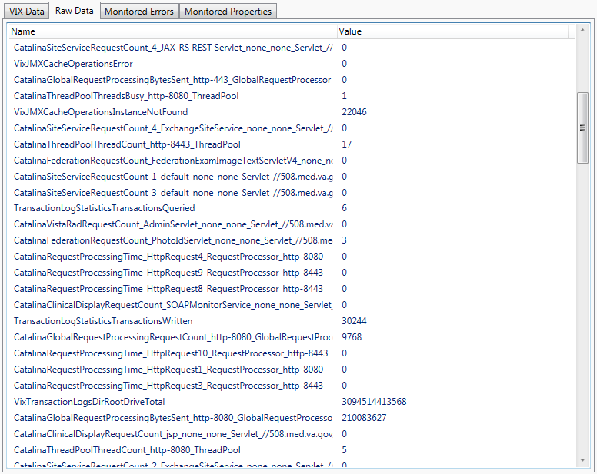

## Monitored Errors Tab

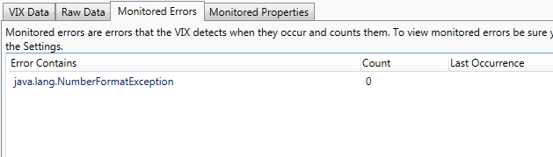

Monitored errors are errors that occur on the VIX/CVIX that the VIX/CVIX has been configured to track and count. This configuration is done on the VIX/CVIX and can be reported and displayed on the VIX Health Monitor. Be sure *monitoredError* is checked as a Health Load Option to view Monitored Errors (see Health Load Options). By default no site has any monitored errors enabled but they might be enabled by development or support.

## Monitored Properties

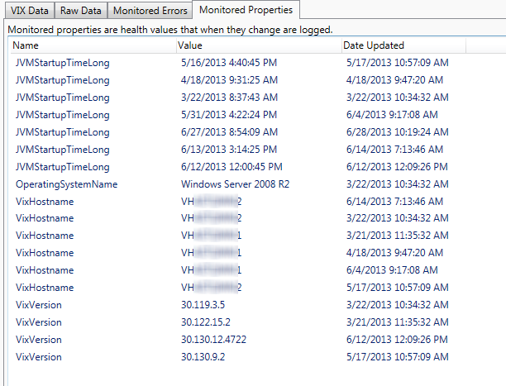

This tab shows monitored properties for the selected VIX/CVIX. See Monitored Properties for more details.

# Quick View Tab

The Quick View tab provides a subset of information about the sites that have an issue, the CVIX sites and statistics from all sites. It is meant as a single location to view all critical information.

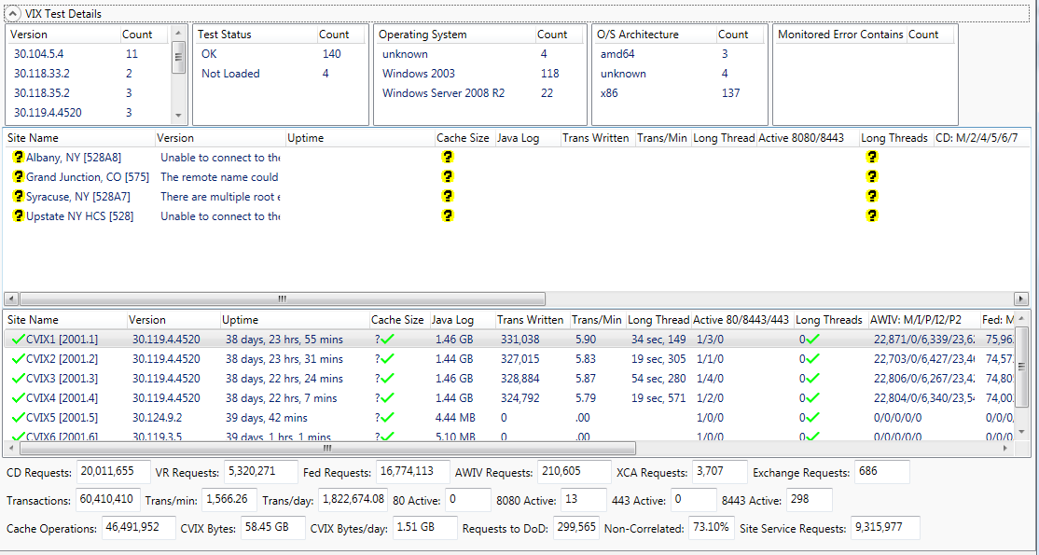

## Test Details Counts

This provides counts of specific properties of all the VIX and CVIX.

## Failed VIX Sites

This list provides a subset of information about the sites that had an error in their health. The list contains the following information:

|  |  |
| --- | --- |
| **Column Header** | **Description** |
| Site Name | The name of the site |
| Version | The installed version of the VIX |
| Uptime | The amount of time the VIX has been running |
| Cache Size | The size of the VIX cache directory |
| Java Log | The size of the Java debug logs directory |
| Trans Written | The number of transactions written |
| Trans/Min | The number of transactions written per minute |
| Long Thread | The amount of time the longest thread has been processing on the VIX |
| Active 8080/8443 | The number of active threads for both 8080/8443 |
| Long Threads | The number of threads that have been running long. Long running threads are threads that have been running longer than specified in the user settings. This is the total number of threads from both the 8080 active threads and the 8443 active threads |
| CD: M/2/4/5/6/7 | The number of requests made by Clinical Display clients.  M=Metadata requests by Clinical Display (all patches)  2= The number of image requests by Clinical Display (Patch 72)  4= The number of image requests by Clinical Display (Patch 93)  5= The number of image requests by Clinical Display (Patch 94)  6= The number of image requests by Clinical Display (Patch 117)  7=The number of image requests by Clinical Display (Patch 122) |
| VR: M/EI/ET | The number of requests made by VistARad clients  M= The number of metadata requests by VistARad  EI= The number of image requests by VistARad  ET= The number of image text file requests by VistARad |
| Fed: M/I4/EI4/ET4/I5/EI5/ET5 | The number of requests made by remote VIX servers  M= The number of metadata requests by a remote VIX (all applications)  I4= The number of Clinical Display image requests by a remote VIX (Patch 104)  EI4= The number of VistARad image requests by a remote VIX (Patch 104)  ET4= The number of VistARad image text file requests by a remote VIX (Patch 104)  I5= The number of Clinical Display image requests by a remote VIX (Patch 122+)  EI5= The number of VistARad image requests by a remote VIX (Patch 122+)  ET5= The number of VistARad image text file requests by a remote VIX (Patch 12+) |
| Rad: M/I/I2 | The number of radiology requests made by the DoD  M= The number of metadata requests by the DoD  I= The number of radiology image requests by the DoD (v1)  I2= The number of radiology image requests by the DoD (v2) |
| Load Time (ms) | The amount of time (in milliseconds) it took to load the health information from the VIX |
| Server OS | The operating system of the VIX server |
| Last Update | Date/Time when the health was last updated |
| Health Requests | Number of times the VIX Health Monitor has requested health from this site |
| Successful Health Requests | Number of successful responses the VIX Health Monitor received from this site |

## CVIX Sites

This list provides a subset of information about the CVIX servers. The list contains the following information:

|  |  |
| --- | --- |
| **Column Header** | **Description** |
| Site Name | The name of the site |
| Version | The installed version of the CVIX |
| Uptime | The amount of time the CVIX has been running |
| Cache Size | The size of the CVIX cache directory |
| Java Log | The size of the Java debug logs directory |
| Trans Written | The number of transactions written |
| Trans/Min | The number of transactions written per minute |
| Long Thread | The amount of time the longest thread has been processing on the CVIX |
| Active 80/8443/443 | The number of active threads for both 80/8443/443 |
| Long Threads | The number of threads that have been running long. Long running threads are threads that have been running longer than specified in the user settings. This is the total number of threads from both the 8080 active threads and the 8443 active threads |
| AWIV: M/I/P/I2/P2 | The number of requests made by AWIV clients.  M=Metadata requests by AWIV (all patches)  I= The number of image requests by AWIV Clinical Display (Patch 105)  P= The number of image requests by Clinical Display (Patch 105)  I2= The number of image requests by Clinical Display (Patch 124)  P2 The number of image requests by Clinical Display (Patch 124) |
| Fed: M/I4/EI4/ET4/I5/EI5/ET5 | The number of requests made by remote VIX servers  M= The number of metadata requests by a remote VIX (all applications)  I4= The number of Clinical Display image requests by a remote VIX (Patch 104)  EI4= The number of VistARad image requests by a remote VIX (Patch 104)  ET4= The number of VistARad image text file requests by a remote VIX (Patch 104)  I5= The number of Clinical Display image requests by a remote VIX (Patch 122+)  EI5= The number of VistARad image requests by a remote VIX (Patch 122+)  ET5= The number of VistARad image text file requests by a remote VIX (Patch 12+) |
| Rad: M/I/I2 | The number of radiology requests made by the DoD  M= The number of metadata requests by the DoD  I= The number of radiology image requests by the DoD (v1)  I2= The number of radiology image requests by the DoD (v2) |
| XCA | The number of first pass queries and second pass retrieves for artifacts from the DoD using the XCA interface |
| Site Service | The number of requests for information from the site service made to this server |
| Load Time (ms) | The amount of time (in milliseconds) it took to load the health information from the VIX |
| DoD Requests | The number of requests for DoD data made by VA clients to this server |
| Thread Count | The number of active threads on the server |

## Statistics

At the bottom of the tab lists statistics collected from all sites.

|  |  |
| --- | --- |
| **Field** | **Description** |
| CD Requests | Total number of image and metadata requests made from Clinical Display |
| VR Requests | Total number of image and metadata requests made from VistARad |
| Fed Requests | Total number of image and metadata requests made from a VIX or CVIX |
| AWIV Requests | Total number of image and metadata requests made from the AWIV |
| XCA Requests | Total number of image and metadata requests made from HAIMS for artifacts |
| Exchange Requests | Total number of image and metadata requests made from the DoD for radiology data |
| Transactions | Total number of transactions |
| Trans/min | Total transactions per minute |
| Trans/day | Total transactions per day |
| 80 Active | Total number of active requests on port 80 |
| 8080 Active | Total number of active requests on port 8080 |
| 443 Active | Total number of active requests on port 443 |
| 8443 Active | Total number of active requests on port 8443 |
| Cache Operations | Total number of cache operations |
| CVIX Bytes | Total number of bytes processed by the CVIX |
| CVIX Bytes/day | Total number of bytes processed by the CVIX per day |
| Requests to DoD | Total number of metadata requests for DoD data made by VA clients to the CVIX |
| Non-Correlated | Percent of metadata requests from VA clients to the CVIX for DoD data for non-correlated patients |
| Site Service Requests | Total number of requests made to the CVIX nodes for site service information |

# Sites List Tab

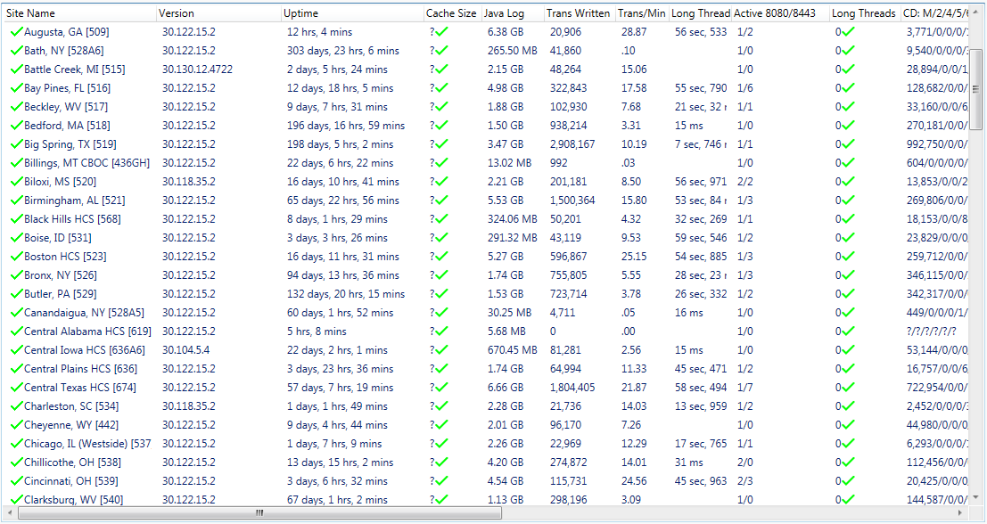

The Sites List tab provides a subset of information from all VIX sites. The information in the columns is sortable.

For details about the information in the columns, see Failed VIX Sites. The columns in the Failed VIX Sites list are identical to these columns.

# Watched Sites Tab

The watched sites tab provides a list of sites that are of interest to the user. The user can designate any site to be watched by right clicking on the site and selecting *Add Watch* from the *Site Details*, *Quick View*, or *Sites List* tabs. The list of sites to be watched is stored in a configuration file on the workstation.

To remove a site from the *Watched Sites* tab, right click on the site and select *Remove Watch*.

For details about the information in the columns, see Failed VIX Sites. The columns in the Failed VIX Sites list are identical to these columns.

# Test Sites Tab

The test sites tab provides a list of sites that are specified as test sites. These are sites not in the site service but that the user wishes to monitor. This can be used for monitoring test VIX/CVIX systems.

To add or remote a site to the Test Sites tab, go to the Test Sites tab in the Settings, see Test Sites Settings.

For details about the information in the columns, see Failed VIX Sites. The columns in the Failed VIX Sites list are identical to these columns.

# Monitored Properties Tab

This tab shows a single day list of monitored properties from all VIX/CVIX servers. See Monitored Properties for more details.

# Long Running Threads Tab

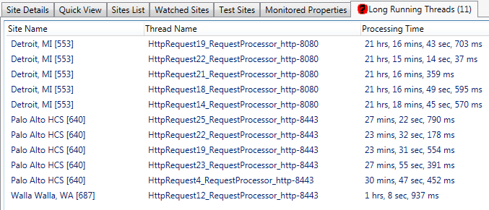The Long Running Threads tab provides a list of the threads from all VIX/CVIX servers that have been running longer than expected. Double Clicking on a thread in the list will launch the Thread Viewer dialog that shows the stack trace for that thread. This provides a quick way to see each long running thread grouped together and to easily access information about the thread.

For more information about thread stack traces, see Thread Stack Traces.

# Monitored Properties

Monitored properties are properties the VIX Health Monitor looks at and if they have changed from the last time information was loaded from a VIX/CVIX then that change is logged. The first time information is loaded, no change will be indicated.

Monitored Properties should be used for properties that do not change frequently but when they change it would be useful to track. This could include the VIX Version or hostname. Monitored properties should not be used for properties that frequently change such as the uptime.

Configuring Monitored Properties can be done in the Settings dialog (see Monitored Properties).

# Active Threads

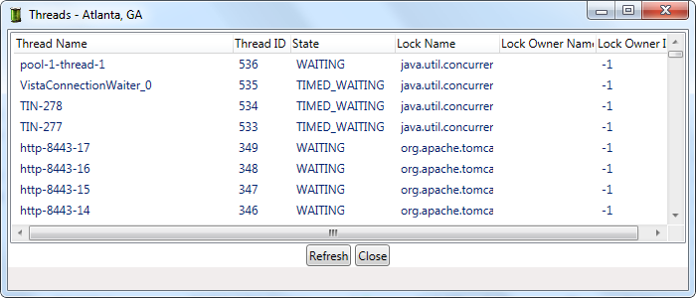

The VIX Health Monitor can request the list of active threads from the VIX/CVIX to give an indicator of the work the VIX/CVIX is currently doing. This is useful is a VIX/CVIX is not working properly and a thread might be deadlocked waiting for another thread. This functionality requests at least the Patch 122 VIX be installed.

The user can double click on any thread to view the stack trace for that thread. See Thread Stack Traces.

# Thread Stack Traces

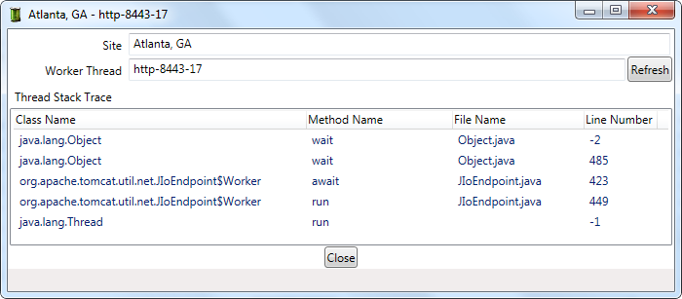

The VIX Health Monitor can request the stack trace of any thread of the VIX/CVIX. This functionality requires at least the Patch 122 VIX be installed. If a thread has been processing for longer than expected, viewing the stack trace can help indicate what it is doing and if there is a problem. The stack trace indicates what method the thread is currently processing which can help determine the cause of an issue.

# Memory Information

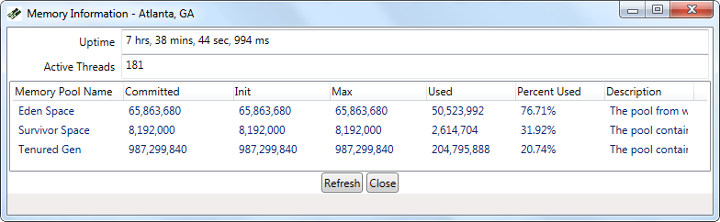

The VIX Health Monitor can request the memory information from the VIX/CVIX. This functionality requires at least the Patch 122 VIX be installed. The memory information can be useful to determine if a VIX/CVIX is using too much memory and might soon run out of memory.

# Logged Test Results

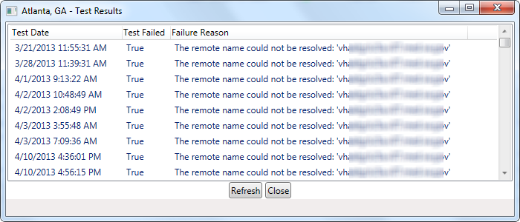

If *Log Failed Health Requests* is enabled in settings (See General), the VIX Health Monitor will track when it tried to retrieve health from a VIX/CVIX and was unable or an issue was detected. This provides a history of the ability of the Health Monitor to load information from a site. This information is stored on the user workstation.

# VIX Administrators

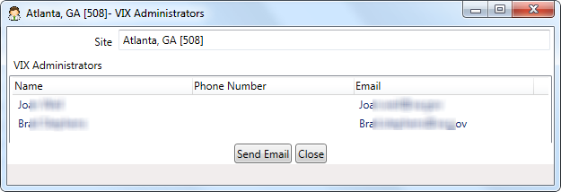

The VIX Administrators dialog shows the contact information for the people assigned to each VIX server. This information is stored in the VIX Wiki and is based on the requestors who configured the VIX. This contact information is useful if there is an issue with a VIX and the administrators at the site need to take action.

The Send Email button can be used to create an email template to send to contact the administrators.

# Checksums

The VIX Health Monitor can retrieve the checksums from the VIX/CVIX and compare them to a known set of good checksums stored on the VIX Wiki. This allows the user to verify the installation of the VIX is correct and no old Java packages are installed. This functionality requires the site have the Patch 138 VIX/CVIX installed.

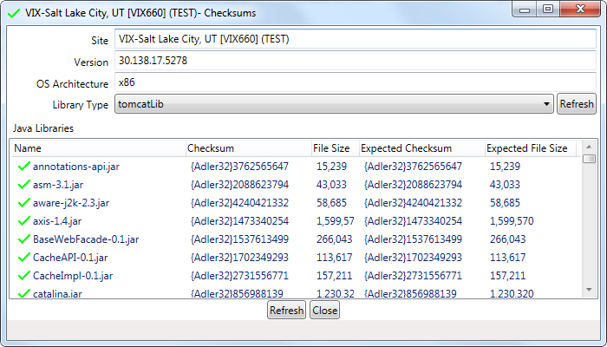

The Checksums dialog by default loads the Java packages from the Tomcat library directory and compares them to the expected values. The dialog can also retrieve the Java packages from the JRE\Lib\Ext directory and compare them to expected values.

Any packages that do not have the correct checksums will have a red icon next to them.

# Settings

Settings can be modified by going to the Edit menu and selecting Settings

## General Settings

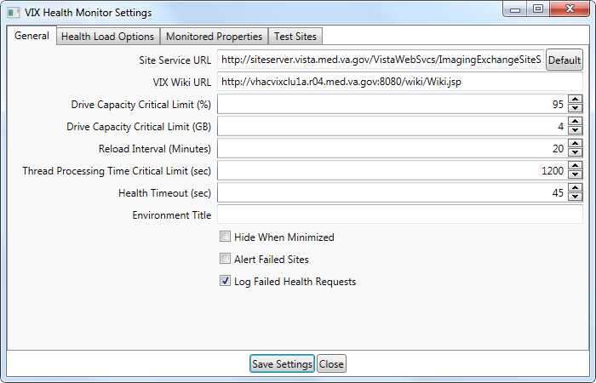

|  |  |
| --- | --- |
| **Field** | **Description** |
| Site Service URL | The URL to use to load the site service information from |
| VIX Wiki URL | Used to retrieve the list of VIX administrator information |
| Drive Capacity Critical Limit (%) | The percentage of the VIX cache must be full for the drive to be marked as critical |
| Drive Capacity Critical Limit (GB) | The amount of the drive that must remain for the drive to be marked as critical |
| Reload Interval (Minutes) | How often (in minutes) the application will query VIX/CVIX Servers for updated health information when the interval test is running |
| Thread Processing Time Critical Limit (sec) | How long a thread must be running for (in seconds) for it to be identified as a long running thread |
| Health Timeout (sec) | The amount of time (in seconds) the VIX Health Monitor will wait to get a response from a VIX/CVIX when requesting the health information |
| Hide When Minimized | When checked, the VIX Health Monitor will hide when minimized. Double clicking the icon in the task bar will restore the VIX Health Monitor |
| Alert Failed Sites | When checked, a balloon will appear in the tray indicating the number of sites that failed |
| Log Failed Health Requests | When checked, failed health requests will be logged on the workstation |

## Health Load Options Settings

This lists the options used when requesting health information from the VIX/CVIX. Checked items will load that set of information from the VIX/CVIX.

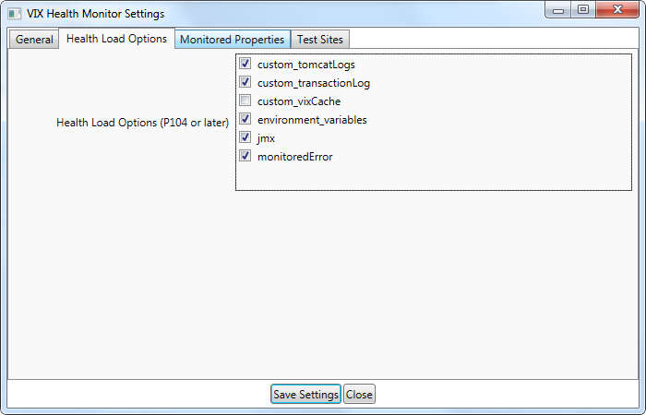

|  |  |
| --- | --- |
| **Field** | **Description** |
| custom_tomcatLogs | Information about the Java logs |
| custom_transactionLog | Information about the Transaction logs |
| custom_vixCache | Information about the cache (recommended to not include this because it greatly increases the amount of time it takes to retrieve health information) |
| environment_variables | Information that is stored in environment variables on the VIX/CVIX |
| jmx | Information stored in JMX on the VIX/CVIX (the majority of useful information) |
| monitoredError | Monitored error information from the VIX/CVIX |

## Monitored Properties Settings

See Monitored Properties for a description of monitored properties.

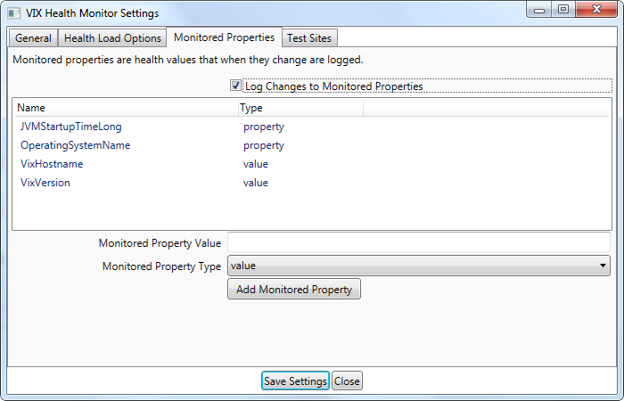

|  |  |
| --- | --- |
| **Field** | **Description** |
| Log Changes to Monitored Properties | When checked, the monitored properties that are configured will be logged when they change |

There are two types of properties that can be monitored, *property* and *value*. Properties are properties of the VIX Health object and require the developer to describe what properties can be added. Values are raw VIX Health values which are shown on the Raw Data tab.

## Test Sites Settings

See Test Sites Tab for a description of test sites.

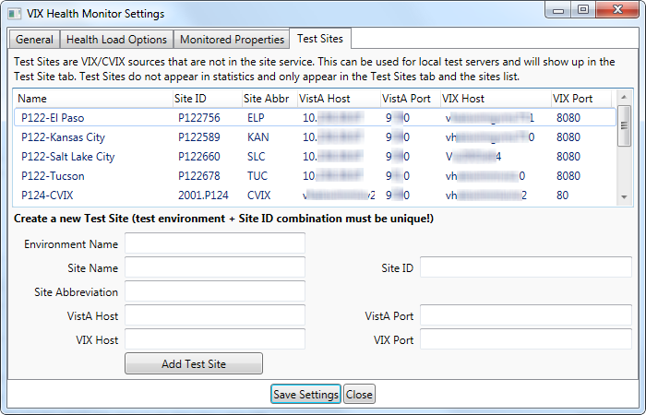

The list shows the existing test sites. Right clicking on a site provides an option to remove a test site.

|  |  |
| --- | --- |
| **Field** | **Description** |
| Environment Name | A unique short description of the enrivonment. This is used to group servers and to uniquely identify a server. This is prepended to the name of the site and appended to the Site ID value to create a unique Site ID |
| Site Name | The name of the site |
| Site ID | The site number for the site |
| Site Abbreviation | The abbreviation of the site |
| VistA Host | The hostname of the VistA database the site uses |
| VistA Port | The port of the VistA database the site uses |
| VIX Host | The hostname of the VIX/CVIX |
| VIX Port | The port of the VIX/CVIX (8080 for VIX, 80 for CVIX) |