

Mag Logger
On-line Help

(Patch 94)

March 2010

Department of Veterans Affairs
System Design and Development
VistA Imaging

This help file provide users with visual instructions on using the VISTA Imaging Clinical Display V.3.0 – Patch 94 logging component which has been upgraded from Patch 93. This utility is called Mag Logger and is referred to as “logger”.

The logger is a utility that is built into Clinical Display, Clinical Capture, and TeleReader. It has been available in patches before Patch 94. In Patch 94 it has been enhanced to deliver more information to the user.

The logger displays messages appropriate the user’s privilege level based on the user being granted the MAG SYSTEM key. If the user has the MAG SYSTEM key all messages (system-level and user-level) are viewable. Otherwise the user can only see user-level messages.

Quick Start -- Guide to the Logger Utility

Start VistA Imaging Display or Capture or TeleReader
The logger display is accessible in Clinical Display at the bottom left side of the main form as a notebook icon.
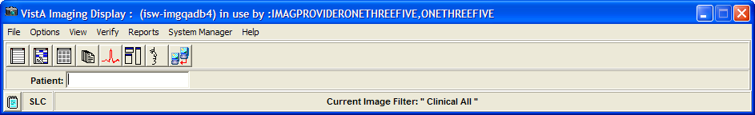

In Clinical Display the logger is also accessible from the main form System Manager menu, “Show Messages from Last OpenSecureFile call” option.
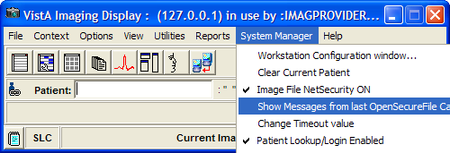
In Clinical Display the logger is also accessible from the Image List form under the Options menu pull-down.

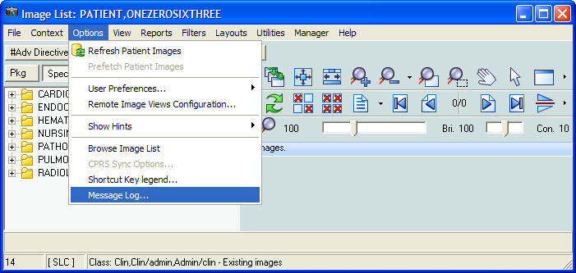

Logger Screens – Message History

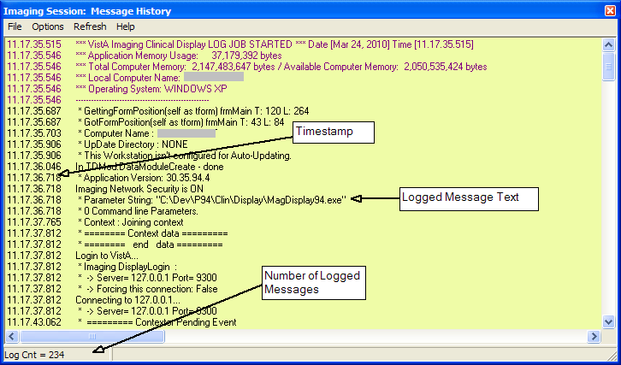

The above screen is a sample. Your log output will display different information.

