

Mag Logger
On-line Help

(Patch 94)

October 2009

Department of Veterans Affairs
System Design and Development
VistA Imaging

This help file provide users with visual instructions on using the VISTA Imaging Clinical Display V.3.0 – Patch 94 logging component which has been upgraded from Patch 93. This utility is called Mag Logger and is referred to as “logger”.

The logger is a utility that is built into Clinical Display, Clinical Capture, and TeleReader. It has been available in patches before Patch 94. In Patch 94 it has been enhanced to deliver more information to the user as well as to write logged information to a local disk file at the conclusion of a session with any of the clinical applications.

The logger displays messages appropriate the user’s privilege level based on the user being granted the MAG SYSTEM key. If the user has the MAG SYSTEM key all messages (system-level and user-level) are viewable. Otherwise the user can only see user-level messages.

All logged messages are captured to your local hard drive in the user’s Documents and Settings folder area. This file is a PKZIP/WINZip compressed file and is encrypted. You must have the password to open the file archive entries. Contact your site IRM for the password. The logger ensures that the disk zip file never exceeds 10 MB in total size. If the file grows to 10 MB or larger the logger removes the oldest archive entries in the zip file before storing a new session. If archives are older than 30 days they are also removed from the zip file.

Quick Start -- Guide to the Logger Utility

Start VistA Imaging Display or Capture or TeleReader
The logger display is accessible in Clinical Display at the bottom left side of the main form as a notebook icon.
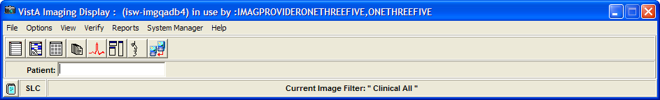

In Clinical Display the logger is also accessible from the main form System Manager menu, “Show Messages from Last OpenSecureFile call” option.
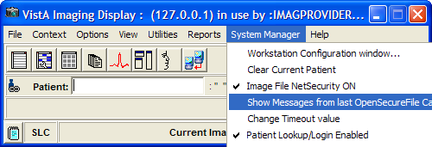
In Clinical Display the logger is also accessible from the Image List form under the Options menu pull-down.

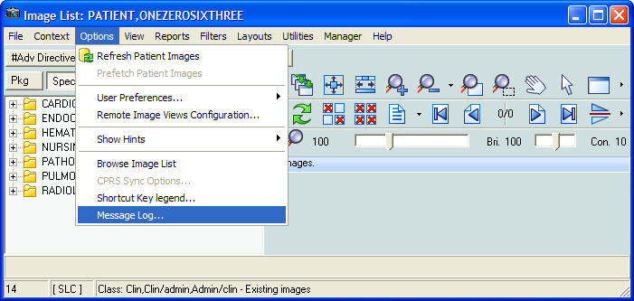

Logger Screens – Message History

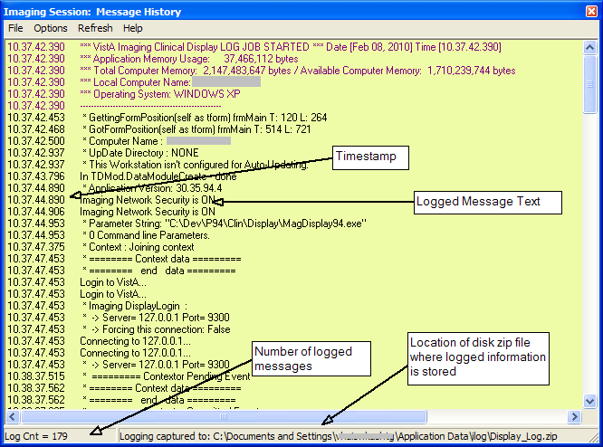

The above screen is a sample. Your log output will display different information. The location of the disk zip file on the bottom of the above screen has redacted the user id within the path. On your machine the path will be the similar except the redacted portion will contain the current user’s ID. The example was generated in Clinical Display. If you start a different clinical application the location and name of the disk zip file will be:
Clinical Display:
C:\Documents and Settings\<your ID>\Application Data\ilog\Display_Log.zip
Clinical Capture:
C:\Documents and Settings\<your ID>\Application Data\ilog\Capture_Log.zip
TeleReader
C:\Documents and Settings\<your ID>\Application Data\ilog\TeleReader_Log.zip

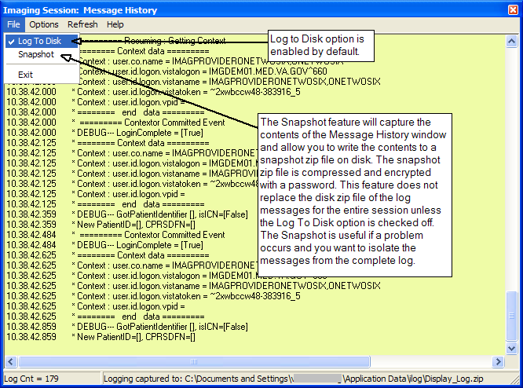
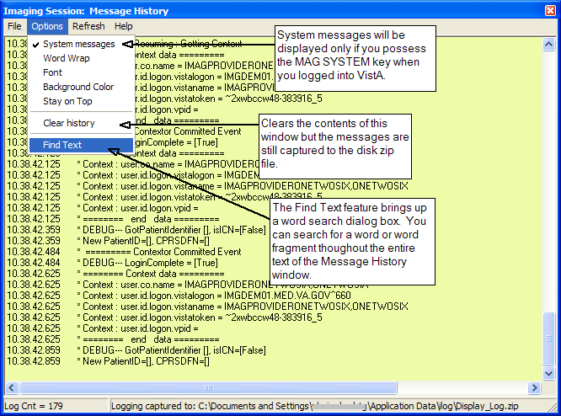
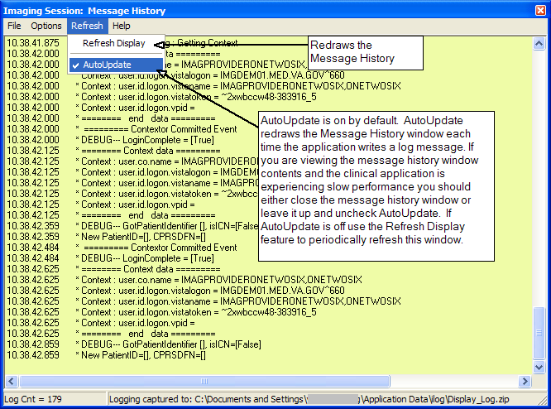

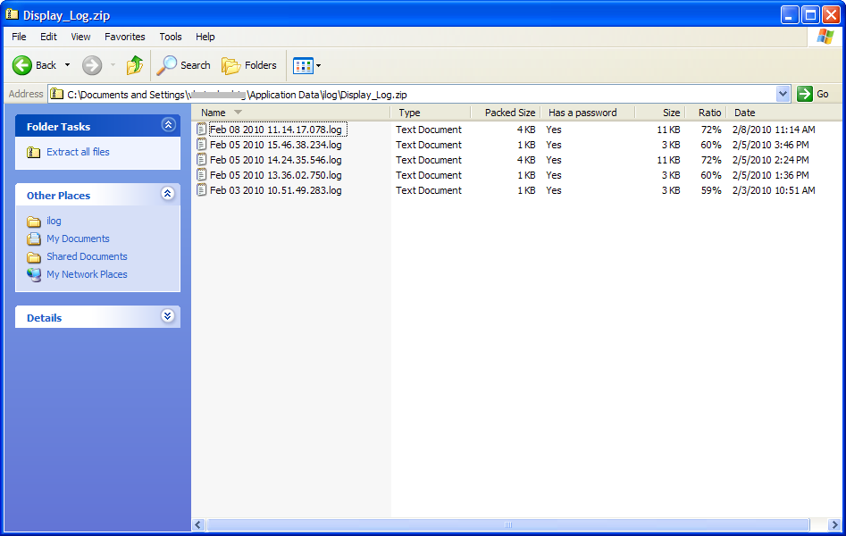

PKZip/WinZip file cotaining individual logged sessions. Each log session corresponds to an execution of the clinical application. Each log session is timestamped and unique. Click on any entry, provide the password, and the zipped contents are displayed in readable format.
Time format is in month, day, year, hour, minute, second, and millisecond.

If the zip file is deleted, a new file will automatically get created when the clinical application is run.
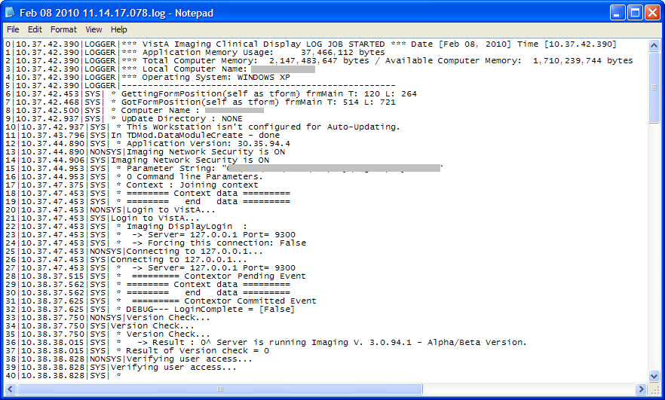
Displaying the contents of a zipped clinical application session after entering the password to open the file. This is the raw unformatted data that is used to populate the display screen.

