TeleReader Configurator
Contents
TeleReader Configurator Main Screen 1
Acquisition Site Setup 1
TeleReader Unread List page 1
TeleReader Unread List Add/Edit Dialog 2
Modality Worklist Page 3
Modality Worklist Add/Edit Dialog 4
Reading Site Setup 6
Acquisition Sites Page 6
Acquisition Site Add/Edit Dialog 7
Readers Page 8
Add Readers/Privileges dialog 9
Activate/Deactivate Privileges 9
Cloning TeleReader Profiles 10
Global Settings 13
System Help 14
Message Log 14
About Box 15
Field Help Text 16

TeleReader Configurator Main Screen
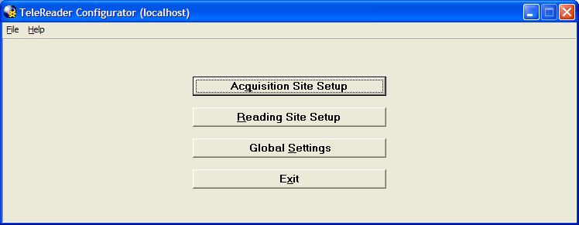
From the TeleReader Configurator Main Screen, the reader has options to set up TeleReader settings relevant to an Acquisition site, a Reading Site or both (Global Settings). The reader can also view the System Log or About box (from the File menu). The main screen title bar displays the login server in parentheses.

Acquisition Site Setup
From the Acquisition Site Setup screen, the reader can view/add/edit/delete records from the TELEREADER ACQUISITION SERVICE file (#2006.5841) on the TeleReader Unread List page or view/add/edit/delete records from the DICOM HEALTHCARE PROVIDER SERVICE file (#2006.5831) on the Modality Worklist page.

TeleReader Unread List page
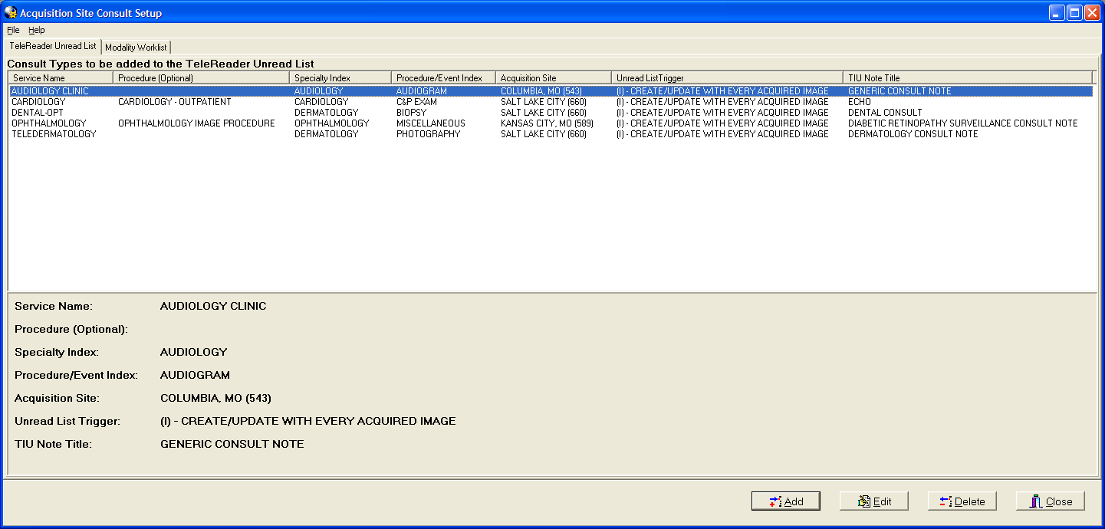
The TeleReader Unread List page displays records in the TELEREADER ACQUISITION SERVICE file (#2006.5841)in a listview. The bottom panel shows the detail of the selected record. The reader can add a new record or edit/delete an existing one.

TeleReader Unread List Add/Edit Dialog
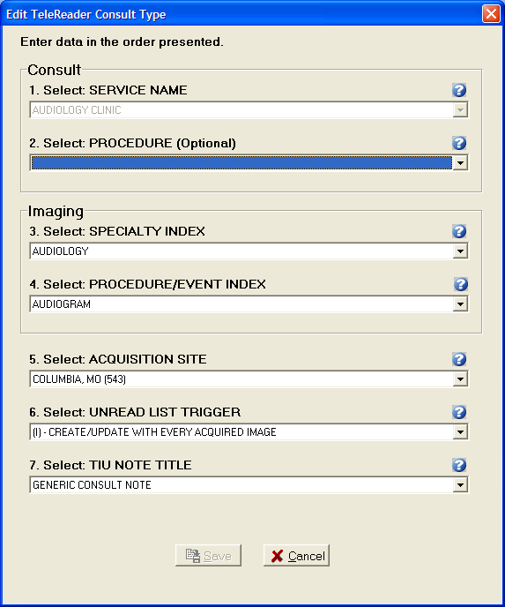
The TeleReader Unread List Add/Edit dialog gives the reader the ability to add a new/edit an existing record from the TELEREADER ACQUISITION SERVICE file (#2006.5841) by choosing values from drop-down lists. In Edit mode, the Service Name combo box is disabled. The Procedure drop-down list will be a subset of the chosen Service Name. The Procedure/Event index drop-down list will be a subset of the chosen Specialty Index. In Add mode, the Acquisition Site defaults to the Login Site and the Unread List Trigger defaults to (I) – Create/Update With Every Acquired Image.

Modality Worklist Page
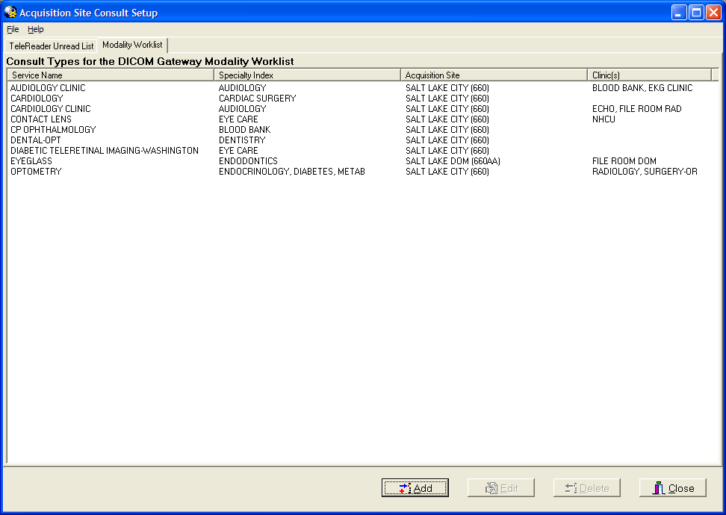
The Modality Worklist page displays records in the DICOM HEALTHCARE PROVIDER SERVICE file (#2006.5831) in a listview. The reader can add a new record or edit/delete an existing one.

Modality Worklist Add/Edit Dialog
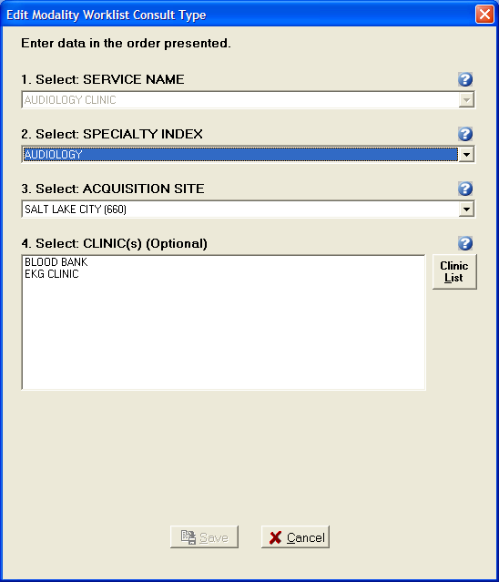
The Modality Worklist Add/Edit dialog gives the reader the ability to add a new/edit an existing record from the DICOM HEALTHCARE PROVIDER SERVICE file (#2006.5831) by choosing values from drop down lists and the Select Clinic(s) dialog. In edit mode the Service Name combo box is disabled. To select one or more clinics click the ‘Clinic List’ to the right of the Clinic(s) list box.
Select Clinics
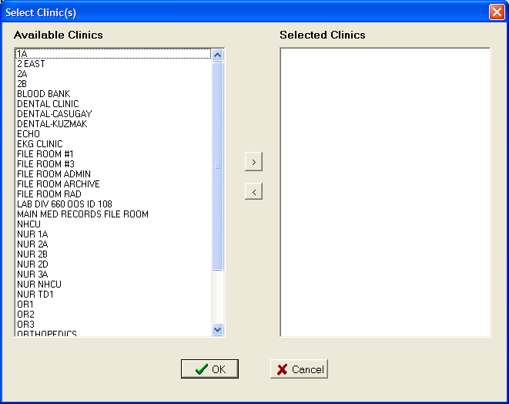
The reader can select clinics from the Available Clinics listbox to the Selected Clinics listbox by double clicking an item in the Available Clinics listbox or by selecting that item and clicking the (>) button. To deselect a clinic from the Selected Clinics listbox double click that item or select the item and click the (<) button. Click OK for make the selection or Cancel to disregard the selections.

Reading Site Setup
From the Reading Site Setup Screen the reader can view/add/edit/delete records from the TELEREADER ACQUISITION SITE file (#2006.5842) on the Acquisition Site page or view/add/edit/delete records from the TELEREADER READER file (#2006.5843) on the Readers page.

Acquisition Sites Page
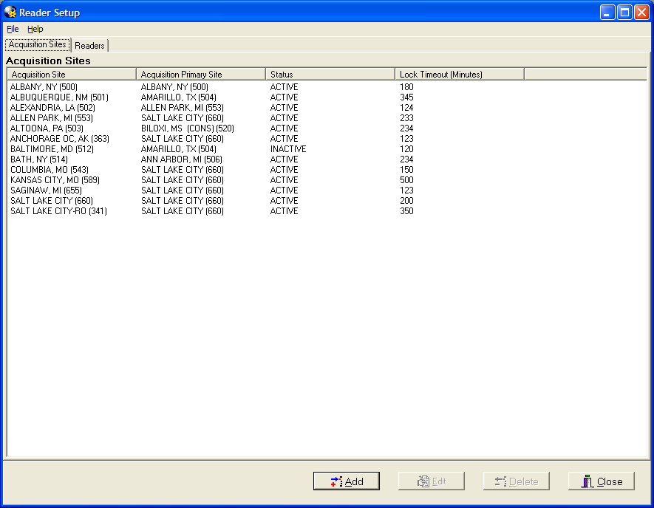

The Acquisition Sites page displays records in the TELEREADER ACQUISITION SITE file (#2006.5842) in a list view. The reader can add a new record or edit/delete an existing one.

Acquisition Site Add/Edit Dialog
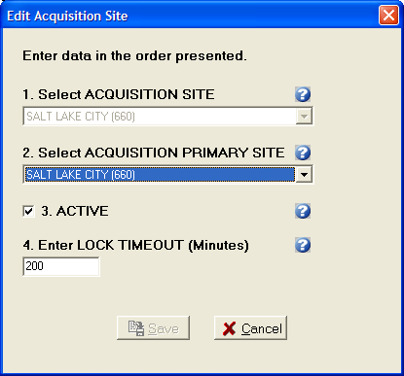
The Acquisition Site Add/Edit dialog gives the reader the ability to add a new/edit an existing record from the TELEREADER ACQUISITION SITE file (#2006.5842) by choosing values from drop down lists, a check box for Active and an edit box for Consult Lock Timeout. In Edit mode the Acquisition Site Combo Box is disabled.

Readers Page
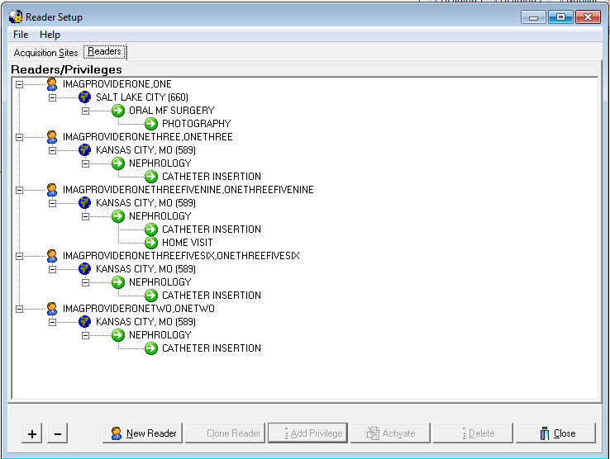
The Readers page displays records in the TELEREADER READER file (#2006.5843) in a tree view. The reader can add/delete new readers, add/delete privileges for those readers (Acquisition Sites, Specialty Index, Procedure Index) and activate/deactivate those privileges. The tree view can be collapsed by clicking the (-) button and expanded (as shown in the image above) by the clicking the (+) button.
To add Privileges, the reader selects the tree view node for he/she wants to add a privilege to. For Example if the user wants to add a new Acquisition Site/Specialty Index/Procedure Index for a Reader, select that Reader’s node and clicks the Add Privilege button. If the reader wants to add a new Procedure Index for a Reader’s Acquisition Site/Specialty Index, the reader selects the Specialty Index node and clicks the Add Privilege button.

Add Readers/Privileges dialog
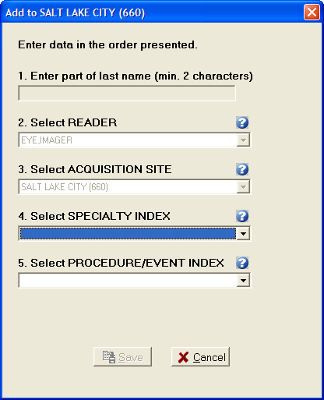
The Add Reader/Privilege dialog gives the reader the ability to add a new Readers/Reader Privileges to the TELEREADER READER file (#2006.5843) by choosing values from drop down lists. When adding a new Privilege, the Reader and any parent Privilege is disabled. For example when adding a new Specialty Index, the Reader and Acquisition Site combo boxes will be disabled.
When adding a new Reader, enter a partial last name (at least first 2 characters) in the step 1 edit box and press enter. The Reader combo box drop down will be the populated with the list of matches against the last name string from the edit box. The 1st match in the list (alphabetically) will default as the selection.

Activate/Deactivate Privileges
To activate/deactivate a privilege, select that node and click the Activate/Deactivate button (the button’s text will read Activate when the Reader tree view’s selected node is on an inactive Privilege and will read Deactivate when on an Active Privilege. When Deactivating an Active Privilege, the all Child Privilege will be deactivated as well. All Deactivated Privileges will have an icon change for their given node (Grayed out globe for Acquisition Site, Gray Pause button for Specialty Index, Procedure index). The Privilege that is explicitly deactivated will have the text ‘[INACTIVE]’ appended to it. To Activate the Privilege and its child Privileges select the appropriate node and click Activate. The Privilege and all child privilege will become Active with the icon changing (colored in globe, green play button) and the ‘[INACTIVE]’ text removed. NOTE: If a child Privilege had been explicitly deactivated at an earlier time, it will remain so, even after the parent privilege is activated until it is explicitly activated.

Cloning TeleReader Profiles
Once a reader profile is set up, a site administrator can clone the profile to provide consistent profiles for other readers who perform the same function.

Clone Reader Function Readers/Privileges Screen
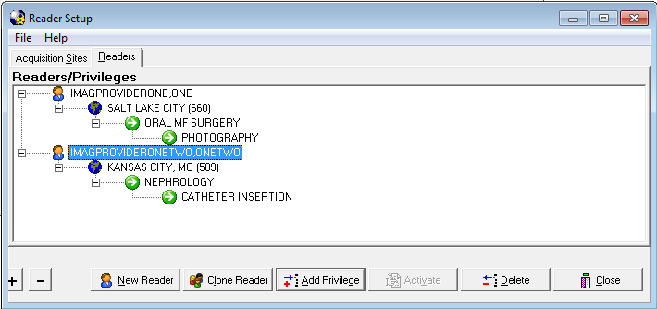
To clone a reader profile, from the TeleReader Configurator main screen click the Reading Site Setup button. The Reader Setup screen opens.
From the Readers/Privileges tree view, select the reader whose privileges you want to clone. The reader is highlighted in blue. Click the Clone Reader button.

The Select Reader(s) to be Cloned screen opens.

Select Readers to Be Cloned Screen
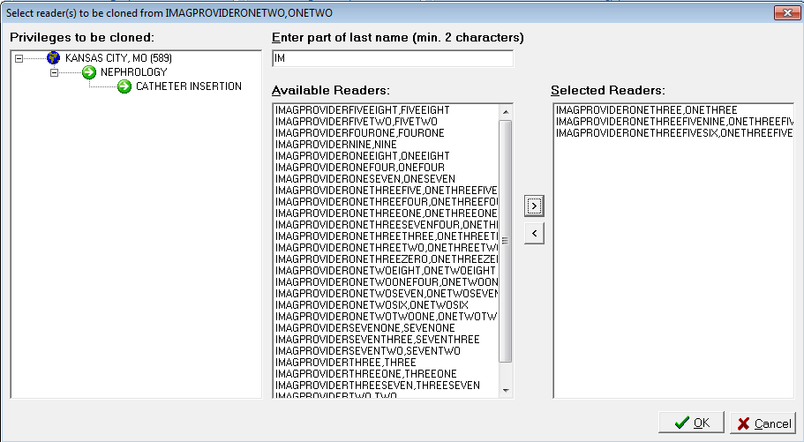

The Privileges to be cloned panel displays the site name and lists the privileges that will be cloned to new readers. In the Enter Part of Last Name field, enter at least the first two characters of the last name of the reader to which you want to clone the selected privileges. The list of readers with no assigned privileges whose names match the search string populates in the Available Readers panel. Use the forward arrow () and backward arrow () to move readers from the Available Readers panel to the Selected Readers panel and vice versa. You may also move readers back and forth by double-clicking on the reader name, or selecting the name and clicking the [Ctrl] button and then the [Enter] button on your keyboard.

 | NOTE: If TeleReader Configurator does not find readers whose names match the search string you enter into the Enter Part of Last Name field, a No Matches Found dialog displays. To return to the previous screen and enter another search string, click the [OK] button.  No Matches Found Dialog
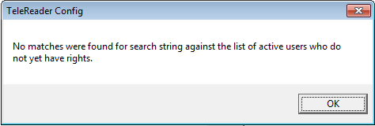
NOTE: You cannot clone privileges from a reader to another reader who already has a reader profile. You must delete that reader’s privileges first. To delete a reader’s privileges, follow the steps in the section titled Deleting a Reader or a Reader Privilege.
Complete the selection of readers to whom you want to clone the privileges. When the Selected Readers panel is populated, the [OK] button activates.
Click [Cancel] to cancel the clone or
Click [OK] to continue.
A confirmation of cloning action dialog opens, listing the readers for whom profiles will be created with the cloned profile.

Global Settings

TeleReader Global System Settings Screen
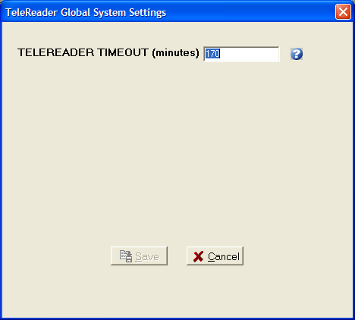
Currently the only setting that is relevant to both the Acquisition Site and Reading Site is the TeleReader Timeout setting, field #131 of the IMAGING SITE PARAMETERS file (#2006.1). This setting specifies how long the TeleReader application can stand idle on a desktop before it closes.

System Help

Message Log
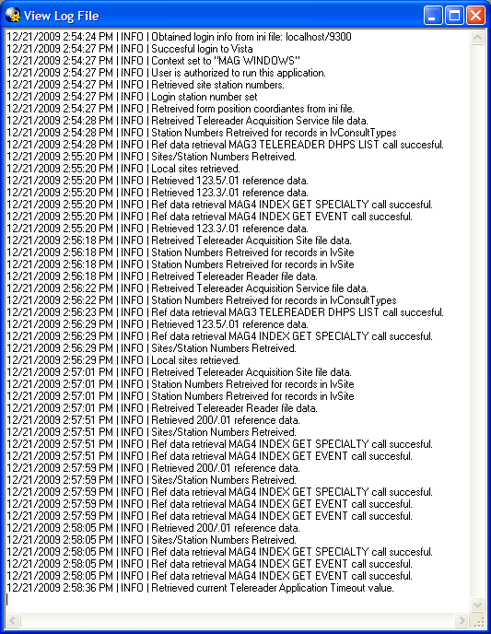
The System log can be accessed from the TeleReader Configurator Main Screen. Under the Help Menu select Message Log. The system log shows Login information, Inserts/Deletes/Updates and Retrievals from VistA database files and SOAP calls to Imaging Exchange Web Service (done when adding a new Acquisition Site in the Add Acquisition Site screen to check that the Primary Site is a valid primary site.

About Box
The About box can be accessed from the TeleReader Configurator Main Screen. Under the Help Menu select About... The About box shows information about the application, such as version number and compilation date.
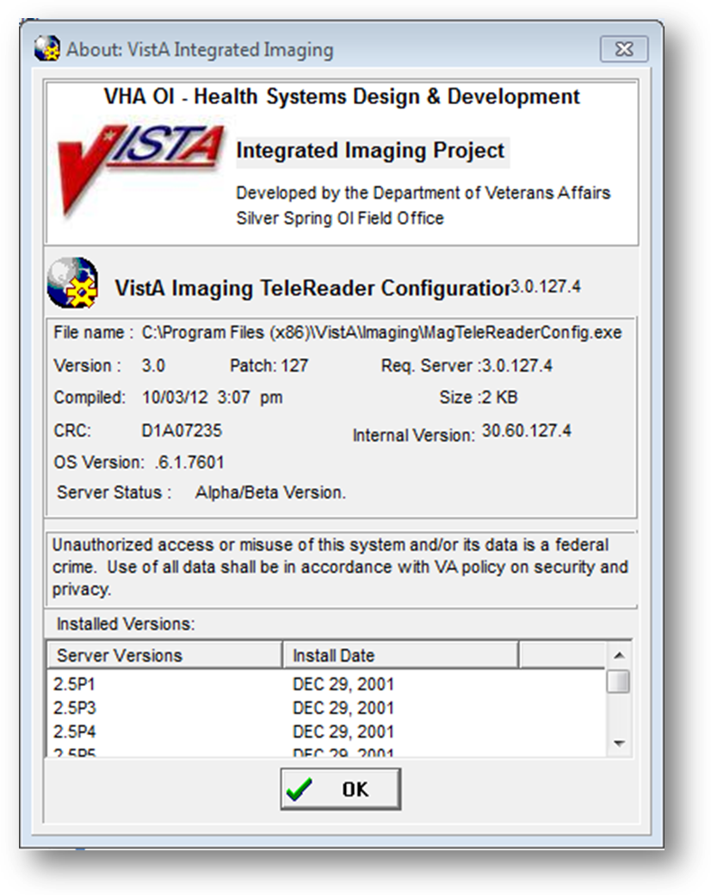

Field Help Text
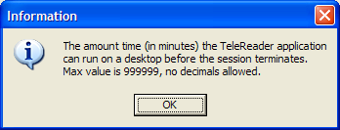

All of the Add/Edit screens have Field Text Help functionality. For any control (combo box, edit box, check box, list box) that is connected to a field in VistA file either click the question mark image to the right of the control or put focus on the control and press F1. A dialog will appear that contains information about the VistA file field such as a description of what data the field holds and allowable input values, such as max minutes allowed for TeleReader Timeout.

