Christopher Henderson

Operating System:

OS X El Capitan 10.11.6 (15G1004)

Browsers:

Chrome: 52.0.2743.116 (64-bit)

Firefox: 40.0

Safari: 9.1.3 (11601.7.8)

|  |  |  |  |
| --- | --- | --- | --- |
| INPUT TYPE | Chrome | Firefox | Safari |
| color | Yes | Yes | No - Plain text box. |
| date | Yes | No - Plain text box. | No - Plain text box. |
| datetime | No - Plain text box. | No - Plain text box. | No - Plain text box. |
| datetime-local | Yes | No - Plain text box. | No - Plain text box. |
| email | Yes | Yes | No - Plain text box. |
| month | Yes | No - Plain text box. | No - Plain text box. |
| number | Yes | Yes - BUT, it will let you type in anything and THEN complain, which isn't great behavior. | No. It has incrementer for selecting a number, but ultimately you can put whatever you want in there and it will accept it. |
| range | Yes | Yes | Yes |
| search | Yes | Yes | Yes |
| tel | No - Plain text box. | No - Plain text box. | No - Plain text box. |
| time | Yes | No - Plain text box. | No - Plain text box. |
| url | Yes | Yes | No - Plain text box. |
| week | Yes | No - Plain text box. | No - Plain text box. |
| RTN | Yes | Yes | No - no validation. |

## MSNBC.com

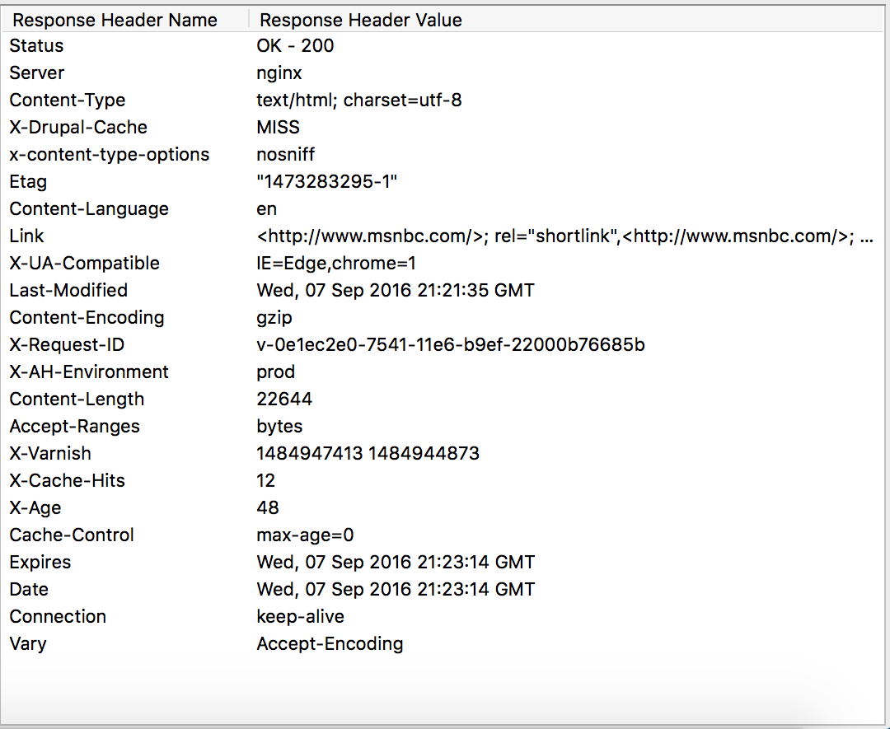

1. Does the site set a cookie?
   1. msnbc.com by *itself* does not appear to setting a cookie, but there were loads of other domains setting cookies.
2. Does the site use persistent connections?
   1. Connection: keep-alive, yes.
3. Does the site compress its content?
   1. Content-Encoding gzip, yes

## 

## bing.com

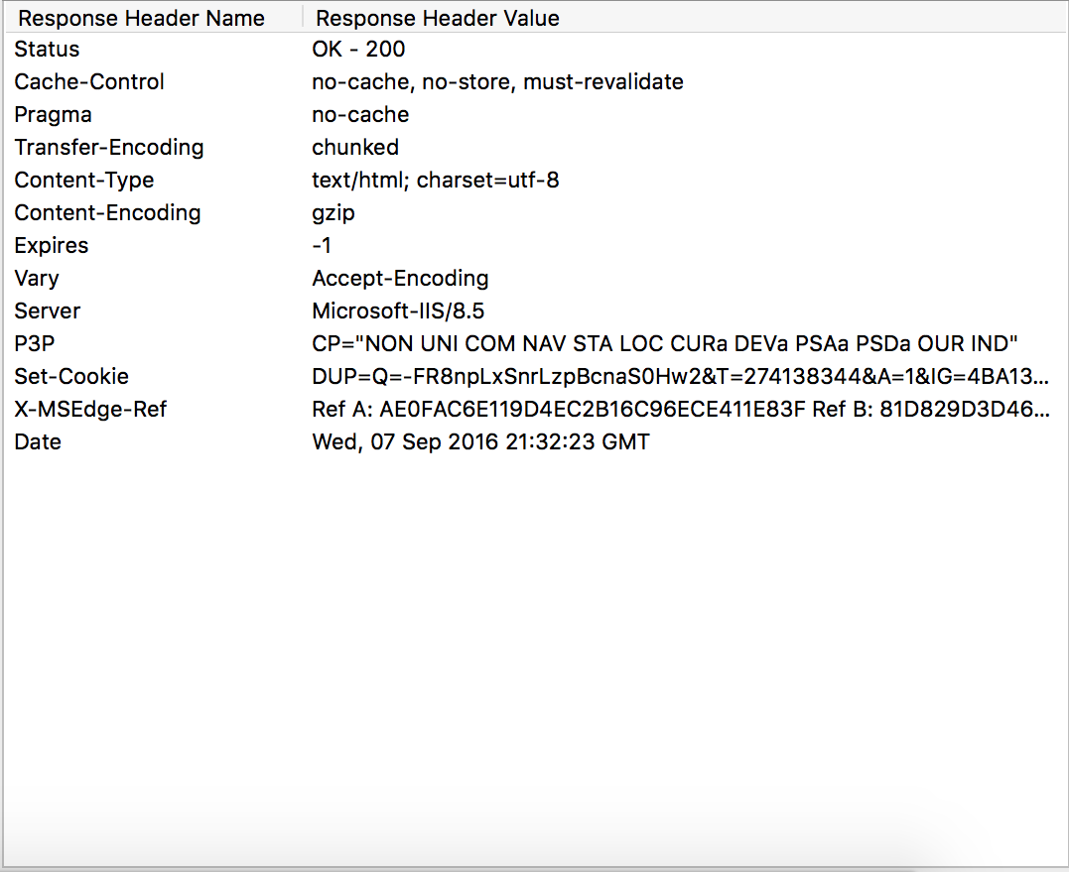

1. Does the site set a cookie?
   1. bing.com by *itself* does not appear to setting a cookie, but there were loads of other domains setting cookies.
2. Does the site use persistent connections?
   1. No.
3. Does the site compress its content?
   1. Content-Encoding gzip, yes