

[**21.5”**](https://www.smartmediaworld.net/products/social-distancing-security-personal-protective-products-covid19.html) **INTERACTIVE DIGITAL KIOSK**

[**WITH HAND - S ANITIZER GEL DISPENSE**](https://www.smartmediaworld.net/products/social-distancing-security-personal-protective-products-covid19.html)**R**

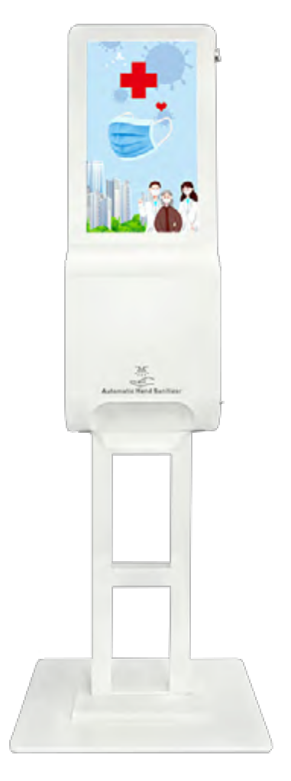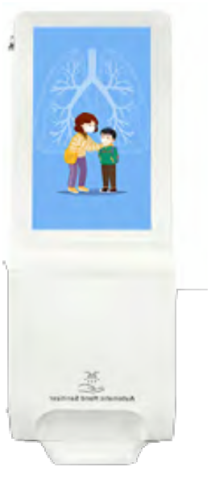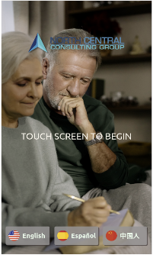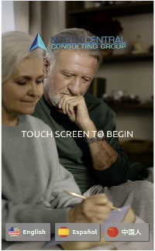

**Simultaneously Provide information to customers while sanitizing hands.**

This Kiosk was designed for business and access to any shared spaces, also to do

an extra effort to educate users about

how to contain the COVID-19 virus.

**The 21.5-inch Display for Digital Signage** makes the information provided more effective and efficient.

The built-in automatic sensor

Dispenser distributes the gel Sanitizer.

The device can be provided with a stand or for wall. Optional side sensor for temperature detection while bringing your wrist closer to 2 inches.

**MAIN FEATURES**

Basic Media Player version: 21.5” - FULL HD - NO TOUCH - USB input - Sanitizer Dispenser with Sensor

**Optional: Code KIO-21ST for Wrist**

**Temperature Detection and Code KIO-**

**21AN for Android Player**

• Wall installation

(standard version)

• Stand installation

(optional version)

Kiosk Indoor for use

in public places such

as shopping malls,

bathrooms, schools,

restaurants, hospitals,

hotels, waiting rooms,

companies.

* The product images are purely indicative and may change at any time without notice.



**MAIN FEATURES**

|  |
| --- |
| **Model** KIO-21SA 21.5” KIOSK WALL MOUNTED SANITIZER (Standard vers.) |
| Display 21.5" LCD, no touch |
| Brightness 350cd/m2 |
| Contrast 1400:1 |
| Active area 15.44 IN (l) x 27.46IN (h) |
| Angle view 178°/178° |
| Resolution 1920 x 1080 |
| Standard version Media Player with image and video playback from USB plug and play. |
| Android-based version Built-in Android 7.1 player, 2GB RAM, 8GB internal memory, lan, wifi,  bluetooth, HDMI input.  SmartMedia SmartSignage Software included - 1 year free |
| Sanitizing Dispenser 1200ml capacity, automatic gel sanitizer dispenser |
| Operating temperature temperature +32 to +104 degrees Fahrenheit, humidity 35%-85% RH, no  condensation |
| Storage temperature temperature +14 to +122 degrees Fahrenheit, humidity 15%-90% RH, no  condensation |
| Integrated speakers 5Watt x 2 |
| Power 110-240V, 35W |
| Certifications CE,RoHS,CCC,FCC,ISO9001 |
| Kiosk body size 14.96 x 8.26 x 42.12 in  (wall installation, l x w x h) |
| Stand size (l x w x h) 21.65 x 15.75 x 67.40 in |
| Stand base size (l x w) 21.65 x 15.75 in |
| Maximum size 21.65 x 15.75 x 71.70 in  (Stand installation, l x w x h) |
| Tested to operate continuously 24 hours a day, 7 days a week |
| * Optional wrist temperature detector (only compatible with Android player) |

**Order codes**

KIO-21SA 21.5” Kiosk Sanitizer Dispenser for wall

(Standard version.)

KIO-21BA Stand for 21,5” Kiosk Sanitizer

Dispenser(optional)

KIO-21AN INTEGRATED ANDROID PLAYER WITH WIFI FOR

21.5” Kiosk Sanitizer Dispenser (optional)

KIO-21ST Wrist Temperature Detection for 21,5” Kiosk Sanitizer Dispenser (optional)