Interface Control Document (ICD)
PowerPoint Object Extraction Utility
Version 0.5
Modular Baseline Interfaces with Control-Logic Verification Coverage
Document Status: Draft baseline for implementation and review

1. Purpose and Scope
This ICD defines the external command interface, input file interface, output CSV interfaces, internal module boundaries, test harness interfaces, error interface, and versioning rules for the PowerPoint Object Extraction Utility. Baseline v0.5 preserves the object CSV contract, adds relationship output as an independent interface, and documents the test harness interface used to grade extractor behavior against manually authored expected results.

2. External Command Interface
End users run main.py from the command line. The command writes both output CSV files needed for downstream ingestion. Figure 2-1 shows the external context.
python src/main.py <pptx_file> <output_dir>
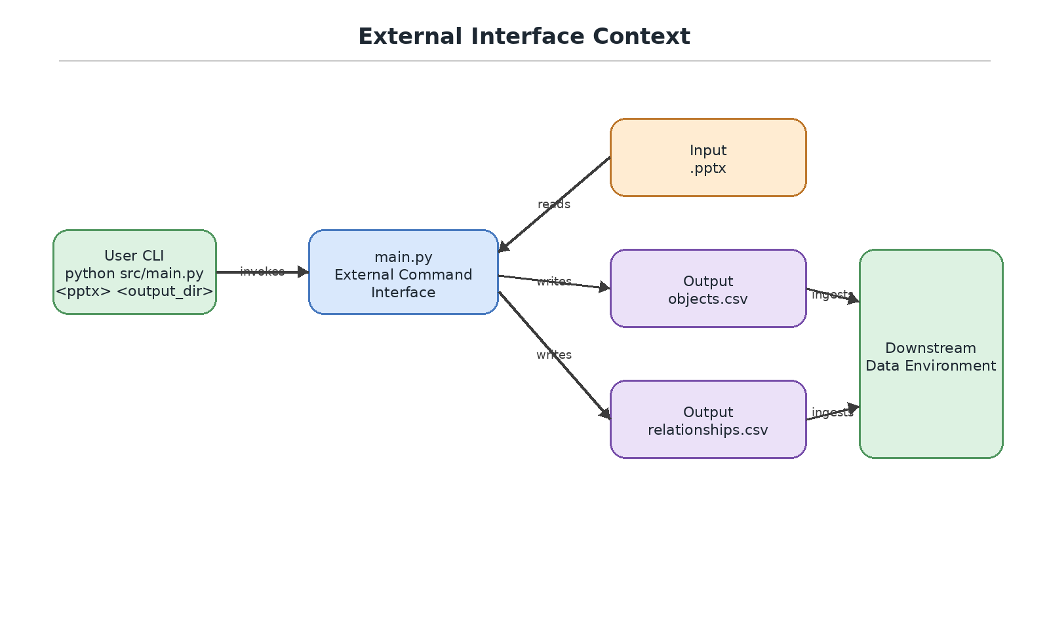
Figure 2-1. External Interface Context
Argument | Type | Required | Description
pptx_file | Path | Yes | Path to the input Microsoft PowerPoint .pptx file.
output_dir | Path | Yes | Directory where objects.csv and relationships.csv should be written.

3. Input File Interface
Interface Item | Contract
Supported file extension | .pptx
Unsupported file extension | .ppt legacy binary files are not supported.
Password protection | Password-protected files are not supported.
Flattened image diagrams | The image object is listed, but image contents are not interpreted.
Slide ordering | Slides are processed in presentation order using one-based slide numbers.
Native objects | Text boxes, AutoShapes, placeholders, pictures, graphic frames, tables, charts, lines, connectors, and grouped shapes may be enumerated if exposed through python-pptx.

4. Output File Interfaces
The runtime output contract consists of objects.csv and relationships.csv. Figure 4-1 shows the two additive CSV interfaces and the compatibility rule.
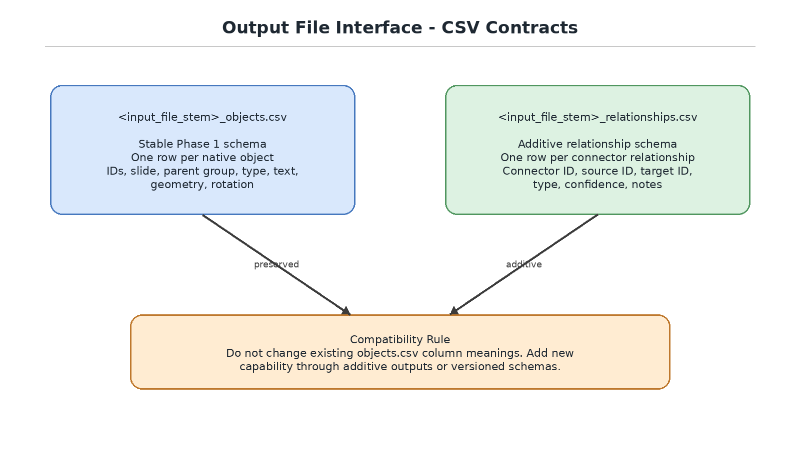
Figure 4-1. Output File Interface - CSV Contracts

4.1 objects.csv
<input_file_stem>_objects.csv preserves the Phase 1 object inventory schema.
Column | Type | Nullable | Description
object_id | string | No | Unique extractor-generated ID.
slide_number | integer | No | One-based slide number.
parent_group_id | string | Yes | Parent group ID if nested.
shape_name | string | Yes | PowerPoint internal shape name.
shape_type | string | No | Readable shape category.
text | string | Yes | Extracted text or blank.
left_in | float | Yes | Left coordinate in inches.
top_in | float | Yes | Top coordinate in inches.
width_in | float | Yes | Width in inches.
height_in | float | Yes | Height in inches.
rotation | float | Yes | Rotation in degrees when available.

4.2 relationships.csv
<input_file_stem>_relationships.csv is additive and contains connector-derived relationships.
Column | Type | Nullable | Description
relationship_id | string | No | Unique extractor-generated relationship ID.
slide_number | integer | No | One-based slide number.
connector_id | string | No | Object ID of the connector object.
source_object_id | string | Yes | Detected source object ID.
target_object_id | string | Yes | Detected target object ID.
relationship_type | string | No | Connector-derived relationship type.
confidence | float | Yes | Extractor confidence value when available.
label_text | string | Yes | Associated label text when available.
notes | string | Yes | Implementation notes or limitations.

5. Internal Module Interfaces
The internal module boundaries are part of the baseline interface. Object extraction owns SlideObject production. Relationship extraction consumes SlideObject records and produces Relationship records. CSV serialization writes output rows without owning extraction logic.
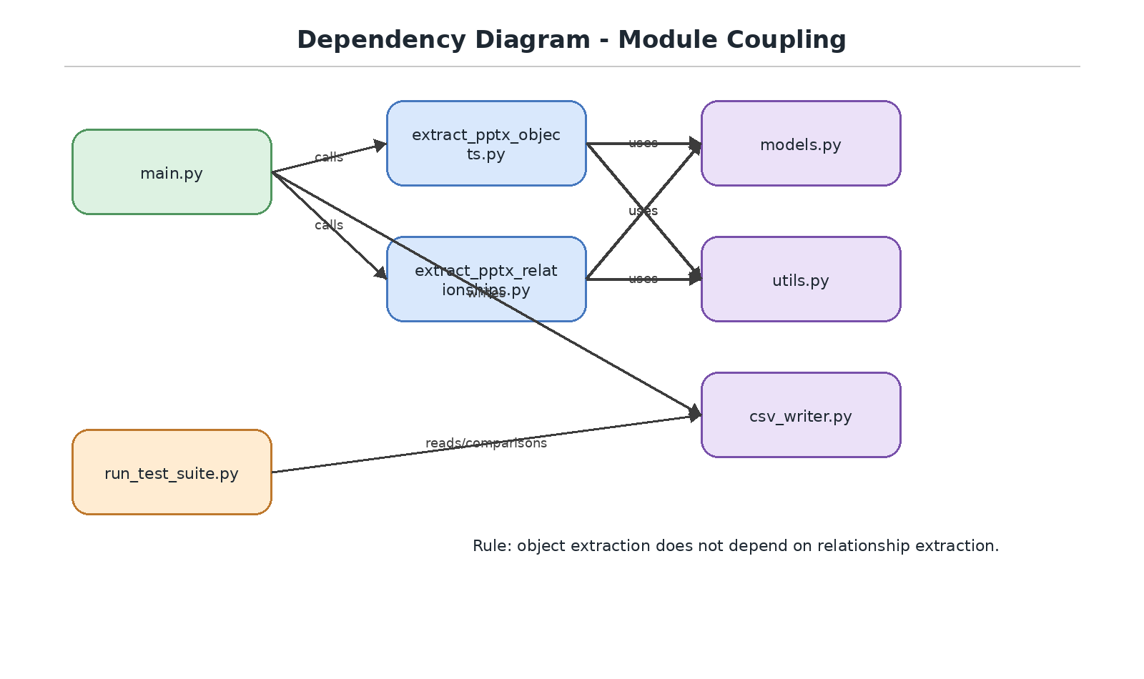
Figure 5-1. Internal Module Interface and Dependency Direction
Module | Public Role | Interface Contract
main.py | CLI orchestrator | Calls domain modules and writes all downstream outputs.
extract_pptx_objects.py | Object domain | Produces List[SlideObject].
extract_pptx_relationships.py | Relationship domain | Consumes List[SlideObject] and produces List[Relationship].
models.py | Shared model boundary | Defines dataclasses and schema constants.
csv_writer.py | Serialization boundary | Writes objects.csv and relationships.csv.

6. Measurement and Identifier Interfaces
Interface | Contract
EMU conversion | PowerPoint EMUs are converted to inches using inches = EMU / 914400 and rounded to three decimal places.
Object ID convention | S<slide_number: three digits>_OBJ_<sequence_number: four digits>.
Relationship ID convention | S<slide_number: three digits>_REL_<sequence_number: four digits>.
Group containment | Child objects reference their group through parent_group_id.

7. Test Harness Interface
The test harness interface uses the manifest to connect input files, expected object CSVs, expected relationship CSVs, and expected counts. Expected files are manually authored ground truth, not generated from the tool. Figure 7-1 shows the test harness interface boundary.
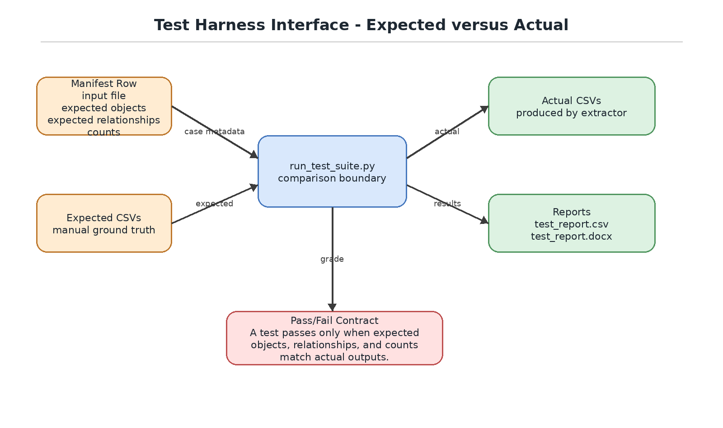
Figure 7-1. Test Harness Interface - Expected versus Actual
Interface Item | Contract
TEST_SUITE_MANIFEST.csv | Defines each test case, input file, expected output files, counts, and purpose.
test_suite/inputs | Contains PowerPoint files used as test inputs.
test_suite/expected | Contains manually authored expected objects and relationships CSVs.
actual output directory | Receives generated actual CSVs and test reports.
test_report.csv | Machine-readable pass/fail report.
test_report.docx | Human-readable Word report.

8. Error Interface
Error / Condition | Detected By | Behavior | Interface Impact
Input path does not exist | main() | Raise FileNotFoundError | No CSV produced.
Input path is not .pptx | main() | Raise ValueError | No CSV produced.
Output directory missing | csv_writer | Create directory | CSV produced.
Shape has no text | safe_text() | Return empty string | text column blank.
Missing geometry attribute | object extraction | Return blank/null | Geometry column blank.
No relationships detected | relationship extraction | Write header-only relationships.csv | Known schema preserved.
Expected CSV missing | run_test_suite.py | Mark test error | Capability grading identifies setup issue.

9. Versioning and Compatibility
The Phase 1 objects.csv schema remains the stable baseline interface. Relationship output is a separate additive interface. Top-level behavior of main.py is to produce all downstream output files required by the data ingestion environment. Future schema changes require explicit version updates and corresponding SDD/ICD updates with diagrams.

Appendix A. Revision History
Version | Date | Description
0.4 | 2026-06-27 | Populated ICD for Phase 1 object extraction utility.
0.5 | 2026-07-03 | Updated ICD for modular object and relationship outputs, test harness Word report, control-logic test coverage, and graphical interface diagrams.

