Software Design Description (SDD)
PowerPoint Object Extraction Utility
Version 0.5
Phase 1+ - Modular Native Object, Connector Relationship, and Control-Logic Test Coverage
Document Status: Draft baseline for implementation and review

1. Introduction

1.1 Purpose
This Software Design Description defines Baseline v0.5 of the PowerPoint Object Extraction Utility. The design separates native object extraction from connector relationship extraction, preserves the Phase 1 objects.csv interface, and adds control-logic verification cases that exercise sensor-to-action-to-logic-gate-to-output relationship extraction.

1.2 Scope
The utility reads a Microsoft PowerPoint .pptx file, extracts native PowerPoint objects, derives connector-based relationships, and writes downstream-ready CSV outputs. Baseline v0.5 extends the verification baseline with control-logic diagrams and manually authored expected results. Semantic inference, OCR, flattened image parsing, and MBSE export remain future extension points.

1.3 Documentation Standard
Supporting documents in this project include graphical engineering diagrams as baseline content. Diagrams are not optional illustrations; they are part of the engineering description and must be updated when affected by a baseline change.
Principle | Design Application
Separation of concerns | Object extraction, relationship extraction, models, utilities, CSV writing, CLI orchestration, and verification are assigned to separate modules.
Backward compatibility | The Phase 1 objects.csv schema is preserved. Relationship capability is added through relationships.csv.
Native extraction first | The utility uses PowerPoint native objects exposed through python-pptx before considering image processing.
Downstream ingest readiness | Outputs remain flat, relational-friendly CSV files suitable for database or MBSE-tool ingestion.
Verification as grading | Expected outputs are manually authored ground truth; the harness grades extractor performance against the expected contract.

2. System Overview
The end user runs main.py from a command line. main.py orchestrates object extraction, relationship extraction, and CSV serialization. Domain modules own their own responsibilities and shared dataclasses live in models.py. Figure 2-1 shows the modular system context.
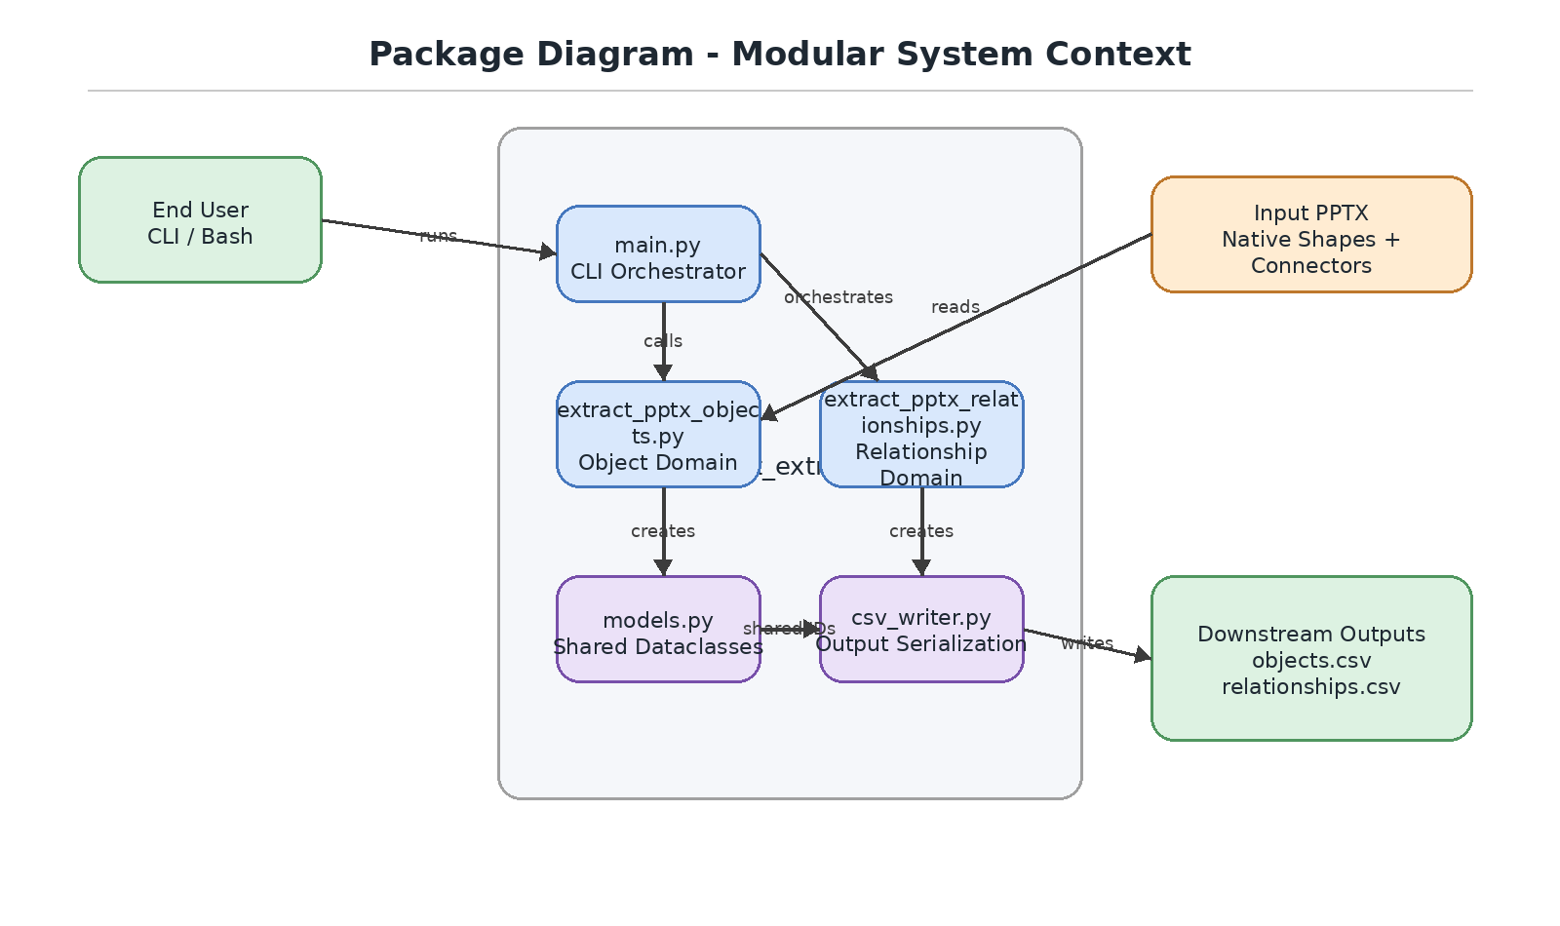
Figure 2-1. Package Diagram - Modular System Context

3. Software Architecture
Baseline v0.5 retains the modular architecture introduced in v0.3. Relationship detection remains a first-class module instead of being embedded inside object extraction. The test harness remains separate from runtime extraction and is used to evaluate capability against expected results.
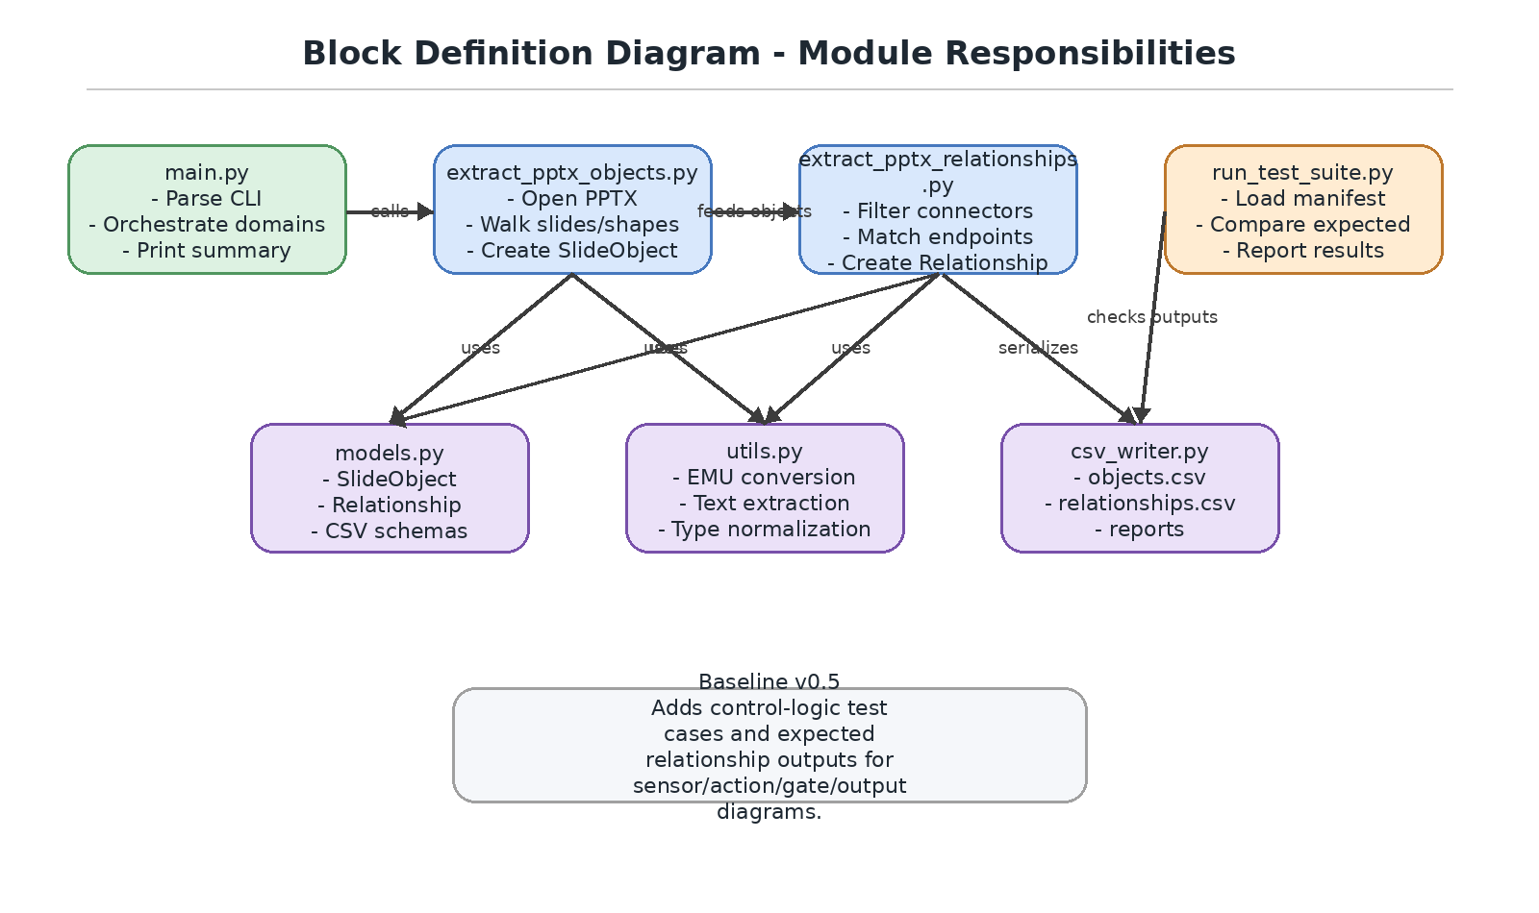
Figure 3-1. Block Definition Diagram - Module Responsibilities
Module | Responsibility | Primary Outputs
main.py | End-user CLI orchestration | Console summary and CSV file paths
extract_pptx_objects.py | Native PowerPoint object extraction only | List[SlideObject]
extract_pptx_relationships.py | Connector relationship extraction only | List[Relationship]
models.py | Shared dataclasses and schemas | SlideObject, Relationship
utils.py | Shared helper functions | Normalized text, types, and measurements
csv_writer.py | CSV serialization | objects.csv, relationships.csv
run_test_suite.py | Manifest-driven verification | test_report.csv and test_report.docx

4. Internal Design
The internal design uses the object inventory as the authoritative intermediate representation. Relationship extraction consumes SlideObject records and generates Relationship records without modifying the object extraction domain. Figure 4-1 shows the internal data flow.
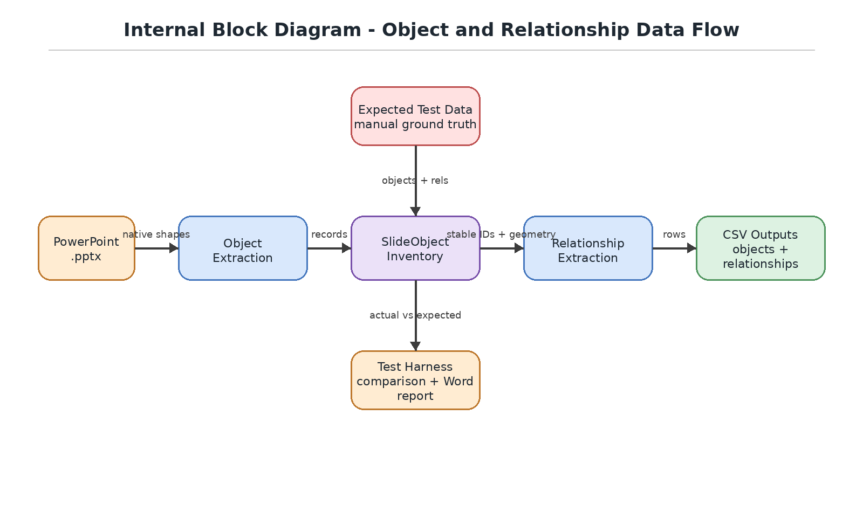
Figure 4-1. Internal Block Diagram - Data Flow

5. Data Design
The central data structures are SlideObject and Relationship. SlideObject remains the Phase 1-compatible object inventory record. Relationship captures connector-derived relationships between detected objects. Figure 5-1 shows how the records map to CSV outputs.
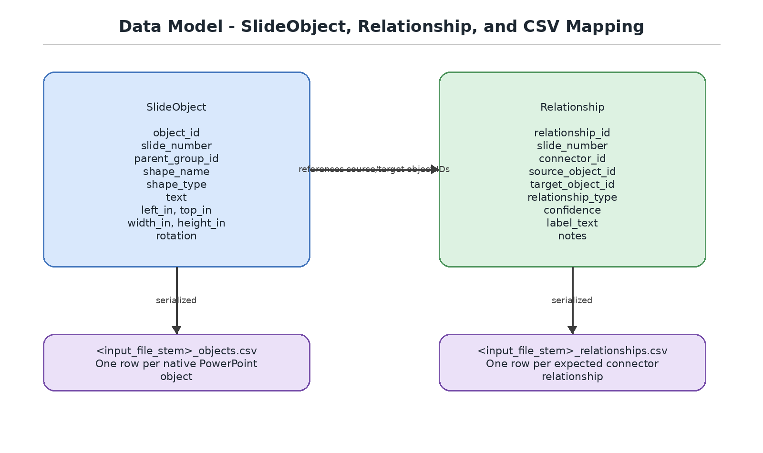
Figure 5-1. Data Model - SlideObject, Relationship, and CSV Mapping
Record | Description | CSV Output
SlideObject | One detected native PowerPoint object. Includes stable ID, slide, group containment, shape type, text, geometry, and rotation. | <input_file_stem>_objects.csv
Relationship | One connector-derived relationship between two detected objects. Includes connector reference, source, target, relationship type, confidence, label text, and notes. | <input_file_stem>_relationships.csv

6. Behavioral Design
The utility follows a deterministic processing flow from user command to two CSV outputs. The object extraction output is always produced. The relationship CSV is also produced, even when no relationships are detected, so downstream ingestion receives a stable schema. Figure 6-1 illustrates the activity flow.
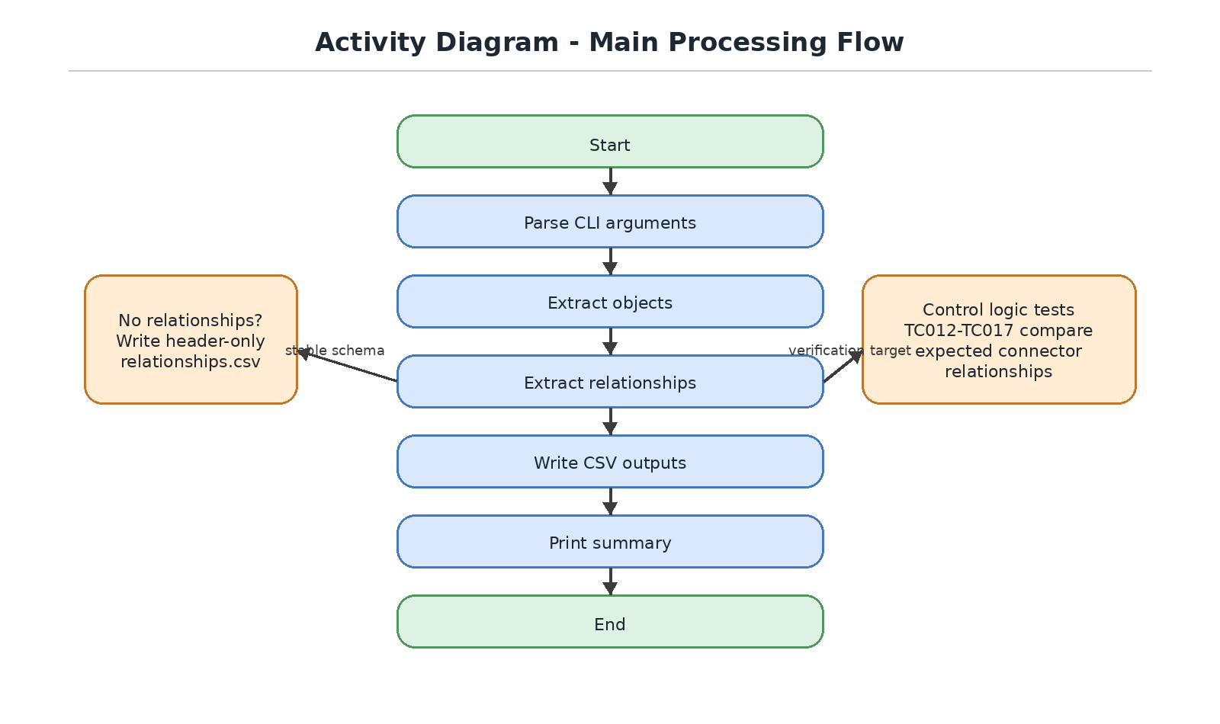
Figure 6-1. Activity Diagram - Main Processing Flow

7. Dynamic Behavior
At runtime, main.py coordinates the domain modules. Object extraction occurs before relationship extraction so that relationships can reference stable object IDs. Figure 7-1 shows runtime interaction. Figure 7-2 shows allowed dependency direction.
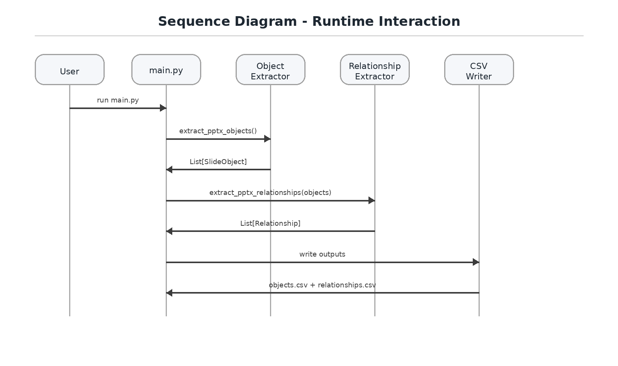
Figure 7-1. Sequence Diagram - Runtime Interaction
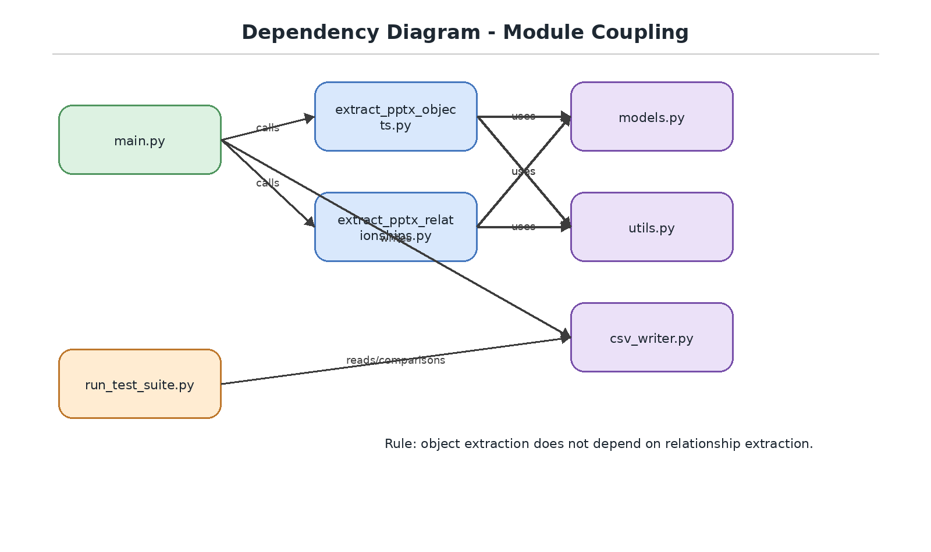
Figure 7-2. Dependency Diagram - Module Coupling

8. Verification Design
Baseline v0.5 adds control-logic test cases that represent sensor inputs, actions, AND/OR logic gates, and outputs. Expected results are manually authored and treated as ground truth. The harness compares actual extractor output against expected objects and relationships and produces machine-readable and Word reports.
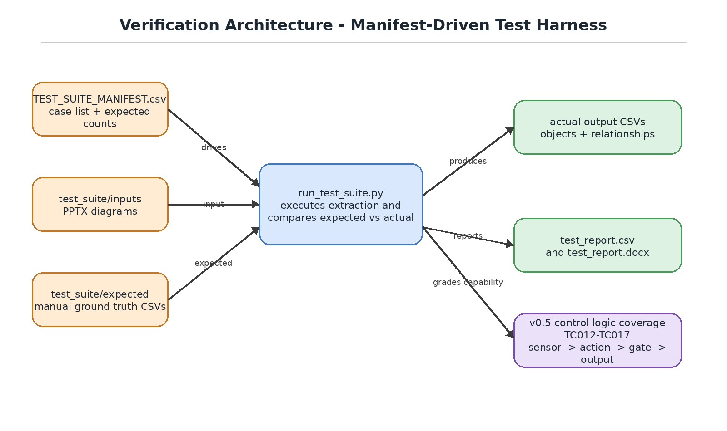
Figure 8-1. Verification Architecture - Manifest-Driven Test Harness
Test Range | Capability Focus | Expected Relationship Scope
TC009-TC010 | Existing hierarchy and workflow cases with relationship extraction | Connector-derived relationships already visible in the diagram.
TC012-TC017 | Control logic coverage | Sensor input -> action -> logic gate -> output connector chains.
Future TC018-TC020 | Reserved expansion | Additional control-logic variants if needed.

9. Algorithm Specifications
Function / Module | Algorithm Summary
extract_pptx_objects() | Validate input, open the presentation, enumerate slides, recursively walk shapes, create SlideObject records, and preserve group containment.
extract_pptx_relationships() | Filter connector-like objects, compute connector endpoints, identify nearest candidate source and target objects on the same slide, and create Relationship records.
write_objects_csv() | Write one row per SlideObject using the Phase 1-compatible object CSV schema.
write_relationships_csv() | Write one row per Relationship using the relationship CSV schema.
run_test_suite.py | Load the manifest, run extraction, compare actual outputs against expected outputs, and write CSV and Word reports.
main() | Parse CLI arguments, call object extraction, call relationship extraction, write both CSV files, and print a summary.

10. Error Handling
Condition | Handling Strategy | User Impact
Input file does not exist | Raise FileNotFoundError | Execution stops with clear missing-file message.
Input file is not .pptx | Raise ValueError | Execution stops before attempting parse.
Output directory missing | Create directory | No user pre-creation required.
No objects detected | Write header-only objects CSV and relationships CSV | Downstream schema remains stable.
No relationships detected | Write header-only relationships CSV | Downstream ingestion still receives known interface.
Shape lacks expected geometry | Write blank/null fields or skip as relationship candidate as appropriate | CSV remains valid.
Expected file missing in test harness | Report test error | Capability grading stops for the affected test case.

11. Limitations and Future Design Hooks
Future Capability | Design Hook Provided by v0.5
Relationship label association | Relationship record includes label_text; nearby text boxes can be associated in a future release.
Semantic classification | relationship_type can evolve beyond connector-derived default values.
Graph/JSON export | SlideObject and Relationship records form a normalized graph foundation.
MBSE export | Stable object and relationship IDs can map to external model elements.
Database ingestion | Flat CSV outputs are relational-friendly.
OCR/image interpretation | Excluded by design; can be added as a separate module later.

Appendix A. Revision History
Version | Date | Description
0.2 | 2026-06-27 | Object extraction design baseline.
0.3 | 2026-06-28 | Updated SDD for modular architecture with graphical package, module responsibility, data flow, data model, activity, sequence, and dependency diagrams.
0.4 | 2026-07-02 | Added relationship test expectations for existing TC009 and TC010 cases.
0.5 | 2026-07-03 | Added control-logic test coverage and restored graphical diagrams as required supporting-document content.

