Homework 8

Christopher Brunswick

11/16/2021

# 1. What will this conditional expression return?

library(dslabs)

## Warning: package 'dslabs' was built under R version 4.0.5

data(murders)  
x <- c(1,2,-3,4)  
if(all(x>0)){  
 print("All Postives")  
} else{  
 print("Not all positives")  
}

## [1] "Not all positives"

# 2. Which of the following expressions is always FALSE when at least one entry of a logical vector x is TRUE?

any(!x)

## [1] FALSE

# 3. The function nchar tells you how many characters long a character vector is. Write a line of code that assigns to the object new_names the state abbreviation when the state name is longer than 8 characters.

state_name <- murders$state  
length_of_name <- nchar(state_name) > 8  
murders$abb[length_of_name]

new_names <- murders$abb[length_of_name]

## [1] "CA" "CT" "DC" "LA" "MA" "MN" "MS" "NH" "NJ" "NM" "NC" "ND" "PA" "RI" "SC"  
## [16] "SD" "TN" "WA" "WV" "WI"

# 4. Create a function sum_n that for any given value, say n, computes the sum of the integers from 1 to n (inclusive). Use the function to determine the sum of integers from 1 to 5,000.

sum_n <- function(n){   
 x <- 1:n   
 print(sum(x))  
 }  
sum_n(5000)

## [1] 12502500

# 5. Create a function altman_plot that takes two arguments, x and y, and plots the difference against the sum.

altman_plot <- function(x,y){  
 print(plot(x-y,x+y))  
}  
altman_plot(10,100)

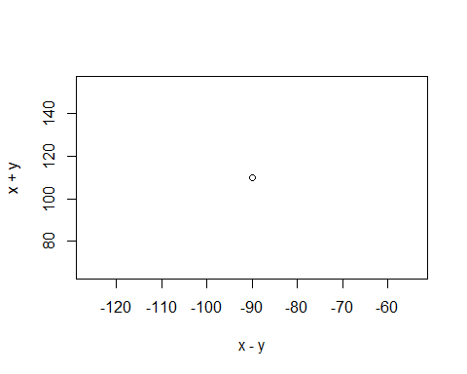

## NULL

# 6. After running the code below, what is the value of x?

x <- 3  
my_func <- function(y){  
 x <- 5  
 y+5  
}  
my_func(x)

## [1] 8

# 7. Write a function compute_s_n that for any given n computes the sum Sn=12+22+32+…n2. Report the value of the sum when n=10.

compute_s_n <- function(n){  
 x <- 1:n  
 q <- x^2  
 sum(q)  
}  
compute_s_n(10)

## [1] 385

# 8. Define an empty numerical vector s_n of size 25 using s_n <- vector(“numeric”, 25) and store in the results of S1,S2,…S25 using a for-loop.

m <- 25  
s_n <- vector( length = m)  
for (n in 1:m){  
 s_n[n] <- compute_s_n(n)  
}  
s_n

## [1] 1 5 14 30 55 91 140 204 285 385 506 650 819 1015 1240  
## [16] 1496 1785 2109 2470 2870 3311 3795 4324 4900 5525

# 9. Repeat exercise 8, but this time use sapply.

n <- 1:25  
sapply(n , compute_s_n)

## [1] 1 5 14 30 55 91 140 204 285 385 506 650 819 1015 1240  
## [16] 1496 1785 2109 2470 2870 3311 3795 4324 4900 5525

# 10. Plot Sn versus n. Use points defined by n=1,…,25.

plot(n,s_n)

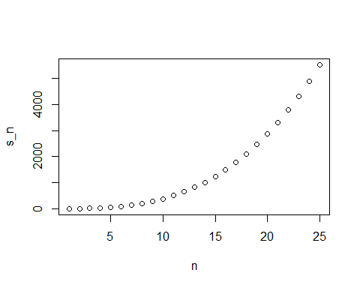

# 11. Confirm that the formula for this sum is Sn=n(n+1)(2n+1)/6.

t <- 1:25  
q <- (t*(t+1)*(2*t+1))/6  
q

## [1] 1 5 14 30 55 91 140 204 285 385 506 650 819 1015 1240  
## [16] 1496 1785 2109 2470 2870 3311 3795 4324 4900 5525