Homework 7

Christopher Brunswick

11/10/2021

1. We made a plot of total murders versus population and noted a strong relationship. Not surprisingly, states with larger populations had more murders.

library(dslabs)

## Warning: package 'dslabs' was built under R version 4.0.5

data(murders)  
population_in_millions <- murders$population/10^6  
total_gun_murders <- murders$total  
plot(population_in_millions, total_gun_murders)

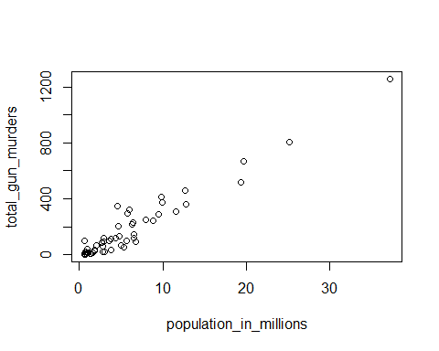

keep in mind that many states have populations below 5 million and are bunched up. We may gain further insights from making this plot in the log scale. Transform the variables using the log10 transformation and then plot them.

plot(log10(population_in_millions), log10(total_gun_murders))

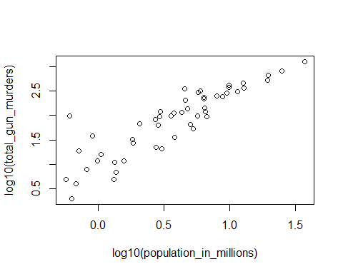

1. Create a histogram of the state populations

state_pop <- with(murders, murders$population)  
hist(state_pop)

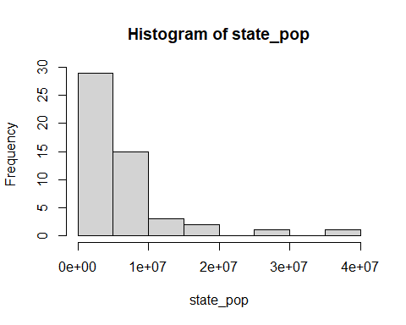

1. Generate boxplots of the state populations by region

boxplot(population~region, data = murders, xlab="region", ylab="population")

