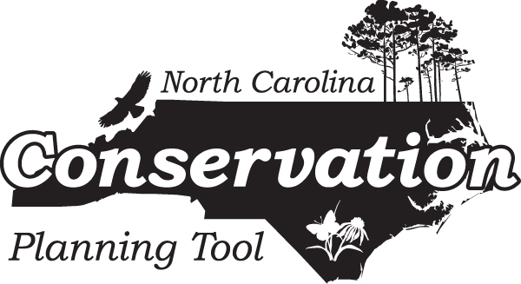

Open Space and Conservation Lands Data
https://www.ncnhp.org/conservation/conservation-planning-tool
July 2022

All shapefiles are in NC State Plane Coordinate System, NAD 83 datum, units of meters. Please refer to the downloadable "Open Space and Conservation Lands" map in PDF form on the NC Conservation Planning Tool (CPT) website for a visual depiction of some of these GIS layers:
https://www.ncnhp.org/content/open-space-and-conservation-lands.

For more information on the Open Space and Conservation Lands data and map, see the CPT report at https://www.ncnhp.org/documents/cpt-report-2018.

Contact: Meredith Wojcik, Natural Heritage Program Data Manager, at meredith.wojcik@ncdcr.gov or 919.707.8630.

Layers Shown on Map:

BAA.shp - boating access locations, contributed by NC Wildlife Resources Commission (April 2022).

marea.shp - publicly- and privately-owned lands and easements that are of some conservation interest
("Managed Areas"), maintained by the NC Natural Heritage Program (April 2022). These data are shown on the CPT map as Conservation Land by owner type. For more information or to download these data directly, visit www.ncnhp.org.

ncprk.shp - NC State Park locations, contributed by NC State Parks (June 2022). These data are shown on the CPT map as Future Expansion Areas (Conservation Land Plans).

prk_pts_all.shp - NC State Park locations as point features, contributed by NC State Parks (June 2022). These data are shown on the CPT map as Potential Conservation Units.

RegionalTrails.shp - existing and planned local, state and federal trails, compiled and contributed by NC State Parks (June 2022). These data are shown on the CPT map.

snsr.shp - State Natural and Scenic Rivers, contributed by NC Division of Parks and Recreation (2015). These data are shown on the CPT map. The Natural and Scenic Rivers System was created by the 1971 General Assembly to preserve and protect certain free flowing rivers, their water quality and their adjacent lands for the benefit of present and future generations. The Natural and Scenic Rivers Act established criteria and methods for inclusion of components to the system. Components of the Natural and Scenic Rivers System are State Rivers, and are also units of the State Parks System.

Layers Not Shown on Map (Informational Purposes Only):
DMS_Local_Watershed_Plans.shp - Local Watershed Planning areas from the Division of Mitigation Services (DMS) (February 2019). For more information, see https://deq.nc.gov/about/divisions/mitigation-services/dms-planning. These data are not shown on the CPT map, but are intended for information purposes.

DMS_Regional_Watershed_Plans.shp - Regional Watershed Planning areas from the Division of Mitigation Services (DMS) (February 2019). For more information, see https://deq.nc.gov/about/divisions/mitigation-services/dms-planning. These data are not shown on the CPT map, but are intended for information purposes.

DMS_Targeted_Local_Watersheds.shp - Targeted Local Watersheds from the Division of Mitigation Services (DMS) (February 2019). For more information, see https://deq.nc.gov/about/divisions/mitigation-services/dms-planning. These data are not shown on the CPT map, but are intended for information purposes.

DMS_Project_Easements.shp – boundaries of Division of Mitigation Services (DMS) easements (February 2019).

