**MUSIC451 Final Project  
Design Document**

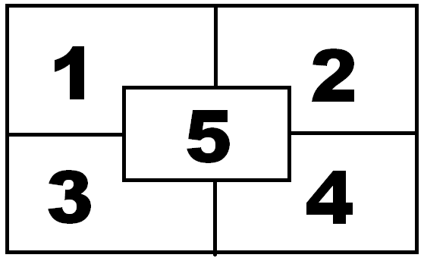

1. Sine/Square/Saw (Lead?)

2. Filtered Noises

3. BG Noise (Bassy)

4. Pulse/Tri/Dust

5. Klank/Pluck (Lead?)

Q1: [0,0] [h/2, w/2]  
Q2: [0,w/2] [h/2, w]  
Q3:[h/2,0] [h, w/2]  
Q4: [h/2,0] [h, w]  
Q5: [h/4,w/4] [3h/4, 3w/4]

**FX Modifiers** (to be triggered by certain conditions)

* Reverb
* Flange
* Resonant Filters
* Ring Modulation
* Chorus

Python 🡪 .csv 🡪 SuperCollider

**Python**  
1) Break image up into quadrants  
2) Get color avgs over each quad (0-255 for RGB  
3) Output .csv R,G,B,R,G,B,R,G,B,… for q1-q5

**SuperCollider**  
1) Read csv into global arrays for each quadrant  
2) 5 different synths control their respective quadrant



Fire Sun Sand Foliage Water

R>G>B  
R+G > 2B  
G+B < R+G  
G+B>R+G  
B>G>R

**Things to use:**Granular synthesis  
FM synthesis  
additive synthesis  
subtractive synthesis  
buffers(?)