Applied Technical Math
Numbers, Measurement, Algebra and Geometry for the Trades
Table of Contents

Part 1 · Numbers
Every measurement, price and specification is a number written in the base ten system. Part 1 makes sure those numbers are read, rounded and rewritten correctly before any calculating begins.

Chapter 1: Place Value and Rounding
A micrometer reads 0.3175 inch. A blueprint calls for 0.318. Are they the same? The answer depends on knowing what each digit is worth and how rounding works. This chapter is the foundation for everything else in the book.
After this chapter you will be able to
- Name the place value of any digit, from millions down to ten-thousandths.
- Read and write decimal numbers the way they are spoken in a shop.
- Compare two decimals and say which is larger.
- Round any number to a named place using the five-step rule.
- Decide how far to round from the wording of a problem.
Key terms
- digit: One of the ten symbols 0 to 9.
- place value: What a digit is worth because of where it sits in the number.
- decimal point: The dot that separates the whole-number part from the part smaller than one.
- rounding digit: The digit in the place you are rounding to.
- test digit: The digit just to the right of the rounding digit. It decides whether to round up.

1.1 The base ten system
Our number system uses only ten digits, yet it can write any amount. It does this by giving each position in a number its own value. Moving one place to the left makes a digit worth ten times as much. Moving one place to the right makes it worth one tenth as much. That single idea runs straight through the decimal point without changing.
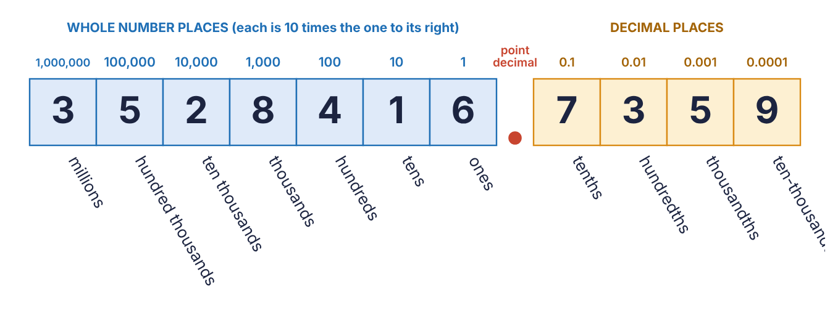
Figure 1.1 The place values used in this course, shown with the number 3,528,416.7359.
In the number above, the digit 5 sits in the hundred thousands place, so it is worth 500,000. Another 5 sits in the thousandths place and is worth only 0.005. Same digit, very different value.
KEY RULE: Whole-number places end in s; decimal places end in ths
To the left of the decimal point: ones, tens, hundreds, thousands, ten thousands, hundred thousands, millions.
To the right of the decimal point: tenths, hundredths, thousandths, ten-thousandths.
There is no “oneths” place. The first place to the right of the point is tenths.
EXAMPLE 1.1
In the number 902,468.7351, name the digit in the (a) ten thousands place, (b) hundredths place, (c) ten-thousandths place.
Work | Why
902,468 . 7351 | Find the decimal point first. Every place is counted from it.
9 0 2, 4 6 8 → ones 8, tens 6, hundreds 4, thousands 2, ten thousands 0 | Count left from the point: ones, tens, hundreds, thousands, ten thousands.
7 3 5 1 → tenths 7, hundredths 3 | Count right from the point: tenths, hundredths.
thousandths 5, ten-thousandths 1 | Keep counting right for the last two places.
Answer: (a) 0 (b) 3 (c) 1
WATCH OUT: A zero is still a digit
In 902,468.7351 the ten thousands digit is 0. A zero holds its place so that the 9 stays in the hundred thousands place. Never skip over a zero when counting places.

1.2 Reading and writing decimals
A decimal is read in three parts: the whole number, the word and for the decimal point, then the decimal part read as if it were a whole number followed by the name of its last place.
Number | Read as
0.7 | seven tenths
0.25 | twenty-five hundredths
3.125 | three and one hundred twenty-five thousandths
12.06 | twelve and six hundredths
0.0625 | six hundred twenty-five ten-thousandths
ON THE JOB: How decimals are spoken in a machine shop
Machinists measure in thousandths of an inch, so they read almost everything in thousandths. The dimension 0.250 in is “two hundred fifty thousandths,” and 0.0005 in is “five tenths” (short for five tenths of a thousandth). The value has not changed, only the way it is said.
Zeros written at the right-hand end of a decimal do not change its value: 0.5, 0.50 and 0.500 are the same amount. On a drawing, however, the extra zeros tell the reader how precisely the part must be made, so copy them exactly.

1.3 Comparing decimals
To decide which of two decimals is larger, line up the decimal points and compare digit by digit from the left. The first place where the digits differ settles it. Filling in zeros so that both numbers have the same number of decimal places makes the comparison easy to see.
EXAMPLE 1.2
Which is larger, 0.8125 or 0.813?
Work | Why
0.8125  0.8130 | Write both with four decimal places. Adding a zero to 0.813 does not change it.
0.8125  0.8130 | The tenths (8) and hundredths (1) match. The thousandths differ: 2 against 3.
3 > 2 | The number with the larger digit in that place is the larger number.
Answer: 0.813 is larger.
WATCH OUT: More digits does not mean a bigger number
0.8125 has more digits than 0.813 but it is the smaller number. Length only matters for whole numbers.

Practice 1.1: Place value
For problems 1 to 10 use the number 4,107,538.2069. Name the digit in each place. For 11 to 16, tell which number is larger.
- the thousands place
- the tenths place
- the ten-thousandths place
- the millions place
- the hundredths place
- the ten thousands place
- the ones place
- the thousandths place
- the hundred thousands place
- the tens place
- 0.5 or 0.45
- 0.062 or 0.0625
- 1.3 or 1.29
- 0.4375 or 0.44
- 2.005 or 2.05
- 0.75 or 0.705

1.4 Rounding
Rounding replaces a number with a nearby number that is easier to use. A tape measure cannot show 37.4286 inches, and a supplier will not sell 71,428.57 psi steel. The question is always the same: which round value is the number closest to?
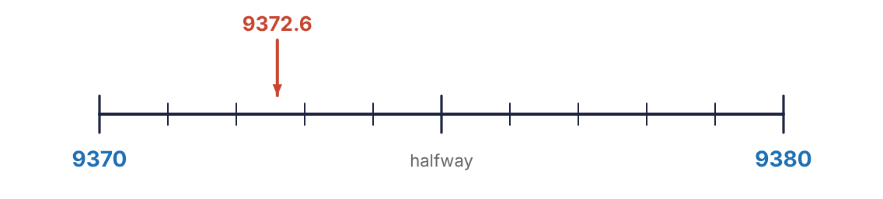
Figure 1.2 Rounding 9372.6 to the nearest ten. It lies between 9370 and 9380, and it is closer to 9370.
KEY RULE: The five steps of rounding
1. Find the rounding digit, the digit in the place you are rounding to. Underline it.
2. Look at the test digit, the one digit immediately to its right. Ignore everything after that.
3. If the test digit is 5, 6, 7, 8 or 9, round up: add one to the rounding digit.
4. If the test digit is 0, 1, 2, 3 or 4, leave the rounding digit as it is.
5. Replace what follows. In a whole number, digits after the rounding digit become zeros. After the decimal point, digits after the rounding digit are dropped.
EXAMPLE 1.3
Round 9372.6485 to the nearest (a) ten, (b) hundredth, (c) thousand.
Work | Why
9372.6485 → test digit 2 | (a) The tens digit is 7. The digit to its right is 2, which is 4 or less, so the 7 stays.
9370 | The ones digit becomes a zero and the decimal part is dropped.
9372.6485 → test digit 8 | (b) The hundredths digit is 4. The test digit 8 is 5 or more, so the 4 becomes 5.
9372.65 | Everything after the hundredths place is dropped.
9372.6485 → test digit 3 | (c) The thousands digit is 9. The test digit 3 leaves it alone.
9000 | The three whole-number places after it become zeros.
Answer: (a) 9370 (b) 9372.65 (c) 9000
EXAMPLE 1.4: When the rounding digit is 9
Round 4.3972 to the nearest hundredth.
Work | Why
4.3972 → test digit 7 | The hundredths digit is 9 and the test digit says round up.
9 + 1 = 10 | Adding one to 9 makes ten, so write 0 and carry 1 to the tenths place.
4.40 | The tenths digit 3 becomes 4. Keep the zero: it shows the number was rounded to hundredths.
Answer: 4.40
WATCH OUT: Round once, from the original number
To round 2.3491 to the nearest tenth, the test digit is 4, so the answer is 2.3. Do not round in stages (2.3491 → 2.35 → 2.4). Rounding twice gives the wrong answer.
The names used for rounding places vary. All of these mean the same thing:
The problem says | Round to this place | Decimal places kept
nearest whole number, nearest unit, nearest one | ones | 0
nearest tenth, nearest 10th, one decimal place | tenths | 1
nearest hundredth, nearest 100th, two decimal places | hundredths | 2
nearest thousandth, three decimal places | thousandths | 3
nearest ten | tens | none; ends in 0
nearest hundred | hundreds | none; ends in 00
WATCH OUT: Ten or tenth? Hundred or hundredth?
Read the last three letters. “Nearest hundred” rounds 3925 to 3900. “Nearest hundredth” rounds 3.925 to 3.93. Mixing these up is one of the most common ways to lose points on a correct calculation.
CALCULATOR TIP: Let the calculator do the arithmetic, not the rounding
Write down more digits than you need from the display, then round by hand using the five steps. Keep the full number in the calculator if the result is needed for another step: rounding in the middle of a problem can change the final answer.

Practice 1.2: Rounding
Round each number to the place named.
- 638.2749 to the nearest tenth
- 638.2749 to the nearest hundredth
- 638.2749 to the nearest ten
- 638.2749 to the nearest hundred
- 15,862.0953 to the nearest thousand
- 15,862.0953 to the nearest thousandth
- 15,862.0953 to the nearest whole number
- 15,862.0953 to the nearest tenth
- 0.9968 to the nearest hundredth
- 0.9968 to the nearest tenth
- 7,449.5 to the nearest whole number
- 7,449.5 to the nearest hundred
- 86.0451 to the nearest hundredth
- 249.96 to the nearest tenth
- 3,925 to the nearest hundred
- 71,428.57 to the nearest hundred
- 55.901 to the nearest whole number
- 0.04449 to the nearest thousandth

1.5 How far should an answer be rounded?
In this course the problem always says. Look for the instruction in parentheses or at the top of the page, and follow it exactly. When there is no instruction, give the full answer.
- “Round to the nearest tenth if needed” means: if the answer comes out even (139.5) or whole (3456), leave it alone. Round only if there are more digits than asked for.
- “Give a non-rounded decimal or a fraction in lowest terms” means rounding is not allowed. Write every digit, or use a fraction.
- “Nearest whole number” in a counting problem (how many pipes, how many sheets) may really mean round up, because 15.6 pipes cannot be bought. The problem will say if it wants that.
ON THE JOB: Rounding costs money
A concrete order of 92.59 cubic yards rounded down to 92 leaves the pour short. Rounded to the nearest tenth it is 92.6. On the job, know whether being a little over or a little under is the safer mistake.
Chapter summary
- Each place is worth ten times the place to its right. Places left of the point end in s; places right of it end in ths.
- To compare decimals, line up the points and compare from the left.
- To round: find the rounding digit, look only at the next digit, 5 or more rounds up, 4 or less stays.
- After rounding, whole-number places fill with zeros and decimal places are dropped.
- Round once, at the end, and only as far as the problem says.

Chapter 1 review
- In 6,052,917.3084, which digit is in the hundredths place?
- In 6,052,917.3084, which digit is in the ten thousands place?
- In 6,052,917.3084, which digit is in the thousandths place?
- In 6,052,917.3084, which digit is in the hundred thousands place?
- In 6,052,917.3084, which digit is in the ten-thousandths place?
- In 6,052,917.3084, which digit is in the tenths place?
- Round 5,274.9638 to the nearest tenth.
- Round 5,274.9638 to the nearest hundred.
- Round 5,274.9638 to the nearest thousandth.
- Round 5,274.9638 to the nearest whole number.
- Round 5,274.9638 to the nearest ten.
- Round 5,274.9638 to the nearest hundredth.
- Which is larger, 0.3125 or 0.32?
- Which is smaller, 1.07 or 1.068?
- Write in digits: forty-two and seven hundredths.
- Write in digits: three hundred seventy-five thousandths.
- A calculation gives 2,866.2 rpm. Round to the nearest hundred rpm.
- A calculation gives 7.4667 microfarads. Round to the nearest hundredth.
- A student rounds 6.2481 to the nearest tenth and writes 6.3. What went wrong, and what is the answer?
- Round 19.996 to the nearest hundredth.

Chapter 2: Fractions, Decimals and Percents
Five-eighths of an inch, 0.625 inch and 62.5% of an inch are the same length written three ways. Tape measures use fractions, calculators use decimals, and specifications use percents. A technician has to translate among them without hesitation.
After this chapter you will be able to
- Reduce a fraction to lowest terms and change between improper fractions and mixed numbers.
- Change a fraction to a decimal and a decimal to a fraction.
- Change a decimal to a percent and a percent to a decimal.
- Move freely among all three forms and recognise the common shop equivalents.
- Add and subtract measurements that mix fractions and decimals.
Key terms
- numerator: The top number of a fraction: how many parts are counted.
- denominator: The bottom number: how many equal parts make one whole.
- lowest terms: A fraction whose top and bottom share no common factor except 1.
- mixed number: A whole number and a fraction together, such as 2 3/8.
- improper fraction: A fraction whose top is as large as or larger than its bottom, such as 19/8.
- percent: Parts out of one hundred. 25% means 25 out of every 100.

2.1 Fractions in lowest terms
A fraction names part of a whole. The denominator says how many equal parts the whole was cut into, and the numerator says how many of those parts are being counted. On an inch ruler cut into sixteenths, the mark 12/16 is the same mark as 6/8 and 3/4. All three are equivalent fractions, but only 3/4 is in lowest terms.
KEY RULE: Reducing to lowest terms
Divide the top and the bottom by the same number, and keep going until no number divides both.
Ruler fractions have denominators 2, 4, 8, 16, 32 and 64, so for them the rule is short: keep halving top and bottom until the top is odd.
EXAMPLE 2.1
Reduce 20/32 to lowest terms.
Work | Why
20/32 = 20 ÷ 2/32 ÷ 2 = 10/16 | Both are even, so divide both by 2.
10/16 = 5/8 | Still both even. Divide by 2 again.
5/8 | The top is odd, so the fraction is in lowest terms.
Answer: 5/8

Mixed numbers and improper fractions
A measurement such as 2 3/8 inches is a mixed number. For multiplying and dividing it is easier to use the improper fraction 19/8. Both say the same thing: nineteen eighths.
Mixed → improper: 2 3/8 = 2 × 8 + 3/8 = 19/8 (whole × bottom + top, over the same bottom)
Improper → mixed: 19/8 = 19 ÷ 8 = 2 remainder 3 = 2 3/8 (divide; the remainder goes on top)

Practice 2.1: Fractions
Reduce 1 to 8 to lowest terms. Write 9 to 12 as improper fractions and 13 to 16 as mixed numbers.
- 6/8
- 12/16
- 10/32
- 24/64
- 14/16
- 28/32
- 36/64
- 4/16
- 1 3/4
- 2 5/8
- 3 7/16
- 5 1/2
- 11/8
- 9/4
- 37/16
- 45/32

2.2 Fraction to decimal
The fraction bar is a division sign. To change any fraction to a decimal, do the division it shows.
KEY RULE: Fraction → decimal
Divide the top by the bottom.
5/8 = 5 ÷ 8 = 0.625
For a mixed number, keep the whole number and convert only the fraction: 3 5/8 = 3 + 0.625 = 3.625. Some divisions never end. 1/3 = 0.3333… and 1/6 = 0.1666… For those, round as the problem directs.
EXAMPLE 2.2
Change 31 3/8 in to a decimal.
Work | Why
3 ÷ 8 = 0.375 | Divide the top of the fraction by the bottom.
31 + 0.375 = 31.375 | Put the whole number back in front.
Answer: 31.375 in
CALCULATOR TIP: Entering a mixed number
On any calculator, 31 3/8 can be keyed as 31 + 3 ÷ 8. The calculator divides before it adds, so the answer is 31.375. Inside a longer calculation, put it in parentheses: (31 + 3 ÷ 8).

2.3 Decimal to fraction
Read the decimal by its place value and write exactly what you say. Then reduce.
KEY RULE: Decimal → fraction
Write the digits after the point over 10, 100, 1000 or 10,000: a 1 followed by one zero for each decimal place. Then reduce.
0.375 = “375 thousandths” = 375/1000 = 3/8
EXAMPLE 2.3
Write 0.4375 as a fraction in lowest terms.
Work | Why
0.4375 = 4375/10,000 | Four decimal places, so the bottom is 1 with four zeros.
4375 ÷ 625/10,000 ÷ 625 = 7/16 | Divide top and bottom by 5 four times (5 × 5 × 5 × 5 = 625).
7 ÷ 16 = 0.4375 ✓ | Check by dividing.
Answer: 7/16
CALCULATOR TIP: The fraction key
Most scientific calculators have a key that converts a decimal answer to a fraction (often marked a b/c, F↔D or ▸Frac). It is the fastest way to reduce, but know the hand method too: the key cannot help when the decimal has been rounded.

Decimal to the nearest ruler fraction
A calculated length such as 2.70 in is not a mark on a tape. To find the nearest 16th, multiply the decimal part by 16 and round to a whole number.
EXAMPLE 2.4
What is 2.70 in to the nearest 16th of an inch?
Work | Why
0.70 × 16 = 11.2 | Multiply only the decimal part by the denominator wanted.
11.2 → 11 | Round to the nearest whole number. That is the number of sixteenths.
2 11/16 in | Put the whole inches back. Reduce if the top came out even.
Answer: 2 11/16 in

2.4 Decimals and percents
Percent means “per hundred.” The symbol % stands for “÷ 100,” so 37.5% is 37.5 ÷ 100 = 0.375. Because dividing or multiplying by 100 only shifts the decimal point two places, the conversions can be done by sight.
KEY RULE: Decimal ↔ percent
Decimal → percent: move the decimal point 2 places right and add the % sign (the same as × 100). 0.167 = 16.7%
Percent → decimal: move the decimal point 2 places left and drop the % sign (the same as ÷ 100). 37.5% = 0.375
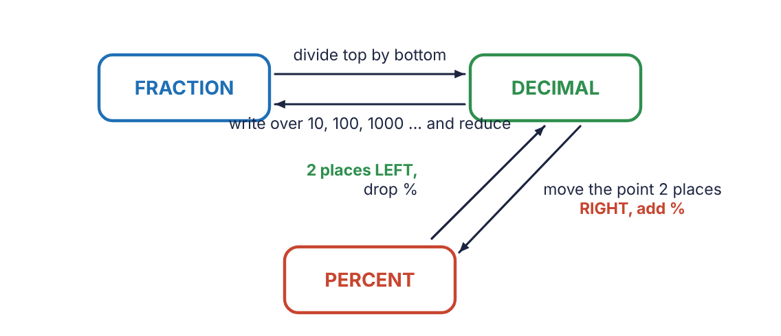
Figure 2.1 The three forms and how to move between them. To go from a fraction to a percent, go through the decimal.
EXAMPLE 2.5
Write each as a percent: (a) 0.08 (b) 1.25 (c) 0.004
Work | Why
0.08 → 0 0 8. → 8% | (a) Two places right. The point lands after the 8.
1.25 → 1 2 5. → 125% | (b) A decimal larger than 1 is a percent larger than 100.
0.004 → 0 0 0.4 → 0.4% | (c) Two places only. This is less than one percent.
Answer: (a) 8% (b) 125% (c) 0.4%
WATCH OUT: Which way does the point move?
A percent is always the bigger-looking number: 0.25 is 25%. If you are going to percent the number should look larger, so the point moves right. Going from percent it should look smaller, so the point moves left.
A single-digit percent needs a zero filled in: 6% = 0.06, not 0.6.

2.5 All three forms together
Any one form leads to the other two. The path always passes through the decimal.
EXAMPLE 2.6
Complete the row: fraction 5/8 → decimal → percent.
Work | Why
5 ÷ 8 = 0.625 | Top divided by bottom.
0.625 → 62.5% | Point two places right, add %.
Answer: 5/8 = 0.625 = 62.5%
EXAMPLE 2.7
Complete the row: 37.5% → decimal → fraction.
Work | Why
37.5% → 0.375 | Point two places left, drop %.
0.375 = 375/1000 | Three decimal places: over 1000.
375 ÷ 125/1000 ÷ 125 = 3/8 | Reduce.
Answer: 37.5% = 0.375 = 3/8
Table 2.1 Equivalents worth knowing by heart (thirds rounded to four places)
Fraction | Decimal | Percent | Fraction | Decimal | Percent
1/16 | 0.0625 | 6.25% | 1/8 | 0.125 | 12.5%
3/16 | 0.1875 | 18.75% | 1/4 | 0.25 | 25%
5/16 | 0.3125 | 31.25% | 3/8 | 0.375 | 37.5%
7/16 | 0.4375 | 43.75% | 1/2 | 0.5 | 50%
9/16 | 0.5625 | 56.25% | 5/8 | 0.625 | 62.5%
11/16 | 0.6875 | 68.75% | 3/4 | 0.75 | 75%
13/16 | 0.8125 | 81.25% | 7/8 | 0.875 | 87.5%
15/16 | 0.9375 | 93.75% | 1/3 | 0.3333 | 33.33%
2/3 | 0.6667 | 66.67% | 1/5 | 0.2 | 20%

Practice 2.2: Changing forms
Write each number in the other two forms. Give fractions in lowest terms and do not round.
- 3/8 (to a decimal and a percent)
- 0.8 (to a fraction and a percent)
- 45% (to a decimal and a fraction)
- 7/16 (to a decimal and a percent)
- 0.065 (to a fraction and a percent)
- 12.5% (to a decimal and a fraction)
- 9/20 (to a decimal and a percent)
- 1.5 (to a fraction and a percent)
- 2% (to a decimal and a fraction)
- 13/16 (to a decimal and a percent)
- 0.3125 (to a fraction and a percent)
- 87.5% (to a decimal and a fraction)

2.6 Adding and subtracting mixed measurements
Drawings often give some dimensions as fractions and others as decimals. Before adding or subtracting, put every number in the same form. Decimals are usually quicker; fractions are exact and match the tape.

Method 1: change everything to decimals
EXAMPLE 2.8
A bracket is 11.25 in long. A second piece 31 3/8 in long is welded to it. What is the total length?
Work | Why
31 3/8 = 31.375 | Change the mixed number to a decimal: 3 ÷ 8 = 0.375.
11.250 + 31.375 = 42.625 | Line up the decimal points and add.
0.625 = 5/8 | If a fraction is wanted, change the decimal part back.
Answer: 42.625 in, or 42 5/8 in

Method 2: keep everything in fractions
Fractions can be added or subtracted only when their denominators match. For ruler fractions the common denominator is simply the larger of the two, because each denominator is a multiple of the smaller ones.
EXAMPLE 2.9
7/8 − 3/16
Work | Why
7/8 = 7 × 2/8 × 2 = 14/16 | Change eighths to sixteenths: multiply top and bottom by 2.
14/16 − 3/16 = 11/16 | Same denominator, so subtract the tops. The bottom does not change.
Answer: 11/16
EXAMPLE 2.10: Borrowing
5 1/4 − 2 5/8
Work | Why
5 2/8 − 2 5/8 | Common denominator 8.
4 10/8 − 2 5/8 | 2 is smaller than 5, so borrow 1 from the 5. One whole is 8/8, and 8/8 + 2/8 = 10/8.
2 5/8 | Subtract the whole numbers (4 − 2) and the fractions (10/8 − 5/8).
Answer: 2 5/8
WATCH OUT: Never add the denominators
1/4 + 1/4 is 2/4 = 1/2, not 2/8. The denominator names the size of the pieces, and the size does not change when pieces are added.

Practice 2.3: Adding and subtracting
Give fraction answers in lowest terms as mixed numbers.
- 3/8 + 1/4
- 5/16 + 1/2
- 7/8 − 3/16
- 3/4 − 5/16
- 2 1/2 + 1 3/8
- 4 3/16 + 2 7/8
- 6 1/4 − 2 5/8
- 10 − 3 7/16
- 14.5 in + 6 3/4 in (decimal answer)
- 22 5/8 in + 9.25 in (decimal answer)
- 48 3/4 in − 17.125 in (decimal answer)
- 60.5 in − 24 7/8 in (decimal answer)
Chapter summary
- A fraction is a division: top ÷ bottom gives the decimal.
- A decimal becomes a fraction by writing it over 10, 100, 1000 … and reducing.
- Decimal to percent: point 2 places right, add %. Percent to decimal: point 2 places left, drop %.
- To go between a fraction and a percent, pass through the decimal.
- Add or subtract fractions only after giving them the same denominator; never add denominators.

Chapter 2 review
- Reduce 18/32 to lowest terms.
- Reduce 40/64 to lowest terms.
- Change 7/8 to a decimal.
- Change 3/16 to a decimal.
- Change 2 9/16 to a decimal.
- Change 0.625 to a fraction in lowest terms.
- Change 0.35 to a fraction in lowest terms.
- Change 0.1875 to a fraction in lowest terms.
- Change 0.42 to a percent.
- Change 0.075 to a percent.
- Change 1.8 to a percent.
- Change 64% to a decimal.
- Change 7% to a decimal.
- Change 112.5% to a decimal.
- Change 0.5% to a decimal.
- Change 11/16 to a percent.
- Change 62.5% to a fraction in lowest terms.
- What is 5.40 in to the nearest 16th of an inch?
- 3 5/8 + 2 9/16
- 8 1/8 − 3 3/4
- A shaft 18.375 in long has 7/16 in cut from one end. What length is left, as a decimal?
- Three spacers measure 3/8 in, 0.25 in and 9/16 in. What is their total thickness as a fraction?
- Which is larger, 13/16 or 0.81?

Chapter 3: The Percent Proportion
Every percent problem is the same sentence with one number missing: the part is some percent of the whole. Learn to find the three pieces in that sentence, and one proportion solves them all.
After this chapter you will be able to
- Identify the part, the whole and the percent in a percent statement.
- Set up the percent proportion and solve it by cross-multiplying.
- Solve all three types of percent problem with one method.
- Use the decimal shortcut for each type.
- Solve applied problems: efficiency, discount, tax, waste and percent change.
Key terms
- part: The piece being compared. It goes with the word is.
- whole: The total or original amount the part is compared to. It follows the word of. Also called the base.
- percent: The number with the % sign. It always sits over 100 in the proportion.
- proportion: A statement that two fractions are equal.
- cross-multiply: Multiply the two numbers that sit diagonally across the equals sign.

3.1 Part, whole and percent
Read this sentence slowly: 45 is 25% of 180. It has three numbers, and each has a job.
- 180 is the whole. It comes right after the word of. It is the total, the starting amount, the 100%.
- 45 is the part. It goes with the word is. It is the piece of the whole being talked about.
- 25% is the percent. It is the easiest to find because it wears the % sign.
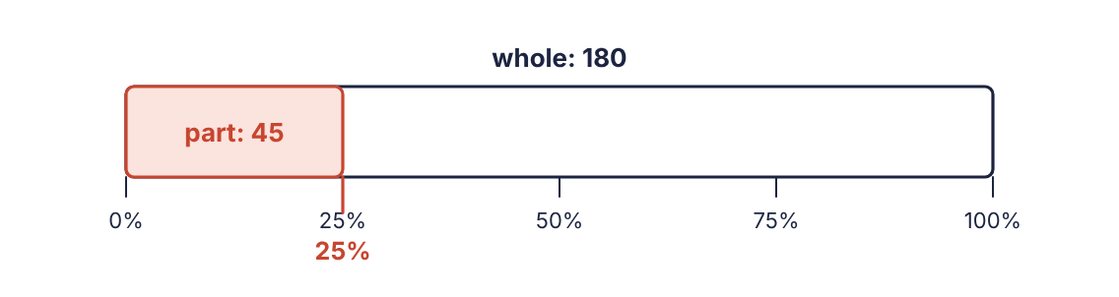
Figure 3.1 45 is 25% of 180. The part fills 25 hundredths of the whole.
KEY RULE: The percent proportion
PART (is)/WHOLE (of) = PERCENT/100
The part compared to the whole is the same comparison as the percent compared to 100.
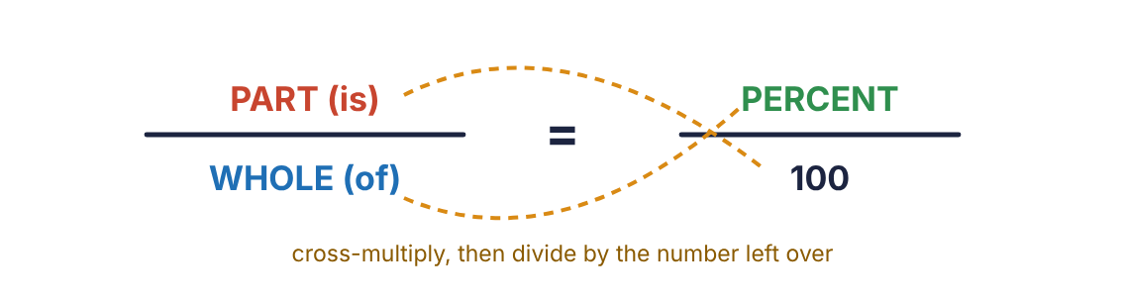
Figure 3.2 Is over of equals percent over 100.
In a problem, one of the three is unknown. Call it x, put the two known numbers in their places, and solve.
WATCH OUT: The whole is not always the bigger number
In “150 is 125% of what number?” the part (150) is larger than the whole (120). Do not decide by size. Decide by the words: the whole follows of, the part goes with is.

3.2 Solving the proportion
KEY RULE: Cross-multiply and divide
1. Multiply the two numbers that are diagonal from each other.
2. Divide by the number that is left over (the one diagonal from x).
This works wherever x happens to be.

Type 1: finding the part
EXAMPLE 3.1
What is 25% of 180?
Work | Why
x/180 = 25/100 | 180 follows of, so it is the whole. 25 has the % sign. The part is unknown.
25 × 180 = 4500 | Cross-multiply the diagonal pair that has two numbers.
4500 ÷ 100 = 45 | Divide by the number left over.
Answer: 45

Type 2: finding the whole
EXAMPLE 3.2
150 is 25% of what number?
Work | Why
150/x = 25/100 | 150 goes with is: the part. “What number” follows of: the whole is unknown.
150 × 100 = 15,000 | Cross-multiply.
15,000 ÷ 25 = 600 | Divide by the number left over.
Answer: 600

Type 3: finding the percent
EXAMPLE 3.3
50 is what percent of 800?
Work | Why
50/800 = x/100 | 50 is the part, 800 follows of, and the percent is unknown.
50 × 100 = 5000 | Cross-multiply.
5000 ÷ 800 = 6.25 | Divide by the number left over.
6.25% | The answer sits in the percent position, so it already is a percent. Just add the sign.
Answer: 6.25%
CALCULATOR TIP: One line on the calculator
Each example is a single chain: 25 × 180 ÷ 100, 150 × 100 ÷ 25, 50 × 100 ÷ 800. Multiply the diagonal pair, divide by the third number. No parentheses are needed.
Table 3.1 The three types at a glance
The question | Proportion | Keystrokes
What is P% of W? | x/W = P/100 | P × W ÷ 100
A is P% of what number? | A/x = P/100 | A × 100 ÷ P
A is what percent of W? | A/W = x/100 | A × 100 ÷ W
WATCH OUT: Check that the answer makes sense
25% is one quarter. One quarter of 180 should be less than 180, and 45 is. If the percent is under 100, the part must be smaller than the whole. If your answer breaks that rule, two numbers are in the wrong seats.

Practice 3.1: The three types
Set up the percent proportion for each and solve. Do not round.
- What is 30% of 400?
- 30 is what percent of 400?
- 400 is 80% of what number?
- What is 15% of 60?
- 18 is 12% of what number?
- 9 is what percent of 72?
- What is 6.5% of 240?
- 45 is what percent of 36?
- 21 is 3.5% of what number?
- What is 120% of 85?
- 3 is what percent of 480?
- 7.2 is 16% of what number?
- What is 0.5% of 900?
- 66 is what percent of 240?
- 250 is 125% of what number?
- What is 37.5% of 64?

3.3 The decimal shortcut
Since percent means “÷ 100,” the proportion can be shortened by changing the percent to a decimal first. These three rules give exactly the same answers as the proportion. Use whichever method you trust most.
KEY RULE: Percent problems with decimals
Part = whole × percent (as a decimal) 25% of 180 = 180 × 0.25 = 45
Whole = part ÷ percent (as a decimal) 150 ÷ 0.25 = 600
Percent = part ÷ whole, then move the point 2 places right 50 ÷ 800 = 0.0625 = 6.25%

3.4 Percent on the job
Word problems hide the words is and of. Find the three pieces by asking: What is the total or original amount (the whole)? What piece of it is being described (the part)? Which number is the percent?
EXAMPLE 3.4: Efficiency
An air conditioner draws 3,500 watts of electrical power and delivers 2,870 watts of useful work at the compressor. What is its efficiency as a percent?
Work | Why
whole = 3,500 W; part = 2,870 W | The power going in is the total. The useful output is the part of it that is not lost.
2870/3500 = x/100 | Efficiency asks: the output is what percent of the input?
2870 × 100 ÷ 3500 = 82 | Cross-multiply and divide.
Answer: 82% efficient
EXAMPLE 3.5: Discount
A roll of copper tubing lists for $186.00. The supply house gives contractors a 15% discount. What is the contractor price?
Work | Why
x/186 = 15/100 | The discount is 15% of the list price. The list price is the whole.
15 × 186 ÷ 100 = 27.90 | The discount is $27.90.
186.00 − 27.90 = 158.10 | The question asks for the price, not the discount. Subtract.
Answer: $158.10
A shortcut for the last example: if 15% comes off, 85% is left. So the price is 85% of 186, or 186 × 0.85 = 158.10 in one step.
EXAMPLE 3.6: Waste allowance
A sheet-metal job needs 240 square feet of material. The shop adds 12% for waste. How much should be ordered?
Work | Why
12 × 240 ÷ 100 = 28.8 | The waste allowance is 12% of the amount needed.
240 + 28.8 = 268.8 | Add the allowance to the original amount.
Answer: 268.8 sq ft
EXAMPLE 3.7: Working backward
After a 6% sales tax, a tool costs $84.80. What was the price before tax?
Work | Why
100% + 6% = 106% | The total is the original price plus 6% of it, so $84.80 is 106% of the price.
84.80/x = 106/100 | 84.80 is the part (it is 106% of the price). The price is the whole.
84.80 × 100 ÷ 106 = 80 | Cross-multiply and divide.
Answer: $80.00
WATCH OUT: Do not take the percent of the wrong number
In the last example, 6% of $84.80 is $5.09, and 84.80 − 5.09 = $79.71, which is wrong. The tax was 6% of the original price, not of the total. When the whole is the unknown, set up the proportion; do not guess with subtraction.

Percent change
A percent increase or decrease always compares the amount of change to the original value.
KEY RULE: Percent change
percent change = amount of change/original amount × 100
The original amount is the whole, no matter whether the value went up or down.
EXAMPLE 3.8
A supply-air temperature drops from 75°F to 57°F. What is the percent decrease?
Work | Why
75 − 57 = 18 | Find the amount of change.
18/75 = x/100 | The change is the part. The original value is the whole.
18 × 100 ÷ 75 = 24 | Cross-multiply and divide.
Answer: 24% decrease

Practice 3.2: Applications
Solve each problem. Round only where the problem says.
- A 250-ft spool of wire has had 85 ft used. What percent has been used?
- A motor rated at 1,200 W input is 88% efficient. What is its output power?
- A technician earns $24.50 per hour and receives a 6% raise. What is the new hourly rate, to the nearest cent?
- A furnace listed at $1,450 is sold at a 20% discount. What is the sale price?
- A job needs 320 sq ft of drywall. Add 10% for waste. How much is ordered?
- 18 of 150 welds failed inspection. What percent failed? What percent passed?
- A down payment of $1,260 is 15% of the price of a used service van. What is the price?
- A tank holds 60 gallons when it is 75% full. What is its full capacity?
- Line voltage falls from 240 V to 228 V. What is the percent decrease?
- The price of a fitting rises from $8.00 to $9.20. What is the percent increase?
- A resistor marked 470 Ω has a tolerance of ±5%. What are its lowest and highest acceptable values?
- With 8% sales tax a compressor costs $702. What was the price before tax?
Chapter summary
- Every percent problem fits one sentence: the part is a percent of the whole.
- The percent proportion is part over whole equals percent over 100.
- Cross-multiply the diagonal pair of numbers, then divide by the third number.
- Decimal shortcut: part = whole × percent; whole = part ÷ percent; percent = part ÷ whole.
- Percent change compares the amount of change to the original amount.

Chapter 3 review
- What is 35% of 260?
- 84 is 70% of what number?
- 27 is what percent of 180?
- What is 4.5% of 800?
- 150 is what percent of 120?
- 9 is 0.6% of what number?
- What is the whole in the statement “12 is 40% of 30”?
- Write the proportion for “What percent of 64 is 24?” Do not solve.
- Use the decimal shortcut: find 18% of 350.
- Use the decimal shortcut: 91 is 65% of what number?
- A pump delivers 1,530 W of output for 1,800 W of input. What is its efficiency?
- A $640 meter is on sale for 25% off. What is the sale price?
- Static pressure rises from 0.50 to 0.62 inch of water. What is the percent increase?
- A crew has installed 45 of 125 light fixtures. What percent remain to be installed?
- A bill of $1,391 includes 7% sales tax. What was the amount before tax?
- A student says 8% of 50 is 40. Explain the error and give the correct answer.

Part 2 · Measurement
Measuring is counting units. Part 2 covers the two systems of units used in American shops, how to move between them, and how to read the instruments that do the measuring.

Chapter 4: Standard Units of Measure
Carpet is sold by the square yard, concrete by the cubic yard, ductwork is laid out in inches and a tank is rated in gallons. The measurements on a job rarely arrive in the unit you need. This chapter is about changing the unit without changing the amount.
After this chapter you will be able to
- State the standard (U.S. customary) units of length, weight and liquid capacity and how they relate.
- Convert a measurement from one unit to another by multiplying or dividing by a conversion factor.
- Decide whether to multiply or divide.
- Convert square units of area and cubic units of volume.
- Convert between cubic measure and gallons.
Key terms
- unit: A fixed amount used for measuring, such as a foot or a pound.
- conversion factor: The number of smaller units that make one larger unit: 12 inches make 1 foot.
- square unit: A unit of area: a square that is one unit long on each side.
- cubic unit: A unit of volume: a cube that is one unit long on each edge.
- capacity: How much liquid a container holds.

4.1 The standard units
The standard system, also called the U.S. customary or English system, grew out of everyday objects and trade. Its conversion factors are not regular, so they have to be memorised or looked up.
Table 4.1 Standard units of length, weight and capacity
Length | Weight | Liquid capacity
1 foot (ft) = 12 inches (in) | 1 pound (lb) = 16 ounces (oz) | 1 pint (pt) = 2 cups
1 yard (yd) = 3 ft = 36 in | 1 ton (T) = 2000 lb | 1 quart (qt) = 2 pt
1 mile (mi) = 5280 ft = 1760 yd |  | 1 gallon (gal) = 4 qt
A measurement has two parts, a number and a unit. Converting changes both: the same board is 8 feet or 96 inches. The number grew because the unit shrank.
This chapter takes the standard system one category at a time. Each category has its own set of facts:
Table 4.2 The five conversion categories
Category | What it measures | Units | Section
Length | how long, how far | in, ft, yd, mi | 4.3
Weight | how heavy | oz, lb, T | 4.4
Liquid capacity | how much a container holds | cup, pt, qt, gal | 4.5
Area | how much surface | sq in, sq ft, sq yd | 4.6
Volume | how much space | cu in, cu ft, cu yd, and gallons | 4.7

4.2 Multiply or divide?
KEY RULE: Converting units
Going to a smaller unit, you will need more of them: multiply by the conversion factor.
Going to a larger unit, you will need fewer of them: divide by the conversion factor.
EXAMPLE 4.1
Convert 7.5 ft to inches.
Work | Why
1 ft = 12 in | Find the fact that connects the two units.
feet → inches: larger → smaller | Inches are smaller than feet, so there will be more of them. Multiply.
7.5 × 12 = 90 | Multiply by the conversion factor.
Answer: 90 in
EXAMPLE 4.2
Convert 150 oz to pounds. Round to the nearest tenth.
Work | Why
1 lb = 16 oz | The connecting fact.
ounces → pounds: smaller → larger | Pounds are larger, so there will be fewer. Divide.
150 ÷ 16 = 9.375 | Divide by the conversion factor.
9.4 | Round to the nearest tenth: the test digit 7 rounds the 3 up.
Answer: 9.4 lb
WATCH OUT: The sanity check
Before writing the answer, ask whether the number should have gone up or down. 150 ounces cannot be 2400 pounds. If the answer moved the wrong way, you multiplied when you should have divided.

Conversions that take two steps
When no single fact joins the two units, go through a unit in between, one step at a time.
EXAMPLE 4.3
How many cups are in 3 gallons?
Work | Why
3 × 4 = 12 qt | Gallons to quarts: smaller unit, multiply by 4.
12 × 2 = 24 pt | Quarts to pints: multiply by 2.
24 × 2 = 48 cups | Pints to cups: multiply by 2.
Answer: 48 cups

Unit fractions: a method that cannot go the wrong way
A conversion fact can be written as a fraction equal to 1, such as 12 in/1 ft or 1 ft/12 in. Multiplying by 1 does not change an amount. Choose the fraction that has the unit you want to get rid of on the bottom, so that it cancels.
7.5 ft × 12 in/1 ft = 90 in (ft cancels ft, inches remain)
150 oz × 1 lb/16 oz = 9.375 lb (oz cancels oz, pounds remain)

4.3 Category 1: length
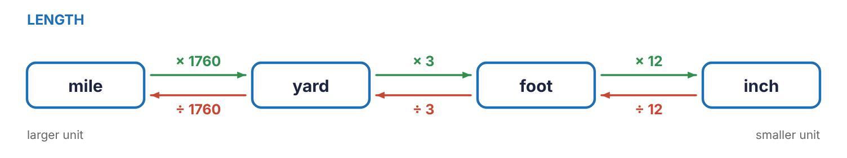
Figure 4.1 The length chain. Move right (to a smaller unit) and multiply; move left (to a larger unit) and divide.
Fact | To go to the smaller unit | To go to the larger unit
1 ft = 12 in | ft → in: × 12 | in → ft: ÷ 12
1 yd = 3 ft | yd → ft: × 3 | ft → yd: ÷ 3
1 yd = 36 in | yd → in: × 36 | in → yd: ÷ 36
1 mi = 5280 ft | mi → ft: × 5280 | ft → mi: ÷ 5280
1 mi = 1760 yd | mi → yd: × 1760 | yd → mi: ÷ 1760
EXAMPLE 4.4
A run of conduit is 46 ft long. How many yards is that, to the nearest tenth? How many inches?
Work | Why
46 ÷ 3 = 15.333… | Feet to yards: a yard is larger, so divide by 3.
15.3 yd | Round to the nearest tenth.
46 × 12 = 552 in | Feet to inches: an inch is smaller, so multiply by 12.
Answer: 15.3 yd; 552 in
EXAMPLE 4.5
A pipeline is 3960 ft long. What part of a mile is that?
Work | Why
1 mi = 5280 ft | The fact.
3960 ÷ 5280 = 0.75 | Feet to miles: divide.
Answer: 0.75 mi

4.4 Category 2: weight
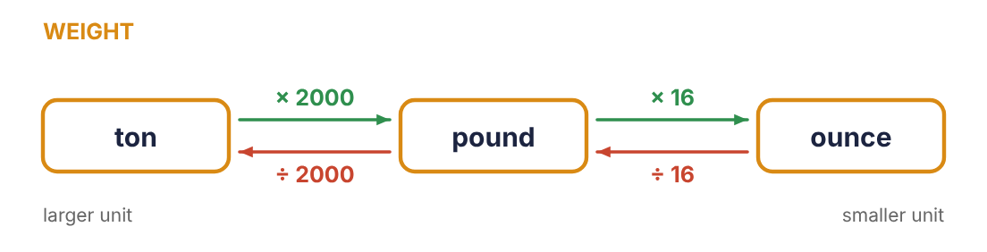
Figure 4.2 The weight chain.
Fact | To go to the smaller unit | To go to the larger unit
1 lb = 16 oz | lb → oz: × 16 | oz → lb: ÷ 16
1 T = 2000 lb | T → lb: × 2000 | lb → T: ÷ 2000
EXAMPLE 4.6
A rooftop unit weighs 1.75 tons. How many pounds is that?
Work | Why
1 T = 2000 lb | The fact.
1.75 × 2000 = 3500 | Tons to pounds: smaller unit, multiply.
Answer: 3500 lb
EXAMPLE 4.7: A measurement in two units
A system is charged with 6 lb 4 oz of refrigerant. Write the charge in ounces, and in pounds as a decimal.
Work | Why
6 × 16 = 96 oz | Change the pounds to ounces.
96 + 4 = 100 oz | Add the extra ounces.
4 ÷ 16 = 0.25 lb | Or change the 4 ounces to pounds.
6 + 0.25 = 6.25 lb | Add to the whole pounds.
Answer: 100 oz, or 6.25 lb

4.5 Category 3: liquid capacity
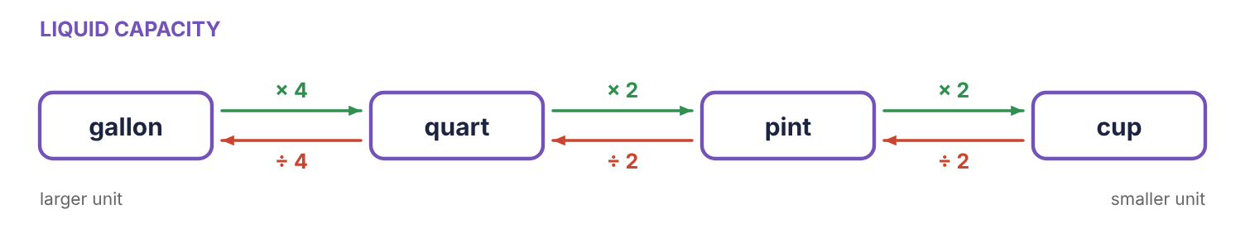
Figure 4.3 The capacity chain.
Fact | To go to the smaller unit | To go to the larger unit
1 pt = 2 cups | pt → cups: × 2 | cups → pt: ÷ 2
1 qt = 2 pt | qt → pt: × 2 | pt → qt: ÷ 2
1 gal = 4 qt | gal → qt: × 4 | qt → gal: ÷ 4
1 gal = 8 pt = 16 cups | gal → pt: × 8 | pt → gal: ÷ 8
EXAMPLE 4.8
A compressor takes 54 fluid quarts of oil over a year. How many gallons is that?
Work | Why
1 gal = 4 qt | The fact.
54 ÷ 4 = 13.5 | Quarts to gallons: larger unit, divide.
Answer: 13.5 gal
EXAMPLE 4.9
How many pints are in 2.5 gallons?
Work | Why
2.5 × 4 = 10 qt | Gallons to quarts.
10 × 2 = 20 pt | Quarts to pints.
Answer: 20 pt

Practice 4.1: Length, weight and capacity
Convert. Round to the nearest tenth if needed. Problems 1 to 6 are length, 7 to 10 weight, 11 to 14 capacity, 15 and 16 length.
- 9 ft to in
- 102 in to ft
- 4.5 yd to ft
- 50 ft to yd
- 2.5 mi to ft
- 9,000 ft to mi
- 5 lb to oz
- 72 oz to lb
- 3.2 T to lb
- 5,500 lb to T
- 6 gal to qt
- 18 qt to gal
- 7 pt to qt
- 2 gal to pt
- 180 in to yd
- 0.75 mi to yd

4.6 Category 4: area
Area is measured in square units. A square foot is a square that measures 1 foot on each side. Since each side is 12 inches, the square holds 12 rows of 12 square inches: 144 of them, not 12.
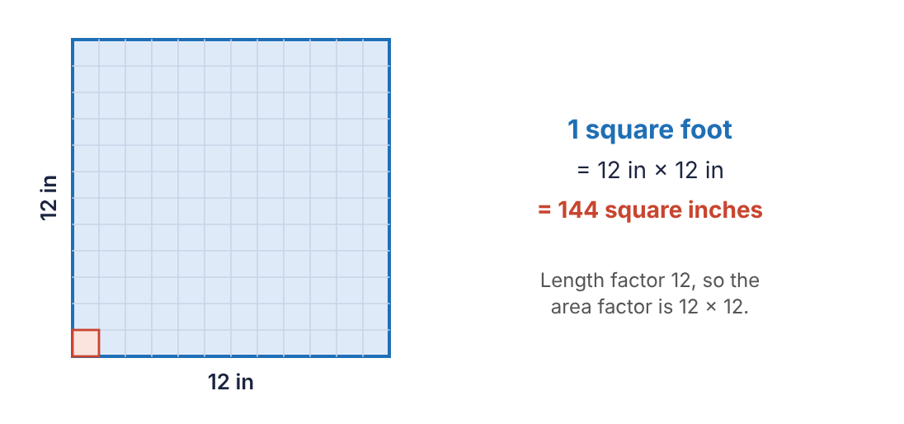
Figure 4.4 One square foot holds 144 square inches. The small red square is one square inch.
KEY RULE: Area conversion factors
Square the length factor.
1 sq ft = 12 × 12 = 144 sq in
1 sq yd = 3 × 3 = 9 sq ft
1 sq yd = 36 × 36 = 1296 sq in
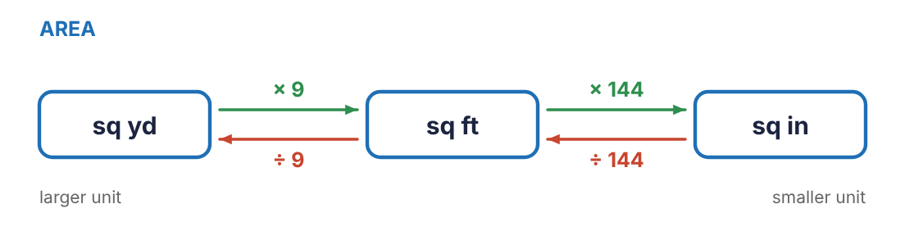
Figure 4.5 The area chain. From square yards straight to square inches the factor is 9 × 144 = 1296.
EXAMPLE 4.10
A duct opening has an area of 1000 sq in. How many square feet is that, to the nearest tenth?
Work | Why
1 sq ft = 144 sq in | The area fact, not the length fact.
sq in → sq ft: smaller → larger | Divide.
1000 ÷ 144 = 6.944… | Divide by 144.
6.9 | Round to the nearest tenth.
Answer: 6.9 sq ft
EXAMPLE 4.11
A room needs 15.5 sq yd of carpet. How many square feet is that?
Work | Why
1 sq yd = 9 sq ft | The area fact.
15.5 × 9 = 139.5 | Larger unit to smaller: multiply.
Answer: 139.5 sq ft
WATCH OUT: The most common conversion mistake
Dividing square inches by 12 to get square feet. Twelve converts lengths. Areas use 144. Watch for the words “square” or “sq” or the exponent in in² and ft².

4.7 Category 5: volume
Volume is measured in cubic units. A cubic foot is a cube 1 foot long on every edge. It holds 12 layers, each with 144 cubic inches, so the length factor is used three times.
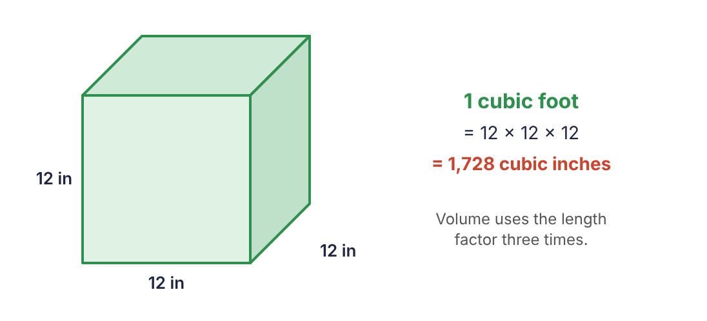
Figure 4.6 One cubic foot holds 12 × 12 × 12 = 1,728 cubic inches.
KEY RULE: Volume conversion factors
Cube the length factor.
1 cu ft = 12 × 12 × 12 = 1728 cu in
1 cu yd = 3 × 3 × 3 = 27 cu ft
1 cu yd = 36 × 36 × 36 = 46,656 cu in
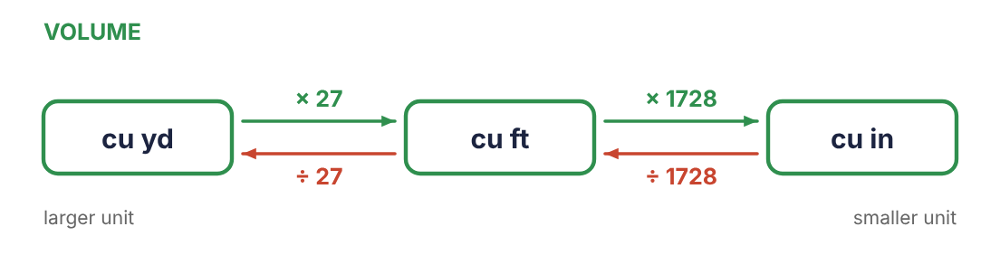
Figure 4.7 The volume chain. From cubic yards straight to cubic inches the factor is 27 × 1728 = 46,656.
EXAMPLE 4.12
An air handler cabinet has a volume of 5.5 cu ft. How many cubic inches is that?
Work | Why
1 cu ft = 1728 cu in | The volume fact.
5.5 × 1728 = 9504 | Larger unit to smaller: multiply.
Answer: 9504 cu in
EXAMPLE 4.13
A slab needs 2500 cu ft of concrete. Concrete is ordered by the cubic yard. How many cubic yards, to the nearest tenth?
Work | Why
1 cu yd = 27 cu ft | The volume fact.
2500 ÷ 27 = 92.592… | Smaller unit to larger: divide.
92.6 | Round to the nearest tenth.
Answer: 92.6 cu yd

Cubic measure and gallons
Tanks, pans and sumps are built to dimensions in inches or feet but are filled in gallons. Two facts connect them.
KEY RULE: Volume and liquid capacity
1 cu ft = 7.48 gallons
1 gallon = 231 cu in
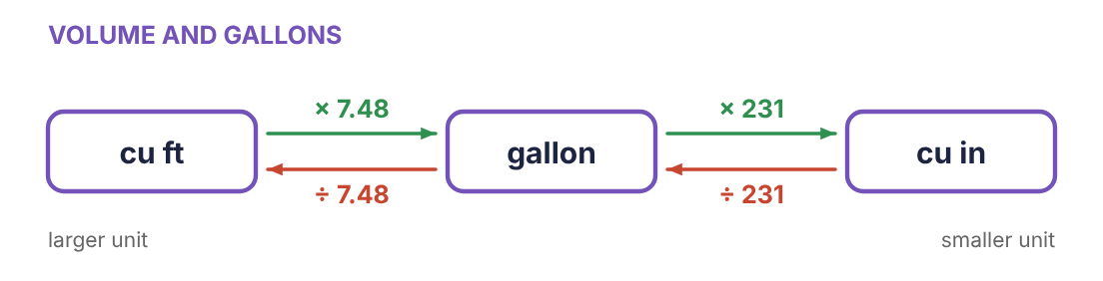
Figure 4.8 A gallon sits between the cubic foot and the cubic inch.
EXAMPLE 4.14
A condensate tank has a volume of 5 cu ft. How many gallons does it hold?
Work | Why
1 cu ft = 7.48 gal | A gallon is smaller than a cubic foot, so there will be more gallons.
5 × 7.48 = 37.4 | Multiply.
Answer: 37.4 gal
EXAMPLE 4.15
A drain pan holds 1500 cu in. How many gallons is that, to the nearest tenth?
Work | Why
1 gal = 231 cu in | A gallon is larger than a cubic inch.
1500 ÷ 231 = 6.493… | Divide.
6.5 | Round.
Answer: 6.5 gal
Table 4.3 Area and volume factors. Multiply going to the smaller unit; divide going to the larger.
To convert | Factor | To convert | Factor
sq ft ↔ sq in | 144 | cu ft ↔ cu in | 1728
sq yd ↔ sq ft | 9 | cu yd ↔ cu ft | 27
sq yd ↔ sq in | 1296 | cu yd ↔ cu in | 46,656
cu ft ↔ gal | 7.48 | gal ↔ cu in | 231
ON THE JOB: Ordering concrete
A patio 20 ft long, 12 ft wide and 4 in thick has a volume of 20 × 12 × 4/12 = 80 cu ft. Divide by 27: 2.96 cu yd. The thickness had to be changed to feet first. All three dimensions must be in the same unit before multiplying.

Practice 4.2: Area and volume
Convert. Round to the nearest tenth if needed.
- 850 sq in to sq ft
- 12.5 sq yd to sq ft
- 18 sq ft to sq in
- 2,000 sq in to sq yd
- 400 sq ft to sq yd
- 1,800 cu ft to cu yd
- 4,000 cu in to cu ft
- 16.5 cu yd to cu ft
- 3.5 cu ft to cu in
- 8 cu ft to gal
- 2,000 cu in to gal
- 40 gal to cu ft
- 3 gal to cu in
- 2 cu yd to cu in
- 120 gal to cu ft
- 0.5 sq yd to sq in
Chapter summary
- Larger unit to smaller unit: multiply. Smaller unit to larger unit: divide.
- Length facts: 12 in per ft, 3 ft per yd, 36 in per yd, 5280 ft per mile.
- Area factors are length factors squared: 144, 9, 1296.
- Volume factors are length factors cubed: 1728, 27, 46,656.
- 1 cu ft = 7.48 gal and 1 gal = 231 cu in.
- Check every answer: should the number have become larger or smaller?

Chapter 4 review
- 14 ft to in
- 200 in to ft
- 7 lb to oz
- 7,000 lb to T
- 10 qt to gal
- 600 sq in to sq ft
- 25 sq yd to sq ft
- 500 cu ft to cu yd
- 2.5 cu ft to cu in
- 12 cu ft to gal
- 1,000 cu in to gal
- 75 gal to cu ft
- Why is the factor from square feet to square inches 144 and not 12?
- A floor is 270 sq ft. Tile is sold by the square yard. How many square yards are needed?
- A trench needs 135 cu ft of gravel. How many cubic yards is that?
- A rectangular tank has a volume of 30 cu ft. How many gallons does it hold?
- How many inches are in 2 miles?
- A 55-gallon drum has what volume in cubic inches?

Chapter 5: The Metric System
Refrigerant charge in grams, pipe in millimetres, pressure in kilopascals: metric units appear on nearly every piece of modern equipment. The good news is that the metric system was designed to be easy. Every conversion inside it is a move of the decimal point.
After this chapter you will be able to
- Name the metric base units and the six common prefixes in order.
- Convert within the metric system by moving the decimal point.
- Convert between metric and standard units with the class conversion factors.
- Judge which of two units is larger.
- Carry out conversions that need more than one step.
Key terms
- base unit: The starting unit for a kind of measurement: metre (length), gram (weight), litre (capacity).
- prefix: A word part put in front of the base unit that multiplies it by a power of ten.
- metric stairs: The seven prefixes written in order from kilo down to milli; also called the metric ladder.

5.1 Base units and prefixes
The metric system has one base unit for each kind of measurement, and the same set of prefixes works with all of them.
Measures | Base unit | Symbol | About the size of
length | metre (meter) | m | a little more than a yard
weight (mass) | gram | g | a paper clip
liquid capacity | litre (liter) | L | a little more than a quart
Table 5.1 The metric prefixes, largest to smallest
Prefix | Symbol | Means | Length | Weight | Capacity
kilo | k | 1000 | km | kg | kL
hecto | h | 100 | hm | hg | hL
deka | da | 10 | dam | dag | daL
(base unit) |  | 1 | m | g | L
deci | d | 0.1 (1/10) | dm | dg | dL
centi | c | 0.01 (1/100) | cm | cg | cL
milli | m | 0.001 (1/1000) | mm | mg | mL
CALCULATOR TIP: Remembering the order
A sentence whose words start with k h da (unit) d c m keeps the prefixes in order. A common one: King Henry Died Unusually Drinking Chocolate Milk.

5.2 Converting on the metric stairs
Each step on the stairs is a factor of 10, and multiplying or dividing by 10 moves the decimal point one place. So a metric conversion is done by counting steps.
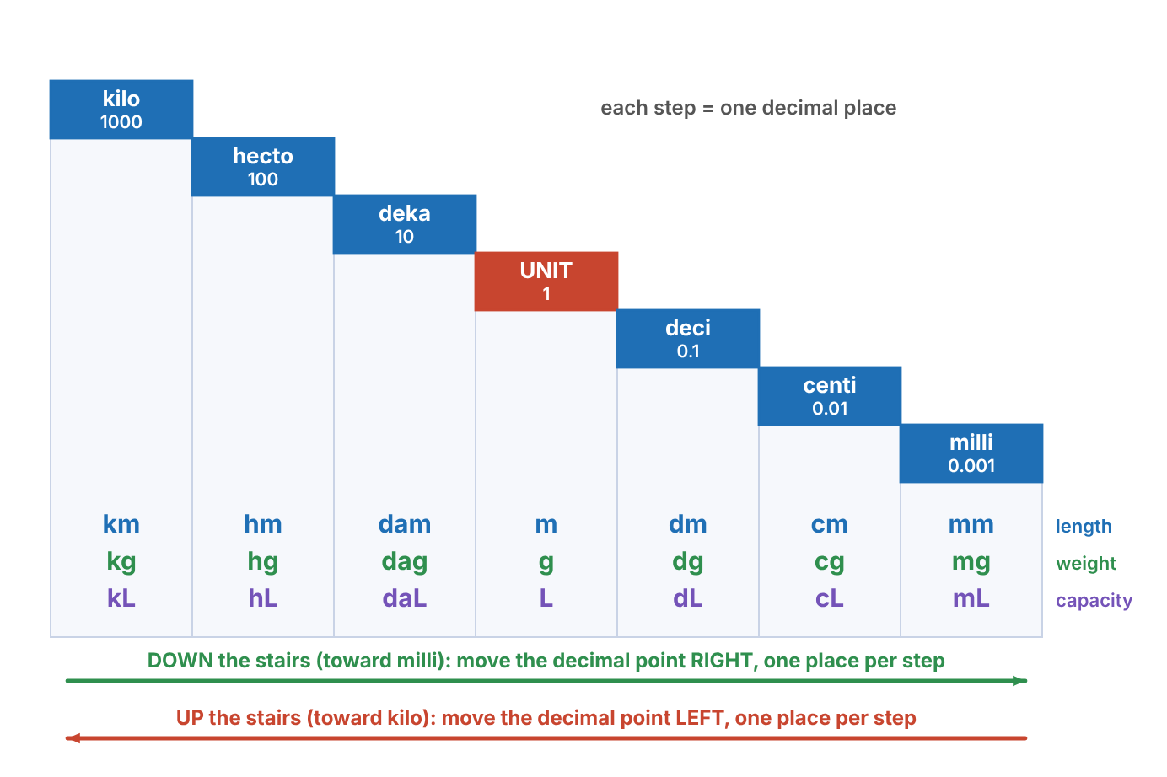
Figure 5.1 The metric stairs. Every step holds a length unit, a weight unit and a capacity unit, and the same stairs serve all three.
KEY RULE: Converting within the metric system
1. Find the unit you have and the unit you want on the stairs.
2. Count the steps between them.
3. Move the decimal point that many places, in the same direction you moved on the stairs: going down toward milli (right on the chart), move the point right; going up toward kilo, move it left.
Fill empty places with zeros.
EXAMPLE 5.1
Convert 250 mm to centimetres.
Work | Why
mm → cm | Centi is one step up the stairs from milli (one step left on the chart).
250. → 25.0 | Move the decimal point one place left.
Answer: 25 cm
EXAMPLE 5.2
Convert 0.25 L to millilitres.
Work | Why
L → dL → cL → mL | From the base unit to milli is three steps down.
0.25 → 0 250. | Move the point three places right. A zero must be added to fill the third place.
Answer: 250 mL
EXAMPLE 5.3
Convert 250 dg to dekagrams.
Work | Why
dg → g → dag | Deci to deka is two steps up, passing the base unit.
250. → 2.50 | Move the point two places left.
Answer: 2.5 dag
WATCH OUT: Count steps, not units
From mm to m is three steps (mm → cm → dm → m), even though only two units are named in the problem. Point at each stair as you count. And remember the unit step: deka → base → deci is two moves.
WATCH OUT: m, mm and M
Lowercase m alone is metre. As a prefix, lowercase m is milli (mm, mg, mL). Do not confuse millimetres with metres, or mg with g: the difference is a factor of 1000.

5.3 The stairs, one category at a time
The stairs never change. Only the base unit changes with what is being measured.

Category 1: metric length (the metre)
km | hm | dam | m | dm | cm | mm
kilometre | hectometre | dekametre | metre | decimetre | centimetre | millimetre
1000 m | 100 m | 10 m | 1 m | 0.1 m | 0.01 m | 0.001 m
The units used most are the kilometre (road distances), the metre (rooms and pipe runs), the centimetre and the millimetre (parts and drawings). Worth knowing by heart: 1 m = 100 cm = 1000 mm, 1 cm = 10 mm, 1 km = 1000 m.
EXAMPLE 5.4
A pipe is 3.2 m long. Give its length in centimetres and in millimetres.
Work | Why
m → dm → cm: 2 steps down | Move the point 2 places right.
3.2 → 320 cm
m → dm → cm → mm: 3 steps down | Move the point 3 places right.
3.2 → 3200 mm
Answer: 320 cm; 3200 mm
EXAMPLE 5.5
Convert 4750 m to kilometres.
Work | Why
m → dam → hm → km: 3 steps up | Move the point 3 places left.
4750. → 4.750
Answer: 4.75 km

Category 2: metric weight (the gram)
kg | hg | dag | g | dg | cg | mg
kilogram | hectogram | dekagram | gram | decigram | centigram | milligram
1000 g | 100 g | 10 g | 1 g | 0.1 g | 0.01 g | 0.001 g
The kilogram, the gram and the milligram do nearly all the work: 1 kg = 1000 g and 1 g = 1000 mg.
EXAMPLE 5.6
A refrigerant charge is 1.36 kg. How many grams is that?
Work | Why
kg → hg → dag → g: 3 steps down | Move the point 3 places right.
1.36 → 1360 | Fill the empty place with a zero.
Answer: 1360 g
EXAMPLE 5.7
Convert 85 cg to grams.
Work | Why
cg → dg → g: 2 steps up | Move the point 2 places left.
85. → 0.85
Answer: 0.85 g

Category 3: metric capacity (the litre)
kL | hL | daL | L | dL | cL | mL
kilolitre | hectolitre | dekalitre | litre | decilitre | centilitre | millilitre
1000 L | 100 L | 10 L | 1 L | 0.1 L | 0.01 L | 0.001 L
The litre and the millilitre are the everyday units: 1 L = 1000 mL.
EXAMPLE 5.8
A sample bottle holds 475 mL. How many litres is that?
Work | Why
mL → cL → dL → L: 3 steps up | Move the point 3 places left.
475. → 0.475
Answer: 0.475 L
EXAMPLE 5.9
Convert 2.6 daL to decilitres.
Work | Why
daL → L → dL: 2 steps down | Deka to deci passes the base unit: two steps. Move the point 2 places right.
2.6 → 260
Answer: 260 dL

The larger prefixes and the smaller ones
Science and electronics reach beyond the seven stairs. These prefixes step by a factor of 1000, three decimal places at a time.
Prefix | Symbol | Multiplies the unit by | Example
tera | T | 1,000,000,000,000 | terabyte
giga | G | 1,000,000,000 | gigawatt
mega | M | 1,000,000 | megohm (MΩ)
kilo | k | 1,000 | kilowatt (kW)
milli | m | 0.001 | milliamp (mA)
micro | µ | 0.000001 | microfarad (µF)
nano | n | 0.000000001 | nanosecond
pico | p | 0.000000000001 | picofarad (pF)

Practice 5.1: Metric to metric
Convert by moving the decimal point.
- 4.5 m to cm
- 380 mm to cm
- 2.4 km to m
- 750 g to kg
- 0.6 L to mL
- 1,250 mL to L
- 35 cm to mm
- 8,200 m to km
- 460 dg to dag
- 3.2 hL to L
- 0.085 kg to g
- 95 cm to m
- 7 dam to dm
- 12,500 mg to g
- 0.4 m to mm
- 64 cL to L

5.4 Between metric and standard
Moving between the two systems needs conversion factors again. The course uses the seven below. Each line is a fact, and the multiply-or-divide rule from Chapter 4 applies: toward the smaller unit multiply, toward the larger unit divide.
Table 5.2 Standard and metric conversion facts used in this course
Length | Weight | Capacity
1 in = 2.54 cm | 1 oz = 28.35 g | 1 L = 1.06 qt
1 m = 3.28 ft | 1 kg = 2.205 lb | 1 gal = 3.785 L
1 mi = 1.61 km
KEY RULE: Which unit is larger?
In each fact, the unit with the 1 in front of it is the larger unit, because it takes more than one of the other to match it.
An inch is larger than a centimetre. A metre is larger than a foot (and a yard). A mile is larger than a kilometre. An ounce is larger than a gram. A kilogram is larger than a pound. A litre is larger than a quart. A gallon is larger than a litre.
EXAMPLE 5.10
Convert 50 cm to inches. Round to the nearest tenth.
Work | Why
1 in = 2.54 cm | The connecting fact. The inch is the larger unit.
cm → in: smaller → larger | Divide.
50 ÷ 2.54 = 19.685… | Divide by the factor.
19.7 | Round.
Answer: 19.7 in
EXAMPLE 5.11
Convert 185 lb to kilograms. Round to the nearest tenth.
Work | Why
1 kg = 2.205 lb | The kilogram is the larger unit.
lb → kg: smaller → larger | Divide.
185 ÷ 2.205 = 83.900… | Divide.
83.9 | Round.
Answer: 83.9 kg
EXAMPLE 5.12
Convert 50 L to quarts.
Work | Why
1 L = 1.06 qt | The litre is the larger unit.
L → qt: larger → smaller | Multiply.
50 × 1.06 = 53 | Multiply.
Answer: 53 qt
The three examples above come from the three categories. Each category is now set out in full, in both directions.

Category 1: length (inch and centimetre, metre and foot, mile and kilometre)
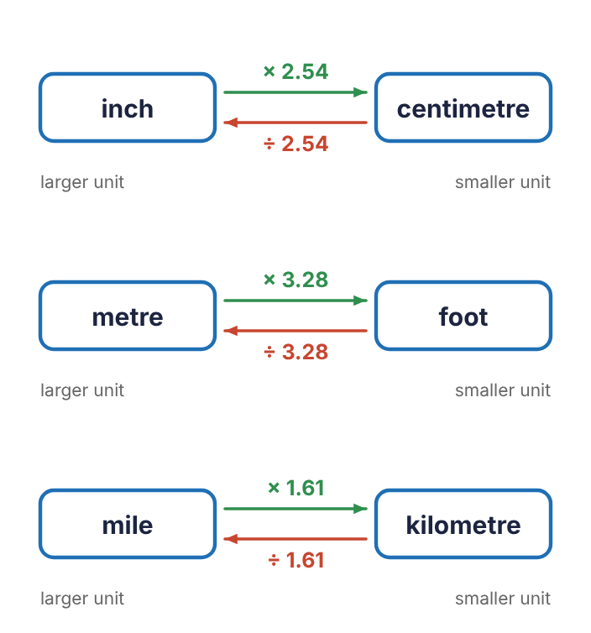
Figure 5.2 Length between the systems.
Fact | Multiply | Divide
1 in = 2.54 cm | in → cm: × 2.54 | cm → in: ÷ 2.54
1 m = 3.28 ft | m → ft: × 3.28 | ft → m: ÷ 3.28
1 mi = 1.61 km | mi → km: × 1.61 | km → mi: ÷ 1.61
EXAMPLE 5.13
A room is 4.5 m long. How many feet is that, to the nearest tenth?
Work | Why
1 m = 3.28 ft | The metre is the larger unit.
4.5 × 3.28 = 14.76 | Metres to feet: multiply.
14.8 | Round.
Answer: 14.8 ft
EXAMPLE 5.14
A job site is 12 km away. How many miles is that, to the nearest tenth?
Work | Why
1 mi = 1.61 km | The mile is the larger unit.
12 ÷ 1.61 = 7.453… | Kilometres to miles: divide.
7.5 | Round.
Answer: 7.5 mi

Category 2: weight (ounce and gram, kilogram and pound)
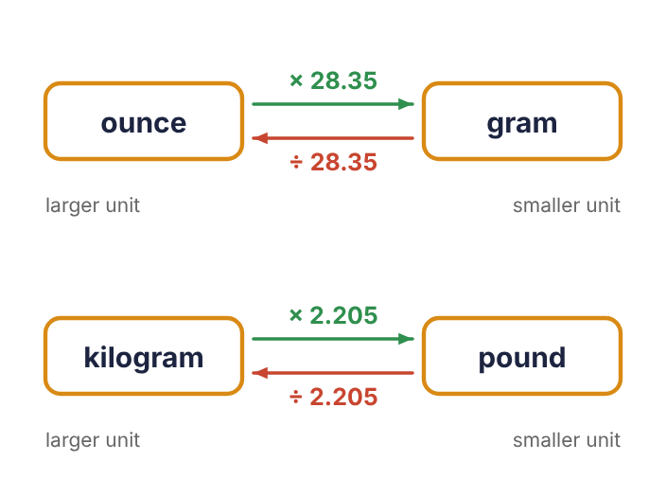
Figure 5.3 Weight between the systems.
Fact | Multiply | Divide
1 oz = 28.35 g | oz → g: × 28.35 | g → oz: ÷ 28.35
1 kg = 2.205 lb | kg → lb: × 2.205 | lb → kg: ÷ 2.205
EXAMPLE 5.15
A nameplate gives a charge of 14 oz. How many grams is that?
Work | Why
1 oz = 28.35 g | The ounce is the larger unit.
14 × 28.35 = 396.9 | Ounces to grams: multiply.
Answer: 396.9 g
EXAMPLE 5.16
A motor has a mass of 32 kg. How many pounds is that, to the nearest tenth?
Work | Why
1 kg = 2.205 lb | The kilogram is the larger unit.
32 × 2.205 = 70.56 | Kilograms to pounds: multiply.
70.6 | Round.
Answer: 70.6 lb

Category 3: capacity (litre and quart, gallon and litre)
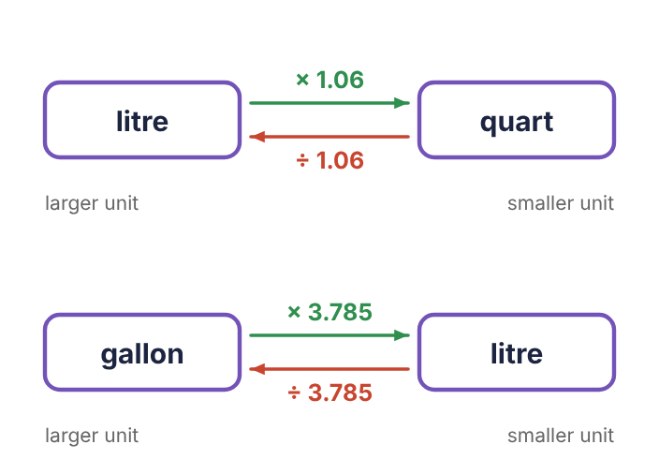
Figure 5.4 Capacity between the systems.
Fact | Multiply | Divide
1 L = 1.06 qt | L → qt: × 1.06 | qt → L: ÷ 1.06
1 gal = 3.785 L | gal → L: × 3.785 | L → gal: ÷ 3.785
EXAMPLE 5.17
A sump holds 12 gal. How many litres is that, to the nearest tenth?
Work | Why
1 gal = 3.785 L | The gallon is the larger unit.
12 × 3.785 = 45.42 | Gallons to litres: multiply.
45.4 | Round.
Answer: 45.4 L
EXAMPLE 5.18
An oil charge is 8 qt. How many litres is that, to the nearest tenth?
Work | Why
1 L = 1.06 qt | The litre is the larger unit.
8 ÷ 1.06 = 7.547… | Quarts to litres: divide.
7.5 | Round.
Answer: 7.5 L

Conversions with more than one step
If the unit you have is not one of the units in the table, first move along the metric stairs or use a standard fact to reach a unit that is. Write down each step with its unit.
EXAMPLE 5.19
Convert 5 km to inches. Round to the nearest whole number.
Work | Why
5 km = 500,000 cm | The table joins inches to centimetres. From kilo to centi is five steps down: move the point five places right.
500,000 ÷ 2.54 = 196,850.39… | Centimetres to inches: smaller to larger, divide by 2.54.
196,850 | Round to the nearest whole number.
Answer: 196,850 in
EXAMPLE 5.20
A recovery cylinder holds 30 lb of refrigerant. How many grams is that? Round to the nearest whole number.
Work | Why
30 ÷ 2.205 = 13.6054… kg | Pounds to kilograms: divide. Keep the digits in the calculator.
13.6054… kg = 13,605.4… g | Kilograms to grams: three steps down the stairs.
13,605 | Round at the end.
Answer: 13,605 g
ON THE JOB: Why technicians need both systems
Refrigerant charge on a nameplate may be given in ounces and in grams. Torque specs appear in foot-pounds and newton-metres. Imported equipment is dimensioned in millimetres, but the tape on your belt reads inches. A quick mental check helps: an inch is about 25 mm, a kilogram is a little over 2 lb, and a litre is about a quart.

Practice 5.2: Metric and standard
Convert. Round to the nearest tenth if needed. For 13 to 16, circle (name) the larger unit.
- 12 in to cm
- 80 cm to in
- 25 m to ft
- 100 ft to m
- 26.2 mi to km
- 10 km to mi
- 8 oz to g
- 500 g to oz
- 70 kg to lb
- 220 lb to kg
- 20 L to qt
- 15 gal to L
- centimetre or inch
- litre or quart
- gram or ounce
- kilometre or mile

Practice 5.3: Conversions by category
Convert. Round to the nearest tenth if needed. 1 to 6 length, 7 to 12 weight, 13 to 18 capacity.
- 2.75 m to cm
- 640 mm to m
- 3.4 km to m
- 18 in to cm
- 60 ft to m
- 55 mi to km
- 2.2 kg to g
- 350 mg to g
- 48 g to cg
- 24 oz to g
- 1,000 g to oz
- 45 kg to lb
- 1.5 L to mL
- 2,400 mL to L
- 36 dL to L
- 30 qt to L
- 60 L to gal
- 7.5 gal to L
Chapter summary
- Base units: metre, gram, litre. Prefixes in order: kilo, hecto, deka, (unit), deci, centi, milli.
- Inside the metric system, count the steps on the stairs and move the decimal point that many places, the same direction.
- Between systems use the facts 2.54, 3.28, 1.61, 28.35, 2.205, 1.06 and 3.785.
- The unit written with the 1 is the larger unit; multiply toward smaller units, divide toward larger ones.
- For multi-step conversions, write each step with its unit and round only at the end.

Chapter 5 review
- 6.8 m to mm
- 425 cm to m
- 0.75 kg to g
- 900 mL to L
- 52 dg to dag
- 1.2 km to cm
- 36 in to cm
- 150 cm to in
- 5 kg to lb
- 160 lb to kg
- 40 L to qt
- 5 gal to L
- 26 qt to L
- 400 km to mi
- Which is larger, a metre or a yard?
- Which is larger, a gallon or a cubic foot?
- Convert 2 m to inches, to the nearest tenth. (Hint: go through centimetres.)
- Convert 3 lb to grams, to the nearest whole number.
- A pipe is 19 mm in diameter. What is that in inches, to the nearest hundredth?
- How many steps, and in which direction, does the decimal point move from hectolitres to centilitres?

Chapter 6: Rulers, Gauges and Tolerance
A calculation is only as good as the measurement that goes into it. This chapter is about reading instruments correctly, and about deciding whether a measurement is close enough.
After this chapter you will be able to
- Read a metric rule in millimetres and centimetres.
- Read an inch rule to the nearest sixteenth and give the reading in lowest terms.
- Estimate the reading of a dial gauge, including a gauge with two scales.
- Find the upper and lower limits of a toleranced dimension and decide whether a part is acceptable.
- Find a missing dimension on a drawing.
Key terms
- graduation: One of the marks on a scale.
- scale value: What the space between two neighbouring marks is worth.
- tolerance: How far a dimension is allowed to vary from the size called for.
- limits: The largest and smallest acceptable sizes.
- nominal size: The size called for on the drawing, before the tolerance is applied.

6.1 The metric rule
On a metric rule the numbered marks are centimetres. Each centimetre is divided into 10 equal parts, and each small part is one millimetre. A slightly longer mark shows the halfway point, 5 mm.
KEY RULE: Reading a metric rule in millimetres
Multiply the last numbered centimetre mark before the point by 10, then add the small marks past it.
A point 6 small marks past the 4 is 40 + 6 = 46 mm, which is also 4.6 cm.
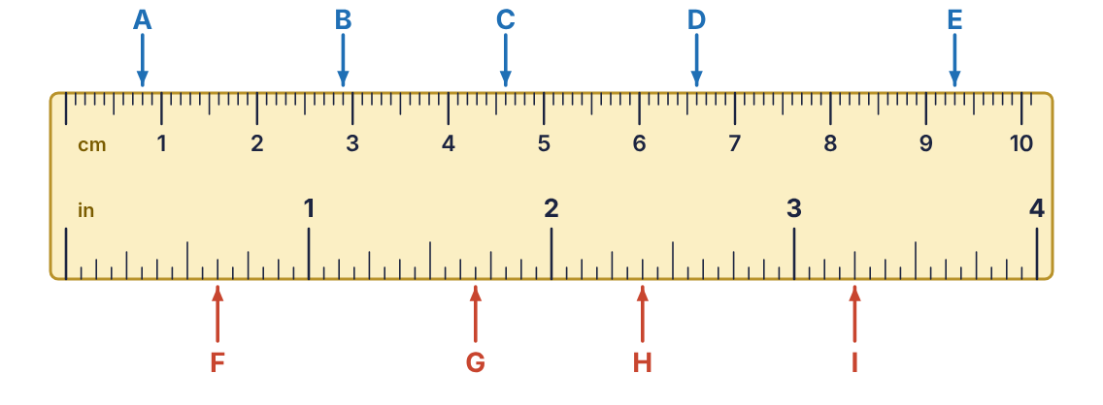
Figure 6.1 A rule with a centimetre scale on the top edge and an inch scale in sixteenths on the bottom edge.
EXAMPLE 6.1
Read points A to E on the metric scale of Figure 6.1, in millimetres.
Work | Why
A: 8 marks from zero | Before the 1 cm mark, so just count: 8 mm.
B: 2 cm + 9 marks = 29 | One mark short of 3 cm.
C: 4 cm + 6 marks = 46 | One mark past the long 5 mm mark.
D: 6 cm + 6 marks = 66
E: 9 cm + 3 marks = 93
Answer: A 8 mm, B 29 mm, C 46 mm, D 66 mm, E 93 mm

6.2 The inch rule
An inch rule is divided by halving, again and again. Half of an inch is 1/2, half of that is 1/4, then 1/8, then 1/16. The marks are made in different lengths so the eye can pick them out: the longer the mark, the larger the fraction.
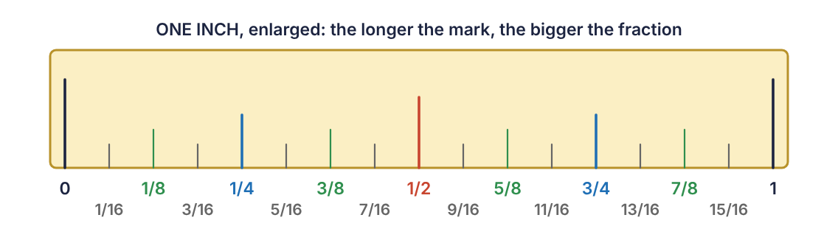
Figure 6.2 One inch divided into sixteenths. Every mark has a name in lowest terms.
KEY RULE: Reading an inch rule
1. Write down the last whole inch before the point.
2. Count the sixteenth spaces from that inch mark to the point.
3. Write the count over 16 and reduce: keep halving top and bottom until the top is odd.
EXAMPLE 6.2
Read points F to I on the inch scale of Figure 6.1.
Work | Why
F: 0 in + 10 sixteenths = 10/16 = 5/8 | Ten spaces from zero. Reduce by 2.
G: 1 in + 11 sixteenths = 1 11/16 | Eleven is odd, so it is already in lowest terms.
H: 2 in + 6 sixteenths = 2 6/16 = 2 3/8 | Reduce by 2.
I: 3 in + 4 sixteenths = 3 4/16 = 3 1/4 | Reduce by 4. This is the quarter-inch mark, the third-longest line.
Answer: F 5/8 in, G 1 11/16 in, H 2 3/8 in, I 3 1/4 in
CALCULATOR TIP: Count from the nearest long mark
Counting eleven tiny spaces invites mistakes. Instead, find the nearest half-inch mark (that is 8/16) and count from there: three marks past the half is 11/16. One mark before the next inch is 15/16.
WATCH OUT: Always reduce
An answer of 2 6/16 is the right place on the ruler but is not finished. Readings are given in lowest terms: 2 3/8.

Rules with other divisions
Some rules are divided into 8ths, 32nds or 64ths, and engineers’ and machinists’ rules are divided into 10ths and 100ths. The method never changes: count how many spaces make one inch, and that count is the denominator.
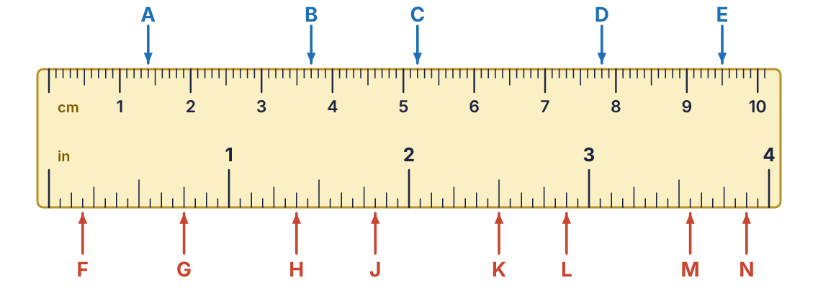
Figure 6.3 Rule for Practice 6.1.

Practice 6.1: Reading a rule
Use Figure 6.3. Give A to E in millimetres. Give F to N in inches, in lowest terms.
- Point A
- Point B
- Point C
- Point D
- Point E
- Point F
- Point G
- Point H
- Point J
- Point K
- Point L
- Point M
- Point N
- Write the reading for point C in centimetres.
- How many millimetres is it from point A to point D?
- How far is it from point G to point K, in inches?

6.3 Reading gauges and meters
A dial is a ruler bent into an arc. The same question unlocks every one of them: what is each small space worth?
KEY RULE: Finding the scale value
1. Pick two neighbouring numbered marks and subtract them.
2. Count the spaces between them (spaces, not marks).
3. Divide: value of one space = difference ÷ number of spaces.
4. Read the needle: last numbered mark + spaces past it × value of a space. If the needle is between two marks, estimate.
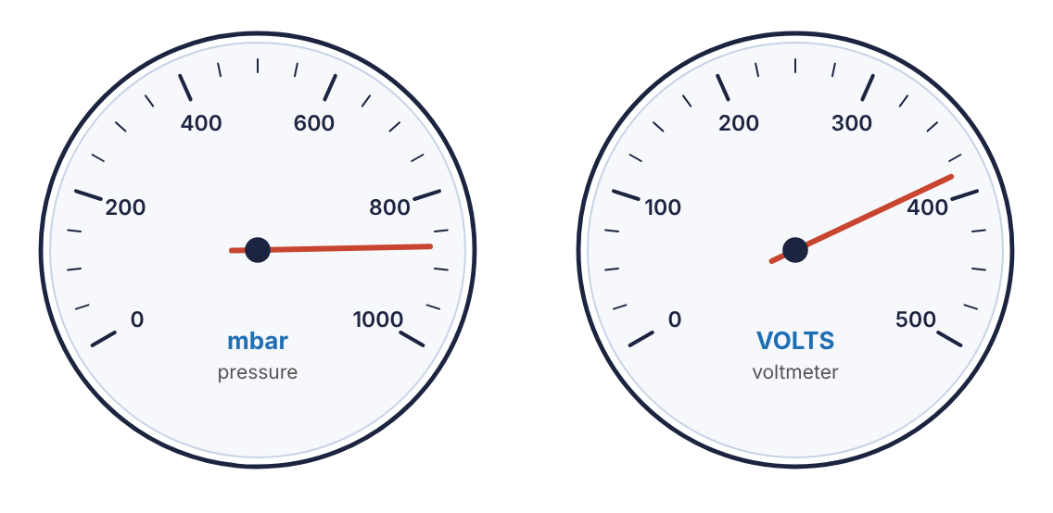
Figure 6.4 Two dials. Left: numbered every 200 with 4 spaces between numbers. Right: numbered every 100 with 4 spaces.
EXAMPLE 6.3
Estimate the reading of the pressure gauge on the left of Figure 6.4.
Work | Why
200 − 0 = 200 | Two neighbouring numbers differ by 200.
200 ÷ 4 spaces = 50 per space | There are four spaces between numbered marks.
800 + 1 space = 850 | The needle is past 800 and past the first small mark.
850 + a little less than half a space ≈ 870 | It sits not quite halfway to 900. Half a space would be 25, so estimate about 20.
Answer: about 870 mbar
On the voltmeter at the right, each space is 100 ÷ 4 = 25 volts. The needle is three spaces past 300 (that is 375) and a bit more, so the reading is about 385 volts. An estimate between marks will differ slightly from person to person; 385 and 390 are both reasonable, 350 is not.
WATCH OUT: Count spaces, and check your scale value
If you think each space is worth 20, count by 20s from one number to the next. If you do not land exactly on the next number, the scale value is wrong. On the gauge above: 0, 50, 100, 150, 200. It lands, so 50 is right.

Gauges with two scales
Many pressure gauges carry two scales on one face, for example kPa on the outer ring and psi on the inner ring. There is one needle but two readings, and each scale has its own numbers and its own scale value.
- Decide which scale the question asks for, and look only at that ring of numbers.
- Work out the scale value for that ring separately. The outer ring might be worth 1000 per space while the inner is worth 100.
- Follow the needle to the ring you are reading. Do not read the psi position against the kPa numbers.
- As a check, 1 psi is about 6.9 kPa, so the kPa reading should be roughly 7 times the psi reading.
EXAMPLE 6.4
A dual-scale gauge reads 6000 kPa on its outer scale. Use the check above to estimate what the inner psi scale should read.
Work | Why
6000 ÷ 6.9 = 869.6 | kPa is the smaller unit, so the psi number is smaller: divide.
≈ 870 | A reading between 860 and 880 psi is consistent.
Answer: about 870 psi
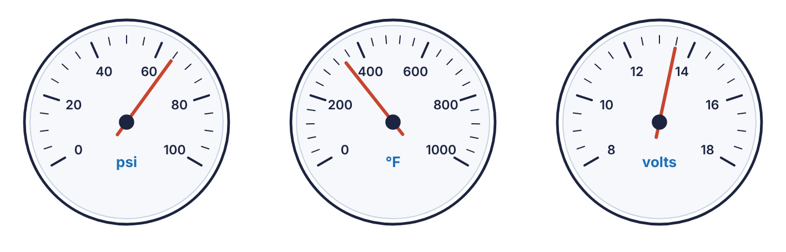
Figure 6.5 Gauges A, B and C for Practice 6.2.
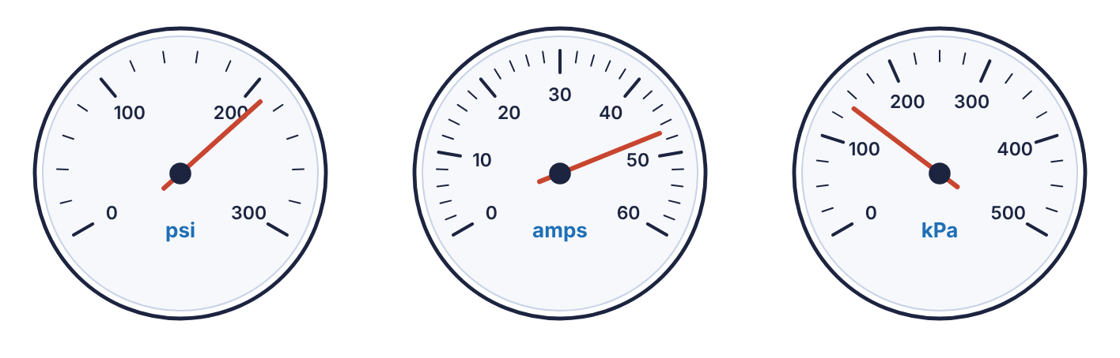
Figure 6.6 Gauges D, E and F for Practice 6.2.

Practice 6.2: Reading gauges
Use Figures 6.5 and 6.6. Estimates within half a space of the answer are acceptable.
- Gauge A: what is one small space worth?
- Gauge A: estimate the reading.
- Gauge B: what is one small space worth?
- Gauge B: estimate the reading.
- Gauge C: what is one small space worth?
- Gauge C: estimate the reading.
- Gauge D: what is one small space worth?
- Gauge D: estimate the reading.
- Gauge E: what is one small space worth?
- Gauge E: estimate the reading.
- Gauge F: what is one small space worth?
- Gauge F: estimate the reading.

6.4 Tolerance
Nothing can be made to an exact size. A drawing therefore gives a nominal size and a tolerance, the amount the part may be over or under. The sign ± is read “plus or minus.”
KEY RULE: Limits of a dimension
upper limit = nominal size + tolerance
lower limit = nominal size − tolerance
A part is acceptable if its size is anywhere from the lower limit to the upper limit, including the limits themselves.
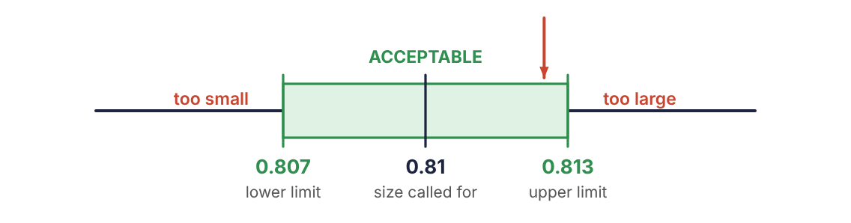
Figure 6.7 The tolerance band for 0.81 ± 0.003 in. The arrow marks a 13/16-in hole at 0.8125 in.
EXAMPLE 6.5
A hole is specified as 0.81 in ± 0.003 in. (a) What are the limits? (b) Will a hole drilled with a 13/16-in bit be within specification?
Work | Why
0.810 + 0.003 = 0.813 | (a) Upper limit. Write 0.81 as 0.810 so the decimal places line up.
0.810 − 0.003 = 0.807 | Lower limit.
13 ÷ 16 = 0.8125 | (b) Change the drill size to a decimal so it can be compared.
0.807 ≤ 0.8125 ≤ 0.813 | Compare using four decimal places: 0.8070, 0.8125, 0.8130. It lies between the limits.
Answer: (a) 0.807 in to 0.813 in (b) Yes
WATCH OUT: Line up the decimal places before adding
0.81 + 0.003 is not 0.84 and not 0.813 by luck. Write 0.810 + 0.003. A tolerance usually has more decimal places than the nominal size.

Fraction and percent tolerances
Tolerances on a tape-measure job are fractions: 24 1/2 in ± 1/16 in gives limits of 24 7/16 in and 24 9/16 in. Electrical parts are often toleranced by percent: a 200-ohm resistor at ±5% may be off by 5% of 200 = 10 ohms, so its limits are 190 and 210 ohms.

6.5 Finding a missing dimension
Drawings rarely repeat information. If the overall length and all but one of the parts are given, the missing part is found by subtracting. The idea is simply: the parts add up to the whole.
KEY RULE: Missing length
missing part = overall length − (sum of the known parts)
Change every dimension to the same form first: all decimals or all fractions.
EXAMPLE 6.6
A bar is 78 3/4 in long overall. It is marked in three sections. The first is 11.25 in and the third is 31 3/8 in. How long is the middle section? Do not round.
Work | Why
78 3/4 = 78.75; 31 3/8 = 31.375 | Change the fractions to decimals.
78.750 − 11.250 − 31.375 | Subtract each known part from the overall length.
= 36.125 | No rounding is needed or allowed.
0.125 = 1/8 | As a mixed number, if wanted.
Answer: 36.125 in, or 36 1/8 in

Practice 6.3: Tolerance and missing lengths
Do not round.
- 2.50 in ± 0.01 in. Find the limits. Is a part measuring 2.495 in acceptable?
- 0.375 in ± 0.005 in. Find the limits. Is a part measuring 0.382 in acceptable?
- 1.25 in ± 0.002 in. Find the limits. Is a part measuring 1.2485 in acceptable?
- 4.0 in ± 0.05 in. Find the limits. Is a part measuring 3.94 in acceptable?
- 0.62 in ± 0.003 in. Find the limits. Is a part measuring 5/8 in acceptable?
- 0.44 in ± 0.004 in. Find the limits. Is a part measuring 7/16 in acceptable?
- Overall length 60 in; known parts 14.5 in, 22 3/8 in. Find the missing part.
- Overall length 96 1/2 in; known parts 18.25 in, 40 5/8 in. Find the missing part.
- Overall length 42 3/8 in; known parts 9.75 in, 12 1/2 in, 6.125 in. Find the missing part.
- Overall length 120 in; known parts 33 7/8 in, 33 7/8 in, 20.5 in. Find the missing part.
- A 150-Ω resistor has a tolerance of ±10%. What are its limits?
- A stud is to be cut 92 5/8 in ± 1/8 in. What are the limits?
Chapter summary
- Metric rule: the numbers are centimetres and each small space is 1 mm.
- Inch rule: count sixteenths past the last whole inch, then reduce the fraction.
- Gauge: scale value = difference between numbered marks ÷ number of spaces between them.
- On a dual-scale gauge, read each scale with its own numbers and its own scale value.
- Limits = nominal ± tolerance. A part on or between the limits is acceptable.
- A missing dimension is the overall length minus the known parts.

Chapter 6 review
- How many millimetres are in 7.3 cm?
- A point is 4 small marks past the 6 on a centimetre scale. Give the reading in mm.
- On an inch rule in sixteenths, a point is 12 spaces past the 2. Give the reading in lowest terms.
- A point is 14 sixteenths past the 5-inch mark. Give the reading in lowest terms.
- Which mark is longer on an inch rule, 3/8 or 3/4?
- A gauge is numbered 0, 40, 80, 120 with 8 spaces between numbers. What is each space worth?
- On that gauge the needle is 3 spaces past 80. What is the reading?
- A gauge is numbered every 500 with 5 spaces between numbers. The needle is halfway between the 2nd and 3rd marks past 1500. Estimate the reading.
- A dual-scale gauge reads 100 psi. About what should the kPa scale read?
- Find the limits of 1.75 in ± 0.015 in.
- A shaft must be 0.50 in ± 0.002 in. Is a shaft measuring 0.5025 in acceptable?
- A hole must be 0.69 in ± 0.005 in. Is an 11/16-in hole acceptable?
- Overall length 54 1/4 in; known parts 20.5 in and 16 3/8 in. Find the missing part without rounding.
- Four equal spaces and two end margins of 1.25 in make up a 30-in panel. How wide is each space?

Part 3 · Algebra
A formula is a set of instructions written in symbols. Part 3 covers the order in which those instructions are carried out, how to put numbers into a formula, and how to run a formula backward to find a missing value.

Chapter 7: Order of Operations
Ask two people to work out 6 + 4 ÷ 2 and you may get 5 from one and 8 from the other. Only one of them is right. Mathematics settles the question with a fixed order of operations, and every formula in the trades depends on it.
After this chapter you will be able to
- State the order of operations and explain why an agreed order is needed.
- Recognise every kind of grouping symbol, including the fraction bar.
- Evaluate expressions with exponents and square roots.
- Work multiplication with division, and addition with subtraction, from left to right.
- Show the work for a multi-step evaluation one operation at a time.
Key terms
- expression: Numbers and operations written together, such as 6 + 4 ÷ 2.
- evaluate: To work an expression down to a single number.
- exponent: The small raised number that tells how many times the base is multiplied by itself: 4² = 4 × 4.
- square root: The number that, multiplied by itself, gives the number under the √ sign: √25 = 5.
- grouping symbol: Anything that says “do this part first”: parentheses, brackets, braces, absolute-value bars, a fraction bar, a root sign.

7.1 Why an order is needed
Consider 6 + 4 ÷ 2. Working from left to right gives 10 ÷ 2 = 5. Dividing first gives 6 + 2 = 8. An expression must have one value, so everyone agrees to the same order. Under that agreement division comes before addition, and the answer is 8.
Wrong: 6 + 4 ÷ 2 = 10 ÷ 2 = 5
Right: 6 + 4 ÷ 2 = 6 + 2 = 8
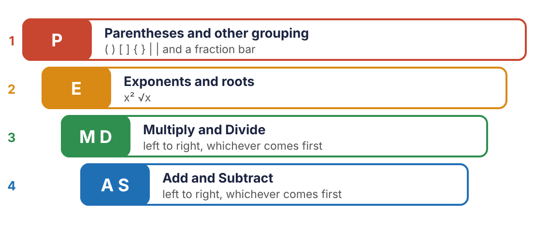
Figure 7.1 The order of operations. Four levels, worked from the top down.
KEY RULE: The order of operations (PEMDAS)
1. P: Parentheses and every other grouping symbol: ( ), [ ], { }, absolute-value bars, and the top and bottom of a fraction bar.
2. E: Exponents and roots.
3. M D: Multiplication and division, whichever comes first, working from left to right.
4. A S: Addition and subtraction, whichever comes first, working from left to right.
WATCH OUT: PEMDAS has four steps, not six
Multiplication does not come before division, and addition does not come before subtraction. Each pair shares a level and is worked in the order it appears, left to right. 24 ÷ 4 × 2 is 6 × 2 = 12, not 24 ÷ 8 = 3.

7.2 Exponents and roots
An exponent is shorthand for repeated multiplication. In 4², the 4 is the base and the 2 is the exponent: use 4 as a factor twice. A square root undoes a square.
4² = 4 × 4 = 16 2³ = 2 × 2 × 2 = 8 6⁴ = 6 × 6 × 6 × 6 = 1296
√16 = 4 because 4 × 4 = 16 √2.25 = 1.5 because 1.5 × 1.5 = 2.25
WATCH OUT: An exponent is not multiplication by the exponent
4² is 4 × 4 = 16, not 4 × 2 = 8. And 2³ is 8, not 6.
A root sign is also a grouping symbol. Everything under the bar must be worked out before the root is taken: √(9 + 16) is √25 = 5. It is not 3 + 4.
CALCULATOR TIP: Powers and roots on a calculator
Use the x² key for squares and the ^ or xʸ key for other powers: 6⁴ is 6 ^ 4. For a root, press √ and then put the whole quantity in parentheses: √(9 + 16). On some calculators the root key is the shifted function of x².

7.3 Multiplying without a times sign
In algebra the × sign is usually left out, because it looks like the letter x. A number written directly against a parenthesis, or against a letter, means multiply.
3(8) means 3 × 8 2(5 + 1) means 2 × (5 + 1) 4C means 4 × C (3)(7) means 3 × 7
CALCULATOR TIP: Some calculators need the times sign
Many calculators accept 3(8) as typed. Others report a syntax error or, worse, read it as something else. If yours does, key in the × yourself: 3 × (8).

7.4 Working an expression step by step
Do one operation per line and copy everything else down unchanged. It feels slow, but it is how errors are found, and it is the work an instructor expects to see.
EXAMPLE 7.1
Evaluate 5 − 3(4² ÷ 2) + 30.
Work | Why
5 − 3(16 ÷ 2) + 30 | Start inside the parentheses. Inside, the exponent comes first: 4² = 16.
5 − 3(8) + 30 | Still inside the parentheses: 16 ÷ 2 = 8.
5 − 24 + 30 | The parentheses now hold one number. Multiply: 3(8) = 24.
−19 + 30 | Add and subtract from left to right: 5 − 24 = −19.
11 | −19 + 30 = 11.
Answer: 11
WATCH OUT: Subtraction before addition, when it comes first
In 5 − 24 + 30, do not add 24 + 30 first. That gives 5 − 54 = −49, which is wrong. Work left to right: 5 − 24, then + 30.
EXAMPLE 7.2
Evaluate 18 − 12 ÷ 3 × 2 + 5².
Work | Why
18 − 12 ÷ 3 × 2 + 25 | No grouping symbols. Exponent first.
18 − 4 × 2 + 25 | Multiplication and division left to right: the division comes first, 12 ÷ 3 = 4.
18 − 8 + 25 | Then 4 × 2 = 8.
10 + 25 | Left to right: 18 − 8 = 10.
35
Answer: 35

The fraction bar
A long fraction bar groups everything above it and everything below it. Work the entire top to one number, work the entire bottom to one number, and divide last.
EXAMPLE 7.3
Evaluate 12 − 3(4² ÷ 2³) + 9/5² − 10. Round to the nearest hundredth if needed.
Work | Why
top: 12 − 3(16 ÷ 8) + 9 | Inside the parentheses, exponents first: 4² = 16 and 2³ = 8.
top: 12 − 3(2) + 9 = 12 − 6 + 9 = 15 | Finish the parentheses, multiply, then go left to right.
bottom: 25 − 10 = 15 | Exponent, then subtract.
15/15 = 1 | Only now divide the top by the bottom.
Answer: 1
CALCULATOR TIP: Entering a fraction bar
A calculator does not see a fraction bar unless you tell it. Put the whole top in parentheses and the whole bottom in parentheses: (12 − 3 × (4² ÷ 2³) + 9) ÷ (5² − 10). Without them the calculator divides only the 9 by the 25.

Grouping inside grouping
When grouping symbols are nested, begin with the innermost pair and work outward.
EXAMPLE 7.4
Evaluate 2[7 + 3(10 − 6)]².
Work | Why
2[7 + 3(4)]² | Innermost parentheses first.
2[7 + 12]² | Inside the brackets, multiply before adding.
2[19]² | Finish the brackets.
2 × 361 | Exponent before multiplication: 19² = 361.
722
Answer: 722

Negative numbers
The Chapter 7 work occasionally passes through a negative number, as −19 did above. Two facts are enough: subtracting a larger number from a smaller one gives a negative result (5 − 24 = −19), and a negative times a positive is negative ((19)(−5) = −95).

Practice 7.1: Order of operations
Evaluate. Show one operation per line. Round to the nearest hundredth only if needed.
- 6 + 4 ÷ 2
- 20 − 8 + 5
- 24 ÷ 4 × 2
- 3 + 5 × 2²
- (3 + 5) × 2²
- 40 ÷ (2 + 3) × 4
- 7 − 2(3² − 4) + 15
- 5 + 12 ÷ 4 × 15 − 3²
- √(36 + 64)
- 4 + √81 × 2
- 18 + 6/2 × 3
- 5² − 1/4 + 2²
- 5 + 12 ÷ 4 × 15 + 15²/6
- 3[20 − 2(4 + 3)]
- 100 − 4(2 + 3)²
- 2³ + 6(9 − 5) ÷ 8
- (7 + 12)(7 − 12)
- 8(6 + 14)/8 + 6 + 14
Chapter summary
- Order: grouping symbols, then exponents and roots, then × and ÷ left to right, then + and − left to right.
- A fraction bar and a root sign are grouping symbols.
- A number against a parenthesis means multiply.
- Write one operation per line and copy the rest unchanged.
- On a calculator, a fraction needs parentheses around its top and around its bottom.

Chapter 7 review
- In your own words, list the four levels of the order of operations.
- 15 − 6 + 4
- 36 ÷ 6 × 3
- 9 + 3 × 4²
- (9 + 3) × 4²
- 50 − 2(3 + 4²)
- 8 − 5(6² ÷ 9) + 20
- √(5² + 12²)
- 3√49 − 2³
- 30 − 2(3² − 4)/2² + 1
- 14 − 2(5² ÷ 5) + 8/3² − 5
- 4[2 + 3(8 − 6)²]
- 6² + 8²/2 × 5
- 2.5(4.2 − 1.7)² (do not round)
- 16(6 + 8)/16 + 6 + 8 (nearest hundredth)
- A student evaluates 30 − 10 + 5 and gets 15. What was the mistake, and what is the answer?
- Write the keystrokes, with parentheses, for 7 + 9/2 × 4.
- Does 3(4)² equal 144 or 48? Explain.

Chapter 8: Evaluating Formulas
The trades run on formulas: for the load a post will carry, the speed of a grinding wheel, the capacitance of a circuit. Nobody memorises them all. What matters is the skill of putting the right numbers in and working them out correctly.
After this chapter you will be able to
- Explain what a formula is and what its letters stand for.
- Substitute given values into a formula, showing the substitution.
- Evaluate the result using the order of operations.
- Evaluate formulas containing exponents, roots and fraction bars.
- Round and label the answer as a problem directs.
Key terms
- formula: A rule written with letters that tells how to calculate one quantity from others.
- variable: A letter that stands for a number.
- substitute: To replace each letter with its given number.
- subscript: A small lowered label that tells similar letters apart, as in C₁ and C₂.
- constant: A number in a formula that never changes, such as the 12 in L = πdr ÷ 12.

8.1 What a formula says
A formula is a sentence in shorthand. The formula A = LW says “the area of a rectangle equals its length times its width.” Each letter is a variable: a placeholder waiting for a number. Letters written side by side are multiplied.
- Capital and lowercase letters are different variables. In N = √(D ÷ d)⁵, D and d are two different diameters.
- A subscript makes a new variable name. C₁, C₂ and C₃ are three different capacitors. The subscript is a label, not a number to calculate with.
- Numbers that appear in a formula, such as 1.085 or 12, are constants. Leave them exactly as they are.

8.2 Substitute, then evaluate
KEY RULE: Three lines for every formula problem
1. Write the formula.
2. Substitute. Rewrite the formula with each letter replaced by its number in parentheses. Change nothing else.
3. Evaluate by the order of operations, then round and write the unit.
The parentheses in step 2 matter. They keep a multiplication from disappearing (2*C* with C = 30 must become 2(30), not 230) and they keep negative numbers and fractions together.
EXAMPLE 8.1
Evaluate L = 3A + 4(B + C) for A = 2, B = 3 and C = 4.
Work | Why
L = 3A + 4(B + C) | Write the formula.
L = 3(2) + 4(3 + 4) | Substitute. Every letter is replaced; nothing else moves.
L = 3(2) + 4(7) | Parentheses first.
L = 6 + 28 | Multiply.
L = 34 | Add.
Answer: L = 34
EXAMPLE 8.2: Two variables that look alike
Evaluate 2C + 1.6(D + d) + D + d/4C for C = 30 in, D = 10 in and d = 5 in. Give a mixed number or a non-rounded decimal.
Work | Why
2(30) + 1.6(10 + 5) + 10 + 5/4(30) | Substitute.
2(30) + 1.6(15) + 15/120 | Grouping: the parentheses, and the top and bottom of the fraction.
60 + 24 + 0.125 | Multiply and divide.
84.125 | Add. The problem forbids rounding, so every digit stays.
Answer: 84.125 in, or 84 1/8 in
WATCH OUT: Show the substitution line
Going straight from the formula to the answer hides where an error happened and usually costs credit. The substitution line is the proof that the right number went in the right place.

8.3 Formulas from the trades
The examples that follow use real formulas. In each one, read the description to match every letter with its number, and note how the answer is to be rounded.
EXAMPLE 8.3
Machine trades. The linear speed of a grinding wheel in feet per minute is L = πdr/12, where d is the wheel diameter in inches and r is the speed in rpm. Find the linear speed of an 8-in wheel turning at 1750 rpm. Use π = 3.14 and round to the nearest whole number.
Work | Why
L = πdr/12 | Formula.
L = (3.14)(8)(1750)/12 | Substitute.
L = 43,960/12 | Multiply across the top.
L = 3663.33… | Divide.
L = 3663 | Round as directed.
Answer: 3663 ft/min
EXAMPLE 8.4: Exponents
Construction. The crushing load in tons of a square wooden post is L = 25T⁴/H², where T is the thickness in inches and H is the height in feet. Find the crushing load of a 4-in post 8 ft high.
Work | Why
L = 25T⁴/H² | Formula.
L = 25(4)⁴/(8)² | Substitute.
L = 25(256)/64 | Exponents first: 4⁴ = 256 and 8² = 64.
L = 6400/64 = 100 | Multiply the top, then divide.
Answer: 100 tons
WATCH OUT: The exponent belongs only to what it touches
In 25T⁴ the exponent applies to T alone. Raise 4 to the fourth power first, then multiply by 25. Multiplying 25 × 4 first and then raising 100 to the fourth power gives one hundred million.
EXAMPLE 8.5: A root
Plumbing. To carry the same flow as one pipe of diameter D, the number of smaller pipes of diameter d needed is N = √(D ÷ d)⁵. How many 2-in pipes are needed to equal one 6-in pipe? Round to the nearest whole number.
Work | Why
N = √(D/d)⁵ | Formula.
N = √(6/2)⁵ | Substitute.
N = √(3)⁵ | Innermost grouping first: 6 ÷ 2 = 3.
N = √243 | The exponent is under the root sign, so it is done before the root: 3⁵ = 243.
N = 15.588… | Take the square root.
N = 16 | Round to the nearest whole number.
Answer: 16 pipes
CALCULATOR TIP: Keying a root of a power
Enter it the way it is grouped: √( (6 ÷ 2) ^ 5 ). Open a parenthesis after the root sign and close it at the very end, so the root covers the whole power.
EXAMPLE 8.6: Subscripts and a fraction bar
Electronics. For one capacitor in series with two in parallel, the total capacitance is C_{T} = C₁(C₂ + C₃)/C₁ + C₂ + C₃. Find C_{T} when C₁ = 12 µF, C₂ = 5 µF and C₃ = 7 µF. Round to the nearest hundredth.
Work | Why
C_{T} = 12(5 + 7)/12 + 5 + 7 | Substitute. The subscripts only say which capacitor is which.
C_{T} = 12(12)/24 | Parentheses on top; add across the bottom.
C_{T} = 144/24 = 6 | Multiply the top, then divide.
Answer: 6 µF
EXAMPLE 8.7
Manufacturing. The capacity of a feeder belt in metric tons per hour is C = W²DS/1.085, where W is the belt width in metres, D is the density of the material in kg/m³ and S is the belt speed in m/s. Find the capacity for W = 1.2 m, D = 800 kg/m³ and S = 2.5 m/s. Round to the nearest whole number.
Work | Why
C = (1.2)²(800)(2.5)/1.085 | Substitute.
C = (1.44)(800)(2.5)/1.085 | Exponent first.
C = 2880/1.085 | Multiply across the top.
C = 2654.37… | Divide.
C = 2654 | Round.
Answer: 2654 metric tons per hour

Practice 8.1: Substitute and evaluate
Write the formula, show the substitution, and evaluate. Do not round unless told to.
- N = (a + b)(a − b); a = 9, b = 14
- L = s(P + p)/2; s = 4.5, P = 42, p = 30
- f = 1/8N; N = 5 (answer as a fraction)
- t = D − d/L; D = 15, d = 6, L = 3
- V = gt²/2; g = 32.2, t = 2.5
- P = 2L + 2W; L = 18.5 ft, W = 12.25 ft
- A = (b₁ + b₂)h/2; b₁ = 9, b₂ = 14, h = 6
- c = √(a² + b²); a = 9, b = 12
- Welding. Tensile strength T = L/A psi. L = 9,800 lb, A = 0.14 sq in.
- Electrical. Power P = I²R watts. I = 2.5 A, R = 48 Ω.
- Machine trades. L = πdr/12. d = 10 in, r = 1200 rpm, π = 3.14.
- Construction. L = 25T⁴/H². T = 6 in, H = 10 ft.
- Plumbing. N = √(D ÷ d)⁵. D = 4 in, d = 1 in.
- Plumbing. N = √(D ÷ d)⁵. D = 3 in, d = 3/4 in. Round to the nearest whole number.
- Electronics. Two inductors in parallel: L_{T} = L₁L₂/L₁ + L₂. L₁ = 300 mH, L₂ = 60 mH.
- Electronics. C_{T} = C₁(C₂ + C₃)/C₁ + C₂ + C₃. C₁ = 20, C₂ = 4, C₃ = 9 (µF). Nearest hundredth.
- Electronics. Inductance of a coil L = R²N²/9R + 10D µH. R = 2 in, D = 5 in, N = 150 turns. Nearest whole number.
- Automotive. Indicated horsepower ihp = MEP × D × S/792,000. MEP = 150 psi, D = 300 cu in, S = 3300 rpm.
- Hydraulics. Force on a piston F = πPD²/4 lb. P = 40 psi, D = 2.5 in, π = 3.14. Nearest whole number.
- Manufacturing. C = W²DS/1.085. W = 0.9 m, D = 1500 kg/m³, S = 2 m/s. Nearest whole number.
Chapter summary
- A formula is a rule; its letters are placeholders for numbers.
- Write the formula, substitute with parentheses, then evaluate by the order of operations.
- Capital and lowercase letters, and letters with different subscripts, are different variables.
- An exponent applies only to the quantity it touches.
- Round only at the end, as the problem directs, and write the unit.

Chapter 8 review
- Evaluate L = 5A + 2(B + C) for A = 3, B = 6, C = 2.
- Evaluate 3C + 2.4(D − d) for C = 12, D = 9, d = 4.
- Evaluate D + d/2C for D = 14, d = 6, C = 8. Give a decimal.
- Evaluate N = (a + b)(a − b) for a = 5, b = 11.
- Evaluate V = gt²/2 for g = 32.2 and t = 3.
- Evaluate A = √(s(s − a)(s − b)(s − c)) for s = 12, a = 6, b = 8, c = 10.
- Tensile strength T = L/A. L = 15,000 lb, A = 0.21 sq in. Round to the nearest hundred psi.
- Grinding wheel L = πdr/12. d = 7 in, r = 3000 rpm, π = 3.14.
- Crushing load L = 25T⁴/H². T = 8 in, H = 16 ft.
- Pipes N = √(D ÷ d)⁵. D = 12 in, d = 4 in. Nearest whole number.
- Feeder belt C = W²DS/1.085. W = 1.5 m, D = 600, S = 3. Nearest whole number.
- Piston force F = πPD²/4. P = 30 psi, D = 4 in, π = 3.14.
- C_{T} = C₁(C₂ + C₃)/C₁ + C₂ + C₃ for C₁ = 18, C₂ = 7, C₃ = 5. Nearest hundredth.
- L_{T} = L₁L₂/L₁ + L₂ for L₁ = 120 mH and L₂ = 80 mH.
- In the formula C = W²DS/1.085, which symbols are variables and which is a constant?
- A student substitutes C = 30 into 2C and writes 230. What should have been written?

Chapter 9: Solving Formulas
In Chapter 8 the unknown always stood alone on the left: put the numbers in and calculate. On the job it is often the other way round. You know the volume a tank must hold and need its height; you know the perimeter of a fence and need its length. Then the formula has to be run backward.
After this chapter you will be able to
- Explain what it means to solve an equation.
- Undo an operation with its inverse, keeping the equation balanced.
- Solve one-step and two-step equations.
- Substitute into a formula and solve for the unknown that is left.
- Solve equations that contain fractions without rounding.
Key terms
- equation: A statement that two expressions are equal.
- solve: To find the value of the unknown that makes the equation true.
- inverse operation: The operation that undoes another: + and −, × and ÷, square and square root.
- isolate: To get the unknown alone on one side of the equals sign.
- coefficient: The number multiplying a variable: the 2 in 2L.

9.1 Equations and balance
An equation is like a balance scale: the two sides weigh the same. Whatever is done to one side must be done to the other, or the scale tips and the equation is no longer true.
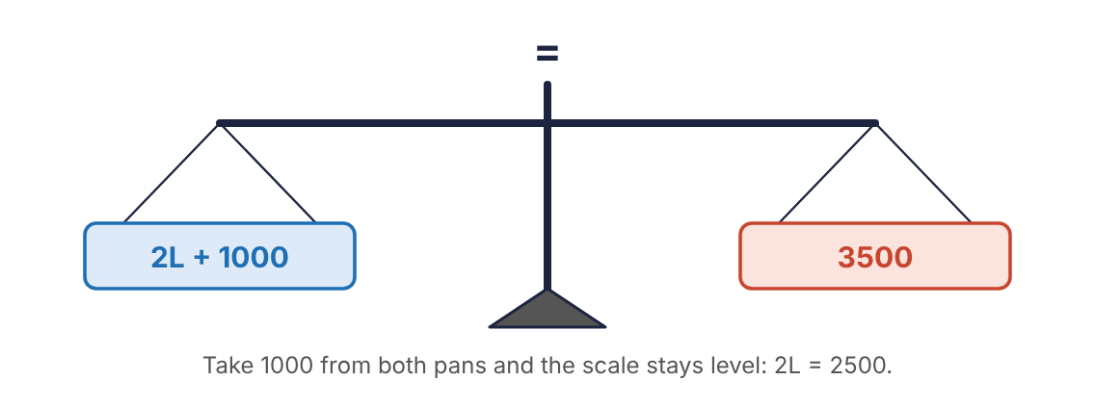
Figure 9.1 An equation is a balance.
KEY RULE: The golden rule of equations
Do the same thing to both sides.
You may add the same number to both sides, subtract the same number from both sides, multiply both sides by the same number, or divide both sides by the same number (except zero).
To solve an equation is to get the unknown letter alone: x = a number. That is done by removing everything else from its side, one operation at a time, using inverse operations.
If the unknown has had this done to it | Undo it by | Example
a number added: x + 7 = 19 | subtracting it from both sides | x = 19 − 7 = 12
a number subtracted: x − 7 = 19 | adding it to both sides | x = 19 + 7 = 26
multiplied by a number: 7x = 21 | dividing both sides by it | x = 21 ÷ 7 = 3
divided by a number: x/7 = 21 | multiplying both sides by it | x = 21 × 7 = 147

9.2 One-step equations
EXAMPLE 9.1
Ohm’s law is I = E/R. A circuit carries a current I = 0.60 A through a resistance R = 400 Ω. Find the voltage E.
Work | Why
I = E/R | Formula.
0.60 = E/400 | Substitute what is known. One letter is left.
0.60 × 400 = E/400 × 400 | E is divided by 400. Undo it: multiply both sides by 400.
240 = E | The 400s cancel on the right.
Answer: E = 240 V
EXAMPLE 9.2
A semi-trailer’s volume is V = LWH. It holds V = 3600 cu ft and is L = 50 ft long and W = 8.5 ft wide. Find its height to the nearest tenth.
Work | Why
3600 = (50)(8.5)H | Substitute.
3600 = 425H | Simplify the right side first: 50 × 8.5 = 425.
3600/425 = 425H/425 | H is multiplied by 425. Divide both sides by 425.
8.4705… = H
H = 8.5 | Round to the nearest tenth.
Answer: H = 8.5 ft
KEY RULE: Simplify before you solve
After substituting, combine everything that can be combined on each side. Then start undoing. In the trailer example, multiplying 50 × 8.5 first left a simple one-step equation.
It makes no difference which side the unknown ends up on: 240 = E says the same thing as E = 240.

Practice 9.1: One-step equations
Substitute and solve. Show the step that undoes the operation.
- Aviation. D = RT. D = 1,400 mi, R = 250 mph. Find T.
- Sheet metal. Water pressure P = 62.4D lb/sq ft at depth D ft. P = 936. Find D.
- Physics. fw = 343. f = 250. Find w.
- Physics. PV = 1080. V = 45 cu ft. Find P.
- Electrical. Transformer E = 40W. E = 1,000 V. Find W.
- Electrical. I = E/R. I = 1.5 A, R = 80 Ω. Find E.
- Welding. T = L/A. T = 60,000 psi, A = 0.25 sq in. Find L.
- A = LW. A = 187 sq ft, W = 11 ft. Find L.
- V = LWH. V = 2,880 cu ft, L = 40 ft, H = 9 ft. Find W.
- x + 14.5 = 32
- y − 3.75 = 12
- n/6 = 4.5

9.3 Two-step equations
When the unknown has been multiplied and something has been added or subtracted, there are two operations to undo. Undo them in the reverse of the order of operations: first the addition or subtraction, then the multiplication or division. Think of taking off shoes and socks: the last thing put on is the first thing taken off.
KEY RULE: Solving a two-step equation
1. Substitute and simplify each side.
2. Undo the addition or subtraction: move the plain number away from the unknown’s side.
3. Undo the multiplication or division: divide by the coefficient.
4. Check by putting the answer back into the original equation.
EXAMPLE 9.3
The perimeter of a rectangle is P = 2L + 2W. A pasture is to be fenced with P = 3200 ft of fence and is W = 450 ft wide. Find its length.
Work | Why
3200 = 2L + 2(450) | Substitute.
3200 = 2L + 900 | Simplify: 2(450) = 900.
3200 − 900 = 2L + 900 − 900 | 900 is added to the 2L. Subtract 900 from both sides.
2300 = 2L
2300/2 = 2L/2 | L is multiplied by 2. Divide both sides by 2.
1150 = L
Check: 2(1150) + 2(450) = 2300 + 900 = 3200 ✓ | The answer makes the original equation true.
Answer: L = 1150 ft
EXAMPLE 9.4
A service call is billed as T = 45 + 60H dollars, where H is the number of hours. A bill came to T = $345. How many hours were worked?
Work | Why
345 = 45 + 60H | Substitute.
345 − 45 = 60H | Subtract 45 from both sides.
300 = 60H
H = 300 ÷ 60 = 5 | Divide both sides by 60.
Answer: H = 5 hours
EXAMPLE 9.5
The length of a belt around two pulleys is L = 2d + 3.26(r + R). With r = 5 in, R = 9 in and L = 90 in, find the distance d between centres to the nearest inch.
Work | Why
90 = 2d + 3.26(5 + 9) | Substitute.
90 = 2d + 3.26(14) | Simplify inside the parentheses.
90 = 2d + 45.64 | Multiply.
90 − 45.64 = 2d | Subtract 45.64 from both sides.
44.36 = 2d
d = 22.18 | Divide both sides by 2.
d = 22 | Round to the nearest inch.
Answer: d = 22 in
WATCH OUT: Subtract first, then divide
In 3200 = 2L + 900, dividing 3200 by 2 first is wrong unless the 900 is divided too. Clear the added number first, and the mistake cannot happen.

When the coefficient is negative
Some formulas subtract a multiple of the unknown. The steps are the same; just carry the negative sign along.
EXAMPLE 9.6
Air temperature falls with altitude: T = −0.002H + G, where G is the ground temperature in °F and H is the height in feet. If G = 70°F, at what height is T = 32°F?
Work | Why
32 = −0.002H + 70 | Substitute.
32 − 70 = −0.002H | Subtract 70 from both sides.
−38 = −0.002H | A smaller number minus a larger one is negative.
H = −38/−0.002 = 19,000 | Divide both sides by −0.002. A negative divided by a negative is positive.
Answer: H = 19,000 ft

9.4 Equations with fractions
Sheet-metal and carpentry formulas are full of fractions, and the answers are expected as exact fractions. The steps do not change. Only the arithmetic does, so take it slowly.
EXAMPLE 9.7
The allowance for a Pittsburgh lock seam is A = 2w + 3/16 in, where w is the width of the pocket. If A = 7/8 in, find w as a fraction in lowest terms.
Work | Why
7/8 = 2w + 3/16 | Substitute.
7/8 − 3/16 = 2w | Subtract 3/16 from both sides.
14/16 − 3/16 = 11/16 = 2w | Common denominator 16: 7/8 = 14/16.
w = 11/16 ÷ 2 = 11/32 | Divide both sides by 2. Dividing a fraction by 2 doubles its denominator.
Check: 2(11/32) + 3/16 = 11/16 + 3/16 = 14/16 = 7/8 ✓
Answer: w = 11/32 in
WATCH OUT: Two traps in the lock-seam problem
Adding instead of subtracting. The 3/16 is added to 2w, so it must be subtracted from both sides. Adding gives 17/16, and the final answer comes out far too large.
Multiplying instead of dividing. 2w means 2 times w, so undo it by dividing by 2. Half of 11/16 is 11/32, a smaller piece. An answer bigger than A itself cannot be right: the pocket is only part of the allowance.
CALCULATOR TIP: Checking with decimals
Even when the answer must be a fraction, a decimal check takes seconds: 0.875 − 0.1875 = 0.6875, and 0.6875 ÷ 2 = 0.34375. Then 11 ÷ 32 = 0.34375. They agree.

Practice 9.2: Two-step equations
Substitute and solve. Show every substitution and the steps.
- P = 2L + 2W. P = 2,600 ft, W = 350 ft. Find L.
- P = 2L + 2W. P = 94 in, L = 28.5 in. Find W.
- Office services. T = 45 + 60H. T = $435. Find H.
- Water/wastewater. P = 0.52D + 14.7. P = 30.3 psi. Find D.
- Electronics. R = 0.02T + 5. R = 5.36. Find T.
- Meteorology. T = −0.002H + G. G = 80°F, T = 44°F. Find H.
- Sports. Maximum heart rate R = −0.8A + 176. R = 140. Find the age A.
- Automotive. P + 2T = C. P = 3.250 in, C = 3.625 in. Find T (do not round).
- Trades management. A = RT + M. A = $2,900, M = $740, R = $72 per hour. Find T.
- Machine trades. L = 2d + 3.26(r + R). r = 4 in, R = 6 in, L = 70 in. Find d to the nearest inch.
- Sheet metal. A = 2w + 3/16. A = 11/16 in. Find w in lowest terms.
- Sheet metal. A = 2w + 3/16. A = 15/16 in. Find w in lowest terms.
- Sheet metal. A = 2w + 3/16. A = 1 1/8 in. Find w in lowest terms.
- 3x + 8 = 29
- 5y − 12 = 48
- n/4 + 6 = 15
Chapter summary
- An equation stays true when the same thing is done to both sides.
- Solve by undoing operations with their inverses until the unknown stands alone.
- Substitute first, simplify each side, then solve.
- In a two-step equation undo addition or subtraction first, then multiplication or division.
- With fractions, find a common denominator to subtract; dividing a fraction by 2 doubles its denominator.
- Always check the answer in the original formula.

Chapter 9 review
- x + 9.5 = 21
- 7m = 94.5
- k/12 = 2.5
- 4x + 7 = 39
- 6y − 15 = 57
- D = RT. D = 1,050 mi, R = 420 mph. Find T.
- I = E/R. I = 2.4 A, R = 50 Ω. Find E.
- V = LWH. V = 4,200 cu ft, L = 48 ft, W = 8.5 ft. Find H to the nearest tenth.
- P = 2L + 2W. P = 4,100 ft, W = 600 ft. Find L.
- T = 45 + 60H. T = $255. Find H.
- P = 0.52D + 14.7. P = 40.7 psi. Find D.
- R = −0.8A + 176. R = 152. Find A.
- A = RT + M. A = $4,150, M = $1,030, R = $78. Find T.
- L = 2d + 3.26(r + R). r = 7 in, R = 7 in, L = 100 in. Find d to the nearest inch.
- A = 2w + 3/16. A = 13/16 in. Find w in lowest terms.
- A = 2w + 3/16. A = 3/4 in. Find w in lowest terms.
- S = πdn/12. S = 5,000 ft/min, d = 6 in, π = 3.14. Find n to the nearest hundred rpm.
- A student solves 5/8 = 2w + 1/8 and gets w = 1 1/2. Find the correct answer and name the likely mistakes.

Part 4 · Geometry
How much trim goes around it? How much material covers it? Part 4 answers those two questions, perimeter and area, for every flat shape met in the trades.

Chapter 10: Perimeter and Area of Quadrilaterals
Baseboard is bought by the foot and flooring by the square foot, for the same room. One measures the distance around; the other measures the surface inside. Mixing them up is the costliest mistake in estimating.
After this chapter you will be able to
- Tell perimeter from area and use the correct unit for each.
- Find the perimeter and area of rectangles and squares.
- Find the perimeter and area of parallelograms and trapezoids.
- Identify the height of a figure and tell it from a slanted side.
- Work backward from an area or perimeter to a missing dimension.
Key terms
- perimeter: The distance around a flat figure. Measured in length units: in, ft, m.
- area: The amount of surface inside a flat figure. Measured in square units: sq in, sq ft, m².
- quadrilateral: A figure with four straight sides.
- parallel: Lines that run the same direction and never meet.
- base: The side a figure is thought of as resting on.
- height: The distance straight up from the base, measured at a right angle to it. Also called altitude.

10.1 Perimeter and area
Perimeter is a length: walk around the edge of the figure and measure how far you went. Area is a count of squares: how many 1-by-1 squares it takes to cover the figure.
 | Perimeter | Area
Measures | distance around the edge | surface inside the edge
Units | in, ft, yd, m, cm | sq in, sq ft, sq yd, m², cm²
Found by | adding the sides | multiplying two dimensions
Used for | trim, fence, gasket, weld length | paint, flooring, sheet metal, insulation
KEY RULE: The perimeter of any straight-sided figure
Add the lengths of all its sides.
The special perimeter formulas are only shortcuts for this.
WATCH OUT: Units tell you which one you have
If two lengths in feet are multiplied, the answer is in square feet. If they are added, the answer is in feet. An area given in plain feet, or a perimeter given in square feet, is wrong before the number is even checked.
All dimensions must be in the same unit before they are added or multiplied. A panel 4 ft by 18 in is 4 ft by 1.5 ft, or 48 in by 18 in.

10.2 Rectangles and squares
A rectangle has four right angles. Its opposite sides are equal, so it has two lengths and two widths. A square is a rectangle with all four sides equal.
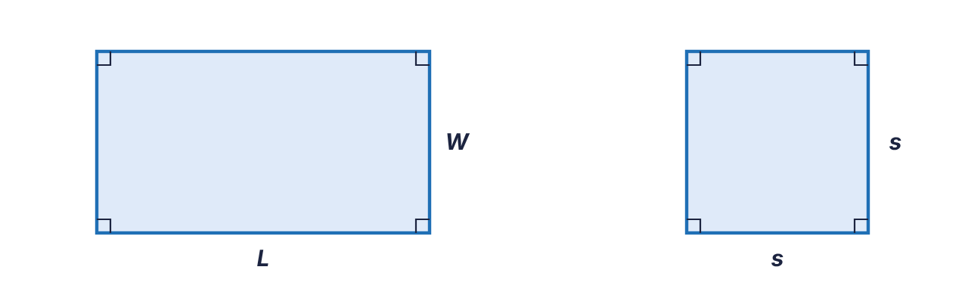
Figure 10.1 A rectangle with length L and width W, and a square with side s.
KEY RULE: Rectangle
Perimeter: P = 2L + 2W
Area: A = LW
KEY RULE: Square
Perimeter: P = 4s
Area: A = s²
EXAMPLE 10.1
A rectangular return-air grille opening is 30 in long and 14 in wide. Find its perimeter and its area.
Work | Why
P = 2L + 2W | Perimeter formula.
P = 2(30) + 2(14) | Substitute.
P = 60 + 28 = 88 | Multiply, then add.
A = LW | Area formula.
A = (30)(14) = 420 | Substitute and multiply.
Answer: P = 88 in; A = 420 sq in
EXAMPLE 10.2
A square concrete pad is 7.5 ft on a side. Find its perimeter and area.
Work | Why
P = 4s = 4(7.5) = 30 | Four equal sides.
A = s² = (7.5)² = 56.25 | 7.5 × 7.5. Do not round unless told to.
Answer: P = 30 ft; A = 56.25 sq ft

Working backward
If the area or perimeter is known and one dimension is missing, substitute what is known and solve, exactly as in Chapter 9.
EXAMPLE 10.3
A rectangular duct must have a cross-section of 216 sq in. It can be only 9 in deep. How wide must it be?
Work | Why
A = LW | Formula.
216 = L(9) | Substitute.
L = 216 ÷ 9 = 24 | Divide both sides by 9.
Answer: 24 in wide
EXAMPLE 10.4
A square room has an area of 196 sq ft. How long is each wall?
Work | Why
A = s² | Formula.
196 = s² | Substitute.
s = √196 = 14 | The inverse of squaring is the square root. Take the root of both sides.
Answer: 14 ft

10.3 Parallelograms
A parallelogram has two pairs of parallel sides. It looks like a rectangle pushed over. Its sides are a base b and a slanted side a.
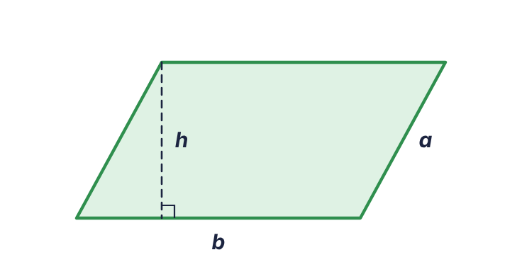
Figure 10.2 A parallelogram. The height h is perpendicular to the base; the side a is slanted.
KEY RULE: Parallelogram
Perimeter: P = 2a + 2b
Area: A = bh
Why base times height and not base times side? Cut the triangle off one end of a parallelogram and slide it to the other end. The result is a rectangle with the same base and the same height. The slanted side does not appear in the area at all.
WATCH OUT: Height is never the slanted side
The height is the straight-up distance between the two parallel sides. It is usually drawn as a dashed line with a small square where it meets the base. Use the slanted side for perimeter and the height for area.
EXAMPLE 10.5
A parallelogram has a base of 18 in, a slanted side of 10 in and a height of 8 in. Find its perimeter and area.
Work | Why
P = 2a + 2b = 2(10) + 2(18) | The perimeter uses the two side lengths.
P = 20 + 36 = 56
A = bh = (18)(8) = 144 | The area uses the base and the height. The 10 is not used.
Answer: P = 56 in; A = 144 sq in

10.4 Trapezoids
A trapezoid has exactly one pair of parallel sides. Those two sides are its bases, b₁ and b₂. They are different lengths. The height is the perpendicular distance between them.
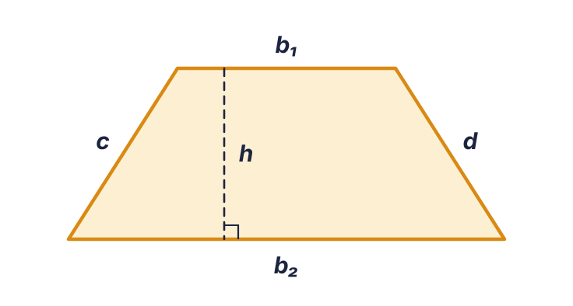
Figure 10.3 A trapezoid with bases b₁ and b₂, height h and slanted sides c and d.
KEY RULE: Trapezoid
Perimeter: P = b₁ + b₂ + c + d (the sum of the four sides)
Area: A = (b₁ + b₂)h/2
The area formula says: average the two bases, then multiply by the height. Two identical trapezoids, one flipped, fit together into a parallelogram whose base is b₁ + b₂. One trapezoid is half of that.
EXAMPLE 10.6
A trapezoidal transition panel has parallel sides of 12 in and 20 in, a height of 9 in, and slanted sides of 9.8 in each. Find the perimeter and the area.
Work | Why
P = 12 + 20 + 9.8 + 9.8 = 51.6 | Add all four sides.
A = (b₁ + b₂)h/2 | Area formula.
A = (12 + 20)(9)/2 | Substitute.
A = (32)(9)/2 = 288/2 | Parentheses first, then multiply across the top.
A = 144 | Divide by 2.
Answer: P = 51.6 in; A = 144 sq in
WATCH OUT: Add the bases before multiplying
(12 + 20)(9) is 32 × 9 = 288. Typing 12 + 20 × 9 gives 192, because the calculator multiplies first. Keep the parentheses.
EXAMPLE 10.7: Working backward
A trapezoid has an area of 150 sq ft. Its bases are 10 ft and 15 ft. Find its height.
Work | Why
150 = (10 + 15)h/2 | Substitute.
150 = 25h/2 | Simplify.
300 = 25h | Multiply both sides by 2 to clear the fraction.
h = 12 | Divide both sides by 25.
Answer: 12 ft
ON THE JOB: Estimating materials
Area tells how much to buy; unit price tells what it costs. A 12 ft by 15 ft room is 180 sq ft, or 180 ÷ 9 = 20 sq yd. Carpet at $32 per square yard costs 20 × 32 = $640. Convert the area to the unit the material is sold in before pricing.

Practice 10.1: Quadrilaterals
Show the formula and the substitution. Do not round.
- Rectangle: L = 16 ft, W = 9 ft. Find P and A.
- Rectangle: L = 8.5 in, W = 11 in. Find P and A.
- Square: s = 13 cm. Find P and A.
- Square: s = 2.4 m. Find P and A.
- Parallelogram: b = 22 in, a = 9 in, h = 7 in. Find P and A.
- Parallelogram: b = 6.5 ft, a = 4 ft, h = 3.2 ft. Find P and A.
- Trapezoid: b₁ = 8 in, b₂ = 14 in, h = 6 in, slanted sides 6.7 in each. Find P and A.
- Trapezoid: b₁ = 5 m, b₂ = 9 m, h = 4.5 m. Find A.
- Trapezoid: b₁ = 3.5 ft, b₂ = 6 ft, h = 2 ft. Find A.
- A rectangle has A = 322 sq in and W = 14 in. Find L.
- A rectangle has P = 76 ft and L = 23 ft. Find W.
- A square has A = 529 sq cm. Find s.
- A square has P = 58 in. Find s and A.
- A parallelogram has A = 195 sq in and b = 15 in. Find h.
- A trapezoid has A = 84 sq ft, b₁ = 9 ft and b₂ = 12 ft. Find h.
- A room is 14 ft by 18 ft. How many square yards of carpet does it need?
- A wall 24 ft long and 8 ft high has a door opening 3 ft by 7 ft. How many square feet are to be painted?
- How many feet of baseboard go around a 12 ft by 15.5 ft room, ignoring doors?
Chapter summary
- Perimeter is the distance around (add; length units). Area is the surface inside (multiply; square units).
- Rectangle: P = 2L + 2W, A = LW. Square: P = 4s, A = s².
- Parallelogram: P = 2a + 2b, A = bh. Trapezoid: P = sum of the sides, A = (b₁ + b₂)h ÷ 2.
- The height is perpendicular to the base and is never a slanted side.
- To find a missing dimension, substitute what is known and solve.

Chapter 10 review
- Would you use perimeter or area to order (a) weather-stripping, (b) roofing felt?
- Rectangle: L = 27 in, W = 16 in. Find P.
- Rectangle: L = 27 in, W = 16 in. Find A.
- Square: s = 9.5 ft. Find P.
- Square: s = 9.5 ft. Find A.
- Parallelogram: b = 30 cm, a = 12 cm, h = 10 cm. Find P.
- Parallelogram: b = 30 cm, a = 12 cm, h = 10 cm. Find A.
- Trapezoid: bases 16 in and 24 in, height 11 in. Find A.
- Trapezoid: sides 16 in, 24 in, 11.7 in and 11.7 in. Find P.
- A rectangle has A = 247 sq ft and L = 19 ft. Find W.
- A square has A = 2.25 sq m. Find s.
- A rectangle has P = 130 in and W = 22 in. Find L.
- A trapezoid has A = 135 sq in and bases 12 in and 18 in. Find h.
- A rectangular sheet is 4 ft by 30 in. Find its area in square feet.
- A 20 ft by 24 ft floor is tiled at $4.50 per square foot. Find the cost.
- Why does the slanted side of a parallelogram not appear in its area formula?

Chapter 11: Triangles
Roof trusses, gussets, braces and offsets are all triangles. The triangle is the one shape that cannot be pushed out of square, which is why it holds up so much of what is built.
After this chapter you will be able to
- Classify a triangle as scalene, isosceles, equilateral or right.
- Find the perimeter of any triangle and its area from base and height.
- Find the area of a triangle from its three sides with Hero’s formula.
- Use the shortcut area formula for an equilateral triangle.
- Use the Pythagorean theorem to find a missing side of a right triangle.
Key terms
- scalene: A triangle with no equal sides.
- isosceles: A triangle with two equal sides (and two equal angles).
- equilateral: A triangle with three equal sides. Every angle is 60°.
- right triangle: A triangle with one 90° angle.
- hypotenuse: The longest side of a right triangle, opposite the right angle.
- leg: Either of the two sides that form the right angle.
- semi-perimeter: Half the perimeter.

11.1 Kinds of triangles
Triangles are named by their sides. The angles of any triangle add up to 180°.
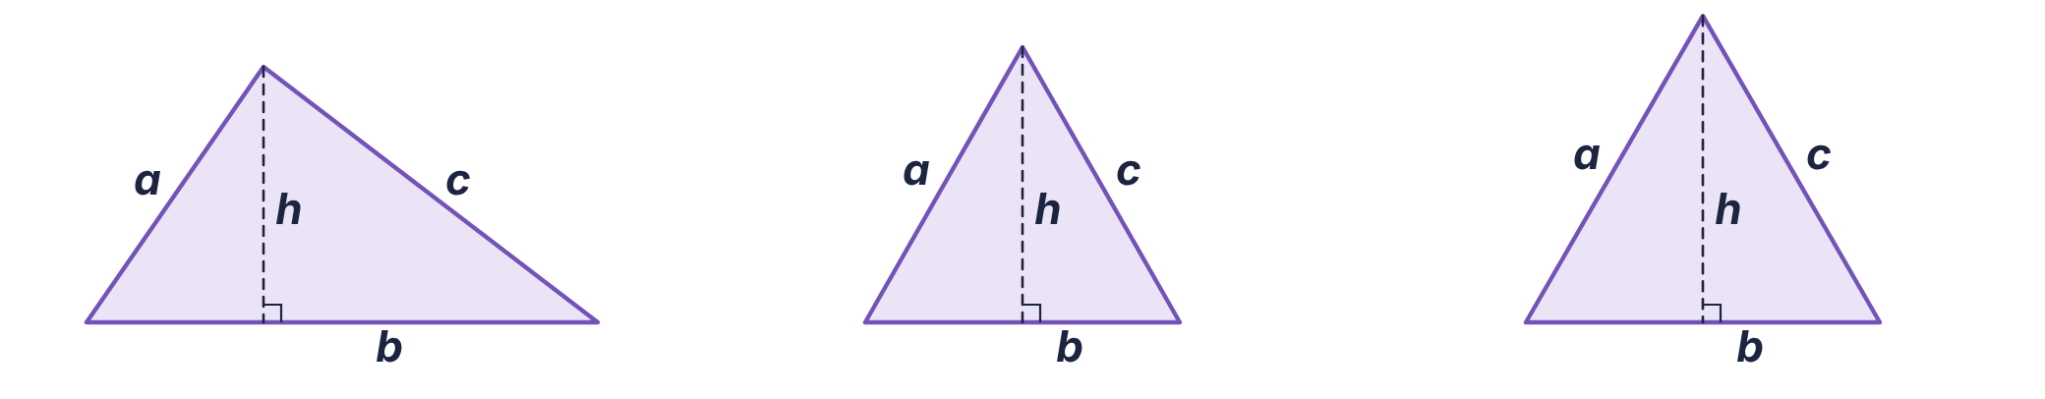
Figure 11.1 Scalene (no sides equal), isosceles (two sides equal), equilateral (all sides equal). The dashed line is the height.
KEY RULE: Any triangle
Perimeter: P = a + b + c
Area: A = bh/2
where b is the base and h is the height measured at a right angle to that base.
A triangle is half of a parallelogram with the same base and height. That is where the “divide by 2” comes from.
EXAMPLE 11.1
A triangular gusset has a base of 16 in and a height of 9 in. Its other two sides are 15 in and 9.85 in. Find its area and perimeter.
Work | Why
A = bh/2 = (16)(9)/2 | Substitute base and height.
A = 144/2 = 72 | Multiply, then halve.
P = 16 + 15 + 9.85 = 40.85 | Perimeter is the sum of the three sides. The height is not a side.
Answer: A = 72 sq in; P = 40.85 in
WATCH OUT: Do not forget the 2
The most common triangle error is stopping at base × height. That is the area of the whole parallelogram, twice the triangle.

11.2 Hero’s formula: area from three sides
On a job the three sides of a triangle can be measured with a tape, but the height usually cannot. Hero’s formula (also written Heron’s) gives the area from the sides alone. It works for every triangle.
KEY RULE: Hero’s formula
First find the semi-perimeter: s = a + b + c/2
Then: A = √(s(s − a)(s − b)(s − c))
EXAMPLE 11.2
Find the area of a triangle with sides 15 m, 20 m and 25 m. Round to the nearest tenth if needed.
Work | Why
s = 15 + 20 + 25/2 = 60/2 = 30 | Semi-perimeter: add the sides and halve.
A = √(30(30 − 15)(30 − 20)(30 − 25)) | Substitute s and each side.
A = √(30(15)(10)(5)) | Do the three subtractions.
A = √22,500 | Multiply the four numbers.
A = 150 | Take the square root.
Answer: 150 m²
EXAMPLE 11.3
A triangular lot has sides of 70 ft, 90 ft and 110 ft. Find its area to the nearest square foot.
Work | Why
s = 70 + 90 + 110/2 = 135 | Semi-perimeter.
A = √(135(65)(45)(25)) | 135 − 70 = 65, 135 − 90 = 45, 135 − 110 = 25.
A = √9,871,875 | Multiply.
A = 3141.9… | Square root.
A = 3142 | Round.
Answer: 3142 sq ft
CALCULATOR TIP: Keying Hero’s formula
Find s first and write it down. Then enter √( s × (s − a) × (s − b) × (s − c) ) with the outer parentheses, so the root covers the whole product. A negative number under the root means a subtraction was entered backward or the three sides cannot form a triangle.

11.3 The equilateral triangle
Because all three sides of an equilateral triangle are the same length s, its area depends on that one number.
KEY RULE: Equilateral triangle
Perimeter: P = 3s
Area: A = 0.433s²
EXAMPLE 11.4
Find the area of an equilateral triangle 8 in on a side.
Work | Why
A = 0.433s² | Formula.
A = 0.433(8)² | Substitute.
A = 0.433(64) | Exponent first.
A = 27.712 | Multiply.
Answer: 27.712 sq in
The 0.433 is a rounded constant (it is √3 ÷ 4), so this shortcut and Hero’s formula agree to about three digits. Here s means the side. In Hero’s formula s means the semi-perimeter. Check which formula you are in.

11.4 Right triangles and the Pythagorean theorem
A right triangle has one square corner. The two sides that form the corner are the legs, a and b. The side across from the right angle is the hypotenuse, c, and it is always the longest side.
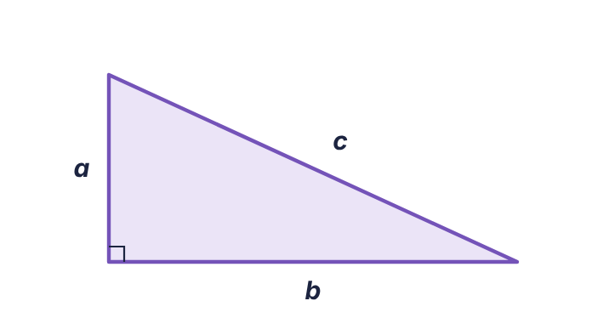
Figure 11.2 A right triangle. The legs a and b form the right angle; the hypotenuse c is opposite it.
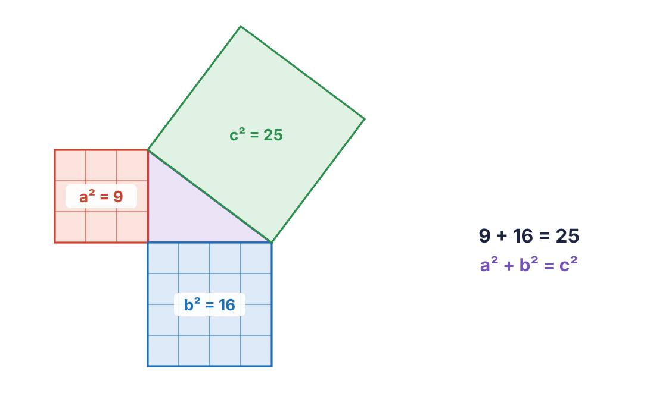
Figure 11.3 The squares built on the two legs of a 3-4-5 triangle together equal the square built on the hypotenuse.
KEY RULE: The Pythagorean theorem
a² + b² = c²
To find the hypotenuse: c = √(a² + b²)
To find a leg: a = √(c² − b²)
It is true only for right triangles.
EXAMPLE 11.5
A ladder’s foot is 5 ft from a wall and its top touches the wall 12 ft up. How long is the ladder?
Work | Why
c = √(a² + b²) | The ladder is the hypotenuse.
c = √(5² + 12²) | Substitute the legs.
c = √(25 + 144) = √169 | Square, then add.
c = 13 | Square root.
Answer: 13 ft
EXAMPLE 11.6: Finding a leg
A 20-ft brace is fastened to a post at a point 16 ft above the ground. How far from the foot of the post does the brace meet the ground?
Work | Why
a = √(c² − b²) | The brace is the hypotenuse; a leg is missing.
a = √(20² − 16²) | Substitute. The hypotenuse goes first.
a = √(400 − 256) = √144 | Square, then subtract.
a = 12 | Square root.
Answer: 12 ft
WATCH OUT: Add for the hypotenuse, subtract for a leg
The hypotenuse is the longest side, so finding it means adding the squares. A leg is shorter than the hypotenuse, so finding it means subtracting. If a “leg” comes out longer than the hypotenuse, the wrong operation was used.
And √(a² + b²) is not a + b. The squares must be added before the root is taken.
In a right triangle the legs are perpendicular, so one leg is the base and the other is the height: A = ab/2.
ON THE JOB: Squaring a corner with 3-4-5
Builders check a corner by measuring 3 ft along one wall and 4 ft along the other. If the diagonal between the marks is exactly 5 ft, the corner is square, because 3² + 4² = 5². Any multiple works: 6-8-10, 9-12-15, 12-16-20.

Practice 11.1: Triangles
Show the formula and the substitution. Round only where the problem says.
- Triangle: b = 14 in, h = 9 in. Find A.
- Triangle: b = 7.5 ft, h = 4 ft. Find A.
- Triangle with sides 9 cm, 12 cm and 17 cm. Find P.
- Hero’s formula: sides 6, 8, 10 in. Find A.
- Hero’s formula: sides 13, 14, 15 ft. Find A.
- Hero’s formula: sides 7, 10, 12 m. Find A to the nearest tenth.
- Hero’s formula: sides 20, 30, 40 ft. Find A to the nearest tenth.
- Equilateral triangle: s = 10 in. Find P and A.
- Equilateral triangle: s = 6.5 cm. Find A to the nearest tenth.
- Right triangle: legs 9 in and 12 in. Find c.
- Right triangle: legs 8 ft and 15 ft. Find c.
- Right triangle: legs 7 m and 9 m. Find c to the nearest tenth.
- Right triangle: c = 25 in, one leg 7 in. Find the other leg.
- Right triangle: c = 30 ft, one leg 18 ft. Find the other leg.
- Right triangle: c = 14 cm, one leg 9 cm. Find the other leg to the nearest tenth.
- Right triangle: legs 10 in and 24 in. Find A and P.
- A rafter rises 6 ft over a horizontal run of 14 ft. Find the rafter length to the nearest tenth.
- A rectangular gate is 4 ft by 7 ft. How long is its diagonal brace, to the nearest hundredth?
Chapter summary
- Any triangle: P = a + b + c and A = bh ÷ 2, with h perpendicular to b.
- Hero’s formula finds area from the three sides: s = (a + b + c) ÷ 2, A = √(s(s − a)(s − b)(s − c)).
- Equilateral triangle: P = 3s, A = 0.433s².
- Right triangle: a² + b² = c². Add the squares to find the hypotenuse; subtract to find a leg.
- The hypotenuse is always the longest side.

Chapter 11 review
- A triangle has sides 5, 5 and 8 in. What kind of triangle is it?
- Each angle of an equilateral triangle measures how many degrees?
- Triangle: b = 18 ft, h = 11 ft. Find A.
- Triangle with sides 14, 17 and 21 in. Find P.
- Hero’s formula: sides 9, 12, 15 m. Find A.
- Hero’s formula: sides 10, 17, 21 cm. Find A.
- Hero’s formula: sides 8, 11, 13 ft. Find A to the nearest tenth.
- Equilateral triangle: s = 12 in. Find A.
- Equilateral triangle: s = 4.2 m. Find P.
- Right triangle: legs 12 ft and 16 ft. Find c.
- Right triangle: legs 5 in and 9 in. Find c to the nearest hundredth.
- Right triangle: c = 26 cm, leg 10 cm. Find the other leg.
- Right triangle: c = 12 ft, leg 7 ft. Find the other leg to the nearest tenth.
- A 16-ft ladder leans against a wall with its foot 4 ft from the wall. How high does it reach, to the nearest tenth?
- Is a triangle with sides 10, 24 and 26 a right triangle? Show why.
- A triangle has area 54 sq in and base 12 in. Find its height.

Chapter 12: Circles, Hexagons and Composite Figures
Pipe, duct, shafting, tanks and bolt heads: round and six-sided shapes are everywhere in mechanical work. And real parts are seldom one simple shape. The last skill in the book is taking a complicated figure apart into shapes you already know.
After this chapter you will be able to
- Name the parts of a circle and convert between radius and diameter.
- Find the circumference and area of a circle using π = 3.14.
- Work backward from circumference or area to the radius or diameter.
- Find the perimeter, area and across-corner and across-flat distances of a regular hexagon.
- Find the area of a composite figure by adding or subtracting simple shapes.
Key terms
- radius: The distance from the centre of a circle to its edge.
- diameter: The distance across a circle through its centre: two radii.
- circumference: The distance around a circle; its perimeter.
- π (pi): The circumference of any circle divided by its diameter; about 3.14.
- regular hexagon: A six-sided figure with all sides equal and all angles 120°.
- composite figure: A figure made of two or more simple shapes.

12.1 The circle
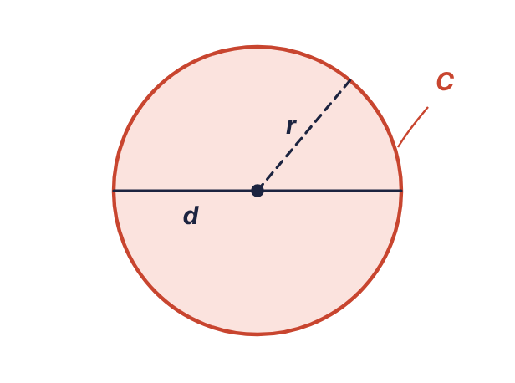
Figure 12.1 The radius r, the diameter d and the circumference C of a circle.
Measure around any circle, divide by the distance across, and the answer is always the same number, a little more than 3. That number is called π (pi). Its decimal never ends; this course uses 3.14.
KEY RULE: Circle
d = 2r and r = d/2
Circumference: C = πd or C = 2πr
Area: A = πr²
Use π = 3.14.
EXAMPLE 12.1
A round duct has a diameter of 14 in. Find its circumference and its cross-sectional area.
Work | Why
C = πd = (3.14)(14) = 43.96 | The circumference formula takes the diameter directly.
r = d/2 = 14/2 = 7 | The area formula needs the radius. Halve the diameter first.
A = πr² = (3.14)(7)² | Substitute.
A = (3.14)(49) = 153.86 | Square the radius first, then multiply by π.
Answer: C = 43.96 in; A = 153.86 sq in
WATCH OUT: Three circle mistakes
Using the diameter in A = πr². Halve it first. Using d makes the area four times too large.
Doubling instead of squaring. r² is r × r. For r = 7, r² is 49, not 14.
Squaring π. In πr² only the r is squared: 3.14 × 49, not (3.14 × 7)².

Working backward
EXAMPLE 12.2
A tank measures 157 in around. What is its diameter?
Work | Why
C = πd | Formula.
157 = 3.14d | Substitute.
d = 157 ÷ 3.14 = 50 | Divide both sides by 3.14.
Answer: 50 in
EXAMPLE 12.3
A circular opening must have an area of 200 sq in. Find the radius to the nearest tenth.
Work | Why
A = πr² | Formula.
200 = 3.14r² | Substitute.
r² = 200 ÷ 3.14 = 63.694… | Divide both sides by 3.14.
r = √63.694… = 7.98… | Take the square root of both sides.
r = 8.0 | Round to the nearest tenth.
Answer: 8.0 in
CALCULATOR TIP: The π key
The calculator’s π key uses 3.14159265…, which gives slightly different answers from 3.14 (153.94 instead of 153.86 above). When the course says to use 3.14, type 3.14.

12.2 The regular hexagon
A regular hexagon has six equal sides and six equal 120° angles. Bolt heads and nuts are hexagons. It can be measured two ways: across the corners (the distance d from one point to the opposite point) and across the flats (the distance f between opposite sides, which is the wrench size).
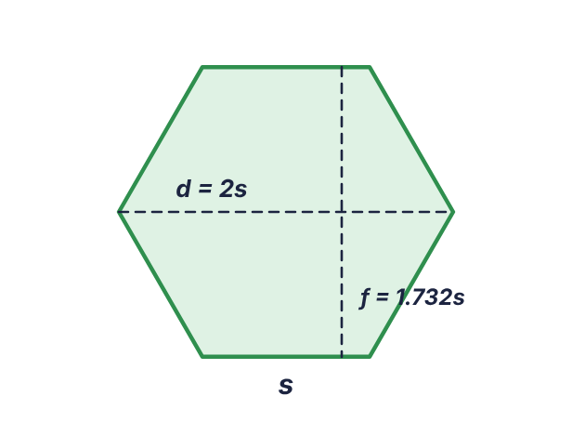
Figure 12.2 A regular hexagon with side s, distance across corners d and distance across flats f.
KEY RULE: Regular hexagon
Perimeter: P = 6s
Area: A = 2.6s²
Across corners: d = 2s
Across flats: f = 1.732s
EXAMPLE 12.4
A hexagonal bar has sides of 0.75 in. Find its perimeter, area, distance across corners and distance across flats.
Work | Why
P = 6s = 6(0.75) = 4.5 | Six equal sides.
A = 2.6s² = 2.6(0.75)² = 2.6(0.5625) = 1.4625 | Square the side first.
d = 2s = 2(0.75) = 1.5 | Across corners.
f = 1.732s = 1.732(0.75) = 1.299 | Across flats.
Answer: P = 4.5 in; A = 1.4625 sq in; d = 1.5 in; f = 1.299 in
EXAMPLE 12.5: Working backward
A hexagonal patio is to cover 500 sq m. How long is each side, to the nearest tenth?
Work | Why
A = 2.6s² | Formula.
500 = 2.6s² | Substitute.
s² = 500 ÷ 2.6 = 192.307… | Divide both sides by 2.6.
s = √192.307… = 13.867… | Square root of both sides.
s = 13.9 | Round.
Answer: 13.9 m
EXAMPLE 12.6
A nut measures 1.5 in across the flats. How long is each side, to the nearest hundredth?
Work | Why
f = 1.732s | Formula.
1.5 = 1.732s | Substitute.
s = 1.5 ÷ 1.732 = 0.866… | Divide.
s = 0.87 | Round.
Answer: 0.87 in

Practice 12.1: Circles and hexagons
Use π = 3.14. Do not round unless told to.
- Circle: d = 10 in. Find C.
- Circle: r = 6 ft. Find C.
- Circle: r = 5 cm. Find A.
- Circle: d = 18 in. Find A.
- Circle: d = 3.5 m. Find C and A.
- Circle: C = 94.2 in. Find d.
- Circle: C = 50 ft. Find r to the nearest hundredth.
- Circle: A = 314 sq in. Find r.
- Circle: A = 120 sq ft. Find d to the nearest tenth.
- Hexagon: s = 4 in. Find P and A.
- Hexagon: s = 2.5 cm. Find d and f.
- Hexagon: s = 12 ft. Find A.
- Hexagon: A = 650 sq in. Find s to the nearest tenth.
- Hexagon: d = 3 in across corners. Find s and f.
- Hexagon: f = 2 in across flats. Find s to the nearest hundredth.
- How far does a 26-in diameter wheel roll in one turn?

12.3 Composite figures
A composite figure is built from two or more simple shapes. No new formula is needed, only a plan.
KEY RULE: Area of a composite figure
1. Separate the figure into shapes you know: rectangles, triangles, circles, trapezoids.
2. Find any dimension that is not given, by adding or subtracting the ones that are.
3. Calculate the area of each shape.
4. Add the areas of shapes that are joined. Subtract the areas of holes and cut-outs.

Adding parts
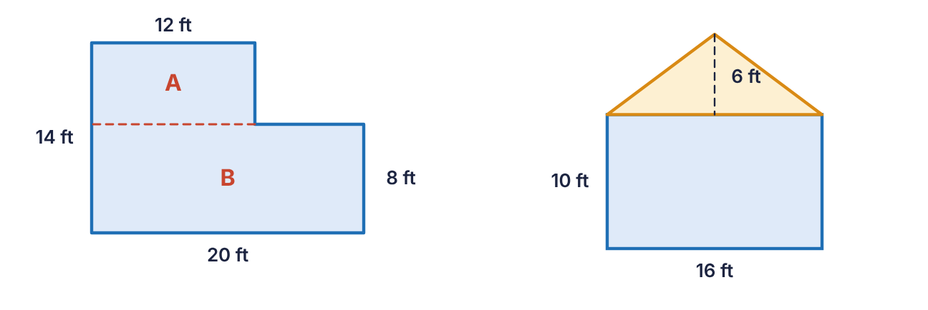
Figure 12.3 Left: an L-shaped floor split into rectangles A and B. Right: a gable wall, a rectangle with a triangle on top.
EXAMPLE 12.7
Find the area of the L-shaped floor in Figure 12.3.
Work | Why
A: 12 ft by 6 ft; B: 20 ft by 8 ft | Split along the dashed line. Rectangle A is 12 ft wide. Its height is 14 − 8 = 6 ft.
Area A = (12)(6) = 72
Area B = (20)(8) = 160
72 + 160 = 232 | The parts are joined, so add.
Answer: 232 sq ft
The same floor can be done by subtraction: a full 20 by 14 rectangle is 280 sq ft, and the missing corner is 8 by 6 = 48 sq ft. 280 − 48 = 232 sq ft. Either plan must give the same answer, which makes a good check.
EXAMPLE 12.8
Find the area of the gable wall in Figure 12.3.
Work | Why
Rectangle: (16)(10) = 160 | The lower part.
Triangle: (16)(6)/2 = 48 | The triangle’s base is the width of the wall, 16 ft; its height is 6 ft.
160 + 48 = 208 | Add.
Answer: 208 sq ft

Subtracting holes
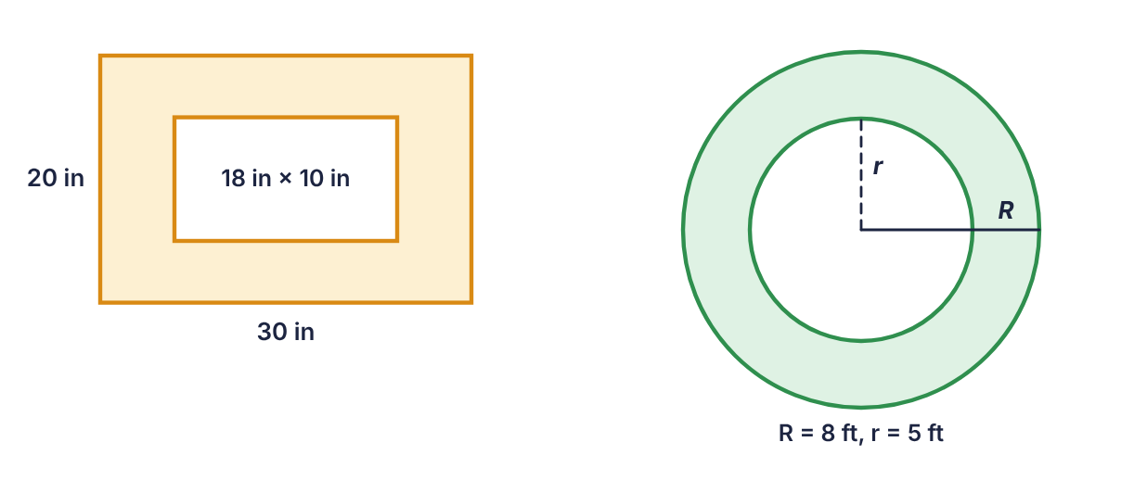
Figure 12.4 Left: a plate with a rectangular opening. Right: a ring (a circle with a circular hole).
EXAMPLE 12.9
A 30 in by 20 in plate has an 18 in by 10 in opening cut from it. Find the area of metal that remains.
Work | Why
Outside: (30)(20) = 600 | The whole plate.
Opening: (18)(10) = 180 | The piece removed.
600 − 180 = 420 | A hole is subtracted.
Answer: 420 sq in
EXAMPLE 12.10
A flat ring gasket has an outside radius of 8 ft and an inside radius of 5 ft. Find its area.
Work | Why
Outer circle: (3.14)(8)² = 200.96
Inner circle: (3.14)(5)² = 78.5
200.96 − 78.5 = 122.46 | Subtract the hole.
Answer: 122.46 sq ft
WATCH OUT: Subtract areas, not radii
The ring is not a circle of radius 8 − 5 = 3. That would give 28.26 sq ft. Find each full area first, then subtract.

Half circles and quarter circles
A semicircle has half the area of the full circle: A = πr²/2. Its curved edge is half the circumference, πd/2. When a semicircle sits on the end of a rectangle, its diameter equals the width of the rectangle.
EXAMPLE 12.11
A window is a rectangle 4 ft wide and 5 ft tall with a semicircle on top. Find its area.
Work | Why
Rectangle: (4)(5) = 20
r = 4 ÷ 2 = 2 | The semicircle’s diameter is the 4-ft width.
Semicircle: (3.14)(2)²/2 = 12.56/2 = 6.28 | Half of a full circle.
20 + 6.28 = 26.28 | Add.
Answer: 26.28 sq ft

Perimeter of a composite figure
The perimeter of a composite figure is the distance around its outside edge only. Do not count the dashed lines where the parts were split; those lines are inside the figure. For the L-shaped floor: 20 + 8 + 8 + 6 + 12 + 14 = 68 ft. For the window above: 4 + 5 + 5 plus the half circumference (3.14)(4) ÷ 2 = 6.28, for 20.28 ft in all.

Practice 12.2: Composite figures
Sketch each figure, split it into simple shapes, and show each area. Use π = 3.14.
- An L-shaped room is 24 ft by 18 ft overall with a 10 ft by 6 ft corner missing. Find its area.
- Find the perimeter of the room in problem 1.
- A gable wall is 28 ft wide and 9 ft high to the eaves, with a triangular gable 7 ft high. Find its area.
- A 36 in by 24 in panel has a 12 in by 12 in square opening. Find the remaining area.
- A 20 in by 20 in plate has a circular hole 8 in in diameter. Find the remaining area.
- A ring has an outside diameter of 12 in and an inside diameter of 6 in. Find its area.
- A table top is a rectangle 6 ft by 3 ft with a semicircle on each 3-ft end. Find its area.
- Find the perimeter of the table top in problem 7.
- A wall 30 ft by 9 ft has two windows 4 ft by 5 ft and a door 3 ft by 7 ft. How much wall is left to paint?
- A trapezoid with bases 10 in and 16 in and height 8 in has a rectangle 16 in by 5 in attached to its longer base. Find the total area.
- A square 10 cm on a side has a quarter circle of radius 10 cm removed from one corner. Find the remaining area.
- A hexagonal nut has sides of 0.5 in and a round hole 0.5 in in diameter. Find the area of its face to the nearest hundredth.
Chapter summary
- Circle: d = 2r, C = πd, A = πr², with π = 3.14. Use the radius for area.
- Regular hexagon: P = 6s, A = 2.6s², across corners d = 2s, across flats f = 1.732s.
- To work backward from an area with a squared term, divide first, then take the square root.
- Composite area: separate, find each area, add joined parts and subtract holes.
- Composite perimeter: follow the outside edge only.

Chapter 12 review
- Circle: r = 9 in. Find d and C.
- Circle: d = 22 ft. Find A.
- Circle: C = 78.5 cm. Find d.
- Circle: A = 50.24 sq in. Find r.
- Circle: A = 90 sq ft. Find r to the nearest hundredth.
- Hexagon: s = 7 in. Find P.
- Hexagon: s = 7 in. Find A.
- Hexagon: s = 7 in. Find d and f.
- Hexagon: A = 400 sq m. Find s to the nearest tenth.
- Hexagon: f = 3 in. Find s to the nearest hundredth.
- An L-shaped slab is 30 ft by 20 ft overall with a 12 ft by 8 ft corner missing. Find its area.
- A 48 in by 30 in sheet has two round holes, each 10 in in diameter. Find the remaining area.
- A ring has an outside radius of 10 cm and an inside radius of 7 cm. Find its area.
- A window is a 3 ft by 4 ft rectangle topped by a semicircle on the 3-ft side. Find its area.
- A gable end is 24 ft wide, 8 ft to the eaves and 5 ft more to the peak. Find its area.
- Why is the area of a ring with radii 10 and 7 not the area of a circle with radius 3?

Reference tables and formulas
Standard units
Length | Weight | Liquid capacity
1 ft = 12 in | 1 lb = 16 oz | 1 pt = 2 cups
1 yd = 3 ft = 36 in | 1 T = 2000 lb | 1 qt = 2 pt
1 mi = 5280 ft = 1760 yd |  | 1 gal = 4 qt
Area and volume
Area | Volume | Volume and capacity
1 sq ft = 144 sq in | 1 cu ft = 1728 cu in | 1 cu ft = 7.48 gal
1 sq yd = 9 sq ft | 1 cu yd = 27 cu ft | 1 gal = 231 cu in
1 sq yd = 1296 sq in | 1 cu yd = 46,656 cu in
Metric stairs (each step is one decimal place)
kilo | hecto | deka | unit | deci | centi | milli
1000 | 100 | 10 | 1 | 0.1 | 0.01 | 0.001
km | hm | dam | m | dm | cm | mm
kg | hg | dag | g | dg | cg | mg
kL | hL | daL | L | dL | cL | mL
Standard and metric
Length | Weight | Capacity
1 in = 2.54 cm | 1 oz = 28.35 g | 1 L = 1.06 qt
1 m = 3.28 ft | 1 kg = 2.205 lb | 1 gal = 3.785 L
1 mi = 1.61 km
Every conversion in both directions
Category | Multiply by the factor | Divide by the factor | Factor
Length | ft → in | in → ft | 12
Length | yd → ft | ft → yd | 3
Length | mi → ft | ft → mi | 5280
Weight | lb → oz | oz → lb | 16
Weight | T → lb | lb → T | 2000
Capacity | gal → qt; qt → pt; pt → cups | qt → gal; pt → qt; cups → pt | 4; 2; 2
Area | sq ft → sq in | sq in → sq ft | 144
Area | sq yd → sq ft | sq ft → sq yd | 9
Area | sq yd → sq in | sq in → sq yd | 1296
Volume | cu ft → cu in | cu in → cu ft | 1728
Volume | cu yd → cu ft | cu ft → cu yd | 27
Volume | cu ft → gal | gal → cu ft | 7.48
Volume | gal → cu in | cu in → gal | 231
Metric length | in → cm | cm → in | 2.54
Metric length | m → ft | ft → m | 3.28
Metric length | mi → km | km → mi | 1.61
Metric weight | oz → g | g → oz | 28.35
Metric weight | kg → lb | lb → kg | 2.205
Metric capacity | L → qt | qt → L | 1.06
Metric capacity | gal → L | L → gal | 3.785
Percent
To find | Proportion | Shortcut
the part | x/whole = percent/100 | whole × percent as a decimal
the whole | part/x = percent/100 | part ÷ percent as a decimal
the percent | part/whole = x/100 | part ÷ whole, point 2 places right
Geometry formulas (π = 3.14)
Figure | Perimeter | Area
Rectangle | P = 2L + 2W | A = LW
Square | P = 4s | A = s²
Parallelogram | P = 2a + 2b | A = bh
Trapezoid | P = sum of the sides | A = (b₁ + b₂)h ÷ 2
Triangle | P = a + b + c | A = bh ÷ 2
Triangle from three sides (Hero) | s = (a + b + c) ÷ 2 | A = √(s(s − a)(s − b)(s − c))
Equilateral triangle | P = 3s | A = 0.433s²
Right triangle | a² + b² = c² | A = ab ÷ 2
Regular hexagon | P = 6s; d = 2s; f = 1.732s | A = 2.6s²
Circle | C = πd = 2πr; d = 2r | A = πr²
Trade formulas used in this book
Trade | Formula | Meaning
Machine trades | L = πdr ÷ 12 | linear speed of a wheel, ft/min (d in, r rpm)
Construction | L = 25T⁴ ÷ H² | crushing load of a square post, tons
Welding | T = L ÷ A | tensile strength, psi
Plumbing | N = √(D ÷ d)⁵ | small pipes equal to one large pipe
Manufacturing | C = W²DS ÷ 1.085 | feeder belt capacity, metric tons per hour
Hydraulics | F = πPD² ÷ 4 | force on a piston, lb
Electronics | C_{T} = C₁(C₂ + C₃) ÷ (C₁ + C₂ + C₃) | series-parallel capacitance
Electronics | L_{T} = L₁L₂ ÷ (L₁ + L₂) | two inductors in parallel
Electronics | L = R²N² ÷ (9R + 10D) | inductance of a coil, µH
Electrical | I = E ÷ R | Ohm’s law
Automotive | ihp = MEP × D × S ÷ 792,000 | indicated horsepower
Machine trades | L = 2d + 3.26(r + R) | belt length around two pulleys
Sheet metal | A = 2w + 3/16 | Pittsburgh lock allowance, in
Water/wastewater | P = 0.52D + 14.7 | pressure at depth D ft, psi
Order of operations and rounding
Rule | Remember
Order of operations | 1 grouping symbols; 2 exponents and roots; 3 × and ÷ left to right; 4 + and − left to right
Rounding | Find the rounding digit; look one digit right; 5 or more rounds up, 4 or less stays; zeros for whole places, drop decimal places
Solving | Substitute, simplify, undo + and − first, then × and ÷; do the same to both sides; check

Answers to practice sets and reviews

Chapter 1: Place Value and Rounding
Practice 1.1: Place value
- 7
- 2
- 9
- 4
- 0
- 0
- 8
- 6
- 1
- 3
- 0.5
- 0.0625
- 1.3
- 0.44
- 2.05
- 0.75
Practice 1.2: Rounding
- 638.3
- 638.27
- 640
- 600
- 16,000
- 15,862.095
- 15,862
- 15,862.1
- 1.00
- 1.0
- 7,450
- 7,400
- 86.05
- 250.0
- 3,900
- 71,400
- 56
- 0.044
Chapter review
- 0
- 5
- 8
- 0
- 4
- 3
- 5,275.0
- 5,300
- 5,274.964
- 5,275
- 5,270
- 5,274.96
- 0.32
- 1.068
- 42.07
- 0.375
- 2,900 rpm
- 7.47 µF
- The student rounded twice (6.2481 → 6.25 → 6.3). The test digit is 4, so the answer is 6.2.
- 20.00

Chapter 2: Fractions, Decimals and Percents
Practice 2.1: Fractions
- 3/4
- 3/4
- 5/16
- 3/8
- 7/8
- 7/8
- 9/16
- 1/4
- 7/4
- 21/8
- 55/16
- 11/2
- 1 3/8
- 2 1/4
- 2 5/16
- 1 13/32
Practice 2.2: Changing forms
- 3/8 = 0.375 = 37.5%
- 4/5 = 0.8 = 80%
- 9/20 = 0.45 = 45%
- 7/16 = 0.4375 = 43.75%
- 13/200 = 0.065 = 6.5%
- 1/8 = 0.125 = 12.5%
- 9/20 = 0.45 = 45%
- 1 1/2 = 1.5 = 150%
- 1/50 = 0.02 = 2%
- 13/16 = 0.8125 = 81.25%
- 5/16 = 0.3125 = 31.25%
- 7/8 = 0.875 = 87.5%
Practice 2.3: Adding and subtracting
- 5/8
- 13/16
- 11/16
- 7/16
- 3 7/8
- 7 1/16
- 3 5/8
- 6 9/16
- 21.25 in
- 31.875 in
- 31.625 in
- 35.625 in
Chapter review
- 9/16
- 5/8
- 0.875
- 0.1875
- 2.5625
- 5/8
- 7/20
- 3/16
- 42%
- 7.5%
- 180%
- 0.64
- 0.07
- 1.125
- 0.005
- 68.75%
- 5/8
- 5 3/8 in (0.40 × 16 = 6.4 → 6/16)
- 6 3/16
- 4 3/8
- 17.9375 in
- 1 3/16 in
- 13/16 (it is 0.8125)

Chapter 3: The Percent Proportion
Practice 3.1: The three types
- 120
- 7.5%
- 500
- 9
- 150
- 12.5%
- 15.6
- 125%
- 600
- 102
- 0.625%
- 45
- 4.5
- 27.5%
- 200
- 24
Practice 3.2: Applications
- 34%
- 1,056 W
- $25.97
- $1,160.00
- 352 sq ft
- 12% failed; 88% passed
- $8,400
- 80 gal
- 5%
- 15%
- 446.5 Ω to 493.5 Ω
- $650.00
Chapter review
- 91
- 120
- 15%
- 36
- 125%
- 1,500
- 30
- 24/64 = x/100
- 63
- 140
- 85%
- $480
- 24%
- 64%
- $1,300
- 8% was used as 0.8 instead of 0.08 (or the ÷ 100 was skipped). 8 × 50 ÷ 100 = 4.

Chapter 4: Standard Units of Measure
Practice 4.1: Length, weight and capacity
- 108 in
- 8.5 ft
- 13.5 ft
- 16.7 yd
- 13,200 ft
- 1.7 mi
- 80 oz
- 4.5 lb
- 6,400 lb
- 2.8 T
- 24 qt
- 4.5 gal
- 3.5 qt
- 16 pt
- 5 yd
- 1,320 yd
Practice 4.2: Area and volume
- 5.9 sq ft
- 112.5 sq ft
- 2,592 sq in
- 1.5 sq yd
- 44.4 sq yd
- 66.7 cu yd
- 2.3 cu ft
- 445.5 cu ft
- 6,048 cu in
- 59.8 gal
- 8.7 gal
- 5.3 cu ft
- 693 cu in
- 93,312 cu in
- 16 cu ft
- 648 sq in
Chapter review
- 168 in
- 16.7 ft
- 112 oz
- 3.5 T
- 2.5 gal
- 4.2 sq ft
- 225 sq ft
- 18.5 cu yd
- 4,320 cu in
- 89.8 gal
- 4.3 gal
- 10 cu ft
- A square foot is 12 in by 12 in, so it holds 12 × 12 = 144 square inches.
- 30 sq yd
- 5 cu yd
- 224.4 gal
- 126,720 in
- 12,705 cu in

Chapter 5: The Metric System
Practice 5.1: Metric to metric
- 450 cm
- 38 cm
- 2,400 m
- 0.75 kg
- 600 mL
- 1.25 L
- 350 mm
- 8.2 km
- 4.6 dag
- 320 L
- 85 g
- 0.95 m
- 700 dm
- 12.5 g
- 400 mm
- 0.64 L
Practice 5.2: Metric and standard
- 30.5 cm
- 31.5 in
- 82 ft
- 30.5 m
- 42.2 km
- 6.2 mi
- 226.8 g
- 17.6 oz
- 154.4 lb
- 99.8 kg
- 21.2 qt
- 56.8 L
- inch
- litre
- ounce
- mile
Practice 5.3: Conversions by category
- 275 cm
- 0.64 m
- 3,400 m
- 45.7 cm
- 18.3 m
- 88.6 km
- 2,200 g
- 0.35 g
- 4,800 cg
- 680.4 g
- 35.3 oz
- 99.2 lb
- 1,500 mL
- 2.4 L
- 3.6 L
- 28.3 L
- 15.9 gal
- 28.4 L
Chapter review
- 6,800 mm
- 4.25 m
- 750 g
- 0.9 L
- 0.52 dag
- 120,000 cm
- 91.4 cm
- 59.1 in
- 11 lb
- 72.6 kg
- 42.4 qt
- 18.9 L
- 24.5 L
- 248.4 mi
- a metre (1 m = 3.28 ft, and a yard is 3 ft)
- a cubic foot (it holds 7.48 gallons)
- 78.7 in
- 1,361 g
- 0.75 in
- 4 places to the right

Chapter 6: Rulers, Gauges and Tolerance
Practice 6.1: Reading a rule
- 14 mm
- 37 mm
- 52 mm
- 78 mm
- 95 mm
- 3/16 in
- 3/4 in
- 1 3/8 in
- 1 13/16 in
- 2 1/2 in
- 2 7/8 in
- 3 9/16 in
- 3 7/8 in
- 5.2 cm
- 64 mm
- 1 3/4 in
Practice 6.2: Reading gauges
- 5 psi
- about 65 psi
- 40 °F
- about 340 °F
- 0.5 volts
- about 13.5 volts
- 20 psi
- about 210 psi
- 2 amps
- about 47 amps
- 25 kPa
- about 140 kPa
Practice 6.3: Tolerance and missing lengths
- 2.49 in to 2.51 in; yes
- 0.37 in to 0.38 in; no
- 1.248 in to 1.252 in; yes
- 3.95 in to 4.05 in; no
- 0.617 in to 0.623 in; no (0.625)
- 0.436 in to 0.444 in; yes (0.4375)
- 23.125 in = 23 1/8 in
- 37.625 in = 37 5/8 in
- 14 in = 14 in
- 31.75 in = 31 3/4 in
- 135 Ω to 165 Ω
- 92 1/2 in to 92 3/4 in
Chapter review
- 73 mm
- 64 mm
- 2 3/4 in
- 5 7/8 in
- 3/4 (quarter marks are longer than eighth marks)
- 5
- 95
- about 1750
- about 690 kPa
- 1.735 in to 1.765 in
- No. The upper limit is 0.502 in.
- Yes. 11/16 = 0.6875, and the limits are 0.685 to 0.695.
- 17.375 in
- 6.875 in

Chapter 7: Order of Operations
Practice 7.1: Order of operations
- 8
- 17
- 12
- 23
- 32
- 32
- 12
- 41
- 10
- 22
- 4
- 3
- 45.83
- 18
- 0
- 11
- -95
- 5.71
Chapter review
- 1 grouping symbols; 2 exponents and roots; 3 multiplication and division, left to right; 4 addition and subtraction, left to right.
- 13
- 18
- 57
- 192
- 12
- 8
- 13
- 13
- 4
- 3
- 56
- 10
- 15.625
- 7.47
- The student added 10 + 5 first. Left to right: 30 − 10 = 20, then 20 + 5 = 25.
- (7 + 9) ÷ (2 × 4) = 2
- 48. The exponent applies to the 4 only and is done before multiplying: 3 × 16.

Chapter 8: Evaluating Formulas
Practice 8.1: Substitute and evaluate
- -115
- 162
- 1/40
- 3
- 100.625
- 61.5 ft
- 69
- 15
- 70,000 psi
- 300 W
- 3,140 ft/min
- 324 tons
- 32 pipes
- 32 pipes
- 50 mH
- 7.88 µF
- 1,324 µH
- 187.5 hp
- 196 lb
- 2,240 t/h
Chapter review
- 31
- 48
- 1.25
- -96
- 144.9
- 24
- 71,400 psi
- 5,495 ft/min
- 400 tons
- 16 pipes
- 3,733 t/h
- 376.8 lb
- 7.2 µF
- 48 mH
- W, D, S and C are variables; 1.085 is a constant.
- 2(30), which is 60.

Chapter 9: Solving Formulas
Practice 9.1: One-step equations
- 5.6 h
- 15 ft
- 1.372 m
- 24 psi
- 25 windings
- 120 V
- 15,000 lb
- 17 ft
- 8 ft
- 17.5
- 15.75
- 27
Practice 9.2: Two-step equations
- 950 ft
- 18.5 in
- 6.5 h
- 30 ft
- 18
- 18,000 ft
- 45 years
- 0.1875 in
- 30 h
- 19 in
- 1/4 in
- 3/8 in
- 15/32 in
- 7
- 12
- 36
Chapter review
- 11.5
- 13.5
- 30
- 8
- 12
- 2.5 h
- 120 V
- 10.3 ft
- 1,450 ft
- 3.5 h
- 50 ft
- 30 years
- 40 h
- 27 in
- 5/16 in
- 9/32 in
- 3,200 rpm
- w = 1/4. The student added 1/8 instead of subtracting it and multiplied by 2 instead of dividing.

Chapter 10: Perimeter and Area of Quadrilaterals
Practice 10.1: Quadrilaterals
- P = 50 ft; A = 144 sq ft
- P = 39 in; A = 93.5 sq in
- P = 52 cm; A = 169 cm²
- P = 9.6 m; A = 5.76 m²
- P = 62 in; A = 154 sq in
- P = 21 ft; A = 20.8 sq ft
- P = 35.4 in; A = 66 sq in
- A = 31.5 m²
- A = 9.5 sq ft
- 23 in
- 15 ft
- 23 cm
- s = 14.5 in; A = 210.25 sq in
- 13 in
- 8 ft
- 28 sq yd
- 171 sq ft
- 55 ft
Chapter review
- (a) perimeter (b) area
- 86 in
- 432 sq in
- 38 ft
- 90.25 sq ft
- 84 cm
- 300 cm²
- 220 sq in
- 63.4 in
- 13 ft
- 1.5 m
- 43 in
- 9 in
- 10 sq ft
- $2,160
- Sliding the end triangle across turns it into a rectangle with the same base and height; only the perpendicular height matters.

Chapter 11: Triangles
Practice 11.1: Triangles
- 63 sq in
- 15 sq ft
- 38 cm
- 24 sq in
- 84 sq ft
- 35 m²
- 290.5 sq ft
- P = 30 in; A = 43.3 sq in
- 18.3 cm²
- 15 in
- 17 ft
- 11.4 m
- 24 in
- 24 ft
- 10.7 cm
- A = 120 sq in; P = 60 in
- 15.2 ft
- 8.06 ft
Chapter review
- isosceles
- 60°
- 99 sq ft
- 52 in
- 54 m²
- 84 cm²
- 43.8 sq ft
- 62.352 sq in
- 12.6 m
- 20 ft
- 10.3 in
- 24 cm
- 9.7 ft
- 15.5 ft
- Yes: 10² + 24² = 100 + 576 = 676 = 26².
- 9 in

Chapter 12: Circles, Hexagons and Composite Figures
Practice 12.1: Circles and hexagons
- 31.4 in
- 37.68 ft
- 78.5 cm²
- 254.34 sq in
- C = 10.99 m; A = 9.61625 m²
- 30 in
- 7.96 ft
- 10 in
- 12.4 ft
- P = 24 in; A = 41.6 sq in
- d = 5 cm; f = 4.33 cm
- 374.4 sq ft
- 15.8 in
- s = 1.5 in; f = 2.598 in
- 1.15 in
- 81.64 in
Practice 12.2: Composite figures
- 372 sq ft
- 84 ft
- 350 sq ft
- 720 sq in
- 349.76 sq in
- 84.78 sq in
- 25.065 sq ft
- 21.42 ft
- 209 sq ft
- 184 sq in
- 21.5 cm²
- 0.45 sq in
Chapter review
- d = 18 in; C = 56.52 in
- 379.94 sq ft
- 25 cm
- 4 in
- 5.35 ft
- 42 in
- 127.4 sq in
- d = 14 in; f = 12.124 in
- 12.4 m
- 1.73 in
- 504 sq ft
- 1,283 sq in
- 160.14 cm²
- 15.5325 sq ft
- 252 sq ft
- Areas depend on the square of the radius: 10² − 7² = 51, but 3² = 9. Subtract the areas, not the radii.

