Exchange View Manual Test Plan

1. Connect to <http://localhost:3001/dashboard>
2. You should see the following welcome page:
   1. 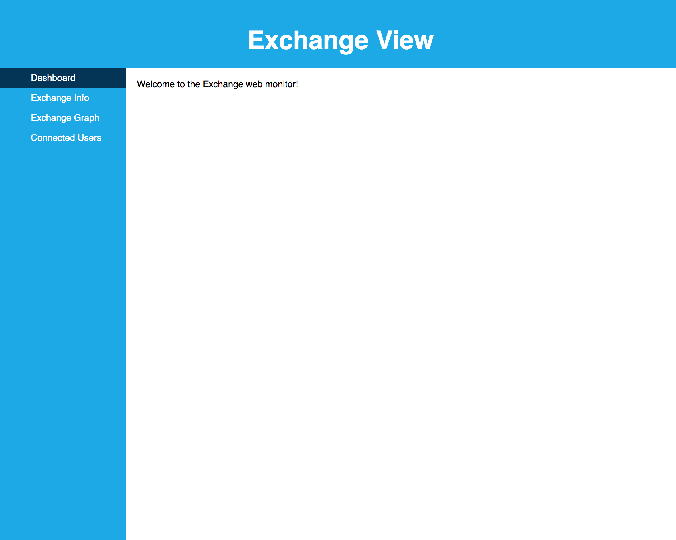
3. If you switch to the “Exchange Info” tab, you should see an info summary:
   1. 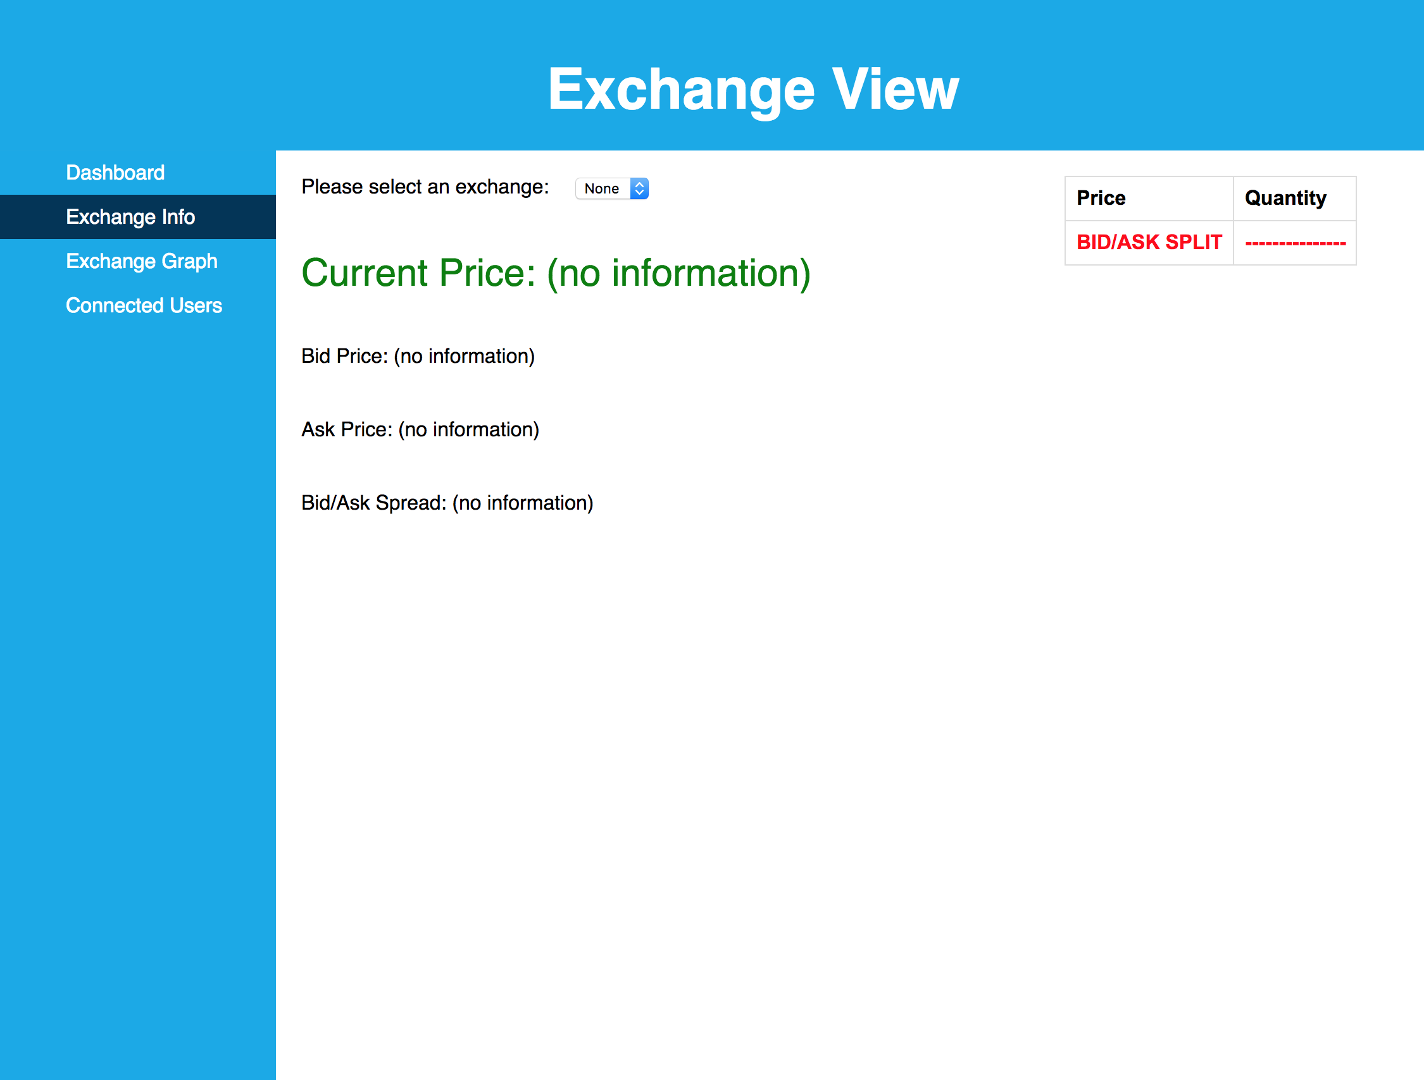
   2. No information should be loaded yet, and “Select an exchange” should be set to “None”
4. Upon selecting an exchange like “CYG”, the following screen should be shown:
   1. 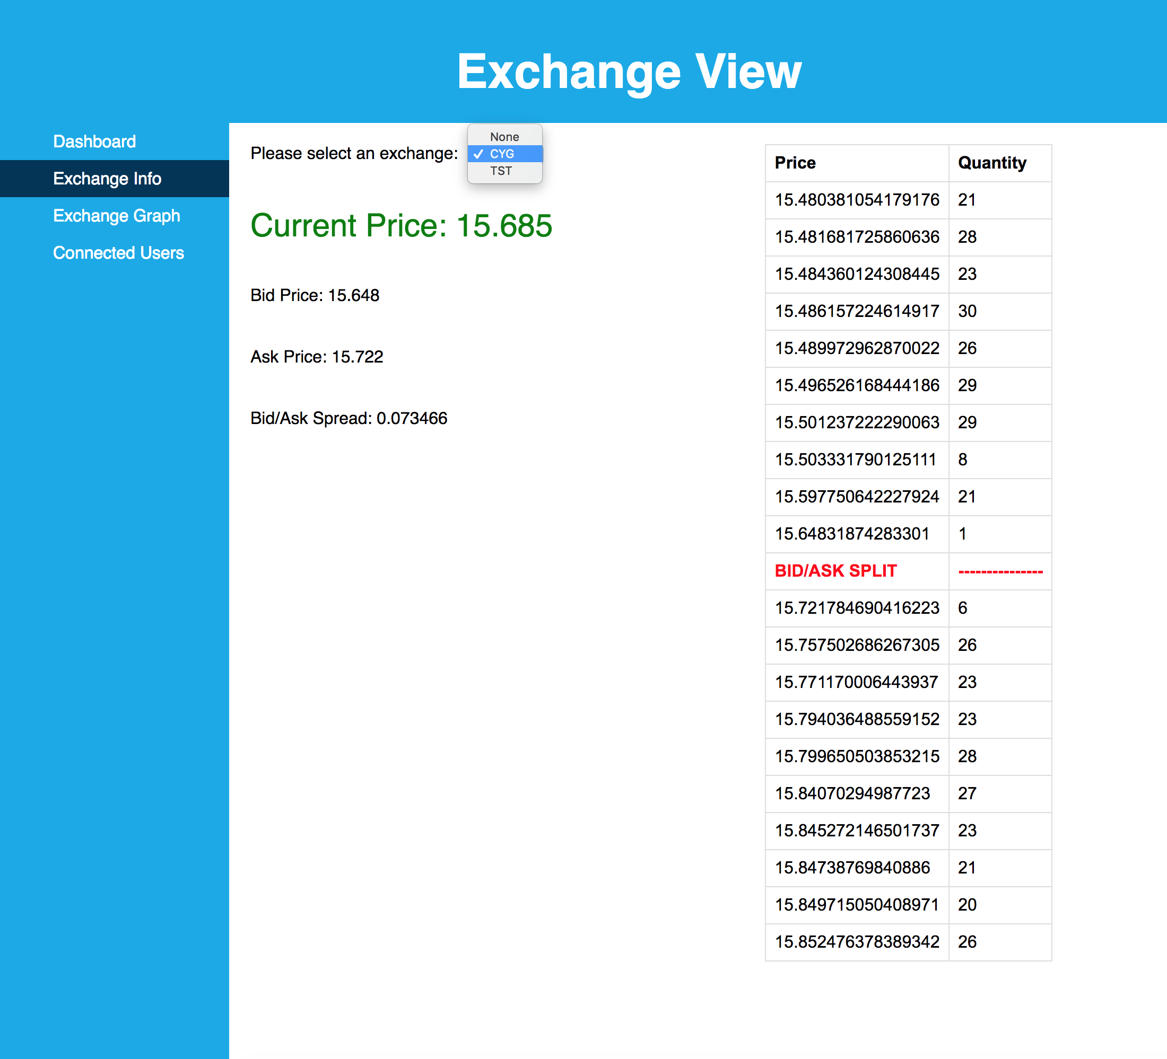
   2. The current price, bid price, ask price, and bid/ask spread should be displayed
   3. The book depth should appear to the right of the screen, with no more than 10 entries above and 10 entries below the “BID/ASK SPLIT”. They should all be in ascending order
5. Switching to the “Connected Users” tab should show the following layout:
   1. 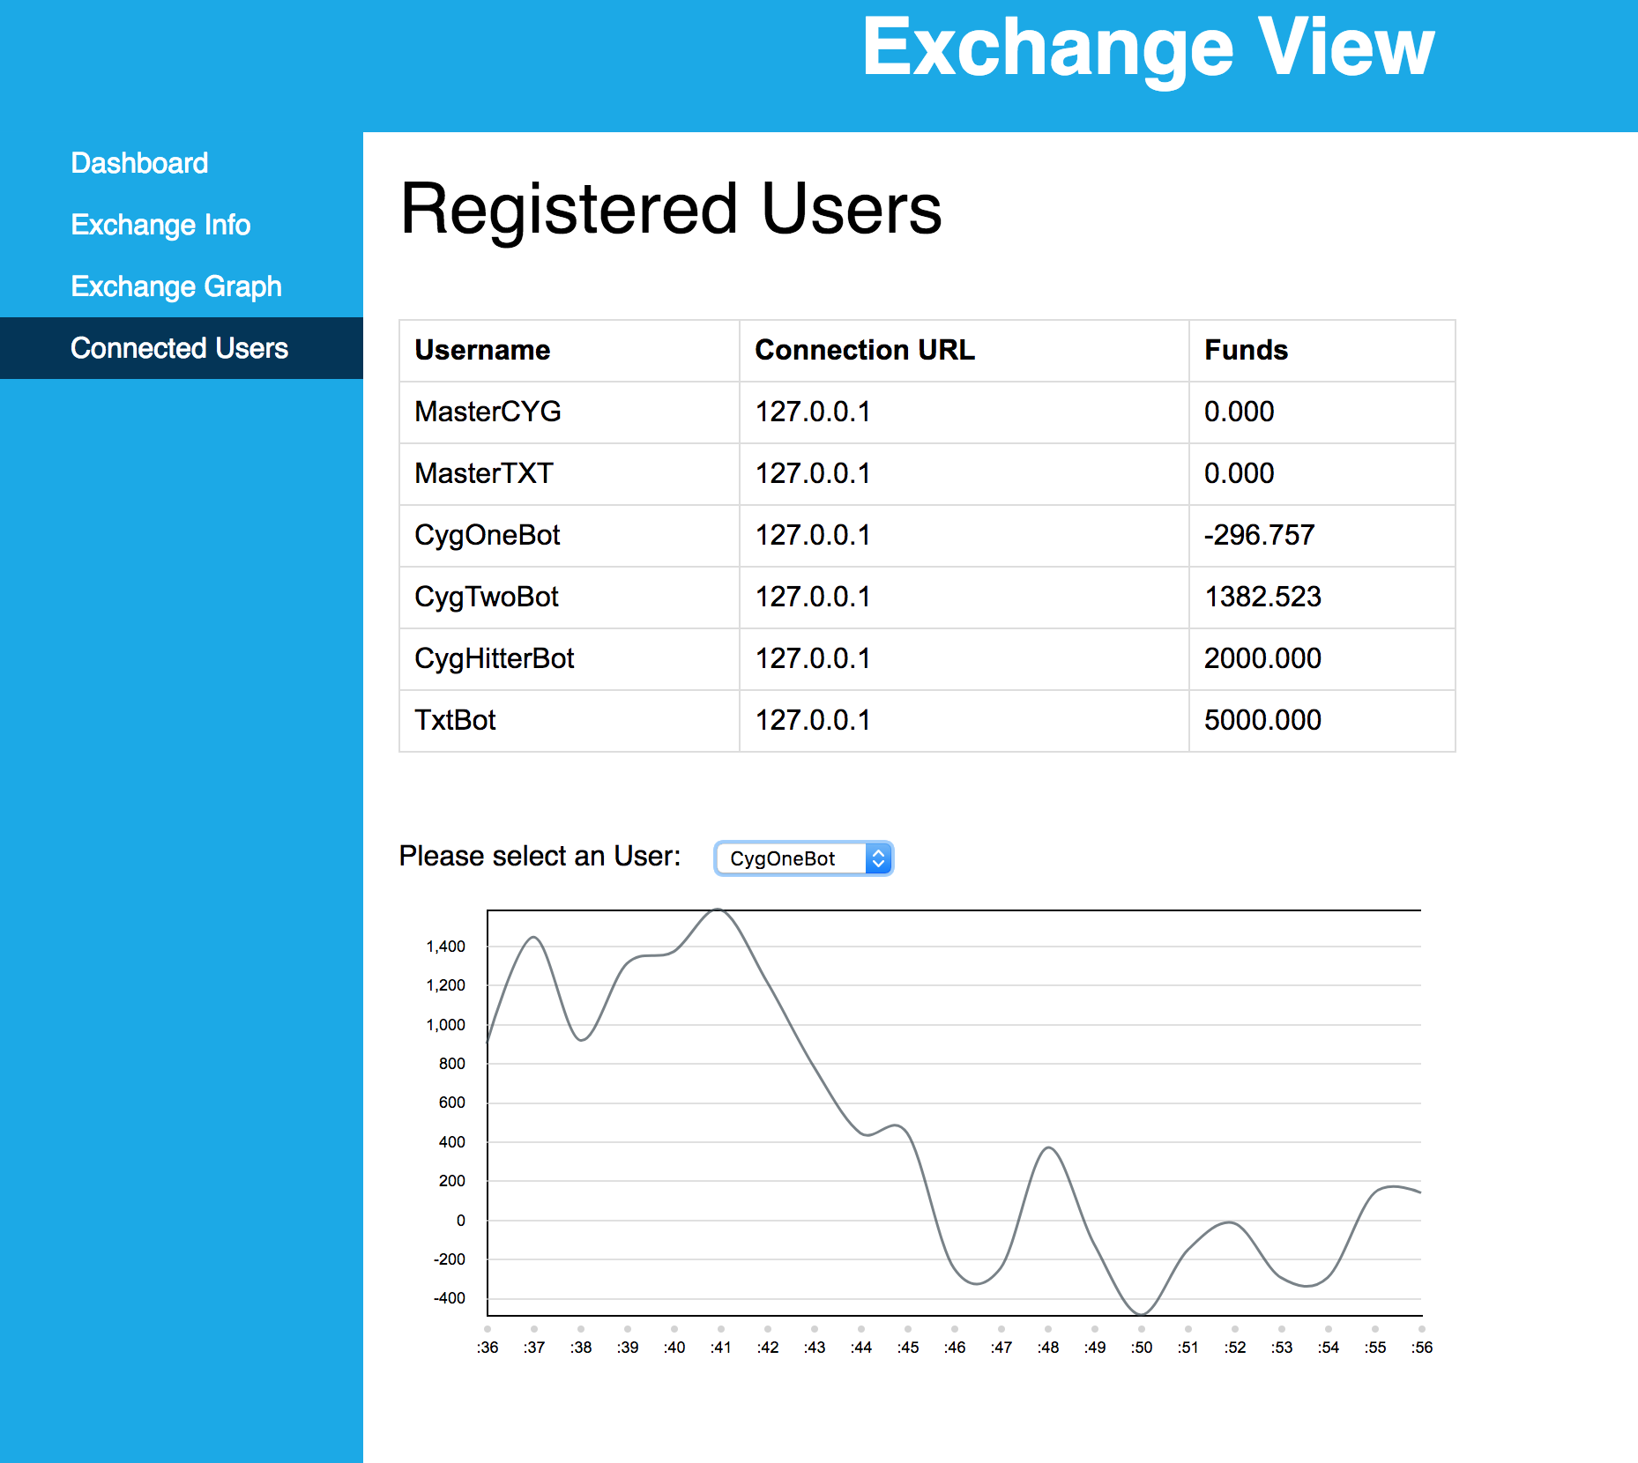
   2. Funds should update as the exchange updates
      1. They can be positive or negative values
      2. Updates occur every 4 seconds
   3. The live updating graph should display beneath the users, and show the fund information for the selected user, as shown above
      1. The graph should update every 1 second
6. Switching to the “Exchange Graph” tab should show the following layout:
   1. 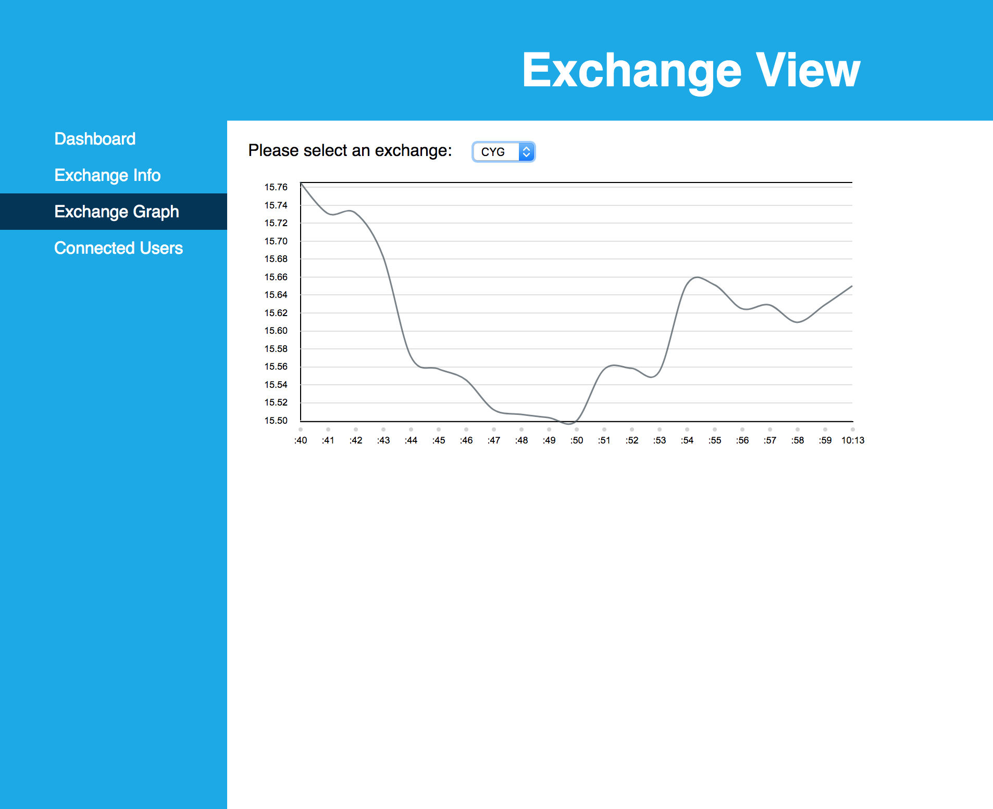
   2. You shall be able to select an exchange with the top selector. If “None” is chosen, it looks like the following:
   3. 