

#twedagsbar  
by lisa risager  
<https://www.flickr.com/photos/risager/4505281019>

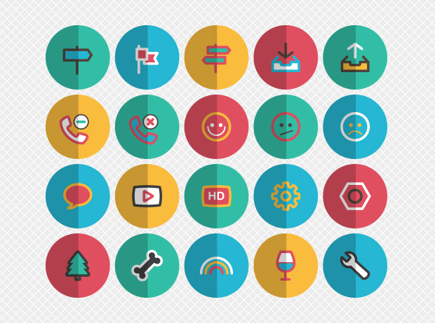

Folded vector icons  
by graphicloads  
<http://graphicloads.com/product/folded-vector-icons/>

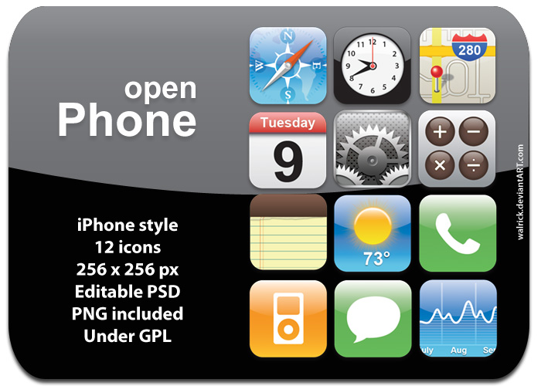Open Phone icons  
by Erick Ribeiro (AKA Walrick)  
<http://walrick.deviantart.com/art/openPhone-49529974>

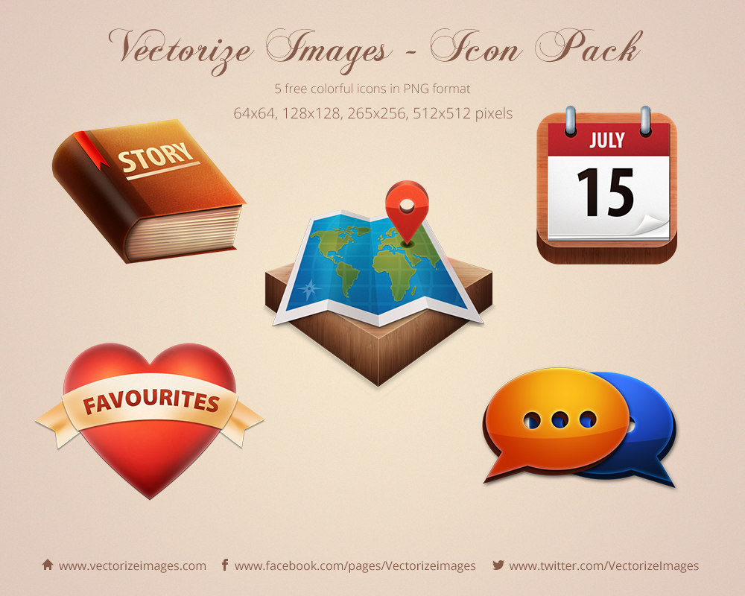

Vectorize Images Free Icon Pack  
By Vectorize Images  
<http://www.vectorizeimages.com/vectorize-images-free-icon-pack/>



Warning SVG  
by Stephen Hutchings  
<http://typicons.com/>



Indigo blue fog  
by chris craven  
<http://www.beplace.com/img/cloud.jpg>