Gather Ring: Promoting Social Interaction on the Playground by Measuring Play
Cindy Bayley  Mechanical Engineering  UC Berkeley  Berkeley, CA 94720, USA  cbayley27@gmail.com | Christopher Fan  School of Information  UC Berkeley  Berkeley, CA 94720, USA  chrisfan@ischool.berkeley.edu | Justin Sampson  College of L&S: Economics  UC Berkeley  Berkeley, CA 94720, USA  justinsampson1992@gmail.com | Ben Sun  Mechanical Engineering  UC Berkeley  Berkeley, CA 94720, USA  hongchengsun@gmail.com

ABSTRACT
Our project is a bracelet designed to monitor and enhance adolescent social development through capturing play activity during the recess of elementary schools. During recess, the Gather Ring bracelet tracks gestures and interactions among children. To do this, the Gather Ring bracelet utilizes several sensors and output devices. The Gather Ring bracelet encourages positive social interaction among children and enables teachers to have the ability to be more aware of the social dynamics and development by monitoring childrens’ play activity.

Author Keywords
Measurement; Gesture; Emotional Intelligence

ACM Classification Keywords
H.5.m. Information interfaces and presentation (e.g., HCI): Miscellaneous.

General Terms
Human Factors; Design;

INTRODUCTION
The goal of this project was to develop a device that promotes positive social inclusion and emotional intelligence development in elementary school children. Currently, teachers can give a child extra help if they see a student not performing well academically or becoming isolated from his/her peers. However, a teacher’s sense of social development for the whole class is limited to his/her personal observations of individual students during class time. Much of the social development during elementary school occurs on the playground with little adult supervision.
We chose to focus on elementary school children because the structured nature of elementary schools provides a consistent environment in which to measure social activity. For example, the notion of a ‘class’ creates a consistent unit of social measurement. Furthermore, the class has a fixed number of students throughout the day and year. In addition, the class has a consistent physical location and there is a dedicated teacher who oversees students’ individual progress throughout the year. Elementary schools have a fixed schedule of play activity comprised of recess time on the playground. This provides consistent opportunity to measure, observe and encourage different types of play activity that can be consistently monitored over the course of a school year. Recess play activity also comes naturally to children in elementary school. Children do not need to be taught to play. Hence, children do not require explicit external encouragement/motivation to actually recreate the activity Gather Ring wants to measure. Children, when left alone, will express play activities in some fashion. This simplifies the measurement task because there is a high confidence that the children will create the play interactions Gather Ring wants to measure.

Permission to make digital or hard copies of all or part of this work for personal or classroom use is granted without fee provided that copies are not made or distributed for profit or commercial advantage and that copies bear this notice and the full citation on the first page. To copy otherwise, or republish, to post on servers or to redistribute to lists, requires prior specific permission and/or a fee.
CHI’14, April 26 – May 1, 2014, Toronto, Canada.
Copyright 2014 ACM 978-1-XXXX-XXXX-X/XX/XX...$10.00.
When in the concept development stage of this project, some ideas for devices that were considered include: a necklace, ring, teddy bear, ankle bracelet, and badge. Ultimately, a bracelet was chosen because it is: unobtrusive, lightweight, easily visible, durable, relatively cheap, and familiar to children.

Related Work
Other researchers have examined how wearable devices can enable communication. BuddyBeads is a wearable bracelet that enables coded communication among a group [4]. The intended users of BuddyBeads are teenagers. Each person has a bracelet with beads that have corresponding messages decided on by the group in advance. Messages are constructed based on a combination of the beads’ shape and varying sequences of vibrations formed by the sender pressing a bead. The message is received in a friend’s bracelet in the form of a corresponding bead, which lights up and vibrates. Kikin-Gil observes that “even though different groups may use the same bead shapes, they will mean different things in each group, according to the specific group’s culture and vernacular” [4].
Another wearable device that enables communication is Connexus, a device worn on the wrist that allows an exploration of how humans would communicate when not co-located and without the use of text or speech; its target audience are couples and close friends. The goal of the design of this device was to use sensors to capture information from one device and transmit them to another. Connexus translates heat, touch and heartbeats into patterns of light, sound and vibrations, signifying a person’s actions and presence [3,4].
Furthermore, a device that encourages play is HandJive, a handheld object for interpersonal entertainment that allows remote play through haptic input and output. HandJive is a gaming device that is manipulated by a user and also receives inputs from another HandJive device [2].

essential characteristics of gather Ring
Our project is a bracelet designed to monitor and enhance adolescent social development through capturing play activity during the recess of elementary schools. There are six essential characteristics that the Gather Ring supports:

- Identity Aware: Each bracelet will have a unique identifier. Every student will be given a device that is unique to them so that it can be measured over time.
- Gesture Activation: Using gesture activation, the bracelet can capture explicit positive intent that a child wants to play with another child. Children can activate the device through a physical gesture with their hands, arms and wrists.
- Input/Output Coincidence: The bracelet communicates to the world with visible lights that are visible to the wearer and nearby children during daylight.
- Wearable: The bracelet is lightweight and wearable on the wrist without inducing discomfort for the duration of recess.
- Wireless Information Transfer: Bracelets will broadcast their presence as “active” to other bracelets near in its vicinity. This will allow each bracelet to be aware of which other bracelets are nearby.
- Data Capture: When two bracelets are both in an “active” state triggered by the gesture, the bracelets will communicate with each other and store information about the interaction. The information recorded with be very basic consisting of: [Bracelet # ][Bracelet Interacted] [Date/Time].

Enhance Student Social and Emotional Development
Much of the social development during elementary school occurs on the playground with little adult supervision. A child’s level of comfort playing with other student peers can be influenced by both extrinsic and intrinsic norms which can encourage or discourage playful activity. Extrinsic norms are often exhibited by the actions shown by peers. For example, encouraging forms of extrinsic norms included students exhibiting “friendliness” or “sportsmanship” to kids entering play activities. Discouraging extrinsic norms can include situations where the actions of other students generate uncomfortable feelings. For example, during cooperative team game play, a student might not want to engage in play activity if that student is always “picked last” during team selection.
Intrinsic norms include building up an individual student’s confidence to approach and invite peers to engage in play activity. Encouraging intrinsic norms can include promoting an atmosphere of “reaching out” to other students to invite play activities. For example, popular students can approach less popular students to play. Or athletic students or “Team Captains” can balance teams by picking less athletic peers. Discouraging intrinsic norms include an individual student’s level of shyness preventing a student from initiating play activities for fear of being rejected or shunned.
The purpose of Gather Ring is to allow for teachers to generate social games to both elevate encouraging forms of social interaction and lessen the discouraging forms of social interactions. Because Gather Ring records interaction data, teachers can monitor whether positive changes occur over time and change tactics as appropriate.

Designing the gather ring
The Gather Ring prototype demonstrates the core aspects of bracelet interaction: Ergonomic Design, Gesture Activation, Bracelet Interactivity, and Wireless Data Capture & Transmission. See Table 1 in the Appendix for a description of each and how these core aspects relate to concepts of tangible user interfaces.
Technical Details
The electrical components of the Gather Ring bracelet include an Arduino Uno, accelerometer, radio receiver & transmitter, and Adafruit’s Neo Pixel Ring [1]. These components are mounted on a piece of silicone rubber, as shown in Image 1 & Image 2.
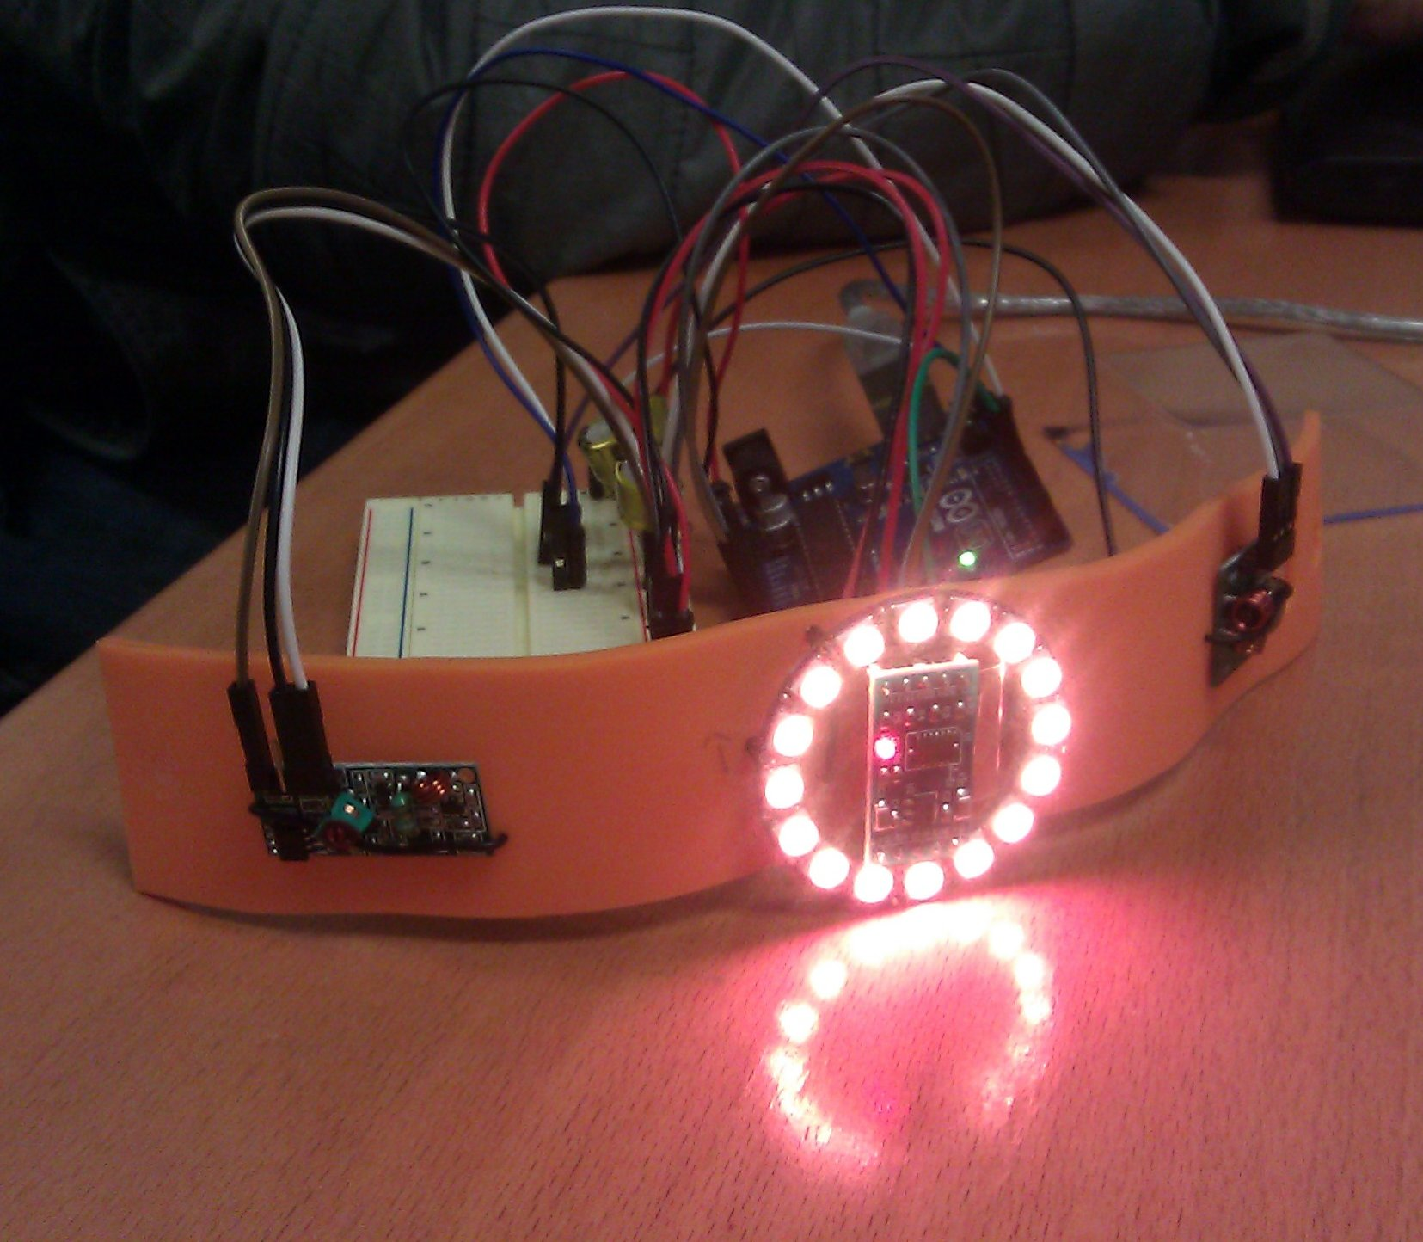
Image 1. The Gather Ring bracelet prototype

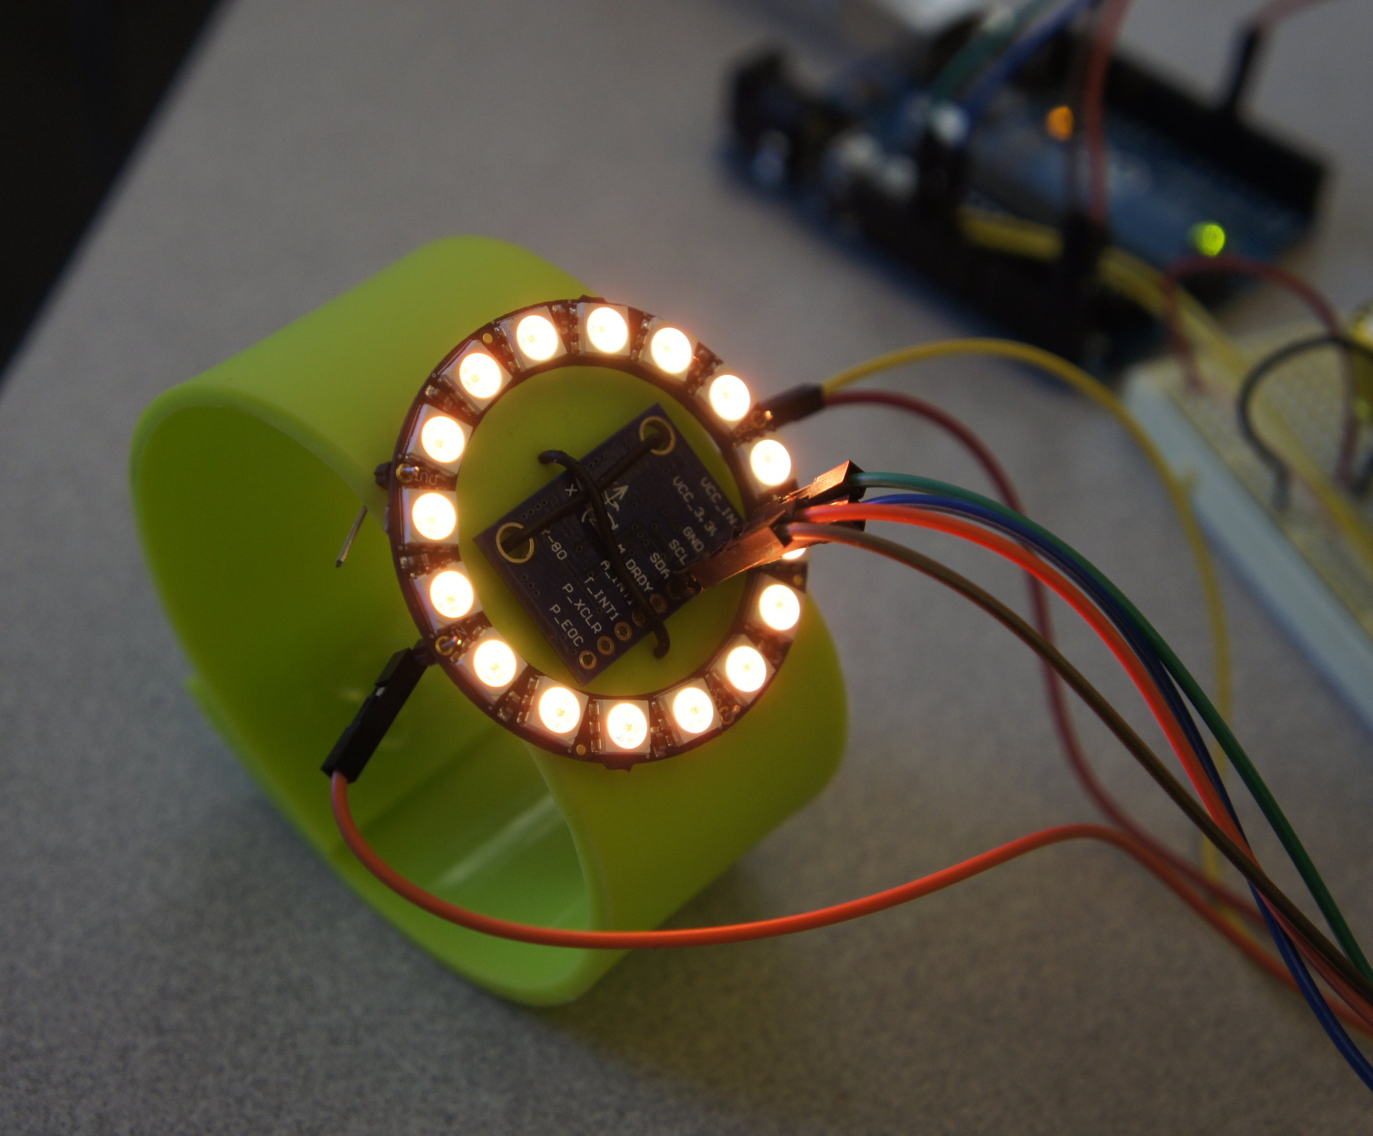
Image 2. The second Gather Ring bracelet prototype

Excluded from this Prototype
Due to time and hardware limitations, there are elements of the Gather Ring concept that were excluded from the scope of the current prototype, which focuses on the children-to-children interactions with the bracelet. For example, the team envisioned a visual mechanism to integrate with the bracelet, referred to as the “Pizzameter.” The “Pizzameter” is a visual display of the aggregate play activity visible to the children in the classroom to promote group goals. We believe that it would serve as an effective motivator. In addition, a “Play Activity Visualization” was also determined to be out of scope for this project. This is a visualization of the aggregate play activity for the teacher to consult when monitoring the progress of his/her classroom. Another aspect of the Gather Ring concept that was also discussed was the ability to track the locations of the children and to infer the kinds of activities the children are engaged in. A near field communication (NFC) device could be used to determine this information.

Encouraging Student Peer interaction with social games
The Gather Ring bracelet will be able to support a number of interactive social features that all aim to encourage elementary school children to interact more closely with their peers. Following is a list of these interactive social features.
Secret Buddy: Each Gather Ring bracelet can be remotely programmed with a secret code made visible using color LEDs. The goal of this game is to find the other child who has a matching code. Children can reveal the secret code found on their bracelets through a gesture activation. When two bracelets are activated with the same matching code, the children complete a simple data handshake creating an acknowledgement signal on both bracelets. Subsequently, the two children can return to the teacher to confirm that they have found each other’s secret buddy. This game in particular could be instrumental in guiding children to interact with others they might not usually play with.

Dynamic Arm Wrestling: Each Gather Ring bracelet can sense the relative position of a person’s arm. Therefore, the bracelet can change color depending on whether a person is on the “winning” or “losing” side of the competition. After two children play the arm wrestling game, the bracelets will record the interaction.

Randomized Team Assignment: When children play in team sports (kickball, basketball etc) one of the key tasks is the assignment of each child to a team. During team formation, the emphasis on creating a “winning” team might create negative social pressures excluding certain individuals who are not the best athletes also know as the “getting picked last” situation. The Gather Ring can help with this situation by providing randomized team assignments. Children who want to play together can all activate their Gather Rings within the same vicinity using the activate gesture. The Gather Rings subsequently can identify the other bracelets in the vicinity and assign rings to random teams via the LED output (Red Team vs. Green Team).

Team Selection:
The teacher instructs the Gather Ring bracelets to divide the assembled children into two teams. The bracelet a child wears then displays one of two colors, indicating which team the child is a member of.

Class Goals “Play with Somebody New”: Since each Gather Ring bracelet is identity aware, there is a social context to determine whether one child has recently played with another child. Teachers can create a classroom meta-game whereby children are encouraged to “play with somebody new” that they have not played with recently. If sufficient numbers of children “play with somebody new” then there can be a classroom reward such as an ice cream or pizza party.

The Gather Ring prototype was designed to demonstrate the ‘Dynamic Arm Wrestling’ game. When a person is winning, the Neo Pixel ring shines blue and yellow and the colors spin faster and faster. When someone wins the game, the NeoPixel ring displays rainbow colors. When a person is losing the game, the Neo Pixel ring shines red and white, also spinning faster and faster.

Using gather ring data
The data captured by the Gather Rings can be used to create a social network graph chronicling the playground interactions of children over time. There are various scenarios in which the data might prove useful.
- Transfer Student Arrival: A new student is transferred to an elementary school midway during the school year. Using the Gather Ring, a teacher can determine whether the student has made friends within a period of time such as within the first few months. If the student had not made friends, this could be an indicator that the student is having a hard time adjusting to the new school.
- Breaking Down Social Cliques: A teacher might want to encourage students to interact with different social circles and breakdown the formation of “cliques” that emphasize exclusivity. This could be something as simple as scenarios encouraging the school genders to interact more with each as opposed to a “boys” vs. “girls” self-segregation.
- Reducing Competitive Pressures of Team Sports: Boys often play with each other in competitive sports that emphasize “winning.” Teachers can create scenarios that might encourage sportsmanship over “winning” by reducing the pressures of kids forming teams.
- Identifying Social Exclusion and Bullying: A student’s lack of play interaction with other peers could detail signs of bullying.

Cost Efficiency
One of the other design principles when constructing the Gather Ring was to use common components to reduce the price of materials. The primary reason is to make the device affordable for public elementary schools. Table 2 shows the itemized cost breakdown for the Gather Ring prototype.

Component | Specification | Cost
Bracelet Material | Silicone Rubber | $2
Accelerometer | ADXL345 | $9
Radio | 315mhz Receiver (MX-05V)  315mhz Transmitter (MX-FS-03V) | $6
LEDs | Adafruit NeoPixel Ring (WS2812) | $10
Battery | 9 V Battery | $4
Microcontroller | Arduino Uno (ATmega 328) | $20
Wires/Pins | Various | $2
Total |  | $53
Table 2. Material costs (excluding taxes) for the Gather Ring prototype.

Future Work
The future steps for developing this device include creating a self-contained bracelet. Currently, the Gather Ring prototype uses an Arduino Uno and circuit board which are not contained on the bracelet and the current set-up of connections prevent it from being truly wearable.
As future work, we also plan to conduct usability tests with elementary school children. During these usability tests we’d like to better understand what aspects of the current prototype the children connect with most and identify the opportunities for improvement. Is using the bracelet a fun experience for them? What other games can they imagine using the bracelet with? We also seek to better understand what the children prefer in terms of aesthetics. Do they like seeing the electronics exposed or is it distracting? These are just some of the many insights we hope to gain by conducting usability testing.
The Gather Ring project initially focused on measuring social activities outside the classroom on the playground. Another area of future focus could potentially lead to adapting the ability of Gather Rings to measure positive social activities within the classroom. For instance, students can be encouraged to express positive feedback. Scenarios include if students are helpful to each other in peer-learning scenarios. For instance, if a student learns something new from another student, a gesture activated sign of appreciation can be initiated.

Conclusion
In this paper we presented Gather Ring, a bracelet designed to promote social interaction and monitor play activity among elementary school children. The prototype demonstrates the six essential characteristics: identity aware, gesture activation, input/output coincidence, wearable, wireless information transfer, and data capture. The Gather Ring bracelet will be able to support a number of interactive social features that aim to encourage elementary school children to interact more closely with their peers. The Gather Ring prototype is a proof of concept for the “Dynamic Arm Wrestling” game. The Gather Ring allows teachers to generate social games to both elevate encouraging forms of social interaction and lessen the discouraging ones. Because Gather Ring records interaction data, teachers can monitor whether positive changes occur over time and change tactics as appropriate.

ACKNOWLEDGMENTS
We would like to thank Kimiko Ryokai and Laura Devendorf for their guidance and many insights with regards to this project. We would also like to thank the individuals who provided feedback during the course exhibition for INFO262 / NWMEDIA262 “Theory and Practice of Tangible User Interfaces.”

REFERENCES
- Adafruit Industries. NeoPixel Ring - 16 x WS2812 5050 RGB LED with Integrated Drivers. http://www.adafruit.com/products/1463, Accessed 12/15/13.
- Fogg, B.J., Cutler, L., Arnold, P., and Eisbach, C., HandJive: A Device for Interpersonal Haptic Entertainment, CHI ’98, 18-23 (1998). http://people.cs.vt.edu/~wangr06/touch%20review%20origanization/FogCAE98.pdf
- Intel Corporation. Connexus (2002). http://www.paulos.net/research/intel/connexus/, Accessed 12/14/13.
- Kikin-Gil, R. Buddy Beads: Mediating Social Relationships Through Mobile Communication.
Masters Thesis. Interaction Design Ivrea, (2005).

 | Definition | TUI Concepts Addressed | Design Features
Ergonomic Design | Comfortable, flexible, and desirable | User Centric Design: Understanding the requirements relevant to playground activity: comfort, durability, ease of use (putting on and taking off) | Silicone rubber material used for the band of the bracelet
Gesture Activation | Children can activate the bracelet with a physical motion using their wrist. Bracelet activates for specific gestures and stays dormant for coincidental movement | Input/Output Coincidence: Input sensor to correlate specific physical movement | Accelerometer
Bracelet Interactivity | The bracelet provides output in the form of visual feedback. | Input/Output Coincidence: Displaying information to user and to children in close proximity | LEDs (NeoPixel Ring) with full RGB output
Wireless Data Capture & Transmission | Bracelets can exchange basic information about which child played with which child. | User Centric Design: Improve ease of use by eliminating nuisances of physically connecting devices to transfer data | Radio Transmission (315mhz)
Appendix I
Table 1: Core Aspects of the Gather Ring

