AWS Cloud Adoption Framework: Coillte Business Case

Christopher Herrera Magana

x19127723@student.ncirl.ie  
MSc Cloud Computing, Utility Computer   
29/11/2019

Word Counting: ≈ 2550

**Abstract**— This document describes the process of designing a Chatbot Classifier with different Trained owned Datasets. One of the most significant achievements was the interpretation of Data Analysis using Machine Learning and Words Vector Representation. Likewise, the deployment to a suitable Cloud provider using the recommended practices for Cloud developer.

**Keywords**— IoT, Machine Learning, AI, Cloud Computing, AWS, Spot Instance, CAF, Cloudonomics.

Introduction

By the year 1989 in Newtownmountkennedy, province in Wicklock blossomed the new epoch for a forestry industry named Coillte, which means "forests"/"woods" [1]. The company got ownership by the Irish State's forests, which originated the trading [2]-[3].

It has been roughly three decades after the organization commenced progressing. In the present era, Coillte's vision methodology has changed aspiring to reach new market objectives (Business Strategy) [4]. Therefore, their operational and functional activities must adjust to fulfil their necessities and demands (Business Drivers) [5]-[6].

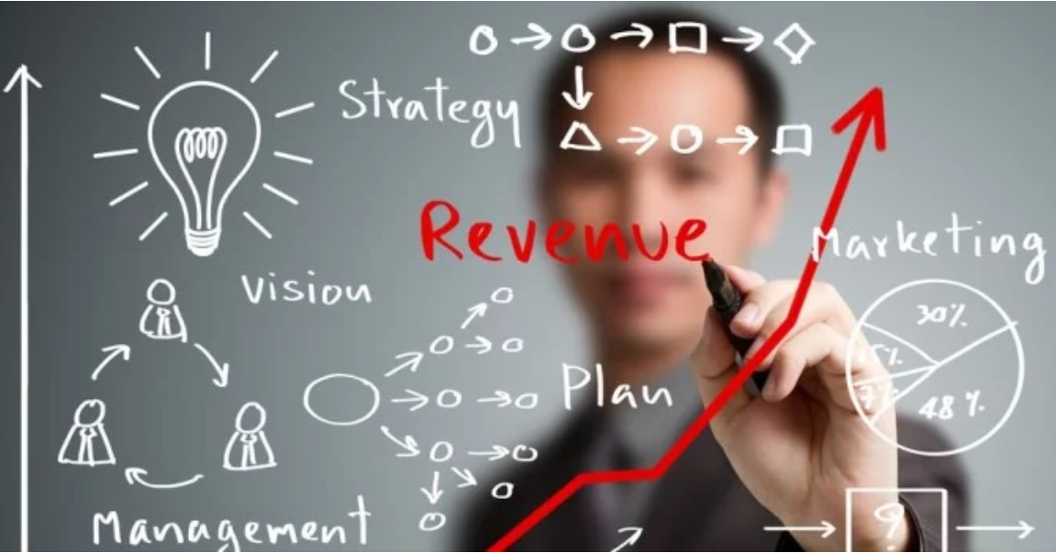

Fig. 1 Strong Brands Are Business Drivers

Source: Adapted from [7]

The image above represents the rubrics involved for the business roadmap, which are imperative to attain desired results. To some extent, this ecosystem has a foundation on a play role model; for this reason, all aspects (Strategy, Revenue, Management, Vision, Marketing, and Plan) are associated and remain essential to structure an adequate cloud adoption model.

Coillte obliges a critical sector for the Irish economy as a market distributor and to protect over 440,000 hectares of forest and land covered in Ireland [3]. Due to its vision and core values, Coillte has been able to generate three central businesses: Forestry, Land Solutions, and Medite Smartply [9].

Forestry:

In this business division, the purpose is the life cycle of the forest, which translates to the manner of nurturing the trees. It is also important to mention that sustainability plays an indispensable role in the Irish forestry sector; As a result, Coillte is conscious about it and donates over 15,000 trees to the council of Ireland every year [8].

Land Solutions:

The company offers a position to buy or sell land, guiding customers or associates to develop unique projects contributing to the inhabitants near the region. It can be from renewable energy wind farms, infrastructure as a telecoms business allowing better communication and recreational activities like camping, picnic, walking, or cycling [9].

Medite Smartply:

This sector focus on the elaboration of high-quality Medium-density-fibreboard known as MDF. Their own brand "Medite" has become one of the most popular across Europe due to the characteristics and appearance to satisfy every customer need.

1. Align cloud & business strategy

After the brief introduction, this business case model will address the forestry division. However, with all this information gathered, it might not be noticeable that the company strategy neither their necessities. As we previously mentioned, Coillte sector not only has an intention to nourish the forest but also selling trees.

Considering the diversity of woods and categories, Coillte has a log on three types. Pulpwood: the leading applications are the elaboration of paper or wood-based panel products — Small-Sawlog: which first applications are for fences or pallets. Moreover, lastly, Large-Sawlog: uses for development in structural applications.

Coillte’s perception is to become the best forestry and land solution company in Europe [10]. With this intention, it is imperative to analyse their obstacles and determine a cloud adoption approach to satisfy higher market demand.

The foundation of their model is to sell wood and preserve ecological stability. How do the company extract or obtain the wood? Also, what are the pieces of equipment necessary for this arduous task? How big is their taskforce? What about the weather conditions to work without risks? Those inquiries can assist in producing an educated model.

The educated model conveys on the actual architecture that blocks their progress. At the same time, what would be the benefits of moving to the cloud. To emphasize, it is crucial to measure the quality of service based on metrics.

The first premise that will comply with the AWS Cloud Adoption Framework (CAF); Coillte requires to have precise information regarding the maturity of the trees to proceed with the workforce to plant and harvest trees. Pretend that the Forestry business model lack of real-time data accuracy, and, they aspire to improve their structure to accomplish their goals.

Overall, in this first CAF stage, it is necessary to understand what are the key elements that are indispensable for Coillte's goals. Moreover, from a business perspective (stakeholders) what would be their expectations (profits) and acceptable risks (loss) from adapting their business to a cloud model.

1. Rapid Discovery, Planning, and migration

Proceeding with the second stage of the AWS Cloud Adoption Framework, there is a key aspect to be established in order to continue with the cloud solution design. Exploring the business capabilities as the power of the underlying mechanism to produce a specific outcome [11]-[12].

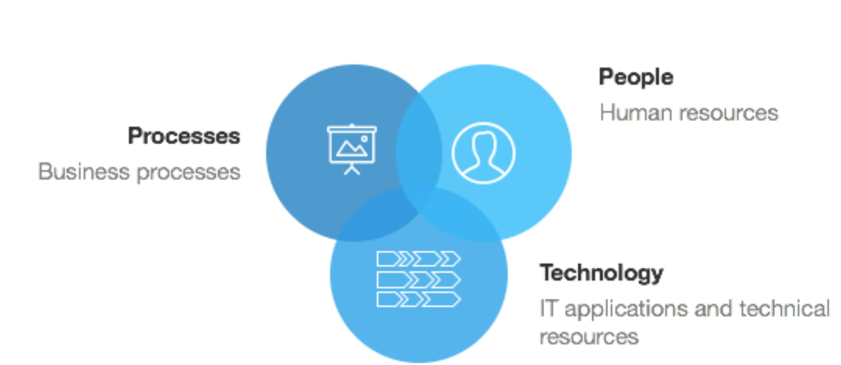

Fig. 2 Elements of a Business Capability

Source: Adapted from [13]

This map exhibits an association that discloses what components are necessary to define a baseline capability and the drivers for asset mapping, which plays an indispensable role in the business strategy. More importantly, to develop a gap analysis for the cloud architecture vision [14].

Coillte Baseline Capabilities: To infer in a significant analysis regarding their objectives, consider the earlier categories People, Processes, and Technology and question about if the capabilities describe "What" rather than the "How." [13].

Having this into consideration, pretend that the Coillte Forestry division has seven Business areas: Human Resources (HR), Information Technology (IT), Sales, Marketing, Banking, Production, and Supply Chain. Additionally, each business area has its business activity [14]. However, their operations readiness for the IT area is facing difficulties that cannot satisfy the real-time data demands.

The actual design of the IT Business area has four servers, two dedicated for Coillte operations, two for the Databases, and two Storage Area Network (SAN). The idea of this architecture was to provide redundancy and avoid service affectation.

To be able to create a new cloud solution design with the actual assets, it is imperative to know which cloud model is feasible for the company model. Breaking this into segments, Infrastructure as a Service (IaaS), Platform as a Service (PaaS), or Software as a Service (Saas); Likewise, a cloud service, whether Public or Private.

Besides, it is necessary to include the business governance appliances, the norms, or data governance that the company needs to follow to protect sensitive data and provide the service. Hence, Regulations can guide the cloud adoption roadmap following their restrictions and the method to implement to adapt the business model.

As a result, Coillte's seven business areas represent the AWS Cloud Adoption Framework Matrix, which are organized depending on the priority level of the activities align with the business strategy.

Coillte Capability Gap Analysis: An effective development for the cloud roadmap, the business capabilities are organize depending on importance necessity; in other words, all the business functions need to interact with each other. However, adopting this cloud model design with the best practices, the cloud solution needs to be loosely coupled to evade conflicts and to be protected from security risks or network failures.

Cloud Adoption Roadmap: Consider the analytical scenario where Platform as a Service on a private cloud architecture would satisfy the Coillte's requirements to achieve their goals. In this case, Coillte would be responsible for their Applications and Data, whereas AWS would take responsibility for the inner layers of the PaaS model.

To sum up, the target of this stage is to develop a strategy to help the company to visualize and classify data in real-time from everywhere, and this information is related to the Forest Cycle processes, which are: Planting, Growing, Managing, and Harvesting.

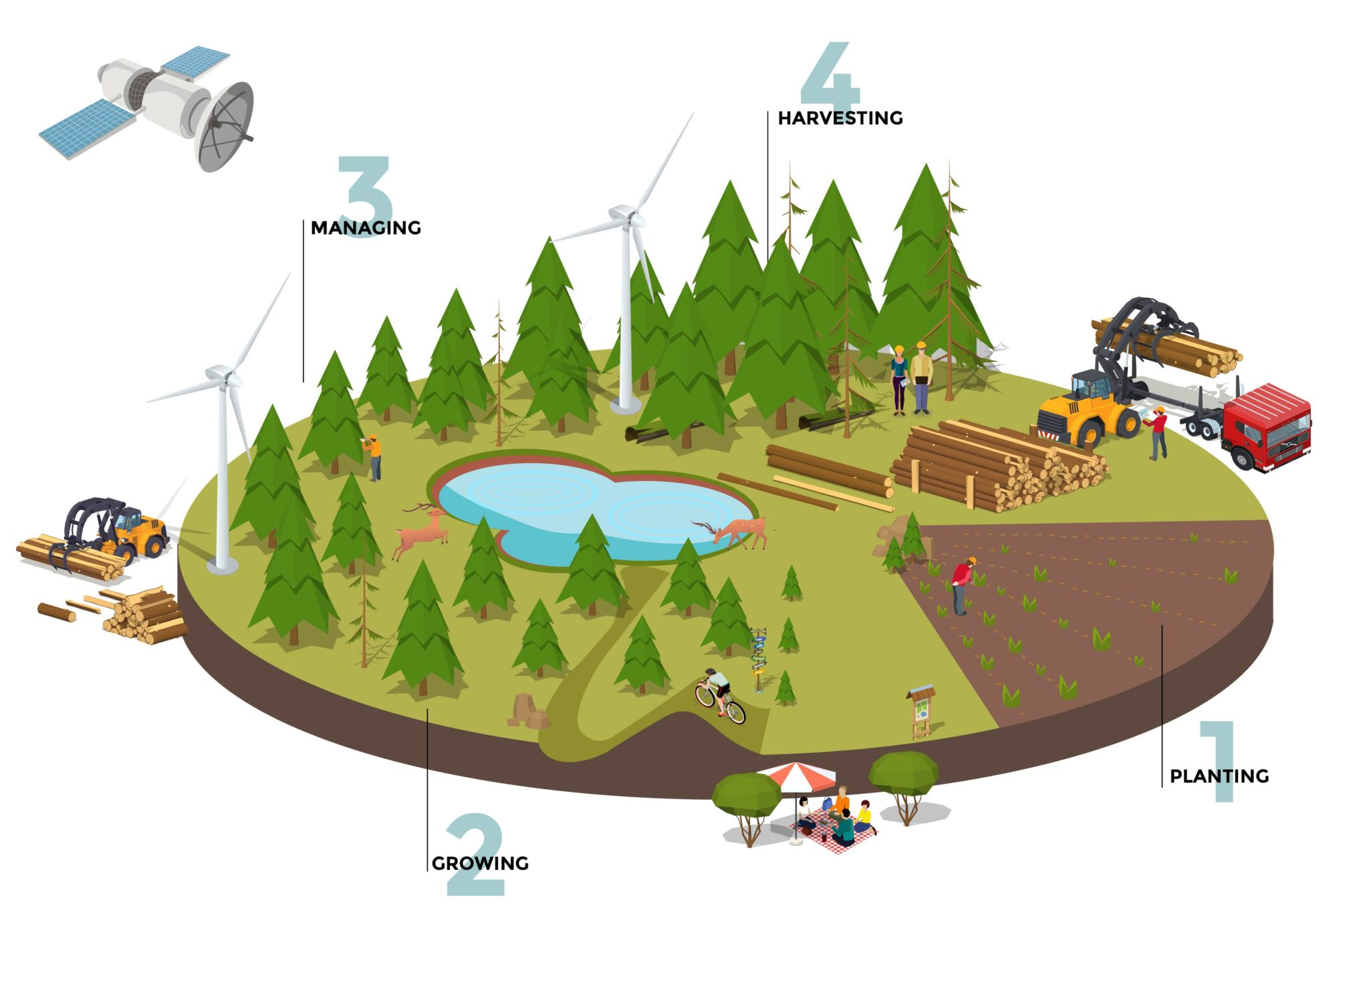

Fig. 3 Coillte’s The Forest Cycle

Source: Adapted from [16]

Using the different services from AWS, the idea is to integrate all the business areas on the cloud on a Pay as you go model; depending on the demand, the cloud resources can increase horizontally, and it can reduce expenses. Furthermore, data can be protected and restricted to different users, and considering the service level agreements; this provides uptime of the services and guarantees data integrity with specific configurations.

1. Realize & Sustain Business Value

Ideally speaking, the Internet of Things (IoT) with Drones Technology and Machine Learning can implement to build this cloud journey. Consider that AWS has a way that can control our devices connected to a network; therefore, each drone could update information at any time. Afterward, with the intelligence provided, our drones would be able to distinguish the conditions of the trees, which interprets into the creation of an on-live land map.

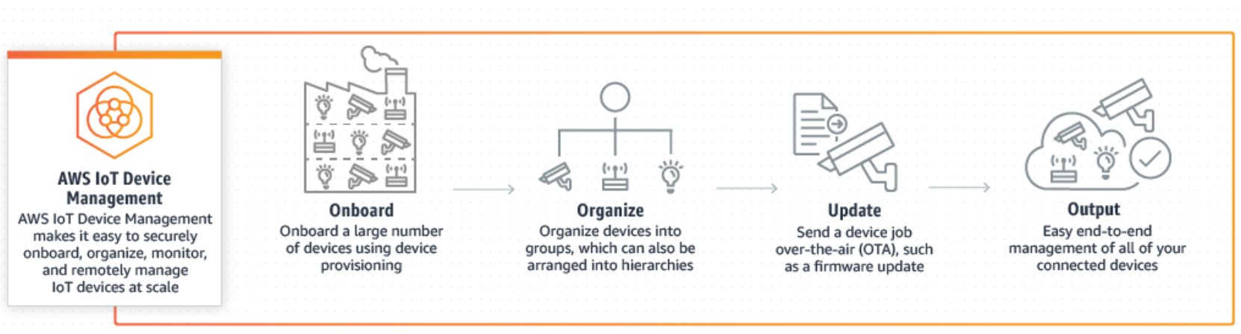

Fig. 4 AWS IoT Device Management

Source: Adapted from [17]

As the image above illustrates, AWS IoT Device Management can provide many other features to satisfy the demands of the Coillte Forestry market. In other words, Head Quarter will deploy drones to analyse the health of the trees to provide a finding report. Under those circumstances, managers can elaborate on a strategy of harvesting trees plans with their workforce. Lastly, the employees would be able to interact with the AWS platform to update their progress or report any issue.

Likewise, the company will have access to different web services depending on the process role, at the same time, it is possible to interact each other to retrieve or update information, saying that the workforce would be able to login in their session and check the status of their progress, drones would confirm and validate that information and with that through AWS Lambda and SNS can update data on real time and notify managers to proceed with other projects.

Managers can configure and organize task to be implemented by drones through AWS IoT Device Management, it also provides security in casa that drones start to malfunction it will send a warning to check the conditions of the equipment. Finally, it can provide a map report with the task completed.

Until this point, the approach of this cloud model has been focusing just on the design of their new architecture; nevertheless, significant market performance metrics are required to support the adoption of the cloud model [23].

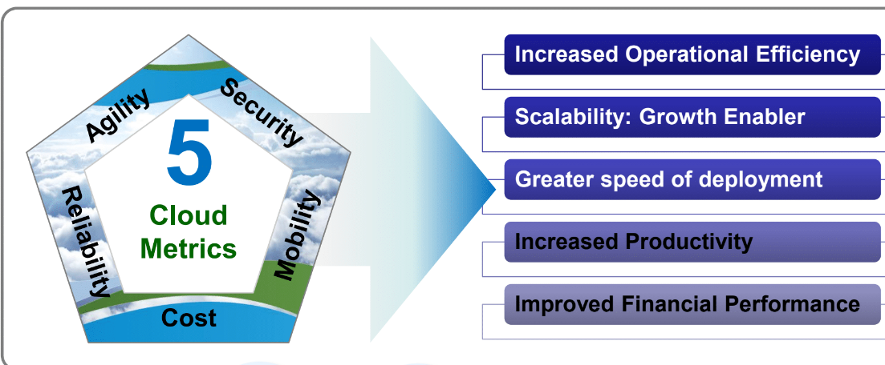

Fig. 5 AWS IoT Device Management

Source: Adapted from [18]

As the figure displays, there are vital aspects that can help us determine acceptable risks, which enter in the adaptability migration process. In order to have a stable foundation, the business staff must get trained with the new cloud adoption to achieve better results.

In this case, the cloud adoption execution takes time to mature and provide the result were expected to produce. For this educated experiment, the customer can give a reasonable period where the staff can get used to the new system. The main idea of this Cloud Adoption Framework stage is to analyse the cloud model with the sustain of the business value.

Monitoring Development of the cloud architecture, it is an essential analysis to examine the performance of the business capabilities, for the intention to generate a report and address any deficiency in the architecture.

1. Innovate & Transform

One point often overlooked is to comprehend what other aspects can add significant value to the business. The Total Cost of Ownership (TCO) by AWS help to decipher what are the hidden components of the on-premise model vs cloud solution model.

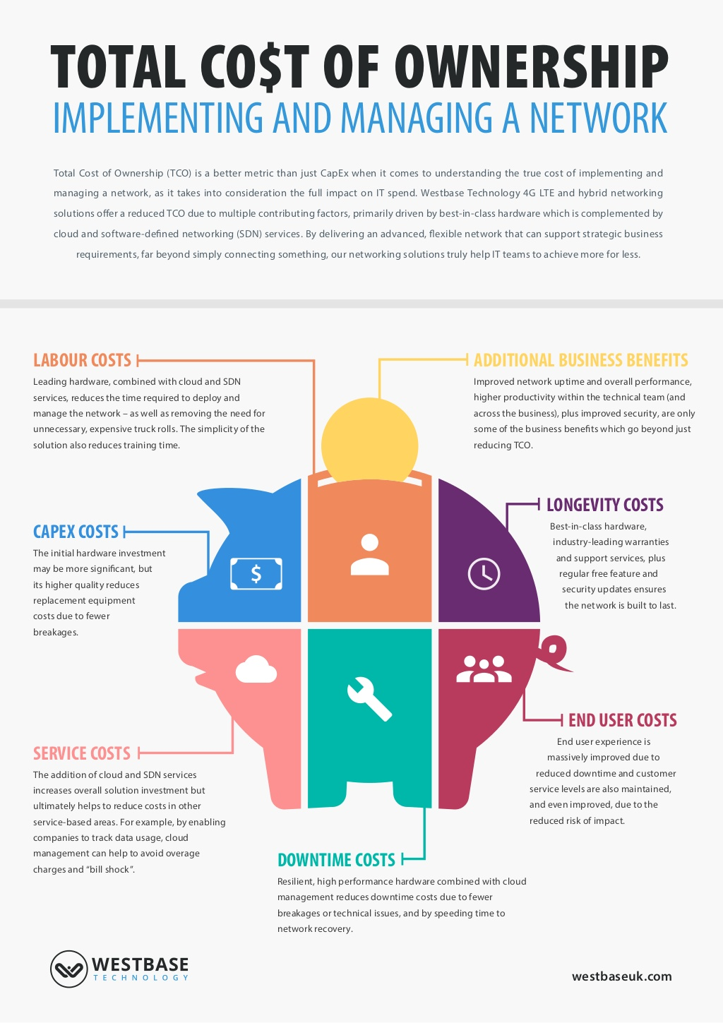

Fig. 6 Total Cost of Ownership: Implementing and Managing a Network

Source: Adapted from [19]

As the image above shows, developing and executing a network infrastructure has its unseen expenses and most of the people do not separate genuinely what other cost could be involved in their solution. This information is essential thus in some circumstances the cloud solution can be even more expensive rather than the on-premise model. Hence it is recommended to check also for a hybrid cloud model.

According to their annual report by 2018, the company declared profits of €115m up 35% on the previous year [7]. Hypothetically speaking, what changes would be necessary to increase that 35% of profits. One idea is taking advantage of the AWS spot instances, reducing unnecessary expenses when you are not using the service.

For instance, if there is a requirement to proceed with a field inspection drones will complete the task faster rather than sending workforce, however you need to upload information using S3 bucket to save the data using Elastic Cloud Compute EC2 instance to process that information it is not require to be active every second it can be turn on once a task is done and it can be synchronize with AWS lambda to trigger that functionality.

Another example would be how much is the cost for a drone to be implement, let us assume a drone with recording capabilities approximate cost between 1000 euros to 1500 euros. How many drones would be required to test this premise? Consider 1000 drones and this is equal to 1,250,000 million, AWS would charge 0.10 euros per 1000 things (drones) registered, every device jobs cost 0.03 euros and searching queries cost 0.05 (per 10,000 queries).

Using an estimated approach, it is true at first the solution would cost a bit more, but the Return of Investment will be quicker. Coillte has struggle to get a faster Return of Investment due to the nature conditions, however this model has the capabilities to scala up to any other division. Amazon offers a free trial per 12-moths which gives the opportunity to try the services that can satisfy customer need.

By means of drones can be used for searching and indexing, this behaviour will reduce time consuming and can provide higher accuracy which means saving money. In addition, once the task is completed you do not pay for the service because you cost is metered for the time you use the service.

For the final stage of the CAF, Coillte can make a revolutionary Business model if they are willing to invest in IoT solutions to have better data accuracy and to perform risky task using drones with a significant reduction of time. This is related to the AWS Well-Architected Framework based on five pillars.

Coillte ambitious goals require to integrate three pillars of the AWS Well-Architected Framework: Reliability, Performance and Cost effective.

By the National Institute of Standards and Technology (NIST) Cloud Computing model is architected for five Characteristics. Agility offers the ability to deploy quick cloud environment to the test any business functionality, in case of failure it can be reinvented or terminate. Hence the company would validate if the environment test can work or not and it reduces hardware obsolescence.

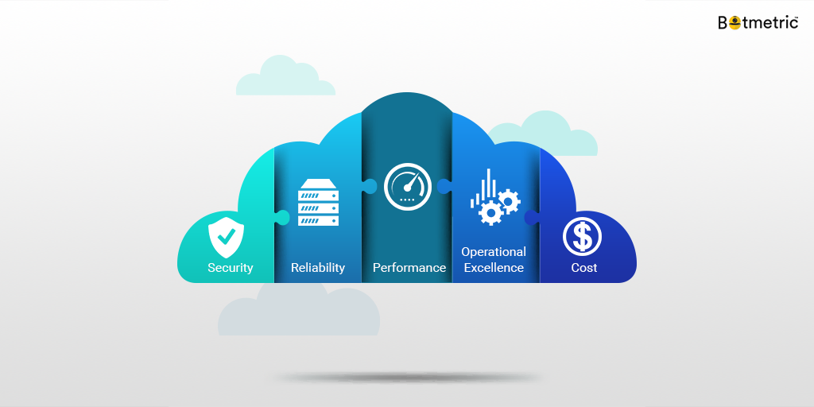

Fig. 7 5 pillars of the AWS Well-Architected Framework

Source: Adapted from [20]

Conclusion

This critical and educated report brings the idea to comprehend all the elements involved to develop a reliable architecture for the cloud adoption model. It is imperative to distinguish and consider the diversity of cloud approaches to solve a problem.

Data analysis is essential to help us imagine a critical insight into any business requirement. In other words, analytical thinking is vital to visualize all the conditions (variables) that are crucial to adapt the cloud business strategy.

Still, there are many questions to be asked once we comprehend the business capabilities while thinking on the best approach. For some customers, performance efficiency might represent a demanding area, whereas, for other clients, cost optimization is their priority.

The cloud diagnosis for Coillte business case model, convey on endless opportunities to improve the company necessities to achieve their goals. As we previous mentioned, to create a proper cloud migration adoption there are essential elements to be consider avoiding losses.

In my point of view, AWS CAF provides the foundation of Cloud model, however, it is also imperative to map the design approach with other utility fundamentals (metered services) Cloudonomics. Likewise, depending on customer expectations the cloud implementation can have a period of maturity, which gives the option to configure any faulty.

Finally, in an era where every device is connected to the cloud, risky decision should be made with the intention to satisfy the high demand. Nevertheless, with an adequate Cloud Foundations (CAF & Well Architecture Framework) and Business examination the transition will be satisfactory.

References

1. Wikipedia, “Coillte,” 2019. [Online]. Available: https://en.wikipedia.org/wiki/Coillte/ [Accessed on: Nov.10, 2019].
2. Coillte, “About Us - Our Story.” [Online]. Available: https://www.coillte.ie/about-us/our-story/ [Accessed on: Nov.10, 2019].
3. Paul Ruane, “Mid-West Business Area Unit Strategic Plan 2016-2020,” 2018 [Online]. Available: https://www.coillte.ie/media/2018/03/B2-Mid-West-BAU-Strategic-Plan-2016-to-2020. [Accessed on: Nov.10, 2019].
4. Business-Case-Analysis, “Formulate a Winning Business Strategy, Business Model, Strategic Framework,” 2019. [Online]. Available: https://www.business-case-analysis.com/business-strategy.html [Accessed on: Nov.18,2019].
5. CFI, “Business Drivers,” 2019. [Online]. Available: https://corporatefinanceinstitute.com/resources/knowledge/modeling/business-drivers/ [Accessed on: Nov.18,2019].
6. Evolve, “What are business drivers?” 2019. [Online]. Available: https://evolve.ie/q-and-a/what-is-business-drivers/ [Accessed on: Nov.18,2019].
7. MartinRoll, “Strong Brands Are Business Drivers,” 2019. [Online image]. Available: https://martinroll.com/resources/articles/growth/strong-brands-are-business-drivers/ [Accessed on: Nov.18,2019].
8. Tree Council of Ireland, “Coillte trees on the way …...,” 2019. [Online]. Available: https://treecouncil.ie/testt/ [Accessed on: Nov.10,2019].
9. Coillte, “Attractions.” [Online]. Available: http://www.coillte.ie/our-forests/attractions/ [Accessed on: Nov.10, 2019].
10. Coillte, “CEO Message,” 2019. [Online]. Available: https://www.coillte.ie/about-us/our-story/ceo-message/ [Accessed on: Nov.10, 2019].
11. Eam-Initiative, “Business Capability & Business Capability Map,” 2013. [Online]. Available: https://eam-initiative.org/pages/yg7qjgxv78f5/Business-Capability-Business-Capability-Map [Accessed on: Nov.19,2019].
12. Capstera, “Business Capability Definition: What is a Capability?” 2019. [Online]. Available: https://www.capstera.com/business-capability-definition/ [Accessed on: Nov.19,2019].
13. T. Mannmeusel. “EAM im Mittelstand.” In: Enterprise Architecture Management (EAM) in der Praxis. Düsseldorf: Symposion Publishing GmbH, 2010, pp. 331–376.]
14. OpenGroup, “Cloud Computing for Business – Establishing your Cloud Vision,” 2016. [Online]. Available: http://www.opengroup.org/cloud/cloud_for_business/p3.htm [Accessed on: Nov.19,2019].
15. LeanIX, “Define Your Business Capability Model in 4 Steps,” 2019. [Online image]. Available: https://blog.leanix.net/en/in-four-steps-to-your-business-capability-model [Accessed on: Nov.19,2019].
16. Coillte, “Forestry,” 2019. [Online image]. Available: https://www.coillte.ie/our-business/our-divisions/forestry/ [Accessed on: Nov.10, 2019].
17. AWS, “AWS IoT Device Management,” 2019. [Online image]. Available: https://aws.amazon.com/iot-device-management/# [Accessed on: Nov.16,2019].
18. Victor del Rosal, “Utility Computing,” 2019. [Online image]. Available: https://www.dropbox.com/sh/g74dhe5t5g61rj3/AACEzkrsvHVOKiYzEFhlQjkra?dl=0&preview=UC03.pptx# [Accessed on: Nov.10,2019].
19. Westbaseuk, “The Total Cost of Ownership: Implementing and Managing a Network,” 2016. [Online image]. Available: https://www.slideshare.net/WestbaseTechnology/total-cost-of-ownership-implementing-and-managing-a-network [Accessed on: Nov.16,2019].
20. Medium, “The 5 Pillars of AWS Well-Architected Framework”, 2016. [Online image]. Available: https://medium.com/@nutanix/the-5-pillars-of-aws-well-architected-framework-84345ca54a30 [Accessed on 25.Nov,2019]
21. Coillte, “Wood.” [Online image]. Available: https://www.coillte.ie/our-business/our-products/wood-about/ [Accessed on: Nov.10, 2019].
22. Coillte, “Coillte Annual Report 2018,” 2019. [Online]. Available: https://www.coillte.ie/coillte-annual-report-2018/ [Accessed on: 10. Nov,2019].
23. AWS, “AWS Total Cost of Ownership (TCO) Calculator,” 2019. [Online image]. Available: https://awstcocalculator.com/# [Accessed on: Nov.16,2019].
24. Treemetrics, “Case Studies,” 2016. [Online]. Available: http://www.treemetrics.com/casestudies/ [Accessed on: Nov.10,2019].
25. Paul Ruane, “Mid-West Business Area Unit Strategic Plan 2016-2020,” 2018 [Online]. Available: https://www.coillte.ie/media/2018/03/B2-Mid-West-BAU-Strategic-Plan-2016-to-2020. [Accessed on: Nov.10, 2019].
26. Forest Service, “Irish Forests – A Brief History,” 2008. Available: https://www.agriculture.gov.ie/media/migration/forestry/forestservicegeneralinformation/abouttheforestservice/IrishForestryAbriefhistory200810.pdf. [Accessed on Nov. 10, 2019].
27. Coillte, “The Connected Forest.” [Online]. Available: https://www.coillte.ie/our-business/our-projects/connectedforest/ [Accessed on: Nov.10, 2019].
28. NIST, “The NIST Definition of Cloud Computing” 2011. [Online]. Available: https://csrc.nist.gov/publications/detail/sp/800-145/final [Accessed on: Nov.27,2019]