Homework 4
Christopher Horyczun
April 17, 2026
- Question 1
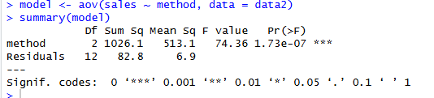
  - I ran a one-way ANOVA to compare the average weekly sales across the three different marketing strategies (A, B, and C). I used the aov() function in R to set up the model and then looked at the summary output to begin analyzing whether there were any differences between the groups.
  - The results of the one-way ANOVA showed a statistically significant difference in mean weekly sales between the three marketing strategies, F(2, 12) = 74.36, p = 1.73e-07.
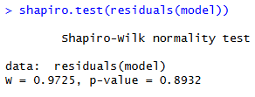
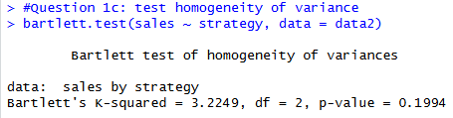
  - A Bartlett test was conducted to check the homogeneity of variance assumption. The results were not statistically significant, χ²(2) = 3.2249, p = 0.1994, indicating that the variances are equal across the three marketing strategies. Therefore, the homogeneity of variance assumption is satisfied.
  - A Shapiro-Wilk test was performed to assess the normality of the residuals. The results were not statistically significant, W = 0.9725, p = 0.8932, indicating that the residuals are approximately normally distributed. Therefore, the normality assumption is satisfied.
  - Since both the homogeneity of variance and normality assumptions were satisfied, no correction was necessary. Therefore, a standard one-way ANOVA was considered appropriate for this analysis.
  - Because the ANOVA assumptions were satisfied, no correction method was needed. As a result, the original one-way ANOVA remained the final model, and no re-run of the analysis was necessary.
  - Strategy B produced significantly higher sales than Strategy A (p = 0.0020), Strategy C produced significantly higher sales than Strategy A (p < 0.001), and Strategy C also produced significantly higher sales than Strategy B (p < 0.001). Overall, Strategy C had the highest sales, followed by Strategy B, and then Strategy A.
  - Since all assumptions were satisfied, no correction was needed, and the results remained unchanged from the original ANOVA.
  - Strategy C is the most effective marketing strategy, as it produced the highest average weekly sales and was significantly different from the other two strategies. Strategy B performed better than Strategy A but was still significantly lower than Strategy C. Therefore, the company should adopt Strategy C to maximize sales performance.
- Question 2
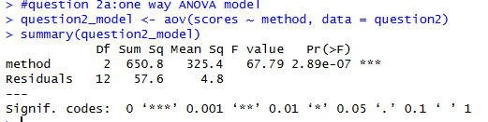
  - The model was created using the aov() function in R, with scores as the response variable and teaching method as the predictor.
  - The results of the one-way ANOVA showed a statistically significant difference in exam scores between the three teaching methods, F(2, 12) = 67.79, p = 2.89 × 10⁻⁷.
  - RH: teaching method influences students exam scores
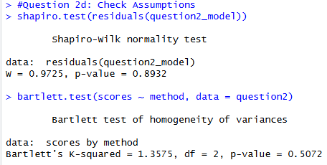
H₀: all means are equal
H₁: at least one is different
  - Normality (p = 0.8932)
Homogeneity (p = 0.5072)
  - The Shapiro-Wilk test indicated that the residuals are normally distributed (p = 0.8932), and the Bartlett test showed that the variances are equal across groups (p = 0.5072). Therefore, the use of a one-way ANOVA is appropriate for this analysis.
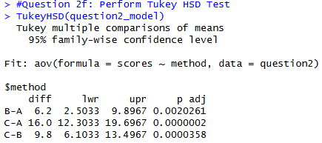
  - Method B had significantly higher scores than Method A (p = 0.0020), Method C had significantly higher scores than Method A (p < 0.001), and Method C also had significantly higher scores than Method B (p < 0.001). Overall, Method C produced the highest exam scores, followed by Method B, and then Method A.
  - All pairwise comparisons were statistically significant, meaning that each teaching method differs from the others in terms of average exam scores.
  - A one-way ANOVA was conducted to determine whether different teaching methods impacted student exam scores. The results showed a statistically significant difference between the three methods, F(2, 12) = 67.79, p = 2.89 × 10⁻⁷, indicating that at least one method leads to different performance outcomes. Assumption testing confirmed that both normality (p = 0.8932) and homogeneity of variance (p = 0.5072) were satisfied, supporting the validity of the ANOVA results. A Tukey HSD post-hoc test revealed that all teaching methods differed significantly from each other. Method C (active learning) produced the highest exam scores, followed by Method B (hybrid), and then Method A (traditional lecture). Based on these findings, it is recommended that the university adopt active learning strategies, as they appear to produce the strongest student performance.
- Question 3
  - 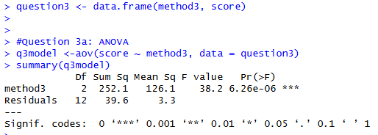
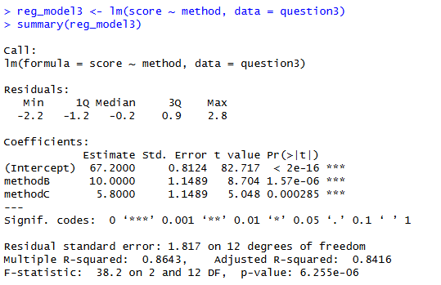
  - Tutoring increased scores by an average of 10 points (p < 0.001), while group study increased scores by an average of 5.8 points (p < 0.001). The overall model was statistically significant (F(2, 12) = 38.2, p = 6.26 × 10⁻⁶) with an adjusted R² of 0.8416, indicating that study method explains a large portion of the variation in exam scores
  - The ANOVA model and the regression model produce the same conclusions because they are mathematically equivalent when analyzing a categorical predictor. In this case, the study method is a categorical variable, and the regression model internally converts it into dummy variables. Both approaches are testing whether there are differences in the group means, which is why they result in the same F-statistic and p-value. Therefore, ANOVA can be viewed as a specific case of linear regression.
  - The ANOVA results showed a statistically significant effect of study method on exam scores, F(2, 12) = 38.2, p = 6.26 × 10⁻⁶.
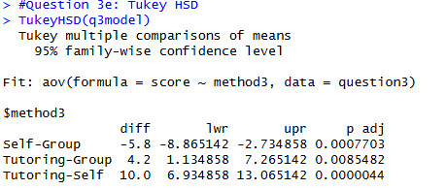
  - Group study resulted in significantly higher scores than self-study (p < 0.001), tutoring resulted in significantly higher scores than group study (p = 0.0085), and tutoring also resulted in significantly higher scores than self-study (p < 0.001). Overall, tutoring produced the highest exam scores, followed by group study, and then self-study.
  - The results showed a statistically significant difference between the three methods, F(2, 12) = 38.2, p = 6.26 × 10⁻⁶, indicating that study method has a significant impact on exam scores. A Tukey HSD post-hoc test revealed that all study methods differed significantly from each other. Specifically, tutoring produced the highest scores, followed by group study, and then self-study. These results suggest that students who receive tutoring tend to perform better than those who rely on group study or self-study alone. Based on these findings, it is recommended that students seek tutoring when possible to maximize their academic performance.
- Question 4
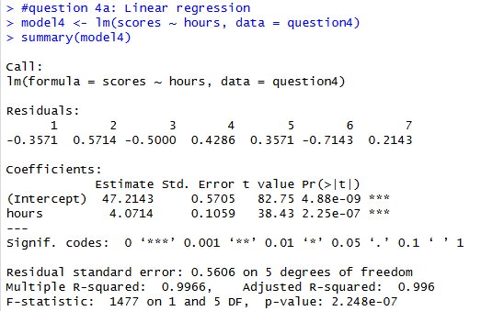
  - The model was created using the lm() function in R, with exam score as the response variable and hours studied as the predictor.
  - Score = 47.21 + 4.07(Hours)
The slope coefficient for hours studied is 4.07 (p < 0.001), indicating that each additional hour of studying is associated with an increase of about 4.07 points in exam score. The intercept is 47.21 (p < 0.001), representing the predicted score when no hours are studied. The model has a very high R² value of 0.9966 (adjusted R² = 0.996), meaning that approximately 99.66% of the variation in exam scores is explained by hours studied.
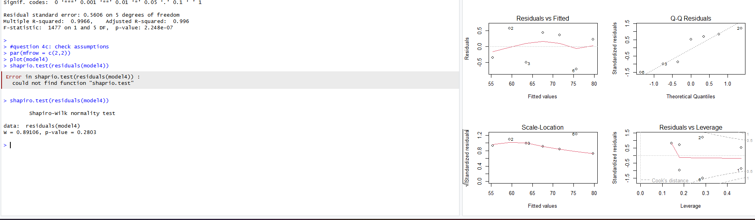
  - Several diagnostic checks were performed to evaluate the assumptions of the linear regression model. The residuals vs fitted plot showed no clear pattern, indicating that the linearity assumption is satisfied. The Q-Q plot and Shapiro-Wilk test (p > 0.05) suggest that the residuals are approximately normally distributed. The spread of residuals appeared consistent across fitted values, indicating that the homoscedasticity assumption is satisfied. Additionally, there were no obvious outliers or influential points based on the diagnostic plots. Overall, all regression assumptions appear to be met.
  - The regression model shows a strong positive relationship between hours studied and exam scores. Specifically, for each additional hour a student studies, their exam score is expected to increase by approximately 4.07 points. The intercept of 47.21 represents the predicted score for a student who does not study at all, although this may not be practically meaningful in context. Overall, the model suggests that increased study time leads to higher exam performance, and the very high R² value indicates that hours studied is an excellent predictor of exam scores.
- Question 5
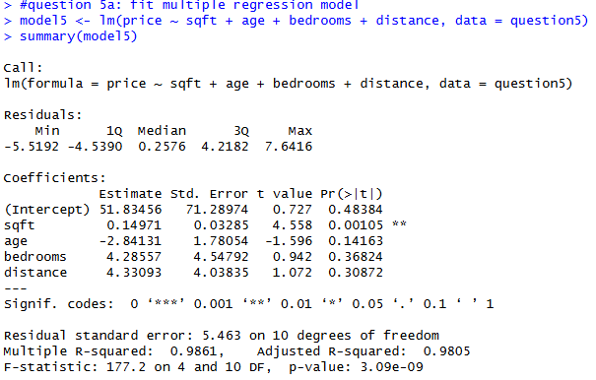
  - A multiple linear regression model was fitted to predict house prices using square footage, age, number of bedrooms, and distance to the city center as predictor variables. The model was created using the lm() function in R, with price as the response variable and the other variables as predictors.
  - The overall model was statistically significant (F(4, 10) = 177.2, p = 3.09 × 10⁻⁹), suggesting that the predictors, as a group, explain a significant portion of the variation in house prices.
  - The adjusted R² value for the model is 0.9805, indicating that approximately 98.05% of the variation in house prices is explained by the predictor variables included in the model. This suggests that the model provides an excellent fit to the data, even after accounting for the number of predictors used.]
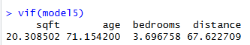
  - The results showed that square footage (VIF = 20.31), age (VIF = 71.15), and distance (VIF = 67.62) have extremely high VIF values, indicating severe multicollinearity. Bedrooms had a lower VIF (3.70), suggesting it is not strongly affected.
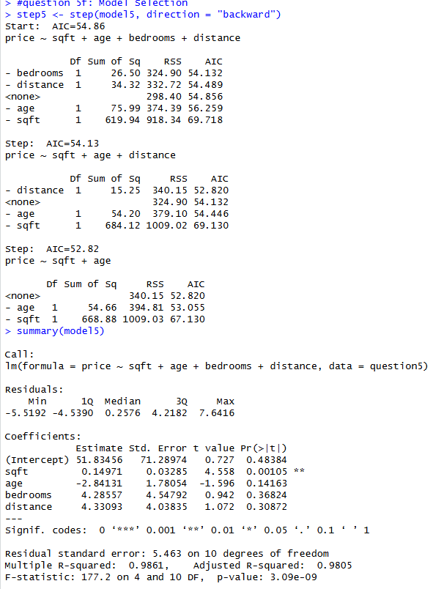
  - 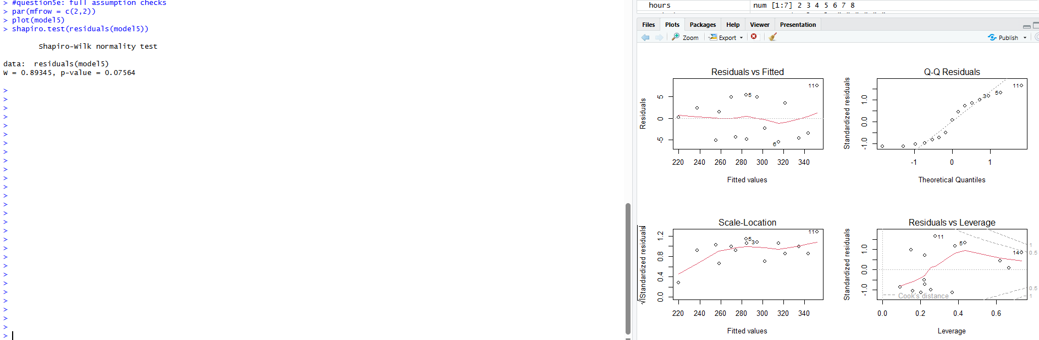
  - Model selection was performed using backward elimination based on AIC to identify the most appropriate predictors. The results suggested that square footage alone provides the best predictive model, while age, number of bedrooms, and distance to the city center were removed due to their lack of significance and high multicollinearity. The final model was simplified to include only square footage as the predictor, resulting in a more stable and interpretable model.
  - Price = −16.03 + 0.194(SqFt)
The coefficient for square footage (0.194) indicates that for each additional square foot, the price of the home is expected to increase by approximately 0.194 thousand dollars (or about $194). This predictor is highly statistically significant (p < 0.001), showing that square footage is a strong determinant of house price. The intercept (−16.03) represents the predicted price when square footage is zero, although this is not practically meaningful in this context. Overall, the model explains a very large portion of the variation in house prices (R² = 0.9816), indicating an excellent fit.
  - Based on the results of the analysis, square footage is the most important factor in predicting house prices. While the initial model included age, number of bedrooms, and distance to the city center, these variables were not statistically significant and showed high multicollinearity, which reduced the reliability of the model. After applying model selection, the final model using only square footage provided a simpler and more stable prediction with excellent explanatory power. This suggests that larger homes tend to have higher prices, and square footage alone is sufficient for making accurate predictions. Therefore, the real estate firm should prioritize square footage when estimating home values, as it is the strongest and most reliable predictor in this dataset.
- Question 6
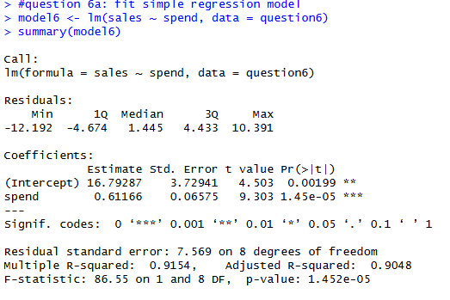
  - A simple linear regression model was fitted to examine the relationship between advertising spend and monthly sales. The model was created using the lm() function in R, with sales as the response variable and advertising spend as the predictor.
  - 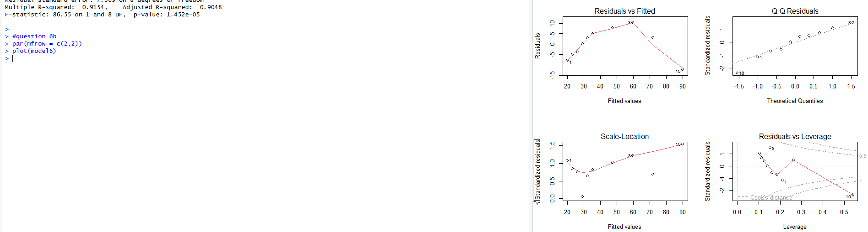
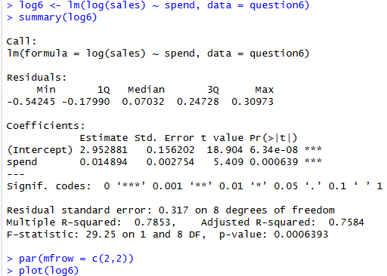
  - To address the issue of heteroscedasticity, a log transformation was applied to the sales variable. A new regression model was then fitted using log(sales) as the response variable. This transformation helps stabilize the variance and improve the reliability of the model.
  - After applying the log transformation to the sales variable, a new regression model was fitted using log(sales) as the response variable. The results showed that advertising spend remained a statistically significant predictor (β = 0.0149, p = 0.000639). The model also demonstrated a reasonable fit, with an adjusted R² of 0.7584. This indicates that the transformed model still explains a substantial portion of the variation in sales while better addressing the heteroscedasticity issue observed in the original model.
  - The transformed model remained statistically significant (p = 0.000639), indicating that advertising spend is still a strong predictor of sales. Overall, the log transformation improved the validity of the model by addressing the heteroscedasticity issue and producing more reliable results.
  - Based on the analysis, advertising spend has a significant positive relationship with monthly sales. However, the original model showed heteroscedasticity, which reduced the reliability of its predictions. After applying a log transformation to the sales variable, the model assumptions were better satisfied, resulting in a more stable and reliable model. Therefore, it is recommended that the company use the transformed model when analyzing the relationship between advertising spend and sales. Additionally, the results suggest that increasing advertising spend is likely to lead to higher sales, although the rate of increase may not be perfectly linear.
- Question 7
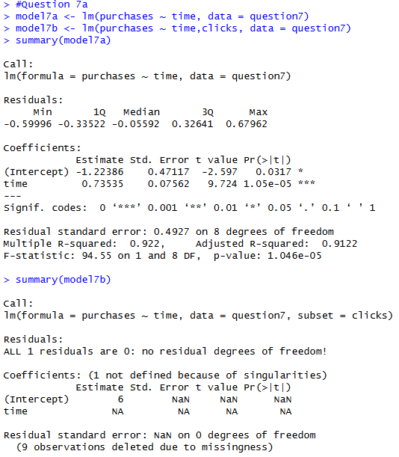
  - Two regression models were fitted to examine how customer engagement predicts purchasing behavior. The first model used time spent on the site as the only predictor of purchases. The second model included both time spent on the site and the number of clicks as predictors. This allows for comparison to determine whether adding clicks improves the model.
  - Time on site as the only predictor, showed that time is a statistically significant predictor of purchases (β = 0.735, p < 0.001), with an adjusted R² of 0.9122. This indicates that time alone explains a large portion of the variation in purchasing behavior.
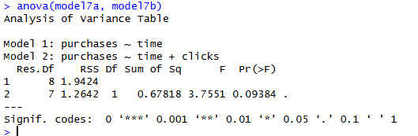
  - The two models were compared to determine whether adding the number of clicks improves the prediction of purchases beyond time on site alone. The first model, which included only time, already showed a very high adjusted R² (0.9122), indicating strong explanatory power.
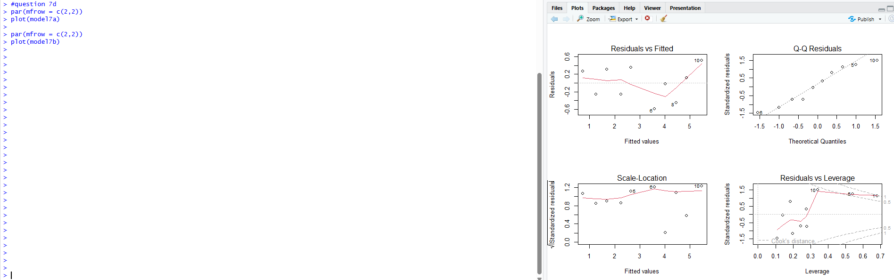
  - Diagnostic plots were used to evaluate the assumptions of both regression models. For the first model (time only), the residuals vs fitted plot showed no clear pattern, indicating that the linearity assumption is satisfied. The Q-Q plot suggested that the residuals are approximately normally distributed, and the spread of residuals appeared relatively constant, supporting the homoscedasticity assumption. For the second model (time and clicks), the diagnostic plots also showed no major violations of linearity, normality, or homoscedasticity. However, due to the strong relationship between time and clicks, there is evidence of multicollinearity, which may affect the stability of the coefficient estimates.
  - The model using time on site as the only predictor was selected as the final model. Although the second model included both time and clicks, the addition of clicks did not provide a meaningful improvement in predictive power due to the high correlation between the two variables. This multicollinearity can make the model less stable and harder to interpret. The simpler model using time alone has a high adjusted R² and satisfies all regression assumptions, making it both effective and reliable. Therefore, the model using time on site as the sole predictor is preferred for predicting purchasing behavior.
  - A regression analysis was conducted to examine how customer engagement predicts purchasing behavior. The results showed that time spent on the website is a strong and statistically significant predictor of purchases, with higher time on site associated with an increase in the number of items purchased. While a second model including both time and clicks was considered, the addition of clicks did not meaningfully improve the model due to the high correlation between the two variables, which introduced multicollinearity. As a result, the simpler model using time alone was selected as the best predictive model. This suggests that the amount of time a customer spends on the site is a key driver of purchasing behavior. Based on these findings, the company should focus on strategies that increase user engagement time to improve sales outcomes.

