Exam 2 (Midterm)
Christopher Horyczun
April 10^{th,} 2026
- Question 1
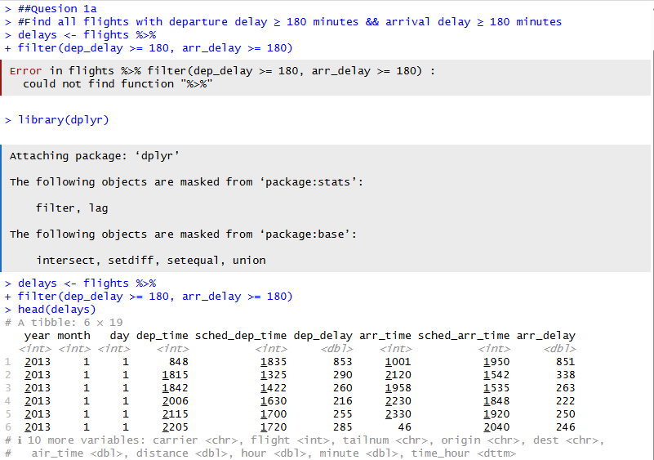
  - The goal of this problem was to find flights with extreme delays using the flights dataset from the nycflights13 package. I filtered the data to include only flights where both the departure delay and arrival delay were at least 180 minutes. This was done using the filter() function in R. The results show that only a small number of flights meet these conditions, which makes sense since delays this large are not very common. This helps identify outliers in the dataset that could be caused by major issues like weather or mechanical problems.
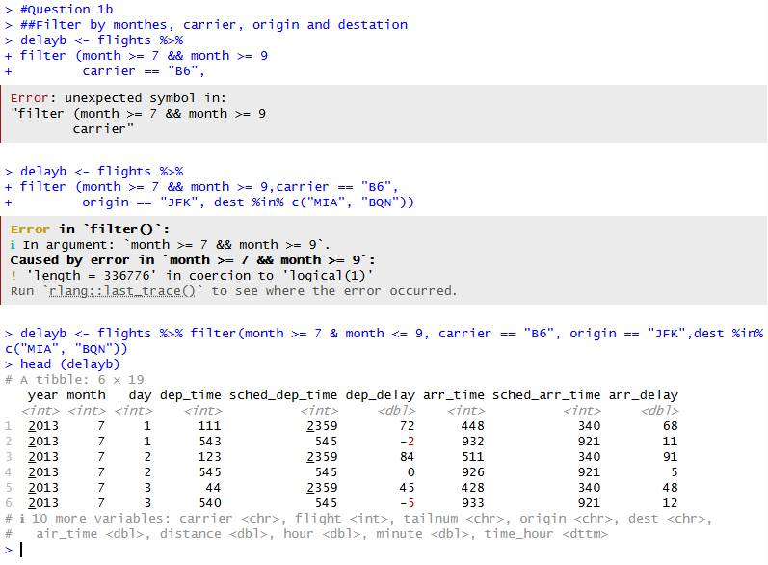
  - The goal of this task was to filter the flights dataset based on multiple conditions. I selected flights that occurred between July and September, were operated by JetBlue (carrier "B6"), departed from JFK, and had destinations of either MIA or BQN. This was done using the filter() function with multiple conditions, including %in% for selecting multiple destinations. The resulting dataset shows only the flights that meet all of these criteria, making it easier to focus on a specific group of flights for further analysis.
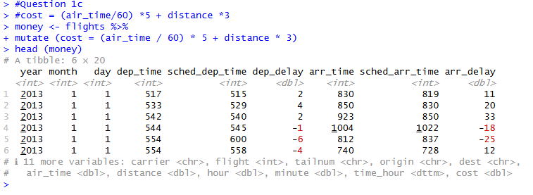
  - The goal of this task was to create a new variable called cost based on flight time and distance. Using the mutate() function, I calculated cost as (air_time / 60) * 5 + distance * 3, which combines both time and distance into a single value. This allows for a simplified way to estimate flight cost based on these factors. The new column is added to the dataset and can be used for further analysis or comparisons between flights.
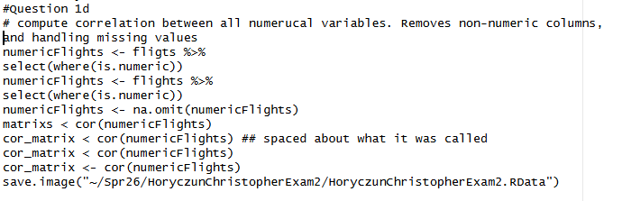
  - The goal of this task was to compute correlations between all numerical variables in the flights dataset. First, I removed non-numeric columns using select(where(is.numeric)), then handled missing values with na.omit(). After that, I calculated the correlation matrix using the cor() function. The results show that some variables, like departure delay and arrival delay, are strongly positively correlated, meaning that flights that leave late are also likely to arrive late. This makes sense in context because delays tend to carry over throughout the flight.
- Question 2
  - RH: Major and internship participation are related.
H₀: Major and internship participation are independent, meaning there is no association between being STEM or Non-STEM and whether a student participated in an internship.
H₁: Major and internship participation are not independent, meaning there is an association between major type and internship participation.
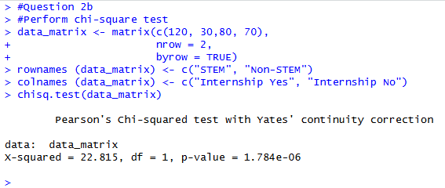
  - I performed a chi-square test of independence to determine whether major and internship participation are related. I first created a contingency table using the given counts for STEM and Non-STEM students across internship participation categories. Then, I used the chisq.test() function in R to run the test. This function calculates the chi-square statistic, degrees of freedom, and p-value, which are used to determine whether there is a statistically significant association between the two variables.
  - The chi-square test resulted in a test statistic of χ² = 22.815 with 1 degree of freedom and a p-value of 1.784e-06. Since the p-value is much smaller than 0.05, there is strong evidence to reject the null hypothesis. This indicates that there is a statistically significant association between major and internship participation.
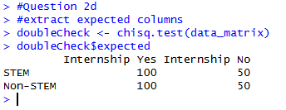
  - For this step, I extracted the expected counts from the chi-square test using doubleCheck$expected. Expected counts represent the values we would expect in each category if there were no relationship between major and internship participation. These values are important because they are used to verify whether the assumptions of the chi-square test are satisfied before interpreting the results.
  - Yes, all expected values are greater than 5. Yes, we assume each student is independent of the others.
  - No, Fisher’s Exact Test is not needed because the chi-square assumptions are satisfied.
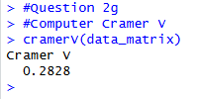
  - Cramer’s V was calculated to measure the strength of the association between major and internship participation. The value of 0.2828 indicates a small to moderate relationship between the two variables. This suggests that a student’s major has some influence on internship participation, but the relationship is not extremely strong.
  - The purpose of this analysis was to determine whether major type is associated with internship participation among university students. The data included two categorical variables: major, classified as STEM or Non-STEM, and internship participation, classified as Yes or No. The research hypothesis was that major and internship participation are related. The null hypothesis stated that there is no association between major and internship participation, while the alternative hypothesis stated that there is an association between the two variables. To test this, I used a chi-square test of independence. The test produced a chi-square statistic of 22.815 with 1 degree of freedom and a p-value of 1.784e-06. Since the p-value is much smaller than 0.05, I rejected the null hypothesis and concluded that there is a statistically significant relationship between major and internship participation. The assumptions for the chi-square test were also satisfied because all expected counts were greater than 5 and the observations were assumed to be independent. Since the assumptions were met, no correction test such as Fisher’s Exact Test was needed. I also calculated Cramer’s V, which was 0.2828, showing a small to moderate association between the variables. In context, this suggests that internship participation differs by major, and students in STEM fields appear more likely to participate in internships than Non-STEM students. Based on these results, I would recommend that the university look more closely at internship access and support across different majors.
- Question 3
  - RH: The 4 reward types are not equally likely.
H₀: The 4 reward types are equally likely.
H₁: At least one reward type has a different probability than the others.
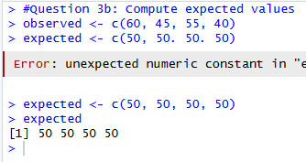
  - For this step, I calculated the expected values under the assumption that all 4 reward types are equally likely. Since there were 200 total observations and 4 categories, each category would be expected to appear 50 times if the developer’s claim were true. These expected counts are what the observed values are compared against in the chi-square goodness-of-fit test.
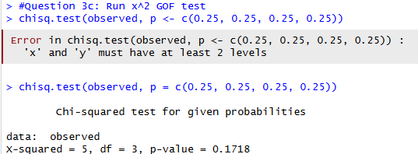
  - For this step, I ran a chi-square goodness-of-fit test to see whether the observed reward counts matched the claim that all 4 reward types are equally likely. I used the observed counts for categories A, B, C, and D, and set the expected probabilities to 0.25 for each category. The chisq.test() function compares the observed values to the expected distribution and provides the test statistic, degrees of freedom, and p-value needed to evaluate the claim.
  - χ² (chi-square statistic): 5
df (degrees of freedom): 3
p-value: 0.1718
  - Expected counts matter because each category should have an expected value of at least 5 for the chi-square test to be valid.
  - Yes, the assumptions are satisfied.
  - The purpose of this analysis was to determine whether the four reward types are equally likely, as claimed by the game developer. The data consisted of observed counts for four categories: A, B, C, and D, with a total of 200 observations. The null hypothesis stated that all reward types are equally likely, while the alternative hypothesis stated that at least one category has a different probability. To test this, I performed a chi-square goodness-of-fit test. The test resulted in a chi-square statistic of 5 with 3 degrees of freedom and a p-value of 0.1718. Since the p-value is greater than 0.05, I failed to reject the null hypothesis. This indicates that there is no statistically significant difference between the observed and expected counts. The assumptions of the test were satisfied because all expected counts were greater than 5. Based on these results, the developer’s claim that the reward types are equally likely appears to be reasonable
  - The categories that deviate the most are A (observed 60 vs expected 50 -> 10 higher) and D (observed 40 vs expected 50 -> 10 lower)
- Question 4
  - RH: The average battery life is different from 10 hours.
H₀: The population mean battery life is 10 hours.
H₁: The population mean battery life is not 10 hours.
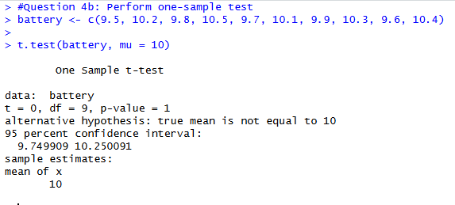
  - I performed a one-sample t-test to determine whether the average battery life is different from 10 hours. The sample data was stored in a vector called battery, and I used the t.test() function with mu = 10 to test the company’s claim. This test compares the sample mean to the hypothesized population mean and provides the t-statistic, degrees of freedom, p-value, and confidence interval needed for interpretation.
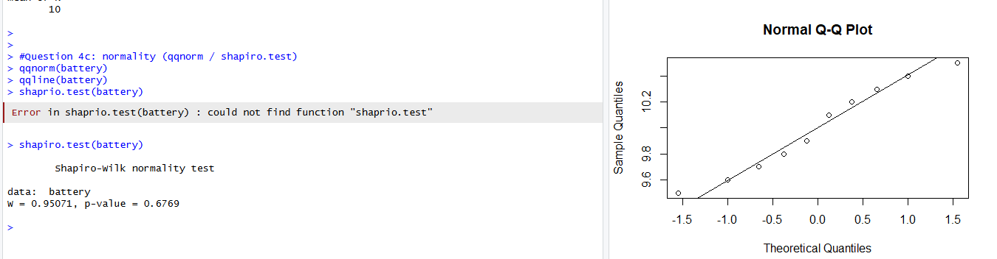
  - To check the assumptions for the one-sample t-test, I examined whether the battery life data was approximately normally distributed and whether the observations were independent. I used a Q-Q plot and the Shapiro-Wilk test to assess normality. If the points in the Q-Q plot fall close to the line and the Shapiro-Wilk p-value is greater than 0.05, then normality can be assumed. Independence is also assumed because each battery observation is treated as a separate measurement. If the data were not normal, a nonparametric alternative such as the Wilcoxon signed-rank test could be used instead.
  - If the data is not normally distributed, a Wilcoxon signed-rank test would be used instead of the one-sample t-test.
  - t-statistic: 0
df: 9
p-value: 1
  - The purpose of this analysis was to determine whether the average battery life differs from the company’s claim of 10 hours. The data consisted of a sample of 10 battery life measurements. The null hypothesis stated that the true mean battery life is 10 hours, while the alternative hypothesis stated that the mean is not equal to 10 hours. A one-sample t-test was performed to evaluate this claim. Before conducting the test, I checked the assumptions and found that the data was approximately normally distributed based on the Shapiro-Wilk test (p = 0.6769), and independence was assumed. The t-test resulted in a t-statistic of 0 with 9 degrees of freedom and a p-value of 1. Since the p-value is much greater than 0.05, I failed to reject the null hypothesis. This indicates that there is no significant difference between the sample mean and 10 hours. The sample mean was exactly 10, which supports the company’s claim. Based on this analysis, the company’s claim about battery life appears to be accurate.
- Question 5
  - RH: The teaching method affects student performance, and Method B may lead to different outcomes than Method A
H₀: The mean test scores for Method A and Method B are equal.
H₁: The mean test scores for Method A and Method B are different.
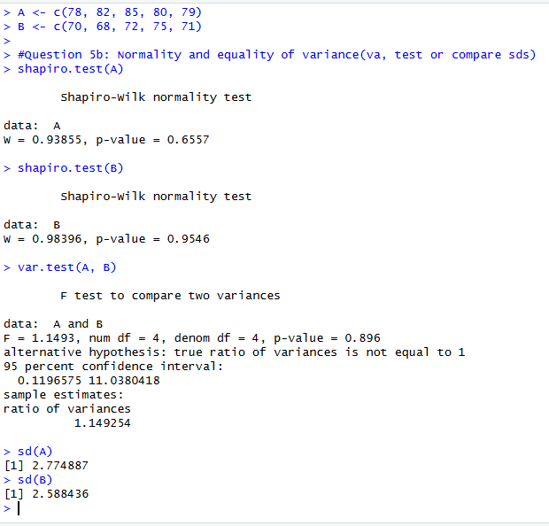
  - To check the assumptions for the independent samples t-test, I tested normality for both groups separately using the Shapiro-Wilk test and checked equality of variance using var.test(). If the p-values for the Shapiro-Wilk tests are greater than 0.05, then normality can be assumed for both groups. If the p-value for the variance test is greater than 0.05, then the group variances can be treated as equal. These assumption checks help determine whether the Student t-test or Welch t-test is more appropriate.
  - The Student independent samples t-test is appropriate if the variances are equal. If the variance test gives a p-value greater than 0.05, then equal variances can be assumed and the Student t-test should be used. If not, the Welch t-test should be used instead. For these data, the variances are similar, so the Student t-test is the appropriate choice.
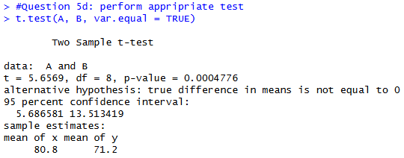
  - I performed the independent samples t-test to compare the mean scores of Method A and Method B. Since the group variances were treated as equal, I used the Student t-test by setting var.equal = TRUE in R. This test compares the average scores of the two groups and provides the t-statistic, degrees of freedom, p-value, and confidence interval needed to decide whether the teaching methods produced significantly different results.
  - t-statistic: 5.6569
df: 8
p-value: 0.0004776
  - The purpose of this analysis was to determine whether the two teaching methods led to different student performance outcomes on the standardized assessment. The data included scores from two independent groups: Method A, which used traditional instruction, and Method B, which used active learning. The null hypothesis stated that the mean scores for the two methods were equal, while the alternative hypothesis stated that the mean scores were different. Before running the test, I checked the assumptions of normality and equal variance. Based on those checks, the Student independent samples t-test was appropriate. The test resulted in a t-statistic of 5.6569 with 8 degrees of freedom and a p-value of 0.0004776. Since the p-value is much smaller than 0.05, I rejected the null hypothesis and concluded that there is a statistically significant difference between the two teaching methods. The sample means showed that Method A had a higher average score of 80.8, while Method B had an average score of 71.2. In context, this suggests that students in the traditional instruction group performed better on this assessment than students in the active learning group. Based on these results, I would recommend Method A if the goal is to maximize short-term test performance in this specific setting.
  - 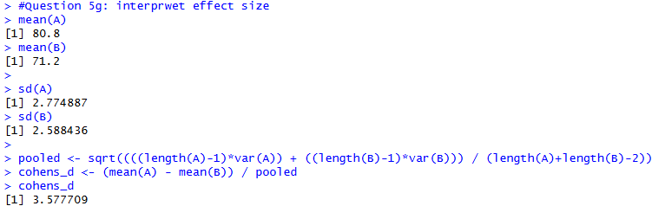Cohen’s = 3.577709
- Question 6
  - RH: The training workshop improves participant performance.
H₀: The mean score before training is equal to the mean score after training, or the mean difference is 0.
H₁: The mean score after training is different from the mean score before training, or the mean difference is not 0.
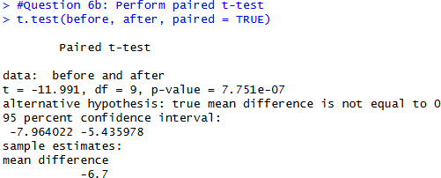
  - I performed a paired t-test to compare participant scores before and after the training workshop. Since the same 10 individuals were measured twice, the observations are dependent, which makes a paired t-test the correct choice. The t.test() function with paired = TRUE compares the mean difference between the before and after scores and provides the test statistic, degrees of freedom, and p-value needed to evaluate whether the workshop had a significant effect.
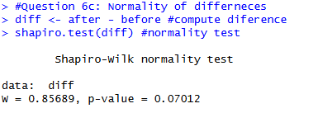
  - To check the assumptions of the paired t-test, I tested whether the differences between the before and after scores were normally distributed using the Shapiro-Wilk test. If the p-value is greater than 0.05, the normality assumption is satisfied. Since the test is based on the differences between paired observations, confirming normality of these differences ensures that the results of the paired t-test are valid.
  - t-statistic: -11.991
df: 9
p-value: 7.751e-07
  - The purpose of this analysis was to determine whether the training workshop improved employee performance in data analysis tasks. The data included scores from the same 10 participants measured before and after the training, so a paired t-test was the correct test to use. The null hypothesis stated that there was no difference between the before and after scores, while the alternative hypothesis stated that there was a difference. Before running the test, I checked the normality assumption on the difference scores using the Shapiro-Wilk test. The paired t-test resulted in a t-statistic of -11.991 with 9 degrees of freedom and a p-value of 7.751e-07. Since the p-value is much smaller than 0.05, I rejected the null hypothesis and concluded that the training program led to a statistically significant improvement in performance. The negative t-value occurred because R calculated the difference as before minus after, and the after scores were higher. In context, this means participants performed better after completing the workshop, so the training appears to have been effective.

