Christopher Horyczun
March 13th 2026
Cs 2020
Assignment 2

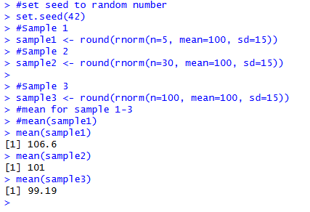
  - From these results, I noticed that the mean of the smallest sample (n = 5) is farther away from the population mean of 100. The samples with 30 and 100 values are much closer to 100. This shows that smaller samples can vary more, while larger samples tend to produce averages that are closer to the true population mean. This is why larger samples are usually more reliable when estimating population parameter
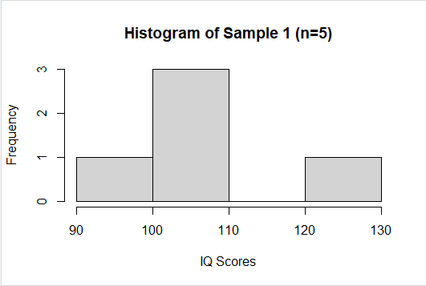
  - The Central Limit Theorem (CLT) says that as the sample size gets larger, the sampling distribution of the sample mean becomes closer to a normal distribution. It also means the sample mean will usually get closer to the true population mean. Because of this, larger samples are more reliable when estimating population parameters. Small samples can vary a lot just by chance, which can make the average farther from the real population mean. When the sample size increases, random variation has less of an effect, so the estimate becomes more accurate and stable. This is why researchers usually try to collect larger samples when possible.
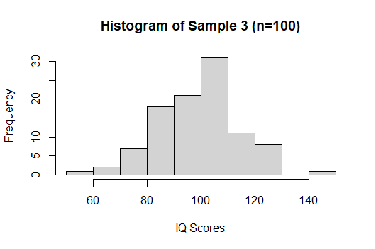
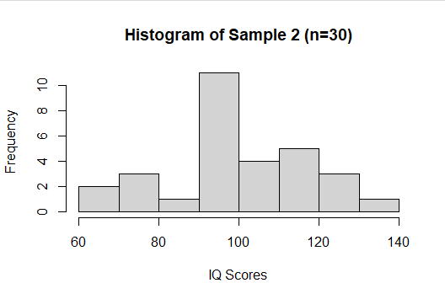
  - When looking at the histograms, the one for sample1 (n = 5) looks uneven because there are only a few data points. With such a small sample size, it’s hard to see any clear pattern in the distribution. The histogram for sample2 (n = 30) starts to look more balanced and spread out. With more observations, the distribution becomes easier to interpret. The histogram for sample3 (n = 100) looks much smoother and more like a bell-shaped curve. This is what we expect for data that comes from a normal distribution. As the sample size increases, the distribution becomes more stable and better represents the population. 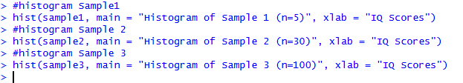

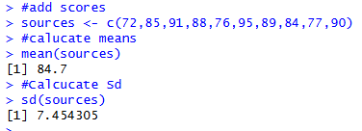
  - The sample standard deviation is about 7.45, which shows how much the scores typically vary from the average. A standard deviation of around 7 means most of the exam scores are within about 7 points of the mean.
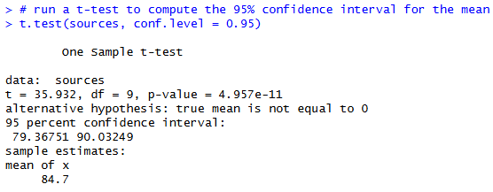
  - The 95% confidence interval is approximately (79.37, 90.03). This interval gives a range of values that likely contains the true population mean exam score. Based on this sample, the average exam score for the population is estimated to be somewhere between about 79.37 and 90.03.
  - In simple terms, this means I am 95% confident that the true average exam score for the whole population is between 79.37 and 90.03. In other words, based on this sample, the real average score is likely somewhere in that range. It does not mean that 95% of individual students scored in that interval. It only refers to where the population mean is likely to be.
- A
  - Null hypothesis (H₀): p=0.75
Alternative hypothesis (Hₐ): p>0.75
The null hypothesis says that the new teaching method does not improve the pass rate, so the true pass rate is still 75%. The alternative hypothesis says that the new method does improve the pass rate, meaning the true pass rate is greater than 75%.
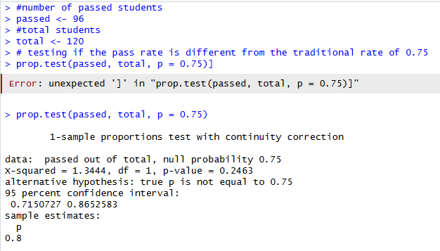
  - This code runs a one-sample proportion test comparing the observed pass rate (96 out of 120) to the traditional pass rate of 0.75. The test will calculate the p-value, which we use in the next part to determine whether the new teaching method significantly improves the pass rate.
  - Since the p-value (0.21) is greater than the significance level (0.05), we fail to reject the null hypothesis. This means there is not enough statistical evidence to say that the new teaching method improves the pass rate. Even though 80% of the students passed with the new method, that difference is not large enough to be considered statistically significant at the 5% level.
- A
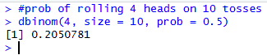
  - This uses the binomial distribution because each coin toss has two possible outcomes, heads or tails, and the probability of heads stays the same each time.
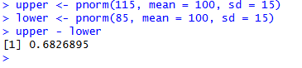
  - This uses the normal distribution because IQ scores are given as normally distributed with a mean of 100 and standard deviation of 15.
  - The histogram of the t-distribution looks similar to a normal distribution because it is also symmetric and centered around zero. However, the t-distribution has heavier tails, which means extreme values occur a little more often compared to a normal distribution. This happens because the t-distribution accounts for additional uncertainty when working with smaller sample sizes. As the degrees of freedom increase, the t-distribution starts to look more and more like a normal distribution. 