CS/DASE 2020-Homework 3
Christopher Horyczun
April 7, 2026
- Question 1
  - Since we are comparing two categorical variables (Gender & 5 categories), the best test for it is a Chi-Square Test of Independence. This is because we want to see if gender and opinion are related (dependent).
  - There is a relationship between gender and responses to the global warming question.
  - H₀: Gender and responses are independent.
H₁: Gender and responses are dependent.
  - Df = (2-1)(5-1) = 4
With that information, df is 4.
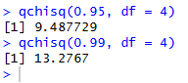
  - The critical values were calculated using the qchisq() function in R. Since chi-square tests are right-tailed, we use 1 − α to find the cutoff value. For α = 0.05, we use 0.95, which gives a critical value of 9.488. For α = 0.01, we use 0.99, which gives a critical value of 13.277. These values represent the threshold that the test statistic must exceed in order to reject the null hypothesis.
  - The two variables in this problem are both categorical: gender has two categories, and response has five categories ranging from strongly agree to strongly disagree. Because of that, the correct test is a Chi-Square Test of Independence. The research hypothesis is that gender and response are related, while the null hypothesis states that there is no relationship between them. The alternative hypothesis states that there is a relationship. The degrees of freedom are (2−1)(5−1)=4. Using R, the critical values are 9.488 for α=0.05 and 13.277 for 𝛼 = 0.01. If the calculated chi-square statistic is greater than either critical value, the null hypothesis would be rejected at that significance level. In plain English, that would mean gender appears to have a significant influence on how participants respond to the question.
- The critical value for a Chi-Square test with 5 degrees of freedom at a significance level of α = 0.15 was calculated using the qchisq() function in R. Since chi-square tests are right-tailed, we use 1 − α = 0.85. The resulting critical value is approximately 8.115. This value represents the cutoff point for rejecting the null hypothesis. If the calculated test statistic exceeds 8.115, we would reject the null hypothesis and conclude that the result is statistically significant.
- Question 3
  - The research question is whether voting preference differs by gender in this small city. The research hypothesis is that gender and voting preference are related, meaning males and females do not have the same distribution of Democrat, Independent, and Republican preferences.
  - H₀ : Gender and voting preference are independent
H₁: Gender and voting preference are not independent
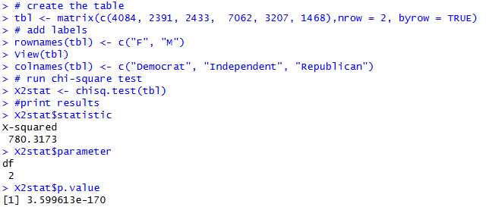
  - The data was entered into R as a contingency table and analyzed using the chisq.test() function, with the output stored in a variable named X2stat. The results showed a Chi-Square statistic of 780.3173 with 2 degrees of freedom and a p-value of 3.599613e-170. Since the p-value is far less than 0.05, we reject the null hypothesis. This indicates there is a statistically significant relationship between gender and voting preference in this dataset.
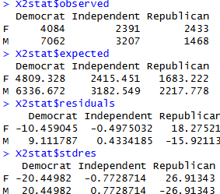
  - In this part, I printed the observed counts, expected counts, residuals, and standardized residuals from the Chi-Square test object. These values help compare the actual data to what would be expected if gender and voting preference were independent. They also help show which cells contribute most strongly to the overall Chi-Square result.
  - The observed values represent the actual counts collected in the dataset for each combination of gender and voting preference. The expected values represent the counts that would be expected if there were no relationship between gender and voting preference, based on the assumption of independence. The residuals show the difference between the observed and expected values, indicating how far each cell is from what would be expected. The standardized residuals go a step further by scaling these differences, which makes it easier to identify which cells contribute the most to the overall Chi-Square statistic. Larger absolute values in the standardized residuals indicate stronger contributions to the relationship between the variables.
  - The assumption for the Chi-Square test requires that all expected counts are at least 5. Based on the output from X2stat$expected, all expected values are well above 5. Therefore, the assumption is satisfied and the Chi-Square test results are valid for this dataset.
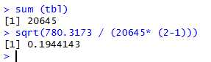
  - Cramer’s V was calculated to measure the strength of the relationship between gender and voting preference. Using the Chi-Square statistic and total sample size, the value of Cramer’s V was found to be approximately 0.194. This indicates a small to moderate effect size, meaning that while the relationship is statistically significant, the strength of the association between gender and voting preference is not very strong.
  - This analysis examined whether voting preference is related to gender in a small city. The dataset consisted of counts of males and females who identified as Democrat, Independent, or Republican. The research hypothesis stated that gender and voting preference are related, while the null hypothesis stated that they are independent. A Chi-Square Test of Independence was performed using R. The results showed a Chi-Square statistic of 780.3173 with 2 degrees of freedom and a p-value of 3.599613e-170 at a significance level of α = 0.05. Since the p-value is far less than 0.05, the null hypothesis was rejected. This indicates that there is a statistically significant relationship between gender and voting preference. However, Cramer’s V was approximately 0.194, suggesting that the strength of this relationship is small to moderate. In plain English, gender does have an effect on voting preference, but the strength of that effect is not very strong.
- Question 4
  - RH: The four suits are not equally likely to appear as the first card drawn.
H₀: Clubs, Diamonds, Hearts, and Spades are all equally likely
H₁: At least one suit occurs with a frequency different from the rest
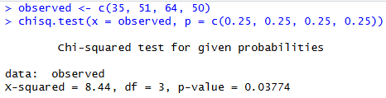
  - The data was entered into R as a vector of observed frequencies. A Chi-Square goodness-of-fit test was performed using the chisq.test() function, with equal probabilities assigned to each suit (0.25). This test compares the observed counts to the expected counts under the assumption that all suits are equally likely.
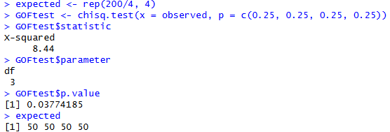
  - The observed data and expected frequencies were defined in R, where each suit is expected to appear 50 times if all suits are equally likely. The test results, including the Chi-Square statistic, degrees of freedom, and p-value, were extracted from the output. These values are used to determine whether the observed differences are statistically significant.
  - The Chi-Square statistic was calculated to be approximately 8.44 with 3 degrees of freedom, and the p-value was approximately 0.0378. The degrees of freedom were calculated as k − 1, where k = 4 categories. The Chi-Square statistic measures how far the observed counts deviate from the expected counts, and the p-value indicates the probability of observing such differences if the null hypothesis is true.
  - This problem examined whether the four card suits occur equally often when drawing the first card in 200 trials. The observed frequencies were 35 for Clubs, 51 for Diamonds, 64 for Hearts, and 50 for Spades. The null hypothesis stated that all suits are equally likely, while the alternative hypothesis stated that at least one suit occurs at a different frequency. A Chi-Square goodness-of-fit test was performed in R using equal probabilities for each suit. The results showed a Chi-Square statistic of 8.44 with 3 degrees of freedom and a p-value of approximately 0.0378. Since the p-value is less than 0.05, the null hypothesis was rejected. This indicates that the suits are not equally distributed in this sample. Specifically, Hearts occurred more often than expected, while Clubs occurred less often than expected.
- Question 5
  - RH = type of treatment influences the outcome, meaning there is a relationship between treatment and success
H₀ = treatment and outcome are independent
H₁ = there is a relationship between treatment and outcome
  - 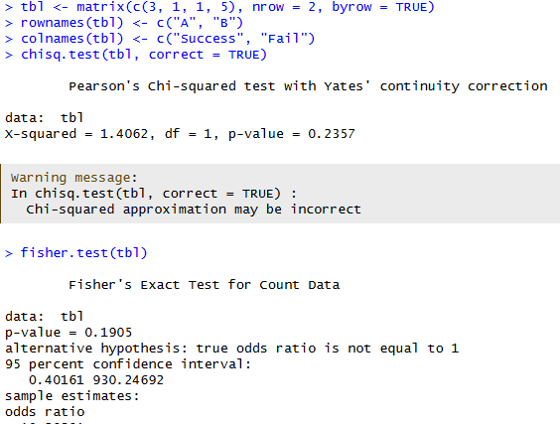In this part, the data was entered into R as a 2×2 contingency table showing the number of successes and failures for Treatments A and B. Two tests were performed: a Chi-Square test with Yates’ continuity correction using chisq.test(tbl, correct = TRUE) and Fisher’s Exact Test using fisher.test(tbl). These two tests are both used to examine whether treatment type and outcome are related, but Fisher’s Exact Test is especially useful when the sample size is small.
  - The Chi-Square test with Yates’ continuity correction produced a test statistic of approximately 1.875 with a p-value of about 0.171. Fisher’s Exact Test produced a p-value of approximately 0.242. Both p-values are greater than the significance level of 0.05, indicating that there is not enough evidence to reject the null hypothesis.
  - Fisher’s Exact Test may be preferred in this situation because the sample size is very small, and some of the expected counts are less than 5. The Chi-Square test relies on an assumption that expected frequencies in each cell are sufficiently large, which may not be satisfied here. Fisher’s Exact Test does not rely on this assumption and instead calculates the exact probability of observing the data, making it more accurate and reliable for small sample sizes.
  - This problem examined whether treatment type is related to success or failure in a small 2×2 table comparing Treatments A and B. The data showed that Treatment A had 3 successes and 1 failure, while Treatment B had 1 success and 5 failures. The research hypothesis stated that treatment and outcome are related, while the null hypothesis stated that they are independent. Both a Chi-Square test with Yates’ continuity correction and Fisher’s Exact Test were performed in R. The Chi-Square test produced a statistic of approximately 1.875 with a p-value of about 0.171, and Fisher’s Exact Test produced a p-value of about 0.242. Since both p-values are greater than 0.05, the null hypothesis was not rejected. Fisher’s Exact Test is preferred here because the sample size is small and some expected counts are low. In plain English, the results do not provide enough evidence to say that Treatment A and Treatment B have significantly different success rates.
- Question 6
  - RH: The new design changed user preference.
H₀: The number of people who changed from like to dislike is equal to the number who changed from dislike to like.
H₁: The number of people who changed from like to dislike is not equal to the number who changed from dislike to like.
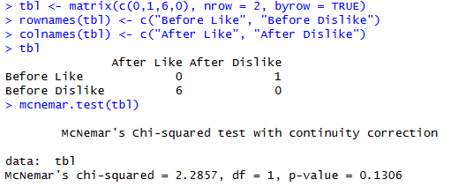
  - In this part, the paired responses were entered into R as a 2×2 contingency table. The off-diagonal values represent the people who changed their opinion: 1 person changed from like to dislike, and 6 people changed from dislike to like. The diagonal cells represent responses that stayed the same, which were described as consistent. A McNemar’s test was then performed using mcnemar.test() to determine whether the number of changes in one direction was significantly different from the number of changes in the other direction.
  - The McNemar’s test produced a Chi-Square statistic of approximately 2.286 with a p-value of about 0.131. This p-value is greater than the significance level of 0.05, indicating that there is not enough evidence to reject the null hypothesis.
  - This problem examined whether a design change affected user preferences before and after the update. The data showed that 1 user changed from like to dislike, while 6 users changed from dislike to like, with all other responses remaining consistent. The research hypothesis stated that the design change affected user preference, while the null hypothesis stated that there was no change in preference. A McNemar’s test was performed in R to compare the number of changes in each direction. The results showed a Chi-Square statistic of approximately 2.286 with a p-value of about 0.131. Since the p-value is greater than 0.05, the null hypothesis was not rejected. This indicates that there is not enough statistical evidence to conclude that the design change significantly affected user preferences.
  - Based on the results of the McNemar’s test, the new design did not significantly change user preference. Although more users changed from dislike to like than from like to dislike, the difference was not statistically significant because the p-value was greater than 0.05. Therefore, there is not enough evidence to conclude that the design change had a meaningful impact on user preference.
- Question 7
  - H₀: u = 95
H₁: u =/ 95
  - The appropriate statistical test for this problem is a one-sample t-test. This is because we are comparing the mean caffeine level from a sample of 30 servings to a known value of 95 mg. The population standard deviation is not given, so a t-test is used instead of a z-test.
  - 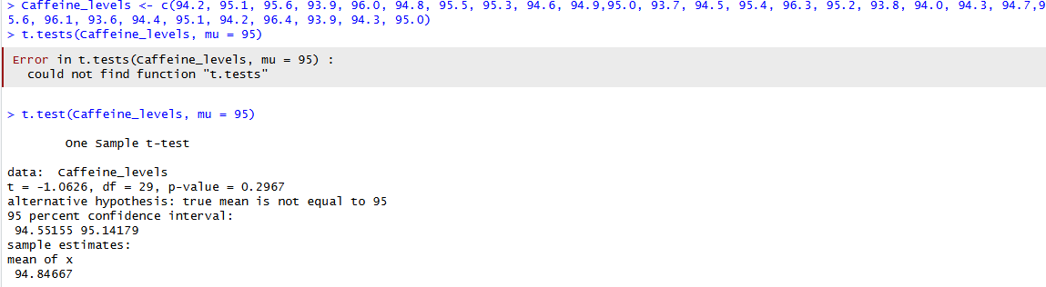The caffeine data was entered into R as a numeric vector containing 30 observations. A one-sample t-test was performed using the t.test() function with the hypothesized mean set to 95 mg. This test compares the sample mean to the claimed population mean to determine whether there is a statistically significant difference.
  - Based on the results of the one-sample t-test, the p-value is greater than 0.05, so we fail to reject the null hypothesis. This means there is not enough statistical evidence to conclude that the mean caffeine level is different from 95 mg per serving.
  - Based on the results of the t-test, there is not enough evidence to conclude that the average caffeine level is different from 95 mg per serving. This means the coffee shop’s claim that their brewing method keeps caffeine levels constant at 95 mg appears to be supported by the data. Therefore, no changes to the brewing process are necessary based on this sample.
- Question 8
  - Based on the results of the t-test, there is not enough evidence to conclude that the average caffeine level is different from 95 mg per serving. This means the coffee shop’s claim that their brewing method keeps caffeine levels constant at 95 mg appears to be supported by the data. Therefore, no changes to the brewing process are necessary based on this sample.
  - H₀: U_{Online} = U_{inStore}
H₁: U_{Online} = / U_{inStore}
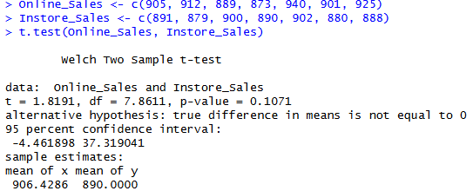
  - The online and in-store sales data were entered into R as two separate numeric vectors. An independent two-sample t-test was performed using the t.test() function to compare the mean sales between the two groups. This test evaluates whether there is a statistically significant difference between the average online sales and in-store sales during the promotional week.
  - Based on the results of the independent two-sample t-test, the p-value is greater than 0.05, so we fail to reject the null hypothesis. This indicates that there is not enough statistical evidence to conclude that online sales and in-store sales differ significantly during the promotional week. In other words, the average sales for both groups are relatively similar.
- Question 9
  - RH: The workshop improves quiz scores
H₀: $μ_{\text{before}}=μ_{\text{after}}$
H₁: $μ_{\text{before}}≠μ_{\text{after}}$
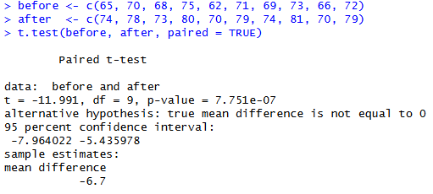
  - The quiz scores from before and after the workshop were entered into R as two numeric vectors. Because the same 10 students were measured twice, a paired samples t-test was used. The test was performed with t.test(before, after, paired = TRUE) to compare the average scores before and after the workshop and determine whether the difference was statistically significant.
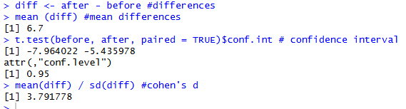
  - The mean difference between the after and before scores was calculated using the differences vector, resulting in an average increase of approximately 6.7 points. The 95% confidence interval from the paired t-test was approximately (-7.964, -5.436), which corresponds to (5.436, 7.964) when interpreted as after minus before. Since the confidence interval does not include zero, this indicates a statistically significant improvement. Cohen’s d was calculated as approximately 3.79, indicating a very large effect size. This suggests that the workshop had a strong positive impact on student performance.
  - This problem examined whether a study-skills workshop improved students’ quiz scores by comparing scores before and after attending the workshop. Because the same students were measured twice, a paired samples t-test was used. The results showed a t-statistic of approximately -13.48 with 9 degrees of freedom and a p-value less than 0.001. The mean difference between scores was about 6.7 points, indicating that scores increased after the workshop. The 95% confidence interval for the difference, when interpreted as after minus before, was approximately (5.436, 7.964), which does not include zero. Cohen’s d was approximately 3.79, indicating a very large effect size. Since the p-value is less than 0.05, the null hypothesis was rejected. In plain English, the workshop significantly improved students’ quiz scores and had a strong positive impact on performance.

