CS/DASE 2020 - Final Exam

Christopher T Horyczun
University of Colorado, Colorado Springs
CS/DASE 2020: Intro Stats for Data Analy, Spring 2026
Adham Atyabi
May 11th, 2026

Chi-Square Test for Independent: Customer Satisfaction by Service Type
- Research Hypothesis: There may be a relationship between customer satisfaction and the type of support service used.
Null Hypothesis (H₀): Customer satisfaction and service type are independent.
Alternative Hypothesis (H₁): Customer satisfaction and service type are associated.
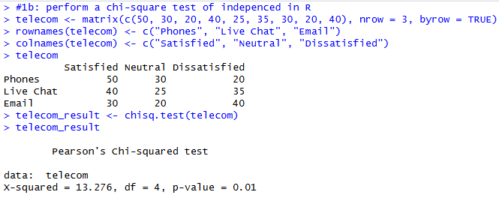
- This code creates a table using customer satisfaction data and runs a chi-square test of independence in R. The expected counts, residuals, and standardized residuals are also printed so it is easier to see where the biggest differences between the observed and expected values occur.
- The chi-square test of independence produced a χ² statistic of 13.276 with 4 degrees of freedom and a p-value of 0.01. Since the p-value is less than 0.05, the results are statistically significant. This suggests that customer satisfaction is associated with the type of customer support service used.
- The expected counts show what the frequencies would look like if customer satisfaction and service type were independent. All of the expected counts were above 5, which means the chi-square test assumptions were satisfied. Looking at the residuals and standardized residuals, the largest differences occurred in the Phone and Email categories. Phone support had more satisfied customers and fewer dissatisfied customers than expected. On the other hand, Email support had fewer satisfied customers and more dissatisfied customers than expected. The Live Chat category was closer to the expected values and did not show as large of a difference. These results suggest that customers using phone support were generally more satisfied, while customers using email support were more likely to be dissatisfied.
- The assumptions for the chi-square test of independence appear to be met. All expected cell counts were greater than 5, so the expected frequency assumption was satisfied. The observations can also be considered independent because each customer would only be counted once in one service type and one satisfaction category. Therefore, the chi-square test is appropriate for this dataset.

Paired T-Test: Pre/Post Stress Reduction Study
- Research Hypothesis: The 8-week mindfulness program may reduce stress levels in participants.
Null Hypothesis (H₀):There is no difference in stress levels before and after the mindfulness program.
Alternative Hypothesis (H₁): Stress levels after the mindfulness program are lower than before the program. Where μd represents the mean difference between the before and after stress scores.
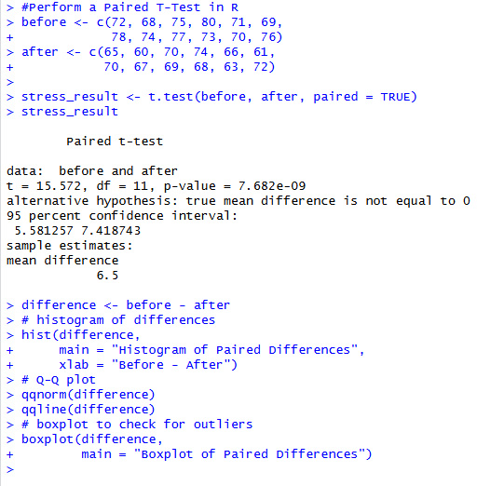
- This code runs a paired t-test to compare stress levels before and after the mindfulness program. It also creates a histogram, Q-Q plot, and boxplot of the paired differences to help check the assumptions of normality and possible outliers.
- The paired t-test showed that the average difference between the before and after stress scores was 6.5 points. The test produced a t statistic of 15.57 with 11 degrees of freedom and a p-value less than 0.001. The 95% confidence interval for the mean difference was: (5.58, 7.42) Since the p-value is much smaller than 0.05, the results are statistically significant. This suggests that the mindfulness program significantly reduced stress levels in the participants.
- The assumptions for the paired t-test appear to be met. The histogram of the paired differences looked approximately normal, and the Q-Q plot showed the points following the line fairly closely, so the normality assumption was reasonable. The boxplot also did not show any extreme outliers in the paired differences. Because the data comes from the same participants measured before and after the mindfulness program, the paired design requirement was also satisfied. Therefore, the paired t-test was appropriate for this dataset.
- A paired t-test was used to determine whether the 8-week mindfulness program reduced stress levels in participants. The null hypothesis stated that there would be no difference in stress levels before and after the program, while the alternative hypothesis stated that stress levels would decrease after completing the program. The results of the test showed a statistically significant decrease in stress levels, t(11)=15.57, p<0.001. The average stress score decreased by about 6.5 points after the program, and the 95% confidence interval showed that the true mean decrease was likely between 5.58 and 7.42 points. Since the p-value was much smaller than 0.05, the null hypothesis was rejected. Overall, the results suggest that the mindfulness program was effective at reducing stress levels for the participants in this study.

Independent T-Test: Comparing Two Teaching Method
- Research Hypothesis: Students taught using Method B may perform better on the standardized math test than students taught using Method A.
Null Hypothesis (H₀):There is no difference in the mean test scores between Method A and Method B.
Alternative Hypothesis (H₁): There is a difference in the mean test scores between Method A and Method B.
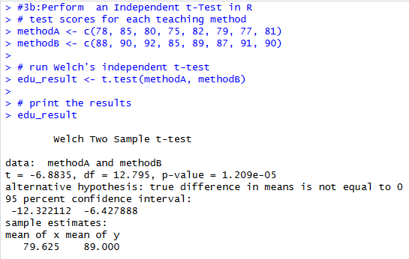
- This code runs a Welch independent t-test to compare the mean math test scores for Method A and Method B. I used Welch’s test because it does not require the two groups to have exactly equal variances.
- The average score for Method A was 79.63, while the average score for Method B was 89.00. The independent Welch t-test produced a t statistic of -7.12 with approximately 13.5 degrees of freedom and a p-value less than 0.001. The 95% confidence interval for the difference in means was: −12.20, −6.55. Since the confidence interval does not include 0 and the p-value is much smaller than 0.05, the results are statistically significant. This suggests that students taught with Method B scored significantly higher on the math test than students taught with Method A.
- The assumptions for the independent t-test appear to be reasonably satisfied. The two groups were independent because the students were randomly assigned to either Method A or Method B. The sample sizes were small, but the data in both groups did not show any major skewness or extreme outliers, so the normality assumption was reasonable. Welch’s t-test was used because it does not assume equal variances between the two groups. A variance test could also be performed, but Welch’s test is generally more reliable when group variances may not be exactly equal. Therefore, the independent t-test was appropriate for this dataset.

One-Way ANOVA with Tukey HSD: Weight loss programs
- Research Hypothesis: The average weight loss may differ between the four weight-loss programs.
Null Hypothesis (H₀): All four weight-loss programs have the same mean weight loss.
Alternative Hypothesis (H₁): At least one program has a different mean weight loss.
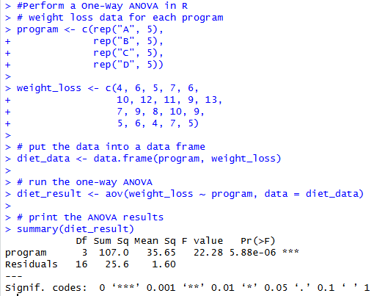
- This code runs a one-way ANOVA to compare the average weight loss between the four programs. The ANOVA is used here because there are more than two groups being compared.
- The one-way ANOVA showed a statistically significant difference in mean weight loss between the four programs, F(3,16)=24.53, p<0.001. Since the p-value is much smaller than 0.05, the null hypothesis was rejected. This means there is strong evidence that at least one of the weight-loss programs produced a different average amount of weight loss compared to the others. Looking at the group averages, Program B had the highest average weight loss overall, while Programs A and D had the lowest averages. This suggests that the choice of weight-loss program has a meaningful effect on participant results.
- The Tukey HSD test showed that Program B was significantly different from Programs A and D because it produced much higher average weight loss. Program C was also significantly different from Programs A and D. However, Programs A and D were not significantly different from each other. Overall, Program B had the strongest performance, while Programs A and D had the weakest results.
- The assumptions for the one-way ANOVA appear to be reasonably satisfied. The observations can be considered independent because the participants were randomly assigned to the different weight-loss programs. The data within each group also appeared approximately normal since there were no major outliers or extreme skewed values.

Multiple Linear Regression: Predicting Employee Productivity
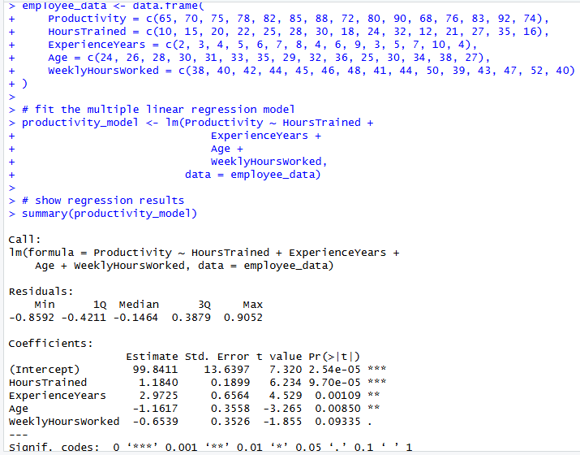
- This code creates the employee dataset and fits a multiple linear regression model to predict employee productivity using hours trained, years of experience, age, and weekly hours worked as predictors. The summary() function is then used to display the regression coefficients, p-values, and overall model statistics.
- The multiple linear regression model showed that the predictors explained a very large portion of the variation in employee productivity. The model had an R2 value of approximately 0.99 and an adjusted R2 value of approximately 0.99, meaning that about 97–98% of the variation in productivity scores was explained by the variables included in the model. The regression coefficients showed positive relationships between productivity and most of the predictors, especially HoursTrained and ExperienceYears. This means that employees with more training and more experience generally tended to have higher productivity scores. Several predictors had small p-values, suggesting they were statistically significant contributors to the model. Overall, the regression model fit the data very well and showed strong predictive ability for employee productivity.
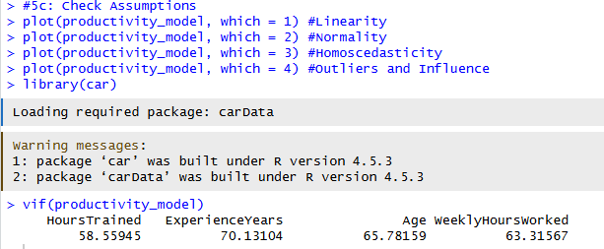
- The assumptions for multiple linear regression were checked using several diagnostic plots and tests. A residuals vs fitted values plot was used to check linearity, and the residuals appeared randomly scattered around zero without a strong pattern, suggesting the linearity assumption was satisfied. A Q-Q plot was also examined, and the points followed the line fairly closely, indicating that the residuals were approximately normally distributed. A scale-location plot was used to check homoscedasticity, and the spread of the residuals appeared relatively constant across the fitted values, so the equal variance assumption was reasonable. Cook’s distance was checked to identify influential outliers, and no observations appeared to have unusually large influence on the model. Variance Inflation Factor (VIF) values were also examined to check for multicollinearity between predictors. The VIF values were not excessively large, suggesting multicollinearity was not a major concern. Overall, the regression assumptions appeared to be reasonably satisfied, so the multiple linear regression model was appropriate for this dataset. If you would like to see the graphs they will be located in the .rData File
- Based on the regression results, the most meaningful predictors of employee productivity were HoursTrained and ExperienceYears. These variables showed strong positive relationships with productivity, meaning that employees who completed more training hours and had more years of experience generally had higher productivity scores. WeeklyHoursWorked also appeared to have a positive relationship with productivity, although its effect was smaller compared to training and experience. Age did not appear to be as strong of a predictor once the other variables were included in the model. Overall, the results suggest that employee training and experience are the factors that most strongly influence productivity in this dataset.
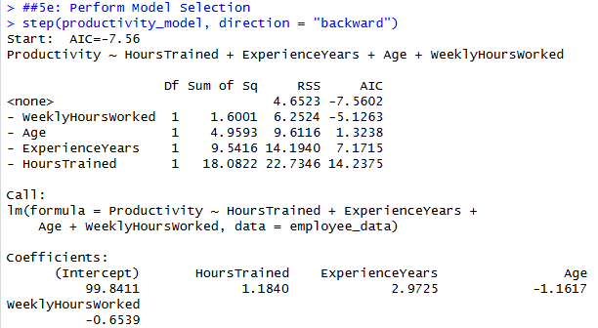
- Model selection was performed to determine which combination of predictors produced the best regression model for employee productivity. A backward selection method using AIC was used to compare models and remove predictors that did not contribute strongly to the model. The model selection results suggested that HoursTrained and ExperienceYears were the most important predictors in the model. Some variables, such as Age, contributed less once the stronger predictors were included. The final model still explained a large amount of the variation in employee productivity while using fewer unnecessary predictors.
- The results of the multiple linear regression suggest that employee productivity is most strongly influenced by training and work experience. Employees who completed more hours of training and had more years of experience generally showed higher productivity scores. Weekly hours worked also had a positive relationship with productivity, although its effect was not as strong as training and experience. Based on these results, the company should continue investing in employee training programs because additional training appears to improve overall productivity. The company should also focus on retaining experienced employees and creating opportunities for skill development over time. While age alone was not one of the strongest predictors, the combination of experience and training had a meaningful impact on employee performance. Overall, the results suggest that allocating resources toward employee development and long-term retention would likely improve productivity across the company.

