Comparing network structures of depressive symptoms and covariates between females and males in a large cross-sectional sample

Christopher Huong & … This Could Be You

Intro

Mental health symptoms have traditionally been understood as indicators of underlying latent causes (e.g., brain disease). The introduction of a network theory of psychopathology has reconceptualized mental disorders as a complex network constituted of interconnected, causally related symptoms, which may reinforce each other thereby maintaining a disordered state. This theoretical shift has been accompanied by an emergence of network psychometric methods, enabling estimation and testing of network models from cross-sectional and longitudinal data. In psychometric network models, nodes typically represent observed variables and edges represent the pair-wise partial correlations between them. Various tools have been developed to investigate the psychometric properties of estimated networks.

Sex differences in the rates of depression have been well established, yet little is known about how relationships between depressive symptoms differ between females and males. In this study we use a network approach to investigate this question.

Methods

This study used cross-sectional data from the Mental Health Million project. Participants took the Mental Health Quotient (MHQ), a novel 47-item questionnaire consolidating symptom items from 126 psychiatric tools assessing ten common mental disorders. We selected 18 items which mapped onto depression found in the DSM-IV, Beck Depression Inventory, and Patient Health Questionnaire-9, as well as 9 covariates hypothesized to be related to depressive symptoms from participants from English-speaking countries (n=66620, 58% female). We estimated two Mixed Graphical Models using a graphical LASSO regularization procedure with the tuning parameter selected with the Extended Bayesian Information Criterion (EBIC). We set the EBIC hyperparameter to 0.25 for a conservative estimation of models. Expected Influence (EI) indices were computed for each network. A network comparison test (NCT) was then used to test differences in global strength, edge weights, and EI.

Results

Though the correlation of edges between the networks was high (r = 0.92), the NCT showed that networks for females and males were significantly different (M = 0.20, p < 0.01, but the global strength was not (S = 0.41, females = 18.19, males = 17.78, p = 0.72). EI indices of the two networks were highly correlated (r = 0.78). The edge invariance test revealed 67 edges which were significantly different (p < 0.01), and the magnitudes were retrieved by subtracting the weighted adjacency matrices. The largest differences in links between depressive symptoms included males showing a stronger association between avoidance and anger, and females showing a stronger negative association between ability to form relationships and suicidal thoughts/intentions.

Discussion

The comparison of female and male networks of depressive symptoms and covariates reveal differences in the strength of associations between nodes. These differences may have implications for how females and males tend to develop depression, and for potential symptom treatment targets. Further research using longitudinal methods are needed to assess whether the temporal dynamics of depressive symptoms are identical in females and males.

Female network: 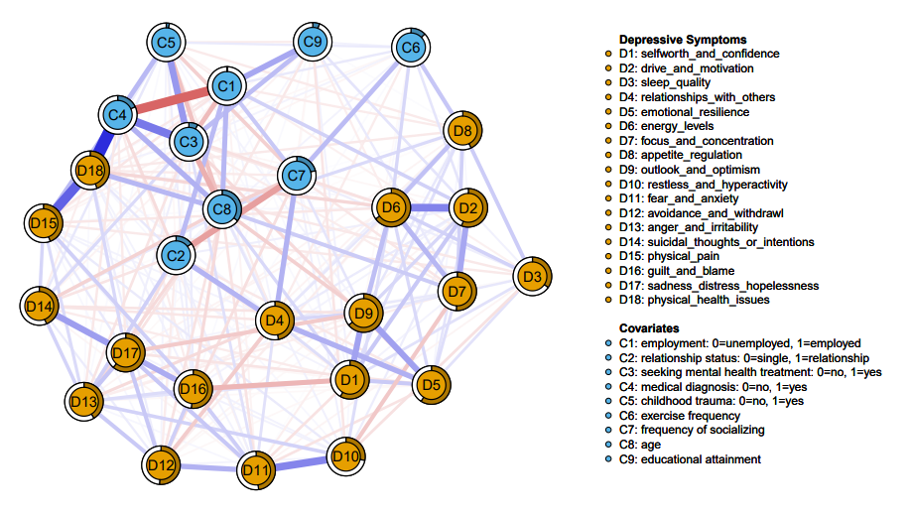

Male network: 