SUPPLEMENTARY

Section A

For the sensitivity analysis we handled missing data with Multiple Imputation using Fully Conditioned Specification as implemented in the R Package *mice* (Van Buuren & Groothuis-Oudshoorn, 2011) with number of imputations set to 5. Multiple imputation preserves the sample size while accounting for uncertainty by incorporating randomness in missing value estimation with multiple data sets. Covariate balancing propensity scores (Imai & Ratkovic, 2014) were used to estimate propensity weights on each imputed dataset as implemented in the R Package *WeightThem* (Pishgar et al., 2020), and the results were combined using the *Within* approach where weights are estimated for each imputed data set, exposure effects are computed for each individual data set and then the coefficients and standard errors are subsequently pooled using Rubin’s Rules (Rubin, 2004) to produce a point estimate of the exposure effect. The within approach demonstrates unbiased estimates when compared to other approaches (Granger et al., 2019; Leyrat et al., 2019).

Section B

Covariate balancing was assessed using the R package *cobalt* (Greifer, 2022). Pre-weighting and imputation assessment indicated 11/41 covariates level were not balanced. After GBM weighting, perfect balance was achieved across all covariate levels. After multiple imputation and covariate balancing propensity score weighting, perfect covariate balance was also achieved. Both love plots are shown in Figures 1 & 2.

Granger, E., Sergeant, J. C., & Lunt, M. (2019). Avoiding pitfalls when combining multiple imputation and propensity scores. *Statistics in medicine*, *38*(26), 5120-5132.

Greifer, N. (2022). cobalt: Covariate balance tables and plots. *R package version*, *4.4.1*.

Imai, K., & Ratkovic, M. (2014). Covariate balancing propensity score. *Journal of the Royal Statistical Society: Series B (Statistical Methodology)*, *76*(1), 243-263.

Leyrat, C., Seaman, S. R., White, I. R., Douglas, I., Smeeth, L., Kim, J., Resche-Rigon, M., Carpenter, J. R., & Williamson, E. J. (2019). Propensity score analysis with partially observed covariates: How should multiple imputation be used? *Statistical methods in medical research*, *28*(1), 3-19.

Pishgar, F., Greifer, N., Leyrat, C., & Stuart, E. (2020). MatchThem:: matching and weighting after multiple imputation. *arXiv preprint arXiv:2009.11772*.

Rubin, D. B. (2004). *Multiple imputation for nonresponse in surveys* (Vol. 81). John Wiley & Sons.

Van Buuren, S., & Groothuis-Oudshoorn, K. (2011). mice: Multivariate imputation by chained equations in R. *Journal of statistical software*, *45*, 1-67.

Figure 1. Love plot displaying covariate balance before and after GBM weighting.

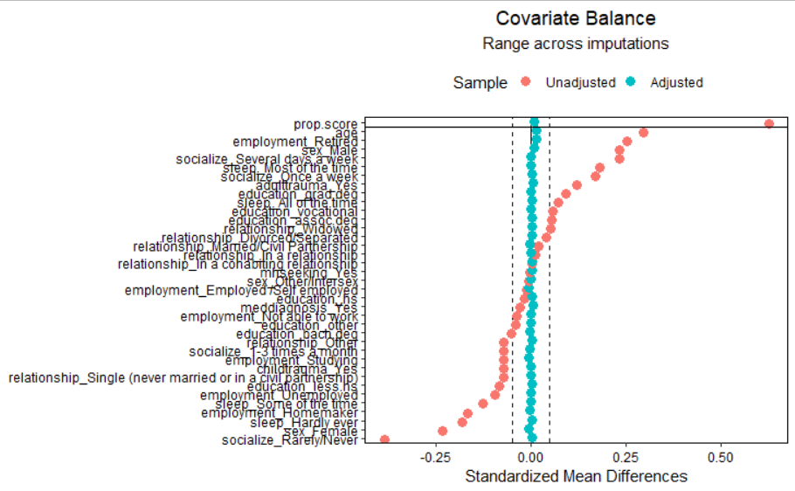

Figure 2. Love plot displaying covariate balance before and after multiple imputation and covariate balancing propensity score weighting.