1. Data wrangling
   1. Subset outcomes, treatment variable, and covariates
   2. Recode and consolidate
   3. Drop ethnicity and genderdiff due to missing data (mice errored)
2. Multiple Imputation of Missing Data
   1. Create prediction matrix, zero out ID and denote country as class variable (-2)
   2. Set imputation methods (pmm default, logreg and polyreg for factors)
   3. Run imputation
   4. Check imputed data
3. Covariate Balancing
   1. Generate balancing weights for covariates to estimate treatment effect of PA (multi-category)
      1. Compute a weighted dataset estimating ATT with focal = “Few days a week”
      2. Compute a weighted dataset estimating ATE (no focal variable)
      3. Compute a weighted dataset estimating ATE with binary treatment (Meet PA guidelines yes/no) (Should we do this? Need to recode PA to binary and re impute missing data)
   2. Check balance
      1. Love plot
4. Estimation of Treatment Effect
   1. Formulate a multi-level (nested by country) survey weighted GLM
      1. Pool estimates and print results for 6 outcomes: MHQ, Cognition, Adaptability and Resilience, Drive and Motivation, Mood and Outlook, Social Self, Mind-Body Connection
   2. Plot PA X Age interaction for 6 outcomes with balanced data (2-way anova?)

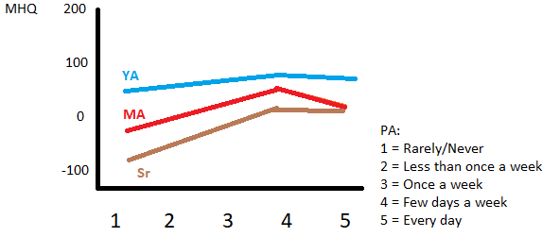

“We used a non-parametric exact matching procedure17 to account for differences across the full covariate set” (MatchIt)

“To account for the fact that participants self-select into various exercise types, we applied a multinomial propensity weighting procedure that uses generalised boosted regression trees to estimate poststratification propensity scores. In this case, these scores reflect the probability that an individual will be assigned to a specific exercise type, given the full covariate set. Propensity scores were then winsorised at a 99% level to minimise the impact of excessive values”

“Non-parametric twosample Wilcoxon rank-sum tests were used to assess for differences in mental health burden between these matched groups (figure 1). Since a previous diagnosis of depression could have an extremely strong association with current mental health burden, we did separate matched sample analyses for individuals who had been diagnosed with depression in the past and those with no previous diagnosis of depression. Finally, to ensure that the findings were not an artifact of covariate adjustment, we did sensitivity analyses without matching procedures”