Design Document for Lab02

Christopher Medlin

### Algorithm

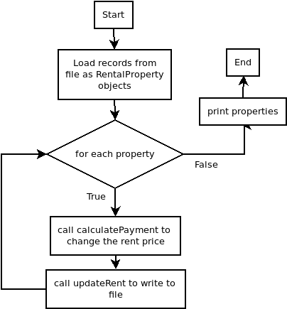

Above is the general algorithm for the program. In order to print out all of the properties, they first have to be sorted through by ID, and the compareTo method of String can be used for that. The instanceof operator could also be used to group them as apartments or single family homes as shown in the output example.

### **UML**

