Design Document for Lab03

Christopher Medlin

### Algorithm

The method for adding a portion of the matrix will probably be like any 2-dimensional array iteration, but with a different condition in the for loop. To divide into 4 separate matrices, the vertical and horizontal length can be divided by 2. For concurrency, my ThreadOperation class will compose an ExecutorService object. In order to wait for thread completion, it will call the awaitTermination method after shutting down.

### UML

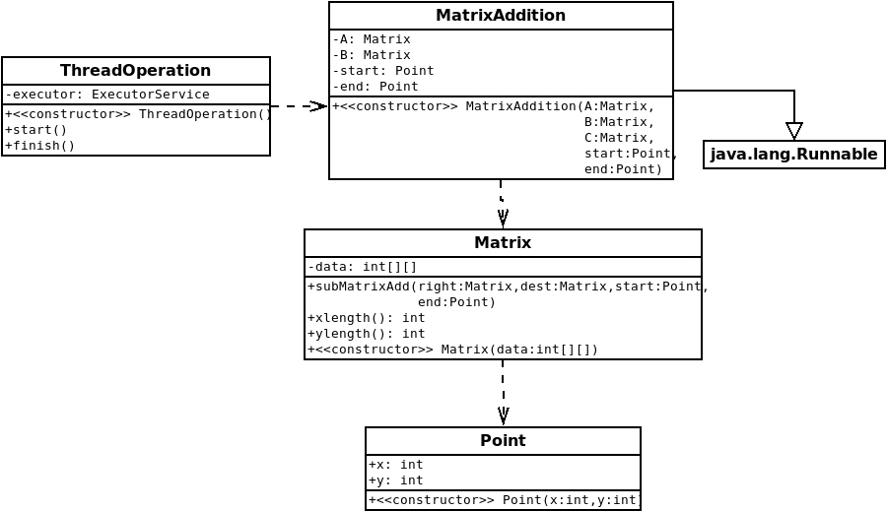(I have a Point class so that I can just pass 2 objects to subMatrixAdd instead of 4 integers)